Assignment Submission Instructions
For Both Activities: Complete the discussion board activity as described, then submit the following artifacts to the LMS for assessment:
Required LMS Submissions:
- Screenshot Collection: Submit a compiled document containing all screenshots from your Schema Study interactions
- Written Reflection: Include a brief reflection (2-3 sentences) on how the AI feedback changed your understanding of the focal concepts
- Cross-Concept Connection: Provide your written scenario demonstrating connections between course terms
- Claim Verification Summary: Document your source verification process and conclusions

Learning Outcomes Addressed:
- Activity 1: Critical evaluation of AI-generated content; source verification skills; academic citation practices
- Activity 2: Conceptual integration; applied reasoning; formative feedback utilization; peer collaboration

Online Discussion Board Activity 1

As artificial intelligence and chatbots like ChatGPT become more integrated into our daily lives, it's crucial to approach the information they provide with a critical mindset. Unlike human experts, chatbots are unable to reliably cite sources, making it harder to verify where their information comes from. While you can follow up with a person and hold them accountable for their claims, chatbots function more like "black boxes," generating responses based on patterns in data without offering direct citations or the ability to clarify. This activity focuses on the importance of cross-checking chatbot-generated information with reliable, scholarly sources.

Step 1: Visit the Schema Study app, open it, and select a term from the dropdown menu that you find confusing or intriguing.

Step 2: Start a conversation with the chatbot about the term, encouraging it to provide detailed explanations. Specifically ask the chatbot to make specific claims about mechanisms, relationships, or applications rather than general definitions. When the chatbot provides information that includes:
- Specific numerical data or statistics
- Causal relationships (X causes Y)
- Research findings or study results
- Mechanistic explanations (how processes work)
- Claims about effectiveness or outcomes
Take a screenshot of that portion of the conversation. Avoid selecting common knowledge statements that don't require citation.

Step 3: In your discussion post, include:

- A screenshot of the chatbot snippet.
- 1-2 sentences explaining why you chose that specific part of the conversation.

Step 4: Find a classmate’s post that hasn't been replied to yet. Conduct online research to verify the chatbot’s information using reliable sources like textbooks, expert writings, government or university websites, peer-reviewed journal articles, or other scholarly references. You can refer to 'What Types of References Are Appropriate?' as a guide.

Step 5: In your reply, provide:

- A citation of the source you found to either confirm or refute the chatbot's information. Use 'APA Formatting and Style Guide' for help with proper APA format.
- A brief explanation detailing how your source confirmed or refuted the chatbot’s claim, using quotations where appropriate.

Example Student Response:
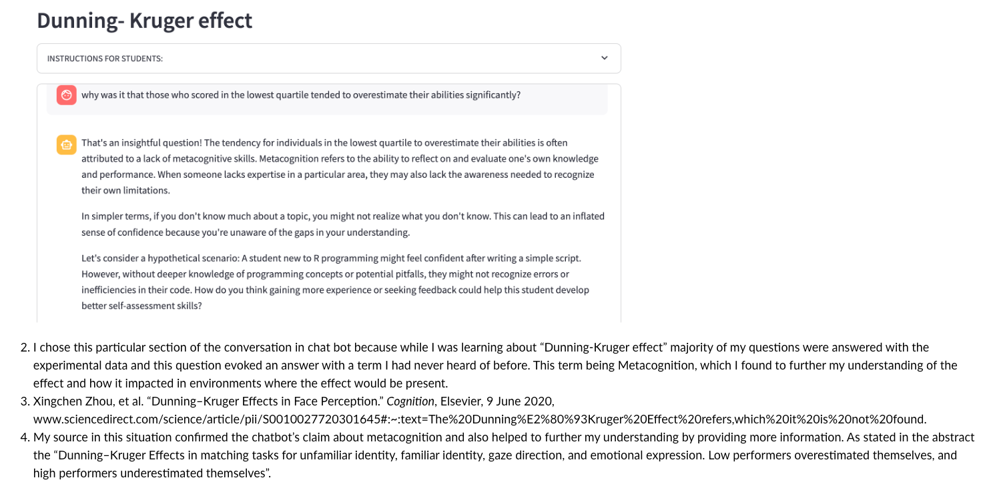

Mastery Rubric for Online Discussion Board Activity 1

This rubric assesses your performance on the Online Discussion Board Activity 1, focusing on your engagement with the chatbot, your critical evaluation of its information, and your ability to verify that information using scholarly sources.

Performance Levels
Criteria | Mastery | Proficient | Developing | Beginning
1. Chatbot Engagement | - Engages deeply with the chatbot, eliciting detailed responses.  - Demonstrates critical thinking and curiosity throughout the interaction. | - Engages with the chatbot adequately but may not fully explore depth.  - Shows some critical thinking in the interaction. | - Limited engagement with the chatbot.  - Interaction lacks depth and critical inquiry. | - Little to no engagement with the chatbot.  - Interaction is superficial or irrelevant.
2. Screenshot Inclusion and Relevance | - Includes a clear and relevant screenshot of the chatbot conversation.  - The selected snippet requires citation and is not common knowledge. | - Includes a mostly relevant screenshot.  - The snippet may be somewhat common knowledge or less critical. | - Screenshot is included but may be unclear or only partially relevant.  - The snippet does not significantly require citation. | - No screenshot included, or the screenshot is irrelevant.  - The snippet is common knowledge or inappropriate.
3. Explanation of Selected Conversation Snippet | - Provides a clear and thoughtful 1-2 sentence explanation of the chosen snippet.  - Explanation demonstrates critical analysis of the chatbot's information. | - Provides an adequate explanation of the chosen snippet.  - Explanation shows some analysis but may lack depth. | - Explanation is unclear or lacks connection to the snippet.  - Minimal analysis is evident. | - No explanation provided, or explanation is irrelevant.  - Lacks any analytical insight.
4. Research and Verification of Chatbot's Info | - Conducts thorough research finding a reliable, appropriate scholarly source. | - Conducts adequate research using an acceptable source.  - Source partially verifies or refutes the chatbot's information. | - Research is minimal or relies on less credible sources.  - Weak connection between research and the chatbot's information. | - Fails to conduct research or uses inappropriate sources.  - Source does not verify or refute the chatbot's information.
5. Citation of Source in APA Format | - Provides a complete and correctly formatted APA citation.  - Includes all necessary components (author, year, title, source). | - Provides an APA citation with minor formatting errors.  - Missing one component or minor mistakes. | - Citation is incomplete or has significant formatting errors.  - Missing multiple components. | - No citation provided, or citation is not in APA format.  - Citation is incorrect or irrelevant.
6. Explanation of Source Confirmation/Refutation | - Offers a clear and concise explanation of how the source confirms or refutes the chatbot's claim.  - Uses direct quotations appropriately to support the explanation. | - Provides an explanation of how the source relates to the chatbot's claim.  - May use quotations but not optimally. | - Explanation is unclear or lacks sufficient detail.  - Does not effectively use quotations. | - No explanation provided, or explanation is irrelevant.  - Fails to connect the source to the chatbot's claim.

Instructions for Use:

- Mastery: Aim for this level by thoroughly completing each part of the assignment with attention to detail and quality.
- Proficient: Meets the basic requirements but may need minor improvements.
- Developing: Needs significant improvement in multiple areas.
- Beginning: Does not meet the basic requirements; major revisions are necessary.

Note: This rubric is designed to help you understand the expectations for the assignment and to self-assess your work before submission. Focus on each criterion to ensure a comprehensive and high-quality contribution to the discussion board.

Online Discussion Board Activity 2

Connecting different concepts deepens your understanding and retention of material, while also enabling you to apply your knowledge in new situations—an essential skill in biology. By linking terms meaningfully, you build a more integrated and applicable knowledge base, making complex topics easier to manage and recall during exams or practical applications. In this activity, you’ll use Schema Study to practice connecting course terms through creative scenarios, with the benefit of receiving formative feedback from the chatbot. This assignment, combined with ongoing practice, will help strengthen your understanding, improve critical thinking, and prepare you for success in the course.

Step 1: Open the Schema Study app, select a term from the dropdown menu that you can confidently explain to a fellow student.

Step 2: Use the following prompt with the chatbot:

"I want to test my ability to connect this term to others in the term list. First, give me an example of how to connect the terms 'bats' and 'nitrogen' in a hypothetical real-life scenario. Second, prompt me to similarly create a logical applied scenario between the term I chose and one other you choose randomly from the course term list. Your role is to provide feedback on the scenario I create."

Engage fully with the chatbot, following its prompt and thoughtfully creating your scenario. If you can’t think of a connection between the two terms, feel free to ask for another random term. Make sure the scenario demonstrates your broader knowledge of the material—avoid surface-level connections like "bats and nitrogen are both course terms" or "both contain the letter 't'." Be creative and take your time.

Step 3: In your discussion post, include the following:

- The term you selected and the random term the chatbot provided.
- The hypothetical scenario you created, connecting the two terms.
- A screenshot of the formative feedback from the chatbot.
- A short reflection (2-3 sentences) on the exercise, including whether you agree with the chatbot’s feedback.

Step 4: Find a classmate’s post that hasn’t been replied to yet. Use the same two terms from their post to create a completely different real-life scenario connecting those terms.

Example Student Response
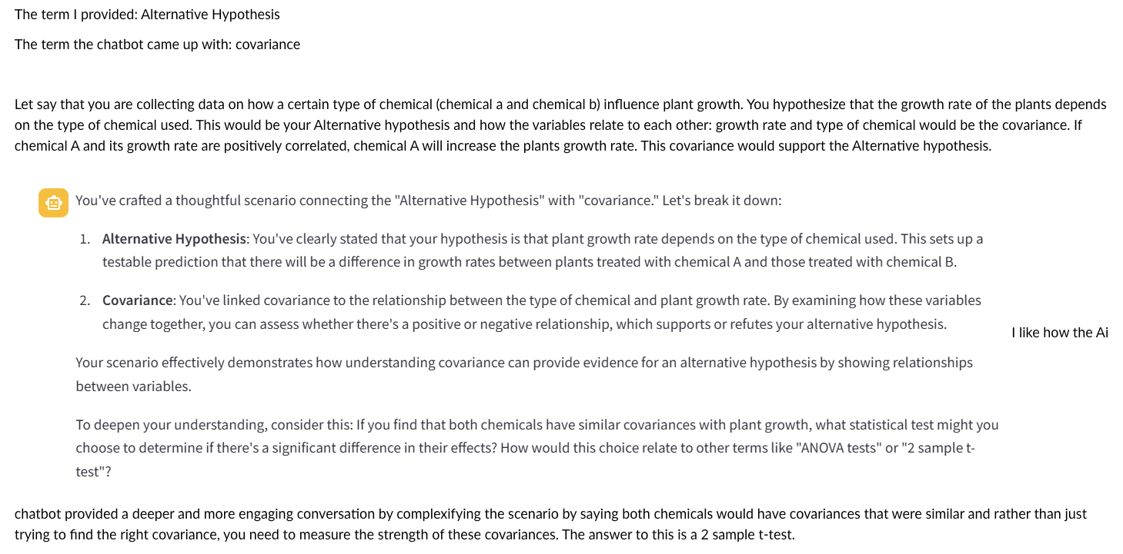

Mastery Rubric for Online Discussion Board Activity 2

This rubric assesses your performance on the Online Discussion Board Activity 2, focusing on your ability to creatively connect course terms, engage with the chatbot for formative feedback, reflect on the exercise, and interact with classmates by creating new scenarios.

Performance Levels
Criteria | Mastery | Proficient | Developing | Beginning
1. Selection of Term and Chatbot Engagement | - Selects a term confidently understood. - Engages fully with the chatbot, following the prompt precisely. - Demonstrates critical thinking and curiosity throughout the interaction. | - Selects an appropriate term. - Engages adequately with the chatbot but may not fully explore depth. - Shows some critical thinking in the interaction. | - Selects a term but engagement with the chatbot is limited or incomplete. - Interaction lacks depth and critical inquiry. | - Fails to select an appropriate term. - Little to no engagement with the chatbot. - Interaction is superficial or irrelevant.
2. Creativity and Depth of Hypothetical Scenario | - Creates a highly creative and logical real-life scenario connecting the two terms. - Demonstrates deep understanding of both terms and their interrelation. - Avoids surface-level connections. | - Creates a logical scenario connecting the two terms. - Shows understanding of the terms but may lack creativity or depth. - May rely slightly on surface-level connections. | - Scenario connects the terms but is simplistic or lacks logic. - Minimal understanding of the terms is evident. | - Scenario is unclear, illogical, or fails to connect the terms meaningfully. - Lacks understanding of the terms.
3. Inclusion and Relevance of Chatbot Feedback Screenshot | - Includes a clear and relevant screenshot of the chatbot's formative feedback. - Feedback is directly related to the scenario and provides valuable insights. | - Includes a screenshot of the chatbot's feedback. - Feedback is somewhat relevant to the scenario. | - Screenshot is included but may be unclear or only partially relevant. - Feedback has minimal connection to the scenario. | - No screenshot included, or the screenshot is irrelevant. - Feedback does not relate to the scenario.
4. Reflection on Exercise and Chatbot Feedback | - Provides a thoughtful 2-3 sentence reflection on the exercise. - Critically evaluates the chatbot’s feedback and expresses agreement or disagreement with clear reasoning. | - Provides a reflection on the exercise. - Addresses the chatbot’s feedback with some reasoning. | - Reflection is minimal or lacks depth. - Limited evaluation of the chatbot’s feedback. | - No reflection provided, or reflection is irrelevant. - Does not address the chatbot’s feedback.
5. Response to Classmate’s Post | - Creates a completely different, creative, and logical real-life scenario using the same terms. - Demonstrates deep understanding and originality. | - Creates a different scenario connecting the terms. - Shows understanding but may lack creativity or depth. | - Scenario is somewhat different but may be simplistic or similar to the original. - Minimal understanding is evident. | - Does not provide a different scenario, or scenario fails to connect the terms meaningfully.

Instructions for Use:

- Mastery: Aim for this level by thoroughly completing each part of the assignment with attention to detail and quality.
- Proficient: Meets the basic requirements but may need minor improvements.
- Developing: Needs significant improvement in multiple areas.
- Beginning: Does not meet the basic requirements; major revisions are necessary.

Note: This rubric is designed to help you understand the expectations for the assignment and to self-assess your work before submission. Focus on each criterion to ensure a comprehensive and high-quality contribution to the discussion board.

