LUMENS
A STRATEGIC ACTION GAME
WITH LIGHT AND PHYSICS SIMULATION, AND EMERGENT ARTIFICIAL INTELLIGENCE
OVERVIEW
CONCEPT
Play as a light-emitting entity, navigating a pitch dark 2D environment. The dark is home to masses of glowing predators, moving in swarms and seeking out sources of light which they feed upon.
You enter a mutual struggle for survival with your unpredictable predators, using strategy, speed, and accuracy in the face of overwhelming numbers. Get in close to the swarm that moves all around – stealthily luring away and picking off individuals one-by-one, without being discovered and overcome by the others.
The dark conceals threats and traps, while the light betrays you to your hunters.

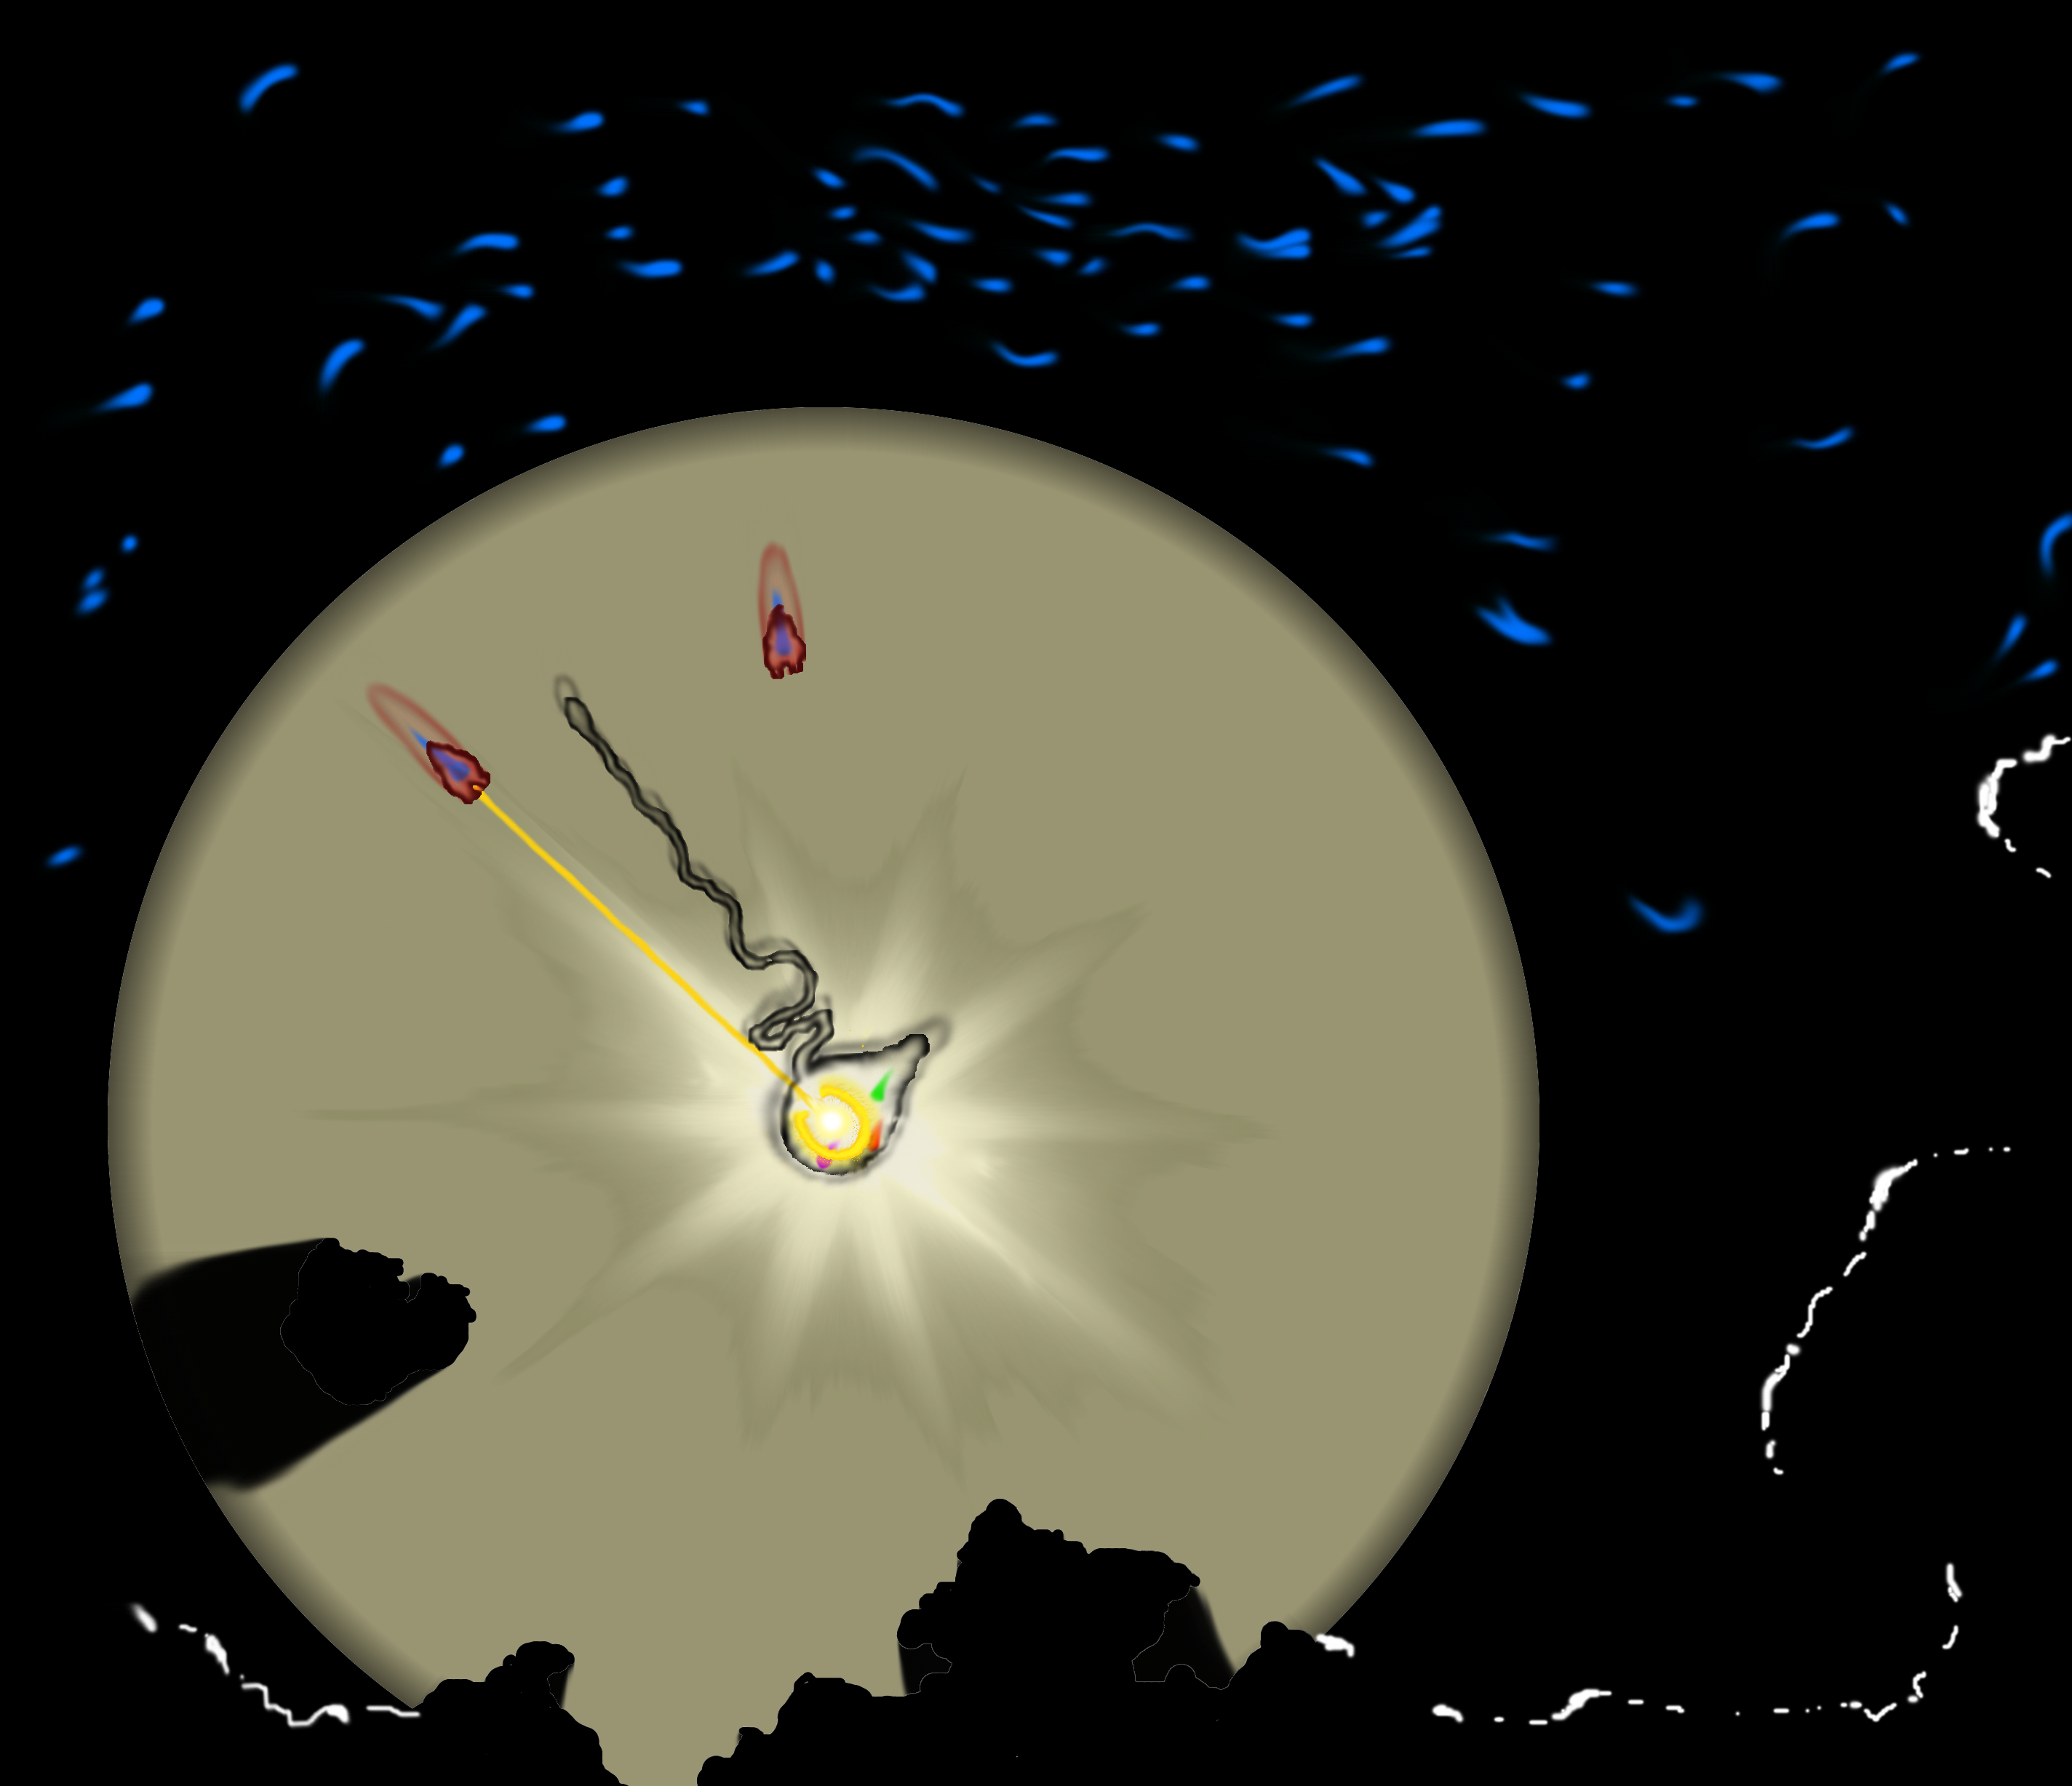
GAMEPLAY
Predators feed on light, hunting out its source when they're lit, while the player can only attack those within range of their emitted light. The range of this light grows with each attack, and only shrinks back to its minimum slowly over time.
The player faces an unpredictable, organic, and mobile swarm of enemies, with this gameplay mechanic making the struggle to remain unseen and survive more difficult the harder they try and the more reckless they are.
Several special abilities provide extra power when it's most needed, the variety of species of predator

FEATURES AND CHALLENGES
LIGHT SIMULATION
Real-time ray-tracing realistically depicts the core visual elements of Lumens – light and its effects.
This is an expensive and challenging technique for a computer to perform. Described simply, a ray is traced backwards from every single pixel of the screen in turn into the environment, and is tested to see if it strikes any objects. If it does, a second (“shadow”) ray is then traced from that point to see whether or not it is lit by a light source. If so, the object's colour is added to the colour of that pixel, and if not, the pixel has shadow added to it.
This is known as backwards ray-tracing – as rays are traced from the eye to the light source – and can be expanded upon with additional reflective and refractive rays, which bounce around the scene more times again, to achieve greater realism.

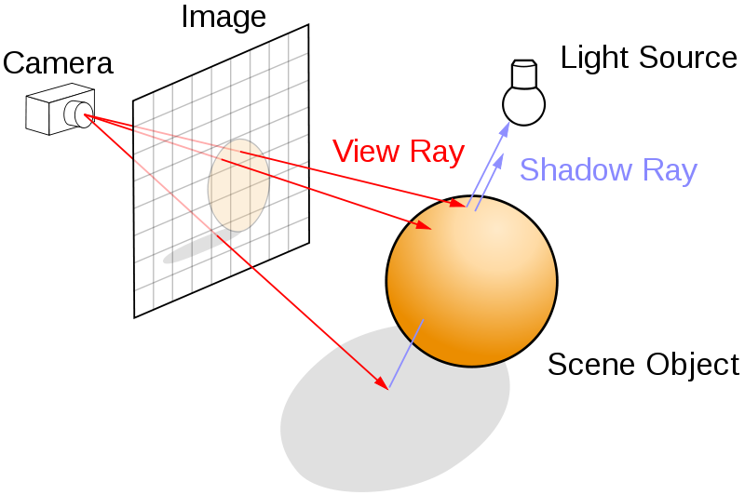
The aim in this case is to achieve several realistic effects of light, such as shadows, reflection, refraction, crepuscular rays, caustics, and afterimage; by using ray-tracing and other techniques.
To achieve real-time performance with this technique, Lumens uses WebGL to run it on the device's graphics card.

EMERGENT ARTIFICIAL INTELLIGENCE
The behaviour of the various entities in Lumens is not controlled in a traditional, predictable, scripted way: instead, each entity observes a set of simple rules which – when combined and applied to each member of the swarm – result in unpredictable, natural-looking and convincing movements. This is known as “emergent” behaviour, where intelligent-seeming actions emerge from simple rules in an unpredictable and non-repeating way. Here, each member of the swarm acts according to its own small viewpoint, yet the swarm moves together as a whole, like birds flocking.

PHYSICS
The physics engine in Lumens is developed, along with everything else, from scratch. This includes simulating the motion of rigid bodies, soft-body dynamics (“blobby” materials), collision-detection and resolution, and techniques such as space-partitioning to improve overall performance.

PROCEDURAL GENERATION
One of the aims of this game is to produce an interesting, exciting experience for the player “on the fly”, with as little as possible is defined in advance.
The levels are generated as you advance, allowing you an unlimited source of new ones. The audio is created dynamically, reacting to the game. What you see is defined by the way light reacts to the environment in real-time, and your enemies behave without following a predictable script.
You never know what's waiting for you in the dark.

TECHNOLOGY AND TARGETS
PLATFORM

Lumens is developed with HTML5, allowing it to run on any device with a modern internet browser – from a portable touchscreen to a desktop PC – and using WebGL, Worker threads, and the audio API, among others.

AUDIENCE
Suitable for both short bursts of play and more involved sessions, it is aimed at those who enjoy challenging action and strategy, unusual ideas, and memorable experiences.

