LUMENS

A STRATEGIC ACTION GAME

WITH LIGHT AND PHYSICS SIMULATION, AND EMERGENT ARTIFICIAL INTELLIGENCE

OVERVIEW

CONCEPT

Play as a light-emitting entity, navigating a pitch dark environment – home to swarms of glowing predators seeking out sources of light which they feed upon.

Use stealth, speed, and accuracy to outmanoeuvre the unpredictable swarm; stealthily lure away and pick off individuals without being discovered by overwhelming numbers.

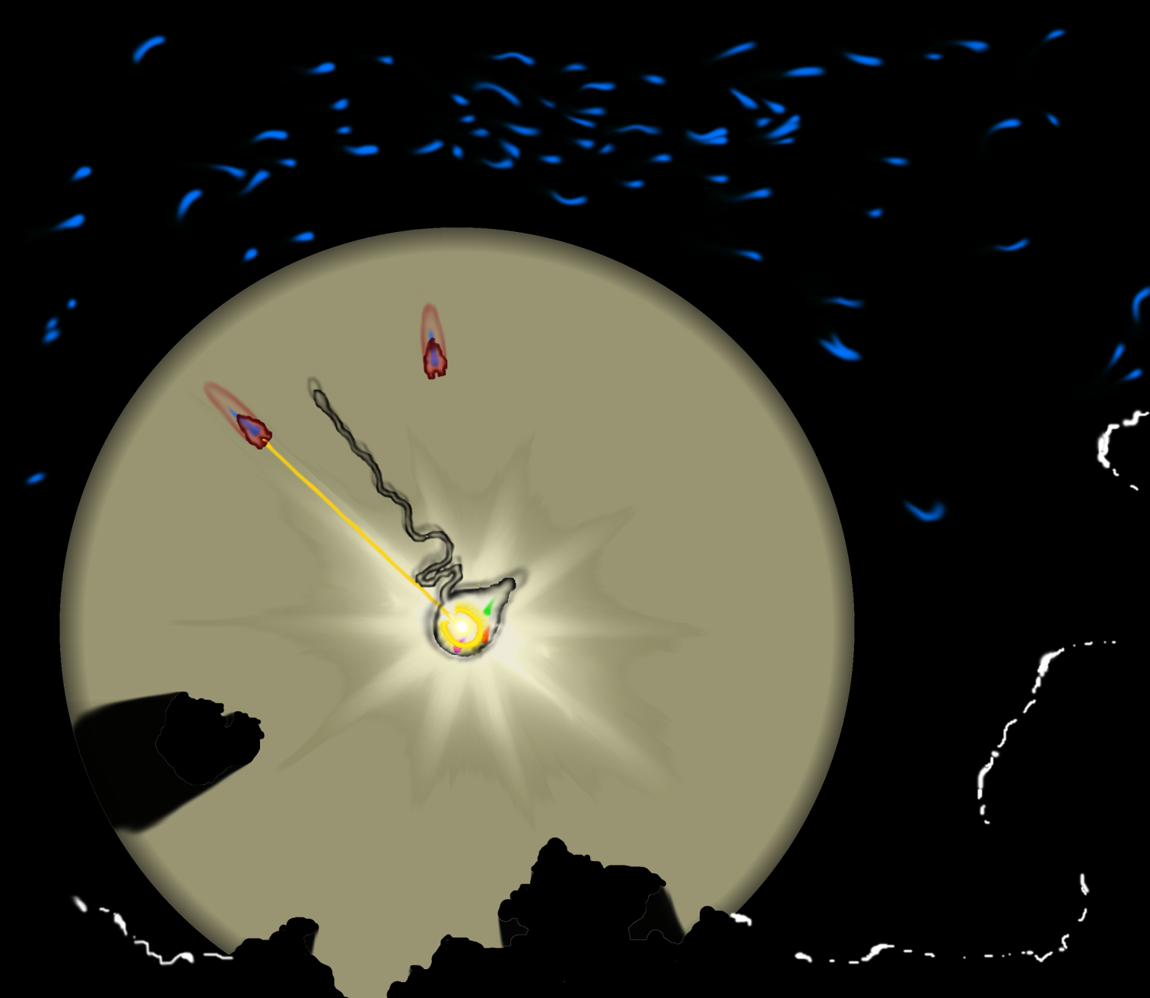

Darkness conceals threats, traps and dead-ends; light betrays you to your hunters.

GAME-PLAY

The swarm of predators roams the environment, blind and oblivious in the dark; when lit, they hunt out the source in a feeding frenzy.

The player’s attack can only reach as far as their emitted light – the pool of light grows with each attack, miss, or use of an enhanced ability; only shrinking back slowly over time.

The more reckless they are, the more difficult the struggle to remain unseen and survive becomes; facing an unpredictable, organic, and mobile swarm of enemies, as the pool of light grows.

Enhanced abilities provide extra power when it's most needed; and several types of predator wander the dark, leaving the player uncertain of what threat they’ll stumble into.

FEATURES AND CHALLENGES

LIGHT SIMULATION

Real-time ray-tracing realistically depicts light and its effects *–* the core of the visuals in *Lumens*.

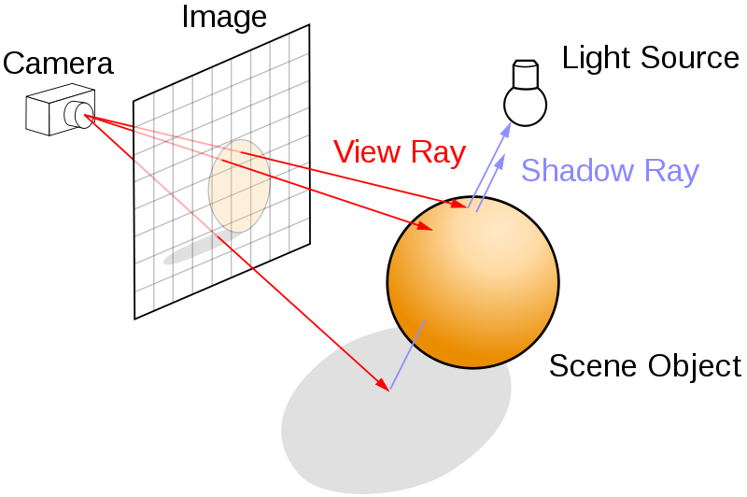Described simply, a ray is traced backwards through every single pixel of the screen into the environment; if it strikes any objects, a second ray is then traced from that point to each light; if the point is directly lit, its colour is added to the colour of that pixel; otherwise the pixel remains in shadow.

This technique can be expanded upon further – with additional reflective and refractive rays and other techniques – to achieve greater realism; producing effects such as shadows, reflection, refraction, caustics, and after-image.

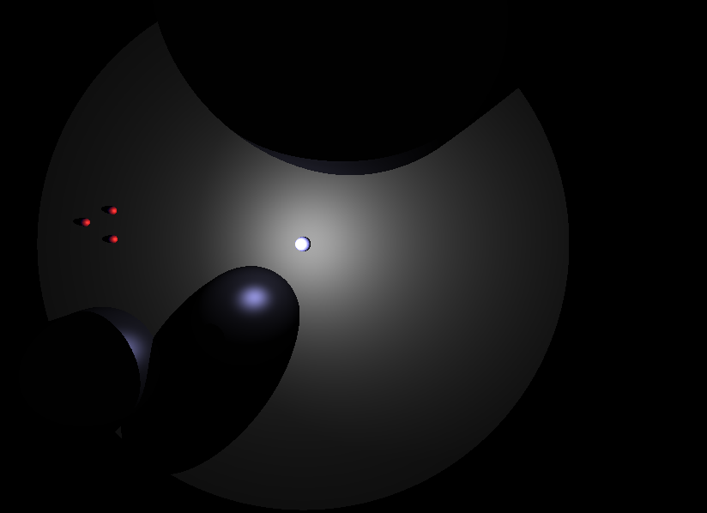

Achieving real-time performance in ray-tracing is a challenge, and so *Lumens* uses the emerging HTML5 WebGL technology to run it directly on the graphics card.

EMERGENT ARTIFICIAL INTELLIGENCE

The behaviour of the various entities in *Lumens* is not controlled in a traditional, predictable, scripted way: instead, each entity observes a set of simple rules which – when combined and applied to each member – result in the unpredictable and convincing movement of the whole swarm.

This is known as “emergent” behaviour, where complex actions emerge from simple rules in an interesting way.

Here, each member of the swarm acts according to its own small point of view, yet the swarm moves together as a whole, like a flock of birds.

PHYSICS

The physics engine in *Lumens* is developed from scratch, simulating the realistic motion of bodies, soft-body models, and collision detection and resolution; with performance-improving techniques such as space-partitioning providing greater speed and responsiveness.

PROCEDURAL GENERATION

One of the aims of this game is to produce an interesting, exciting experience for the player “on the fly”, with as little as possible defined in advance. What you see is defined by the way light reacts to the environment; your enemies behave without a predictable script; levels generated as you go, providing an unlimited source of new ones; and dynamically generated audio reacts to the game.

You never know what's waiting in the dark.

TECHNOLOGY AND TARGETS

PLATFORM

*Lumens* is developed using HTML5, allowing it to run on any device with a modern internet browser – from a desktop PC to a portable touch-screen device.

AUDIENCE

Aimed at those who enjoy challenging action, strategy, unusual ideas, and memorable experiences; and suitable for both short bursts of play and more involved sessions.