Introduction to Valuation

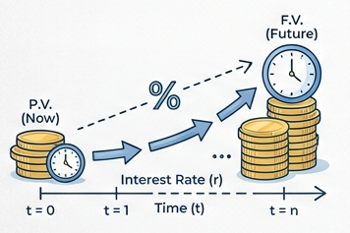

Table of Contents
Topic 1: The Time Value of Money -The Engine of Valuation 3
Topic 2: Meet Mr. Market — Price vs. Value 3
Topic 3: Discounted Free Cash Flow (DCF) Valuation 3
Topic 4: The Price-Earnings (P/E) Ratio 3
Topic 4A: Trailing vs. Forward P/E in Practice - SKHY & NVDA 3
Topic 5: The Margin of Safety 6
Topic 6: Earnings Quality 8

Before You Come to Class — Required Reading
Read the “Mr. Market” section of Warren Buffett’s 1987 Letter to Berkshire Hathaway Shareholders. It is only a few short paragraphs and is the most famous explanation of how to think about market prices.
Free online: www.berkshirehathaway.com/letters/1987.html (open the page, then use Find → “Mr. Market” to jump to the passage).
As you read, keep three questions in mind:
a. Who is Mr. Market, and what is “wrong” with him?
b. Why is he useful to a disciplined investor rather than dangerous?
c. What does Graham’s “voting machine vs. weighing machine” idea mean?
Optional (for the curious): Benjamin Graham, The Intelligent Investor, Chapter 8 (“The Investor and Market Fluctuations”) and Chapter 20 (“Margin of Safety”).

Topic 1: The Time Value of Money -The Engine of Valuation
- A dollar today is worth more than a dollar in the future, because a dollar today can be invested to earn a return. This single idea — the time value of money — is the foundation of every valuation method in this course.
  - The interest rate (or discount rate), r, is the price of time. It converts dollars at one point in time into equivalent dollars at another.
- Two directions, one idea:
  - Compounding moves money forward in time (present → future).
  - Discounting moves money backward in time (future → present). Valuation is almost always discounting.
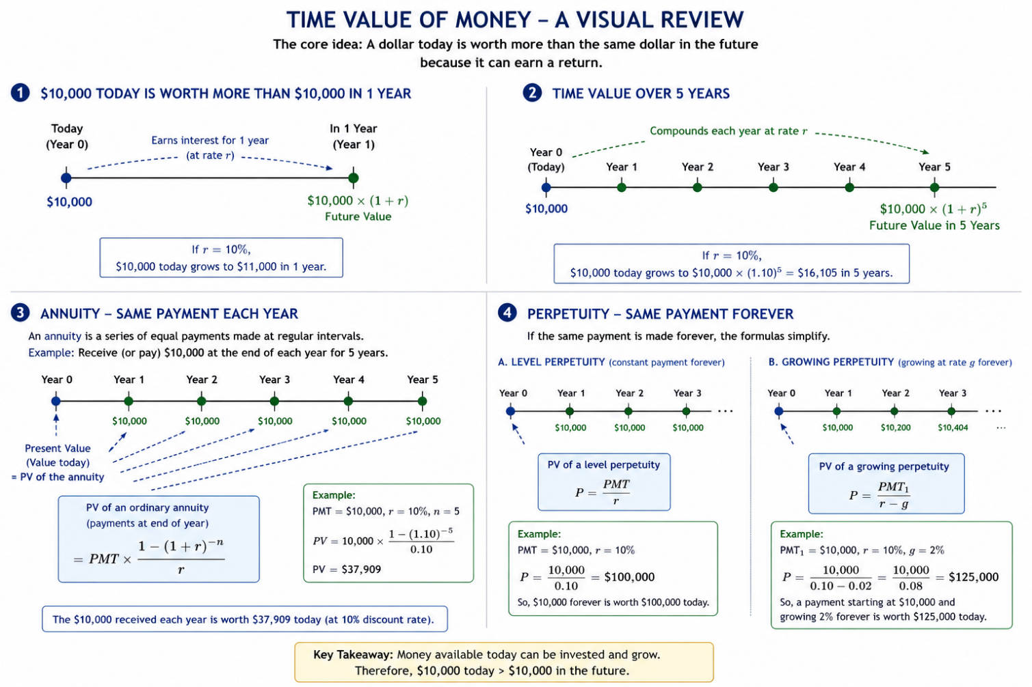

A. Future Value and Present Value of a Single Sum
- Future value (FV) — what a sum invested today will grow to:
$$FV=PV×{\left(1+r\right)}^{n}$$
- Present value (PV) — what a future sum is worth today (just FV rearranged):
$$PV=\frac{FV}{{\left(1+r\right)}^{n}}$$
- Example: at r = 10%, $10,000 today grows to $11,000 in one year and to $16,105 in five years. Run in reverse: $16,105 to be received in five years is worth exactly $10,000 today.
B. Annuities — A Stream of Equal Payments
- An annuity is a series of equal payments made at regular intervals — for example, $10,000 at the end of each year for five years.
- PV of an ordinary annuity (payments at the end of each period):
$$PV=PMT×\frac{1-{\left(1+r\right)}^{-n}}{r}$$
- Example: five annual payments of $10,000, discounted at 10%, are worth $37,909 today — not $50,000 — because the later payments are discounted more heavily.
C. Perpetuities — A Stream That Never Ends
- A perpetuity is an annuity that continues forever. When payments last forever, the formulas collapse to something remarkably simple.
- Level perpetuity (constant payment forever):
$$P=\frac{PMT}{r}$$
  - Example: $10,000 per year forever at 10% is worth $100,000 today.
- Growing perpetuity (payment grows at rate g forever):
$$P=\frac{{PMT}_{1}}{r-g}$$
  - Example: a payment starting at $10,000 and growing 2% forever, discounted at 10%, is worth $125,000 today.
  - Caution: the formula only works when r > g, and PMT₁ is the cash flow one period from today.
- Why this matters most: the growing perpetuity is the single most important tool in valuation. In Topic 4 it reappears as the terminal value — the device we use to capture all cash flows beyond our explicit forecast horizon.

Key Takeaway: Every valuation in this course is one rule applied repeatedly — discount expected future cash flows back to today at a rate that reflects their risk. Master discounting, and the rest is detail.

Concept Quiz #1
1. A dollar to be received three years from now is worth ____ a dollar received today (assume a positive interest rate).
a. more than
b. the same as
c. less than
d. cannot be determined
2. The present value of $5,000 received at the end of every year forever, discounted at 8%, is:
a. $40,000
b. $62,500
c. $625,000
d. infinite
3. Holding the payment and discount rate constant, increasing the growth rate g in a growing perpetuity will ____ its present value.
a. increase
b. decrease
c. not change
d. make it negative

Topic 2: Meet Mr. Market — Price vs. Value
- The next two topics will give us tools to estimate what a business is worth — its intrinsic value. Mr. Market is the parable that explains why the price the market quotes is so often different from that value.
- Benjamin Graham, in The Intelligent Investor, imagined the market as a business partner named Mr. Market. Warren Buffett retold the story in his 1987 letter to Berkshire Hathaway shareholders (your pre-class reading).
A. The Parable (in brief)
- Imagine you own a small business with a partner, Mr. Market. Every day, without fail, he offers to either buy your share or sell you his — and he names a price.
- Mr. Market is emotional. Some days he is euphoric and quotes a wildly high price; other days he is despondent and quotes a price far below the business’s worth. His mood, not the business, drives his quote.
- The crucial point: Mr. Market is there to serve you, not to instruct you. You may trade with him when his price is attractive and ignore him when it is not. He will be back tomorrow with a new quote.
B. The Lesson: Price ≠ Value
- Price is what Mr. Market quotes today; value is what the business is actually worth. The two diverge constantly because price is set by crowd psychology in the short run.
- Graham’s famous formulation: in the short run the market is a voting machine; in the long run, a weighing machine. Sentiment sets prices day to day; fundamentals set them over time.
- The investor’s job is therefore not to predict Mr. Market’s mood, but to (a) form an independent estimate of value, and (b) act only when price departs far enough from value to offer a margin of safety (Topic 5).
C. Two Ways People Try to Beat the Market
- Fundamental analysis — estimate intrinsic value from the business’s cash flows and financial statements (the approach of this course), then buy when price is below value.
- Technical analysis — study patterns in past prices and volume to predict future prices. It ignores intrinsic value and focuses on Mr. Market’s mood swings themselves.
- This course is firmly in the fundamental camp: we use accounting information to estimate value, and we treat market prices as opportunities, not instructions.
D. A Note on Market Efficiency
- The efficient market hypothesis holds that prices already reflect all available information, so Mr. Market is rarely “wrong.” Reality is more nuanced: markets are largely efficient, but emotion, frictions, and information gaps create periodic mispricings.
- Whether or not you can consistently beat the market, the Mr. Market discipline — knowing your own estimate of value and refusing to be ruled by price — protects you from the most common and costly investing mistakes.

Key Takeaway: Mr. Market is your servant, not your guide. Use his quotes; don’t be governed by them. The whole point of learning to value a business is to know when his price is a gift — and when it is a trap.

Discussion Questions
Required:
a. In your own words, explain the difference between the price of a stock and the value of the underlying business. Why do the two diverge?

b. Buffett writes that Mr. Market is there to serve you, not to instruct you. What does this imply about how an investor should react to a sudden 20% drop in a stock’s price?

c. Graham distinguishes a voting machine from a weighing machine. Give one example (real or hypothetical) of each force acting on a stock price.

d. If markets were perfectly efficient, would the Mr. Market parable still be useful? Explain.

Topic 3: Discounted Free Cash Flow (DCF) Valuation
- The DCF model is the most complete expression of the time-value principle: the value of a business equals the present value of the free cash flow it will generate for its investors.
- Free cash flow (FCF) is the cash a business throws off after paying for the operations and investment needed to sustain it — the cash actually available to investors.
- FCF for Firm = CFO + Interest × (1 − t) − CapEx
- We cannot forecast forever, so we split the future into two pieces:
  - An explicit forecast horizon (typically 5 years), where we project FCF year by year.
  - A terminal value, which captures the value of all cash flows beyond the horizon in a single figure.
Firm Value = PV(FCF, Years 1–5) + PV(Terminal Value)
A. The Model, Stated Precisely
- The plain-English version above is exact. Here is the same idea in symbols, built in three steps — each step relaxing an assumption that the previous one could not carry.
- Step 1 — firm value under certainty. If every future cash flow were known with certainty, the value of the firm today would simply be the present value of all of them, discounted at r:
$V_{0}=\frac{{FCF}_{1}}{{\left(1+r\right)}^{1}}+\frac{{FCF}_{2}}{{\left(1+r\right)}^{2}}+\frac{{FCF}_{3}}{{\left(1+r\right)}^{3}}+⋯+\frac{{FCF}_{∞}}{{\left(1+r\right)}^{∞}}$ (1)
  - where V₀ is the value of the firm at t = 0, and FCFₙ is the free cash flow at time t = n. This is Topic 1’s discounting rule, applied to a stream that never ends.
- Step 2 — firm value under uncertainty. No one knows future cash flows. We replace each with its expected value:
$V_{0}=\frac{E\left({FCF}_{1}\right)}{{\left(1+r\right)}^{1}}+\frac{E\left({FCF}_{2}\right)}{{\left(1+r\right)}^{2}}+\frac{E\left({FCF}_{3}\right)}{{\left(1+r\right)}^{3}}+⋯+\frac{E\left({FCF}_{∞}\right)}{{\left(1+r\right)}^{∞}}$ (2)
  - where E(·) denotes the expected value. Note what has quietly changed: r must now compensate for risk as well as time, because the numerators are expectations rather than certainties. This is the risk force from the P/E topic, entering through the discount rate.
- Step 3 — firm value with a finite forecast horizon. Equation (2) is correct but unusable: forecasting to infinity is not possible. In practice analysts split the stream in two:
  - An explicit forecast horizon — typically five years — over which FCF is projected year by year.
  - A terminal value — a single figure capturing everything beyond the horizon.
- Equation (2) can then be rewritten as:
$V_{0}=\frac{E\left({FCF}_{1}\right)}{{\left(1+r\right)}^{1}}+⋯+\frac{E\left({FCF}_{5}\right)}{{\left(1+r\right)}^{5}}+\frac{\text{Terminal Value}}{{\left(1+r\right)}^{5}}$ (3)
- which is exactly the two-piece formula stated above:
Firm Value = PV(FCF, Years 1–5) + PV(Terminal Value)
- What the three steps buy you.
  - Nothing has been approximated between (1) and (3) except the assumption that the terminal value correctly summarizes the tail. The five-year horizon is not where the model becomes an estimate — the expectations in (2) already made it one.
  - The horizon is a matter of forecasting practicality, not theory. Five years is a convention, not a law.
B. The Five-Step Procedure
1. Forecast sales (revenue) for the explicit horizon, anchored to the most recent actual results.
2. Project expenses from the sales forecast to arrive at operating income.
3. Convert income into free cash flow (adjust for non-cash items and reinvestment).
4. Estimate the terminal value at the end of the horizon, assuming FCF grows at a steady long-run rate forever:
$$\text{Terminal Value }\left(\text{end of Year }n\right)=\frac{{FCF}_{n+1}}{r-g}$$
5. Discount the explicit FCFs and the terminal value to the present at the discount rate r, and sum them to obtain firm value.
C. A Worked Example
- Assume a discount rate r = 10% and a long-run growth rate g = 3%. The projected free cash flows and their present values are shown below ($ in millions).

Year | FCF ($M) | Discount factor @ 10% | PV of FCF ($M)
1 | 100.0 | 0.9091 | 90.9
2 | 115.0 | 0.8264 | 95.0
3 | 130.0 | 0.7513 | 97.7
4 | 145.0 | 0.6830 | 99.0
5 | 160.0 | 0.6209 | 99.3

Sum: PV of free cash flows (Years 1–5) | $ 482.0

- Now value everything beyond Year 5 with the growing-perpetuity (terminal value) formula:
FCF in Year 6 = $160.0M × (1 + 0.03) | $ 164.8
$$\text{Terminal Value at end of Year 5}=\frac{\text{\$164.8M}}{0.10-0.03}$$ | $2,354.3
PV of Terminal Value = $2,354.3M × 0.6209 | $1,461.8

- Add the two present values to get the value of the whole firm, then bridge to value per share:
PV of free cash flows (Years 1–5) | $ 482.0
PV of terminal value | $ 1,461.8
Firm (enterprise) value | $ 1,943.8
Less: net debt | ($ 300.0)
Equity value | $ 1,643.8
÷ Shares outstanding (millions) | 100.0
Value per share | $16.44
D. The Punch Line on Terminal Value
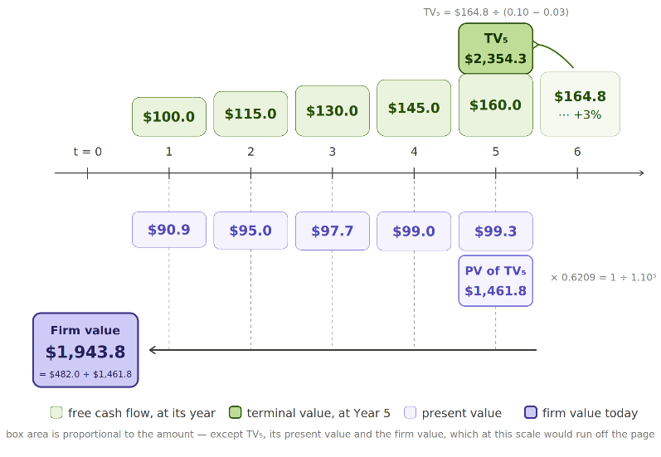
- Notice the terminal value provides about 75% of the firm’s total value. This is typical — and it is why g and r deserve the most scrutiny: small changes in the spread (r − g) move the answer a lot.

- This also closes the loop with Topic 4 — the terminal value is simply a growing perpetuity, discounted back to today.

Key Takeaway: A DCF is only as good as its assumptions — garbage in, garbage out. Its real value is discipline: building one forces you to state, explicitly, what you believe about growth, profitability, reinvestment, and risk.

Concept Quiz #3
1. In a five-year DCF, the terminal value is used to capture:
a. the cash flows of Years 1–5 only
b. the value of all cash flows after the explicit forecast horizon
c. the company’s book value
d. the dividends paid in Year 1
2. A firm’s Year-6 FCF is expected to be $210M and to grow at 3% forever; the discount rate is 9%. The terminal value at the end of Year 5 is:
a. $2,333M
b. $3,500M
c. $23,333M
d. $700M
3. Holding cash flows constant, narrowing the spread between r and g will cause the terminal value to:
a. increase
b. decrease
c. stay the same
d. become zero

Topic 4: The Price-Earnings (P/E) Ratio
- The P/E ratio is the market’s most widely used valuation shorthand. It answers a simple question: how many dollars will investors pay today for one dollar of the company’s annual earnings?
$$\text{P/E}=\frac{\text{Market Price per Share}}{\text{Earnings per Share }\left(\text{EPS}\right)}$$
  - Read it a s a multiple — a P/E of 15 means investors pay $15 for every $1 of current earnings.
A. A Quick Worked Example
- Company A earns EPS of $4.00 and trades at $60.00 per share:
Market price per share | $60.00
Earnings per share (EPS) | $ 4.00
P/E ratio | 15.0×
- Run it in reverse to value a share: if comparable firms trade at 18× and Company A is expected to earn $4.50 next year, a quick comp-based value is 18 × $4.50 = $81.00 per share.
B. What Drives the P/E?
- Three forces push a P/E up or down — the same three that drive all value:
  - Growth — faster expected earnings growth → higher P/E.
  - Risk — higher risk (a higher discount rate) → lower P/E.
  - Earnings quality — more durable, cash-backed earnings → higher P/E (Topic 6).
- This is why a stable utility may trade at 12× while a fast-growing software firm trades at 40×. The market is not irrational; it is paying for growth.
C. The Algebra Behind the Three Forces
- The three forces are not a list to memorize. They all fall out of a single equation, and the starting point is the perpetuity from Topic 1.
- Step 1 — no growth. A firm that pays out all of its earnings and never grows is a perpetuity :
$$P=\frac{E}{r} so \text{P/E}=\frac{1}{r}$$
  - This is the risk force standing alone: the P/E is simply the reciprocal of the discount rate. A higher r means a lower multiple, with nothing else in the picture.
- Step 2 — let the firm reinvest. Write the payout ratio as b, so the dividend is D₁ = b × E₁. The Gordon growth model then gives:
$P=\frac{b×E_{1}}{r-g}$ so $\text{P/E}=\frac{b}{r-g}$
  - Step 1 is the special case where g = 0 and b = 1. Growth enters by eating into the denominator — it does not act on its own, it acts on the spread between r and g.
- Step 3 — let earnings quality matter. If only a fraction q of reported earnings is durable and cash-backed, the market capitalizes q × E rather than E:
$\text{P}=\frac{b×E_{1}×q}{r-g}$ So $\text{P/E}=\frac{b×q}{r-g}$

  - Earnings quality sits in the numerator. Two firms with identical growth and risk will trade at different multiples if one firm’s earnings are accrual-heavy (Topic 6).
- Checking the 12× and the 40×. The two firms from section B are not on the same curve:
  - Utility: b = 0.6, q = 1, r = 7%, g = 2% → $\text{P/E}=\frac{0.6}{0.05}$ = 12.0×
  - Software: b = 0.8, q = 1, r = 10%, g = 8% → $\text{P/E}=\frac{0.8}{0.02}$ = 40.0×
  - The software firm carries the higher discount rate and still earns the higher multiple: narrowing the spread from 5% to 2% overwhelms the extra risk. That is the precise sense in which the market is “paying for growth.”
- Why a high multiple is a fragile multiple. The spread is squared in the derivative, so a high P/E is a narrow spread — and a narrow spread is easily disturbed:
 | g − 0.5 pp | Base case | g + 0.5 pp
Utility (r = 7%, g = 2%) | 10.9× | 12.0× | 13.3× (+11%)
Software (r = 10%, g = 8%) | 32.0× | 40.0× | 53.3× (+33%)

  - The same half-point of growth moves the software multiple three times as far. A 40× multiple is not by itself a claim that the firm is expensive; it is a warning that small revisions to the assumptions will re-rate it sharply. This is why growth stocks fall so hard on an earnings miss.
D. Trailing vs. Forward, and the PEG Refinement
- Trailing P/E uses the last twelve months of actual earnings; forward P/E uses next year’s expected earnings.
- The PEG ratio adjusts the P/E for growth:
$$\text{PEG}=\frac{\text{P/E}}{\text{Earnings Growth Rate }\left(\text{in \%}\right)}$$
- A PEG near 1.0 is often viewed as “reasonably priced.” A firm at 30× growing 30% (PEG = 1.0) may be cheaper than a firm at 15× growing 5% (PEG = 3.0).

Company | Price | EPS | P/E | Growth | PEG
Utility Co. | $36 | $3.00 | 12.0× | 4% | 3.0
Consumer Co. | $80 | $4.00 | 20.0× | 10% | 2.0
Software Co. | $120 | $3.00 | 40.0× | 30% | 1.3
- Caveat: the P/E is a shortcut, not a substitute for analysis. It breaks down when earnings are negative, volatile, or distorted by one-time items or aggressive accounting — exactly why earnings quality (Topic 6) matters. A clean DCF (Topic 4) is the more complete tool.

Key Takeaway: A P/E ratio is a compressed DCF. It silently embeds assumptions about growth, risk, and earnings quality. Use it to compare similar firms quickly — but always ask what the multiple is assuming.

Concept Quiz #4
1. A stock trades at $90 and reports EPS of $6.00. Its P/E ratio is:
a. 6.0× b. 15.0×
c. 0.067× d. 540×
2. All else equal, an increase in a firm’s risk (its discount rate) should cause its justified P/E ratio to:
a. increase b. decrease
c. stay the same d. become negative
3. Firm X has a P/E of 25 and growth of 25%; Firm Y has a P/E of 12 and growth of 4%. Based on PEG alone, which appears more reasonably priced?
a. Firm X (PEG = 1.0)
b. Firm Y (PEG = 3.0)
c. They are identical
d. Cannot tell

Topic 4A: Trailing vs. Forward P/E in Practice - SKHY & NVDA
- Topics 1–4 valued a business from its cash flows. Here we put the P/E ratio to work on two real AI-era stocks and read what the market is telling us through the gap between their trailing and forward multiples.
- Recall the two versions: trailing P/E divides today’s price by the last twelve months of actual earnings; forward P/E divides it by the next twelve months of expected earnings.
- The relationship between the two is itself information. The price is the same numerator in both, so the only thing that changes is the earnings figure in the denominator:
  - forward P/E < trailing P/E ⇒ the market expects EPS to rise (a bigger denominator pulls the ratio down).
  - forward P/E > trailing P/E ⇒ the market expects EPS to fall.
$$\text{Implied 1-Year EPS Growth}≈\frac{\text{Trailing P/E}}{\text{Forward P/E}}-1$$
A. The Snapshot — SK Hynix vs. NVIDIA
- Both companies sit at the center of the AI build-out: NVIDIA designs the accelerators, and SK Hynix supplies the high-bandwidth memory (HBM) that sits beside them. Here is how the market was pricing their earnings in late June 2026:

Metric | SK Hynix (KRX 000660) | NVIDIA (Nasdaq NVDA)
Trailing P/E (last 12 mo. actual EPS) | ~17× | ~32×
Forward P/E (next 12 mo. expected EPS) | ~6× | ~22×
Forward ÷ Trailing | ~0.35 | ~0.69
Implied 1-year EPS growth* | ~+183% | ~+45%

*Implied growth ≈ (Trailing P/E ÷ Forward P/E) − 1. Figures are rounded snapshots from public market-data aggregators in late June 2026; multiples move daily.
- Read the table in one sentence: both stocks have a forward P/E below their trailing P/E — so the market expects both to grow earnings — but SK Hynix’s gap is far larger.

B. Why SK Hynix’s Forward P/E Is So Much Lower Than Its Trailing P/E
- SK Hynix is a cyclical memory maker (DRAM and NAND) and the leading supplier of HBM for AI servers. Memory is essentially a commodity: prices and profits swing violently with the industry supply–demand cycle.
- The company swung from heavy losses in the 2023 memory downturn to record profits in the current AI-driven upcycle. Its trailing earnings still sit partway up that climb; its expected earnings are much higher.
- So a forward P/E of ~6× against a trailing P/E of ~17× is the market saying it expects SK Hynix’s EPS to roughly triple over the next year:
SK Hynix trailing P/E | 17×
SK Hynix forward P/E | 6×
$$\text{Implied 1-year EPS growth}=\frac{17}{6}-1$$ | +183%

- In plain terms: at today’s price, investors are paying only about six times next year’s expected earnings — precisely because those earnings are expected to be far larger than last year’s.

C. What the Low Forward P/E Means — Two Readings
- A low forward multiple on a cyclical company can mean two very different things. A careful analyst holds both in mind.
- Reading 1 — genuine growth. If the HBM and DRAM upcycle delivers the expected earnings jump, then ~6× forward earnings is simply price ÷ a much-bigger denominator, and the stock is reasonably priced or under-priced on forward numbers.
- Reading 2 — the cyclical trap. For a commodity producer, the lowest P/E often appears right at the earnings peak — when profits are highest and about to roll over. If the cycle turns, the optimistic forward EPS never arrives, and the “cheap” 6× multiple was a mirage.
  - This is the mirror image of a cyclical at the bottom, where depressed or negative earnings make the trailing P/E look huge even though the stock may be cheap.
- The discipline: for cyclical firms, judge value on normalized (mid-cycle) earnings, not a single peak-year forward figure — and insist on a margin of safety (Topic 5). Always ask whether the forward estimate simply assumes the up-cycle continues.

Source note: P/E figures compiled from public market-data aggregators (e.g., stockanalysis.com, GuruFocus, Investing.com), late June 2026. Multiples are approximate, rounded, and change daily.

D. The NVIDIA Contrast — Why the Absolute Multiples Differ
- NVIDIA also trades at a forward P/E below its trailing P/E (~32× down to ~22×), implying about +45% expected EPS growth — strong, but a far smaller step-down than SK Hynix:
NVIDIA trailing P/E | 32×
NVIDIA forward P/E | 22×
$$\text{Implied 1-year EPS growth}=\frac{32}{22}-1$$ | +45%

- The more striking difference is the absolute level: the market pays ~22× next year’s earnings for NVIDIA but only ~6× for SK Hynix. Why nearly four times as much for a dollar of NVIDIA’s forward earnings?
- Earnings quality and durability. NVIDIA is a design-and-software franchise — roughly 75% gross margins, a software ecosystem moat, and real pricing power — so its earnings are seen as more sustainable and less commodity-cyclical. SK Hynix sells a more commoditized product whose pricing is set by the memory cycle, so its profits are more volatile and viewed as less durable.
- The lesson in one line: the gap between trailing and forward P/E reflects the expected near-term growth rate; the absolute multiple reflects the market’s view of earnings quality, durability, and risk. Two AI winners, very different multiples.

Key Takeaway: A forward and the trailing P/E below means the market expects earnings to grow — and the wider the gap, the faster the expected growth. But for a cyclical like SK Hynix, an unusually low forward multiple may signal either a real earnings surge or peak-cycle over-optimism, so confirm it against normalized earnings and a margin of safety. The absolute multiple (~6× vs. ~22×) reflects earnings quality, not just growth.

Concept Quiz #4A
1. If a company’s forward P/E is below its trailing P/E, the market is most likely expecting its earnings over the next year to:
a. rise b. fall
c. stay flat d. become negative
2. SK Hynix trades at roughly 17× trailing and 6× forward earnings. The implied one-year EPS growth is closest to:
a. −65% b. +35%
c. +95% d. +185%
3. NVIDIA’s forward P/E (~22×) is far higher than SK Hynix’s (~6×), though both benefit from AI demand. The best single explanation is that:
a. NVIDIA’s earnings are viewed as more durable and less cyclical
b. SK Hynix is unprofitable
c. NVIDIA pays no dividend
d. SK Hynix has fewer shares outstanding

Topic 5: The Margin of Safety
- If Mr. Market explains why price and value diverge, the margin of safety tells you what to do about it. Graham argued these three words best capture sound investing.
- Definition — the margin of safety is the discount of purchase price to estimated intrinsic value. You buy a dollar of value for materially less than a dollar:
$$\text{Margin of Safety}=\frac{\text{Intrinsic Value}-\text{Market Price}}{\text{Intrinsic Value}}$$
- Its purpose is humility about error. Your valuation will be wrong to some degree — forecasts miss, discount rates are imprecise. Buying well below value gives you room to be wrong and still not lose money.
A. A Worked Example
- Suppose your DCF (Topic 4) estimates a stock’s intrinsic value at $100 per share, and Mr. Market is quoting $65:
Intrinsic value (your DCF estimate) | $100.00
Market price (Mr. Market’s quote) | $ 65.00
Margin of safety (in dollars) | $ 35.00
Margin of safety (as a %) | 35.0%

- The 35% cushion means that even if your valuation were too optimistic by, say, 20% (true value ≈ $80), you would still own the business below its worth at the $65 you paid.
B. How Much Margin Is Enough?
- There is no universal number, but the principle scales with uncertainty:
  - Stable, predictable businesses with high earnings quality justify a smaller margin (perhaps 15–25%).
  - Volatile, hard-to-forecast, or lower-quality businesses demand a larger margin (often 40%+).
- The riskier and harder-to-value the business, the wider the discount you should insist on before buying.
C. Why It Connects Everything
- The margin of safety is where the whole class comes together: you estimate value with the time-value tools (Topics 2–4), you accept that Mr. Market’s price will swing around that value (Topic 1), and you protect yourself by buying only at a meaningful discount — and only when the earnings beneath your estimate are trustworthy (Topic 6).

Key Takeaway: Margin of safety = buying value at a discount to protect against the inevitable errors in your own forecasts. It converts an uncertain valuation into a disciplined, survivable investment.

Concept Quiz #5
1. An analyst estimates a stock’s intrinsic value at $50 and can buy it at $40. The margin of safety is:
a. 10%
b. 20%
c. 25%
d. 80%
2. The primary purpose of the margin of safety is to:
a. guarantee a profit on every investment
b. protect against errors in the analyst’s valuation
c. predict short-term price movements
d. eliminate the need to value the business
3. All else equal, a business with highly uncertain future cash flows should require a margin of safety that is:
a. larger
b. smaller
c. exactly zero
d. negative

Topic 6: Earnings Quality
- Every valuation tool in this course runs on accounting numbers — earnings, cash flows, book values. Earnings quality asks the essential question: can we trust the reported numbers as a guide to the future?
- High-quality earnings are (a) sustainable (likely to recur), (b) cash-backed (not just accruals), and (c) a faithful picture of true economic performance.
- Low-quality earnings are the opposite — propped up by one-time gains, aggressive accounting choices, or accruals that reverse later. A P/E or DCF built on low-quality earnings is precise nonsense.
A. Why Earnings and Cash Can Diverge
- Accrual accounting records revenues when earned and expenses when incurred — not when cash changes hands. This is appropriate, but it gives management latitude (estimates, timing, classifications) that can be used to flatter results.
- A useful first screen: compare net income with operating cash flow over time. When earnings persistently and increasingly exceed operating cash flow, the gap is a red flag worth investigating.
B. Common Red Flags

Red flag | What it may signal
Net income rising while operating cash flow stagnates or falls | Earnings supported by accruals, not cash
Revenue growing far faster than receivables can be collected | Aggressive or premature revenue recognition
Heavy reliance on “non-recurring” items that keep recurring | Core earnings weaker than they appear
Frequent changes in estimates, reserves, or accounting policies | Results may be managed to hit targets
Large or growing gap between GAAP and “adjusted” earnings | Inconvenient costs excluded from the headline number

C. The Practical Discipline
- Before trusting an earnings figure for valuation, ask three questions: Is it recurring? Is it cash-backed? Would it survive a skeptical reading of the footnotes?
- Earnings quality is not mainly about catching fraud (though it sometimes does). It is about knowing how much weight a number can bear before you build a valuation on top of it.

Key Takeaway: Earnings quality is the trust you can place in the numbers. A valuation is only as reliable as the earnings beneath it — so vet the earnings before you discount them.

Concept Quiz #6
1. Which of the following is the strongest single indicator that reported earnings may be of low quality?
a. Earnings that have grown steadily for a decade
b. Net income that consistently and increasingly exceeds operating cash flow
c. A dividend that rises each year
d. A low P/E ratio
2. “High-quality” earnings are best described as earnings that are:
a. as large as possible
b. sustainable and backed by cash
c. reported under pro-forma rather than GAAP rules
d. growing faster than revenue
3. Why does earnings quality matter for a DCF or P/E valuation?
a. It does not; only growth matters
b. The valuation is only as reliable as the earnings it is built on
c. It changes the discount rate to zero
d. It eliminates the need for a terminal value

----------------------------------------- The End of the Valuation Primer -----------------------------------------

Since CFO is computed after deducting interest, we add back interest net of tax — Interest × (1 − t) — to measure cash flow available to all capital providers, both debt and equity holders.
The value of a business is the present value of its cash flows, so a valuation formula strictly wants free cash flow, not accounting earnings. The two differ whenever there are non-cash charges or net reinvestment. Step 1 is the one case where they coincide. With no growth, net new investment is zero — capital expenditure merely replaces depreciation, and working capital is flat. So the items that normally separate earnings from free cash flow cancel out. Earnings, dividends, and free cash flow are all equal here — not as an approximation, but because the no-growth assumption forces it. That is what lets us write E in a formula that technically calls for cash flow.

