Exploring Blockchain and Crytpoassets

Table of Contents
Topic 1: Lesson Plans 2
Before the class starts 2
Before the class starts or After the class 2
During the class meeting 3
Assessment - Extra Credit (7 points to your final grade) 3
Topic 2: How Does the Blockchain Work? 5
Topic 3: Conventional Database vs. Blockchain 8
Topic 4: Key Terminology 9

Lesson Plans

Before the class starts
- Students watch the following YouTube videos (a total of 40 minutes) – (a,b,c & d)
- What is BLOCKCHAIN? The best explanation of blockchain technology (6:26)
https://www.youtube.com/watch?v=3xGLc-zz9cA
- The Essence of How Bitcoin Works (Non-Technical) (5:24)
https://www.youtube.com/watch?v=t5JGQXCTe3c
If you want a bit more technical alternative, you can also watch the optional Youtube b-2 (see the link below)
- Blockchain 101 - A Visual Demo (17:49) MUST!
https://www.youtube.com/watch?v=_160oMzblY8&t=2s
& play with it yourself at https://andersbrownworth.com/blockchain
- Blockchain 101 - Part 2 - Public / Private Keys and Signing (8:53)
& play with it yourself at https://www.youtube.com/watch?v=xIDL_akeras
& play with it yourself at https://andersbrownworth.com/blockchain/public-private-keys/

Optional YouTube
b-2) How Bitcoin Works in 5 Minutes (Technical) (5:25) – an alternative to (b)
https://www.youtube.com/watch?v=l9jOJk30eQs
If you would like to see how blockchain is being used these days. Please see the following (optional)
- Blockchains: how can they be used? (Use cases for Blockchains) (7:07)
https://www.youtube.com/watch?v=aQWflNQuP_o

- But how does Bitcoin actually work? (25:15) https://www.youtube.com/watch?v=bBC-nXj3Ng4&t=18s

Before the class starts or After the class
- Recommended Readings
- Tutorials: Blockchain Explained through Bitcoin (16 pages): This is nontechnical, but a good introduction to the underlying technology of blockchain and Bitcoins (click the icon to read).
https://www.tutorialspoint.com/blockchain/blockchain_introduction.htm
- Chapter 12 of Dutta, S. K. (Ed.). (2020). The definitive guide to blockchain for accounting and business: Understanding revolutionary technology. Emerald Group Publishing: You will find a good discussion about how this new technology would affect audit practices (click the icon to read).
https://ebookcentral.proquest.com/lib/cmich-ebooks/detail.action?pq-origsite=primo&docID=6354162
- Appendix – Some Diagrams
- Capturing the details of a simple transaction: Conventional vs. Blockchain Systems
- Blockchain vs. Database
- How does a transaction get into the blockchain
- How a Bitcoin transaction works (more comprehensive)

During the class meeting
- We will go over topics following PowerPoint Slides posted on Bb. Proposed topics are:
- Bitcoin Nuts and Bolts:
- Blockchain
- Hash function
- Public and Private Key Cryptography
- Digital signature
- Illustration of P2P payment system (Bitcoin case)
- Ethereum and Smart Contract
- Blockchain Use Cases
- Bitcoin as Currency?
- The implication of Audit Professions
- Benefits and Drawbacks of Blockchain

Assessment - Extra Credit (up to 7 points to your final exam grade)
- As part of the extra credit assessment, you can earn up to 7 points towards your final exam grade (out of 115) by completing an oral exam with me. To schedule a mini-test, please choose a time slot. The time slots will be posted on my office door. If an alternative arrangement is needed, please let me know.

- During the exam, you will be asked to respond to two questions from a pool of 20 questions related to topics covered in class (not from optional readings). You will have a maximum of 2 minutes to respond to each question, and I may ask follow-up questions.

Question List
- What are the key features of a blockchain?
- How is data stored on a blockchain?
- What is a smart contract?
- What is cryptocurrency?
- How does cryptocurrency differ from traditional currency?
- What is Bitcoin and how does it work?
- What is mining in the context of cryptocurrency?
- How are new Bitcoins created?
- How are transactions verified on the Bitcoin network?
- What are some potential use cases for blockchain technology outside of cryptocurrencies?
- What are some of the benefits of using blockchain technology?
- Can you explain the concept of consensus in blockchain technology?
- How does the proof-of-work consensus mechanism work in the Bitcoin network?
- What is a node in the context of a blockchain network?
- What is a hash function and why is it important in blockchain technology?
- Can you explain the concept of a double spend in the context of cryptocurrency transactions?
- What is the role of public and private keys in cryptocurrency transactions?
- How does blockchain technology enable secure and transparent supply chain management?
- Can you explain the concept of a non-fungible token (NFT)?
- Do you think cryptocurrencies like Bitcoin s are worth owning as an investment?

MOOC Courses to Enhance Your Understanding of Blockchain Technology
Listed below, the first two courses, taught by finance professors, are easy to follow. However, the last course, instructed by computer science faculty members from Princeton, is a bit more technical presenting a challenge for us business students. Still, I find it within our reach. Given a choice between these three offerings, I highly endorse Andrew Wu's blockchain and cryptocurrency course from the University of Michigan, which comes at just $39.99. Here are the three MOOC courses:
- Blockchain and Cryptocurrency Explained by Andrew Wu, University of Michigan. Available through Coursera.
- Blockchain and Money by Gary Gensler, MIT. 2018. Available free of charge at
https://ocw.mit.edu/courses/15-s12-blockchain-and-money-fall-2018/
- Bitcoin and Cryptocurrency Technologies, Arvind Narayanan. Princeton University. 2017. Available through Coursera.

How Does the Blockchain Work?
From <https://www.geeksforgeeks.org/how-does-the-blockchain-work/?ref=lbp>
Last Updated: 17 Feb 2023

A blockchain is a distributed database that stores information electronically in a digital format and is shared among the nodes of a computer network. A typical difference between a blockchain and a database is how data is structured. A blockchain is a shared, immutable ledger as the name suggests structures data into chunks or blocks, and a database structures data into tables. A blockchain is a chain of blocks. Once a block is filled with data and it is chained to the previous blocks. Different types of information can be stored on the blockchain network but the most important is transactions.
How Does a Blockchain Work?
The transaction process in a blockchain can be summarized as follows:
1. Facilitating a transaction: A new transaction enters the blockchain network. All the information that needs to be transmitted is doubly encrypted using public and private keys.
2. Verification of transaction: The transaction is then transmitted to the network of peer-to-peer computers distributed across the world. All the nodes on the network will check for the validity of the transaction like if a sufficient balance is available for carrying out the transaction.
3. Formation of a new block: In a typical blockchain network there are many nodes and many transactions get verified at a time. Once the transaction is verified and declared a legitimate transaction, it will be added to the mempool. All the verified transactions at a particular node form a mempool and such multiple mempools form a block.
4. Consensus Algorithm: The nodes that form a block will try to add the block to the blockchain network to make it permanent. But if every node is allowed to add blocks in this manner then it will disrupt the working of the blockchain network. To solve this problem, the nodes use a consensus mechanism to ensure that every new block that is added to the Blockchain is the one and only version of the truth that is agreed upon by all the nodes in the Blockchain, and only a valid block is securely attached to the blockchain. The node that is selected to add a block to the blockchain will get a reward and hence we call them “miners”. The consensus algorithm creates a hash code for that block which is required to add the block to the blockchain.
5. Addition of the new block to the blockchain: After the newly created block has got its hash value and is authenticated, now it is ready to be added to the blockchain. In every block, there is a hash value of the previous block and that is how the blocks are cryptographically linked to each other to form a blockchain. A new block gets added to the open end of the blockchain.
6. Transaction complete: As soon as the block is added to the blockchain the transaction is completed and the details of this transaction are permanently stored in the blockchain. Anyone can fetch the details of the transaction and confirm the transaction.
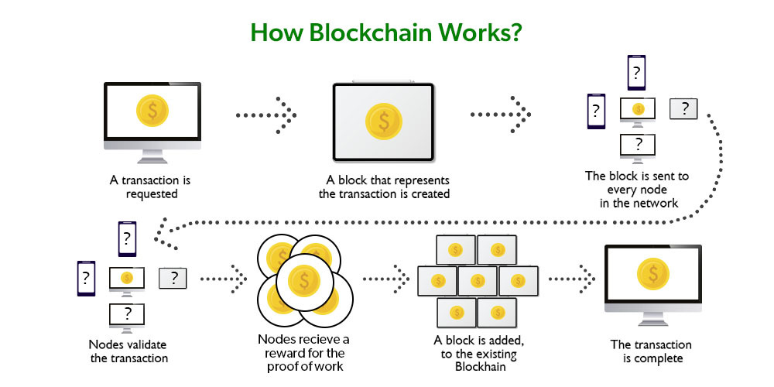

Let’s understand this working of blockchain with the help of an example:
Let’s say Jack and Phil are two nodes on the Bitcoin blockchain network that wants to carry out a transaction between them.
Step 1: Facilitating the transaction: Jack wants to send 20 BTC to Phil via the Blockchain network.
Step 2: Verification of transaction: The message for verification will be sent to all the nodes on the network. All the nodes will check the important parameters related to the transaction like Does Jack has sufficient balance i.e., at least 20BTC to perform the transaction. Is Jack a registered node? Is Phil a registered node? After checking the parameters, the transaction is verified.
Step 3: Formation of a new block: A number of verified transactions stack up in mempools and get stored in a block. This verified transaction will also get stored in a block.
Step 4: Consensus algorithm: Since here we are talking about Bitcoin s so the Proof-of-Work consensus algorithm will be used for block verification. In proof-of-work, the system assigns the target hash value to a node, and according to this, it must come up with a hash for the new block. The node has to calculate the hash value for the new block that is less than the target value. If two or more miners mine the same block at the same time, the block with more difficulty is selected. The others are known as stale blocks. Mining usually rewards miners with blockchain currency. In this case, the blockchain currency is Bitcoin .
Step 5: Addition of the new block in the blockchain: After the newly created block has got the hash value and authentication through proof-of-work only then it will be added to the network and the transaction will mark as complete. Phil will receive 20 BTC from Jack.
The new block will be linked to the open end of the blockchain.
Step 6: Transaction complete: As soon as the block is added to the blockchain, the transaction will take place and 20 BTCs will get transferred from Jack’s wallet to Phil’s wallet. The details of the transaction are permanently secured on the blockchain.
Anyone on the network can fetch the information and confirm the transaction. This will help to keep track of all the transactions and to verify whether any user is trying to double spend. For example, if Jack tries to carry out a transaction in the future, the rest of the nodes can check Jack’s past transaction records to check whether Jack has enough balance to carry out the current transaction. If there is enough balance then the transaction will be approved.
Is Blockchain Secure?
In the most basic way, one can think of a blockchain as a linked list. Each of the next items in the list is dependent on the previous item, except for the first block, also known as the genesis block, which is hardcoded into the blockchain. In the blockchain, each block contains the hash of the previous block’s header and a hash of the transactions in the Merkle tree of the current block. In this way, each block is cryptographically chained to the previous block. Let’s understand with an example what happens when someone attempts to change a transaction or block data in a blockchain network.
- Suppose, there is a chain of 10 blocks, where the 10th block depends on the 9th block, the 9th block depends on the 8th block, and so on.
- In this way, the 10th block depends on all the previous blocks and the genesis block as well.
- If someone tries to change data on the 2nd block, then the attacker will have to change data on all the later blocks as well, otherwise, the blockchain will become invalid since the later blocks depend on the hash value present in the 2nd block and the 2nd block has changed, but not the later blocks.
- Thus, as the blocks are added, immutability increases as changing the block is an expensive operation.
- Also, to add/change a block in a blockchain, a consensus algorithm is used by nodes in the blockchain network. In order to compensate for the change in one block, one must have to recalculate the hash of every block to update the hash value of the block header in the next block. This will involve a lot of time and computational resources.
- In order to succeed with such kind of attack, the hacker has to simultaneously control and change 51% or more copies of the blockchain so that their new copy becomes the majority copy and thus the agreed-upon chain.
- Thus, requiring an immense amount of time, money, and computational resources.

Conventional Database vs. Blockchain
- Advantages of Blockchain in the Supply Chain Industry (HBR 2020/05)
  - Improved visibility in complex supply chains
  - Enhanced connection of information, inventory, and financial flows
  - Reduction of execution errors and supply chain conflicts
  - Transparent and tamper-proof audit trail
  - Real-time error detection and accountability
  - Improved supply chain financing and lending decisions
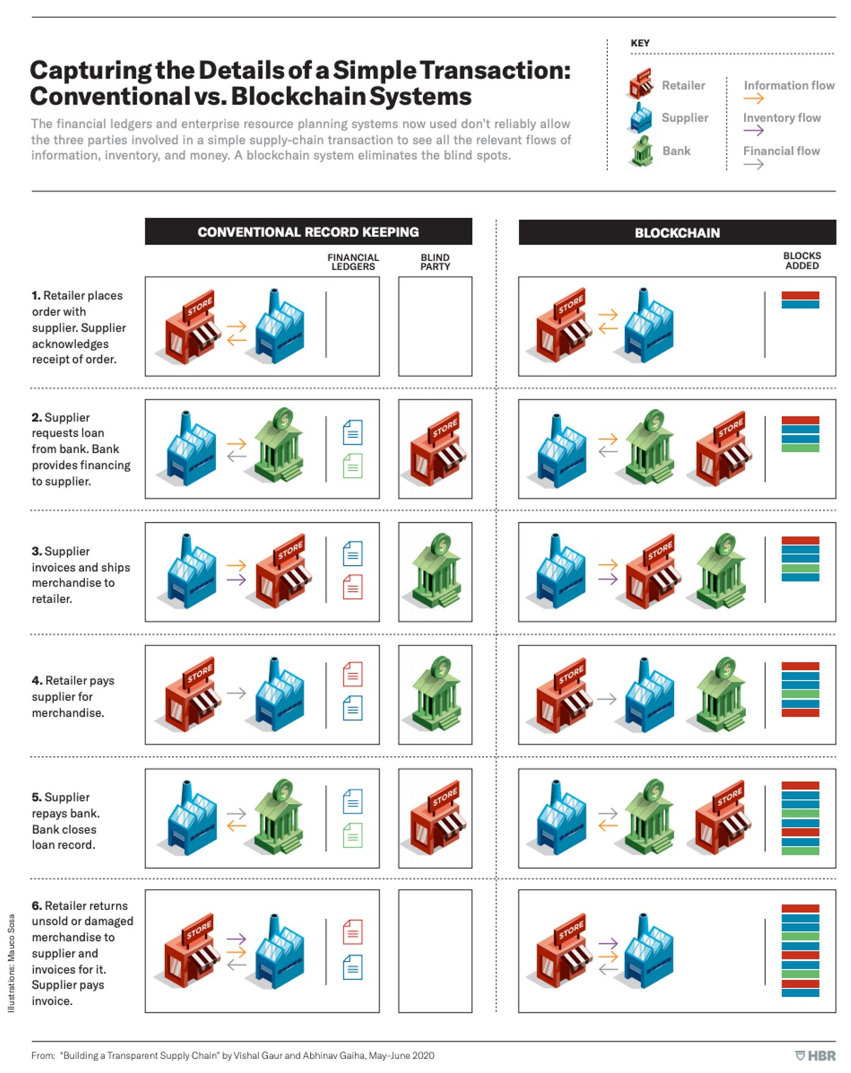
  - Automation through smart contracts

Key Terminology
Bitcoin is a crypto-currency (a kind of digital currency), mainly created to simplify a transaction without having third-party intermediaries. It all started when this mysterious man under the name of Satoshi Nakamoto (whose actual identity is still unknown) published a white paper named Bitcoin: A Peer-to-Peer Electronic Cash System in 2009. A Satoshi is the smallest unit of Bitcoin. A unit of Satoshi is equal to 0.00000001 Bitcoin.
The most interesting part here is that these Bitcoin s are not issued by any centralized banks or authorities. They are ‘mined’ by a group of people called as ‘miners’. They solve complex mathematical problems/puzzles and are issued a certain number of Bitcoin s in exchange.
Blockchain is a data structure or ledger that stores information about any transactions that occur (not just Bitcoin). Anything that is stored once can’t be changed or modified. This feature of Blockchain makes it the most secure. It is decentralized and establishes a peer-to-peer network thus eliminating any middlemen.
Blockchain is made up of blocks that are stored in chronological order. Each block has a capacity of around 500 transactions on average. Thanks to the cryptography involved, these blocks are extremely secure. Each block will have a unique ‘hash’ value attached to it which is calculated based on the data stored in the block. Every time a new block is added to the chain, the new block contains the hash of the previous block as well. So, modifying the contents of any previous block is practically impossible (and would destroy the whole chain). This makes Blockchain immutable.
Block: A collection of data or transactions bundled together and added to the blockchain.

Blockchain is decentralized: It means that it doesn’t rely on a central point of control. Everything is spread over. This makes the system fair and secure.

Blockchain is immutable: It means once data has been written to a blockchain no one, not even a system administrator, can change it. The blockchain can be changed in an append-only fashion. In other words, transactions can only be added to the blockchain. Modifications and deletions are not allowed.

Blockchain: A decentralized digital ledger that records transactions across multiple computers, ensuring the data's security, transparency, and immutability.

Consensus mechanism: A set of rules or algorithms that allows the nodes in a blockchain network to agree on the contents of the distributed ledger.

Consensus protocols: These are a set of protocols that keep all the nodes in the network synchronized with each other. It prevents any single entity from controlling the whole blockchain system. Consensus protocols aim to guarantee a single chain is used and followed.

Cryptocurrency: A digital or virtual currency that uses cryptography for security and operates on a decentralized blockchain network.

Cryptographic hash function: A mathematical algorithm that takes input data and produces a fixed-size output (hash), which is typically a unique representation of the input data.

Decentralization: The distribution of power and authority in a network, eliminating the need for a central authority or intermediary.

Digital signature: A cryptographic mechanism that allows a user to sign digital data, proving the data's authenticity and integrity.

Distributed ledger: A database that is shared, replicated, and synchronized among the members of a decentralized network.

Hash: A unique alphanumeric string generated by a cryptographic algorithm that represents data in a fixed length.

Hashing: It is a process in which the data stored in a block is converted into a fixed-length output through a mathematical algorithm (e.g., SHA-256 is used by Bitcoin). The value of hash is unique for the same data, and it is impossible to produce the same hash using different pieces of data.

Initial Coin Offering (ICO): A fundraising method used by startups and projects to raise capital by issuing new tokens or cryptocurrencies to investors.

Miner: An individual or entity that participates in the mining process, using specialized hardware and software to solve complex mathematical problems and validate transactions.

Mining: The process of validating transactions, creating new blocks, and securing the network in Proof-of-Work-based blockchain systems.

Node: A computer participating in a blockchain network, validating, and relaying transactions, and maintaining a copy of the distributed ledger.

Non-fungible token (NFT): A unique digital asset that represents ownership or provenance of a specific item or piece of content, such as art, music, or collectibles, issued on a blockchain.

Permissioned blockchain: A type of blockchain that restricts participation to a specific group of users, often used for private or enterprise applications.
Permissionless blockchain: A type of blockchain that allows anyone to participate in the network, such as Bitcoin or Ethereum.

Private key: A secret cryptographic key that is used in public-key cryptography to decrypt data or create a digital signature.

Proof-of-Stake (PoS): A consensus mechanism in which validators lock up a portion of their cryptocurrency holdings as a stake and are then chosen to validate transactions and create new blocks based on their stake and other factors.

Proof-of-Work (PoW): A consensus mechanism in which miners solve complex mathematical puzzles to validate transactions, create new blocks, and secure the network.

Public key: A cryptographic key that is publicly available and used in public-key cryptography to encrypt data or verify a digital signature.

Smart Contracts: These are a set of protocols or more like a computer program that are stored in a blockchain and are executed when certain conditions are met.

Token: A digital asset issued on a blockchain, which can represent various forms of value, such as currency, shares, or other assets.

Wallet: A Bitcoin wallet is like a physical wallet. It contains your private key which can be used by you to store/spend Bitcoin s on the Blockchain.

