Chapter 5 — Ratio Analysis
Analyzing and Interpreting Financial Statements · Student Copy
Name __________________________________ Date ____________________
Part 1 · Discussion Questions

Q5-1
Explain in general terms the concept of return on investment. Why is this concept important in the analysis of financial performance?

Answer

Q5-2
(a) Explain how an increase in financial leverage can increase a company’s ROE.
(b) Given the potentially positive relation between financial leverage and ROE, why don’t we see companies with 100% financial leverage?

Answer

Q5-3
Identify two factors that can cause gross profit margin to decline. Is a reduction in the gross profit margin always bad news?

Answer

Q5-5
Describe the concept of asset turnover. What does it mean, and why is it important to understanding financial performance?

Answer

Q5-6
Explain what it means when a company’s ROE exceeds its ROA.

Answer

Q5-8
How does a firm go about increasing its asset turnover ratio? What strategies are likely to be most effective?

Answer

Q5-9
What is meant by the term "net" in net operating assets (NOA)?

Answer

Q5-10
Why is it important to disaggregate ROA into profit margin (PM) and asset turnover (AT)?

Answer

Q5-12
Explain the concept of liquidity and why it is crucial to company survival.

Answer

E5-28 · Compute, Disaggregate, and Interpret ROE — Intel Corporation

Selected data ($ millions)
Description | 2020 | 2019
Total assets | 153,091 | 136,524
Total shareholders’ equity | 81,038 | 77,659
Sales revenue | 77,867 | 71,965
Interest expense | 629 | 489
Net income | 20,899 | 21,048

Required
a. Calculate Intel’s return on equity (ROE) for fiscal years 2020 and 2019.
b. Calculate Intel’s return on assets (ROA) and return on financial leverage (ROFL) for each year. Is financial leverage working to the advantage of Intel’s shareholders? Use a statutory tax rate of 25%.
c. Use the DuPont formulation to analyze the variations in Intel’s ROE over this period.

Answer

E5-33 · Liquidity and Solvency Ratios — Siemens AG

Selected data (€ millions)
Year | Current Assets | Current Liabilities | CFO | Pretax Income | Interest Expense
2018 | 64,570 | 47,874 | 8,425 | 8,050 | 1,089
2019 | 70,370 | 50,723 | 8,456 | 6,933 | 965
2020 | 52,968 | 34,117 | 8,886 | 5,672 | 815

Required
a. Compute the current ratio for each year and discuss any trend in liquidity.
b. Compute times interest earned and the debt-to-equity ratio for each year and discuss any trends.
c. Assess the company’s liquidity and solvency based on your calculations.

Answer

P5-36 · Return on Investment for Competitors — Nike vs. Adidas

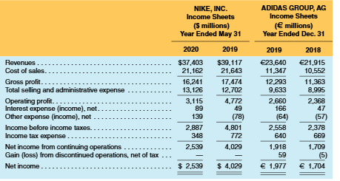
Nike, Inc. — financial statements
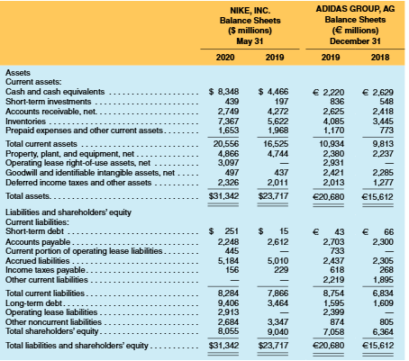
Adidas Group — financial statements
Required
a. Compute ROE, ROA, and ROFL for Nike and Adidas in the most recent year. The corporate tax rate in Germany is about 30%; assume 25% for Nike.
b. Disaggregate the ROAs into profit margin (PM) and asset turnover (AT). Which factor drives ROA for each company?
c. Compute the gross profit margin (GPM) and operating expense-to-sales ratios. How do these compare?
d. Compute accounts receivable turnover (ART), inventory turnover (INVT), and PP&E turnover (PPET). How do these compare?
e. Nike’s fiscal year ends May 31, 2020; Adidas’ ends December 31, 2019. How does this affect your analysis?
f. Nike follows U.S. GAAP and Adidas follows IFRS. How does this affect your comparison?

Answer

P5-37 · Liquidity and Solvency for Competitors — Nike vs. Adidas

Required
Refer to the financial statements of Nike and Adidas presented in P5-36.
a. Compute each company’s current ratio and quick ratio for each year. Comment on any changes.
b. Compute each company’s times interest earned ratio and debt-to-equity ratio for each year. Comment on any changes.
c. Compare the two companies on liquidity and solvency. Do you have concerns about either company’s ability to meet its debt obligations?

Answer

