Chapter 3 — Adjusting Accounts
Adjusting Accounts for Financial Statements · Homework Week #2 · Solutions
Part 1 · Discussion Questions

Q3-4
What is the nature and purpose of a general journal?

Solution
A general journal is a book of original entry that may be used for the initial recording of any type of transaction. It contains space for dates and for the accounts to be debited and credited, columns for the amounts of the debits and credits, and a posting reference column for the numbers of the accounts that are posted.

Q3-5
Explain the process of posting.

Solution
When entries are posted, the page number and identifying initials of the appropriate journal are placed next to the amounts in the appropriate accounts. The account number is entered beside the related amount in the journal’s posting reference column.
This procedure enables users to trace amounts in the ledger back to the originating journal entry, and lets us know which entries have already been posted.

Q3-6
What is an adjusting journal entry?

Solution
An adjusting journal entry is an entry made at the end of an accounting period to reflect accrual accounting. It usually affects one balance sheet account and one income statement account, and rarely involves cash.

Q3-10
On January 1, Prepaid Insurance was debited with the cost of a two-year premium, $2,448. What adjusting entry should be made on January 31 before financial statements are prepared for the month?

Solution
Monthly expense = $2,448 ÷ 24 months = $102
Account | Debit | Credit
Jan. 31 Insurance expense (+E, −SE) | 102
Prepaid insurance (−A) |  | 102
To record insurance expense for January.

Q3-11
What is a contra account? What contra account is used in reporting the book value of a depreciable asset?

Solution
A contra account is an account that is related to, and deducted from, another account when financial statements are prepared or when book values are computed.
Accumulated depreciation is deducted from the cost of a depreciable asset in computing and portraying the asset’s net book value.

Q3-13
The publisher of International View, a monthly magazine, received two-year digital subscriptions totaling $12,600 on January 1.
(a) What entry should be made to record the receipt of the $12,600?
(b) What entry should be made at the end of January before financial statements are prepared for the month?

(a) Receipt of subscriptions on January 1
Account | Debit | Credit
Jan. 1 Cash (+A) | 12,600
Unearned subscription revenue (+L) |  | 12,600
Cash is received before the service is delivered, so the credit is a liability, not revenue.

(b) Adjusting entry on January 31
Monthly revenue earned = $12,600 ÷ 24 months = $525
Account | Debit | Credit
Jan. 31 Unearned subscription revenue (−L) | 525
Subscription revenue (+R, +SE) |  | 525
After the entry, the remaining liability is $12,075 (23 months of undelivered issues).

Note on the source file
The solution originally filed under Q3-13 discussed a building’s accumulated depreciation and had no connection to the magazine-subscription question. It appears to have been pasted from a different problem. The solution above answers the question as stated.

Part 2 · Problems

M3-23 / M3-24 (a). Journal Entries — Minute Maid, April
Minute Maid, a firm providing housecleaning services, began business on April 1. The entries for the month follow.
April journal entries
Account | Debit | Credit
April 1 Cash (+A) | 13,500
Common stock (+SE) |  | 13,500
April 2 Prepaid van lease (+A) | 4,200
Cash (−A) |  | 4,200
April 3 Cash (+A) | 15,000
Notes payable (+L) |  | 15,000
April 3 Equipment (+A) | 8,200
Cash (−A) |  | 3,800
Accounts payable (+L) |  | 4,400
April 4 Supplies (+A) | 6,400
Cash (−A) |  | 6,400
April 7 Advertising expense (+E, −SE) | 500
Cash (−A) |  | 500
April 21 Accounts receivable (+A) | 5,500
Cleaning fees earned (+R, +SE) |  | 5,500
April 23 Accounts payable (−L) | 4,400
Cash (−A) |  | 4,400
April 28 Cash (+A) | 4,000
Accounts receivable (−A) |  | 4,000
April 29 Retained earnings (−SE) | 1,500
Cash (−A) |  | 1,500
April 30 Wages expense (+E, −SE) | 2,600
Cash (−A) |  | 2,600
April 30 Van fuel expense (+E, −SE) | 1,480
Cash (−A) |  | 1,480

M3-24 (b). T-Account Ending Balances

Account | Ending Balance ($)
Cash (A) | 7,620
Accounts receivable (A) | 1,500
Supplies (A) | 6,400
Prepaid van lease (A) | 4,200
Equipment (A) | 8,200
Accounts payable (L) | 0
Notes payable (L) | 15,000
Common stock (SE) | 13,500
Retained earnings (SE) | (1,500)
Cleaning fees earned (R) | 5,500
Advertising expense (E) | 500
Wages expense (E) | 2,600
Van fuel expense (E) | 1,480

Proof
Cash: 13,500 + 15,000 + 4,000 = 32,500 received; 4,200 + 3,800 + 6,400 + 500 + 4,400 + 1,500 + 2,600 + 1,480 = 24,880 paid. Balance = $7,620.
Accounts payable: 4,400 recorded on April 3 and 4,400 paid on April 23, so the account closes at zero.

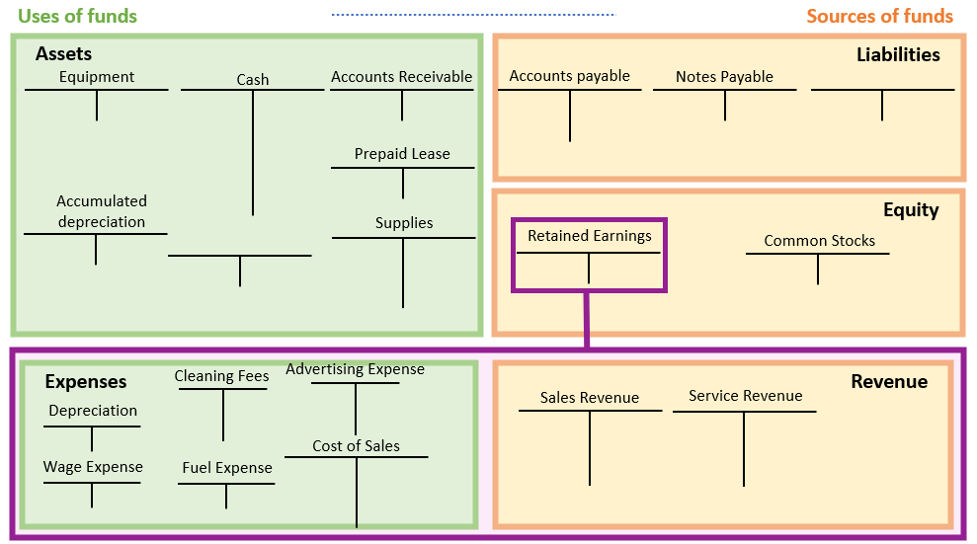
Reference framework — Uses of funds (green) and Sources of funds (orange)

