9. Analyzing and Interpreting Financial Statements (Ch 5)
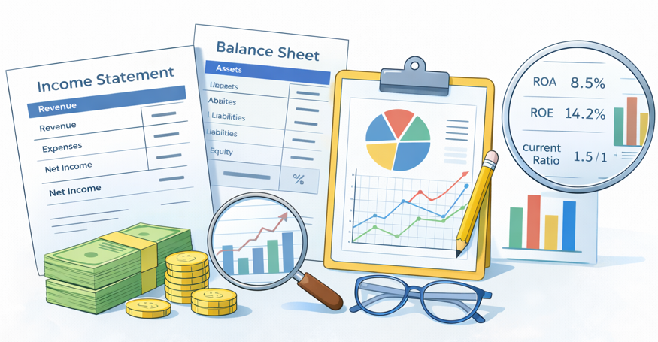

Table of Contents
Part 1: Vertical and Horizontal Analysis 2
5.1 Financial Statement Analysis 2
5.2 Vertical Analysis : Common-size financial statements 2
5.3 Horizontal Analysis 3
Part 2: Return on Investment 5
5.4 ROE, ROA, and ROFL 5
5.5 ROA Disaggregation 7
Disaggregating ROA into Profit Margin × Asset Turnover 7
Trade-Off Between Profit Margin and Asset Turnover 8
Further Disaggregation of Profit Margin and Asset Turnover 9
The DuPont Model 10
Part 3: Liquidity and Solvency 12
5.6 How Debt Financing Can Increase a Firm’s ROE 12
5.7 Liquidity Analysis 13
5.8 Solvency Analysis 15
5.9 Using Working Capital: A Source of Funds Perspective 16
5.10 Limitations of Ratio Analysis 18
5.11 Using Ratios to Predict Bankruptcy — Altman Z-Score (FYI only) 19
5.12 Using Ratios Analyzing and Interpreting Core Operating Activities 20
5.13 Key Ratios - Formula 21
Review Problems 1-5 Ratio Exercise – The Coca-Cola Company 22

Part 1: Vertical and Horizontal Analysis

9.1 Financial Statement Analysis
Financial Statement Analysis
- Identifies relationships and trends within financial statement numbers over time and compared to other companies or industry averages.

- Helps users (investors, creditors, managers) interpret and understand company performance, financial health, and risks.

- Enables meaningful comparisons to assess investment risk, credit risk, and growth potential.
Assessing the Business Environment First
- Before interpreting financial ratios, we must understand the company’s context (industry, operations, risks). This helps ensure ratios are interpreted correctly.
- Understand the company’s stage and strategy.
  - Identify where the company is in its life cycle (start-up, growth, mature)
- Analyze what the company sells and to whom.
- Evaluate products, customer demographics, and demand trends
- Evaluate competitive position.
- Determine how the firm compares to rivals and whether new entrants threaten it
- Assess internal resources & capabilities.
- Review suppliers, labor, technology, and operational support systems
- Review financing and capital structure.
- Understand reliance on debt, ability to raise capital, and financial risk
- Consider regulatory and political environment.
- Identify laws and government influence that may affect operations

9.2 Vertical Analysis: Common-size financial statements
- A financial statement analysis method that expresses each item in a financial statement as a percentage of a designated base amount
  - Income statement items % of net sales
  - Balance sheet items % of total assets
- Also called common-size financial statements, which facilitate meaningful comparisons across companies of varying sizes and within different time periods.​
- By restating financial data in proportional terms, vertical analysis reveals important insights such as the composition of assets, liabilities, and equity on the balance sheet, as well as cost structure and profit margins on the income statement.​
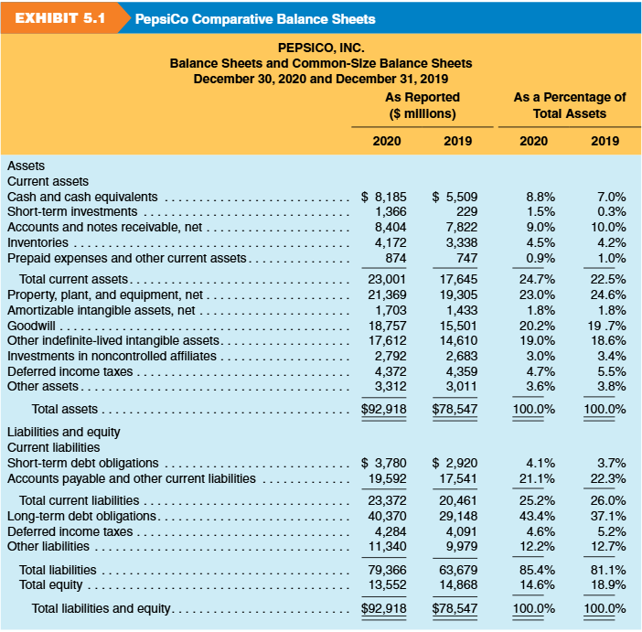
Vertical Analysis of Balance Sheet (Exhibit 5.1)

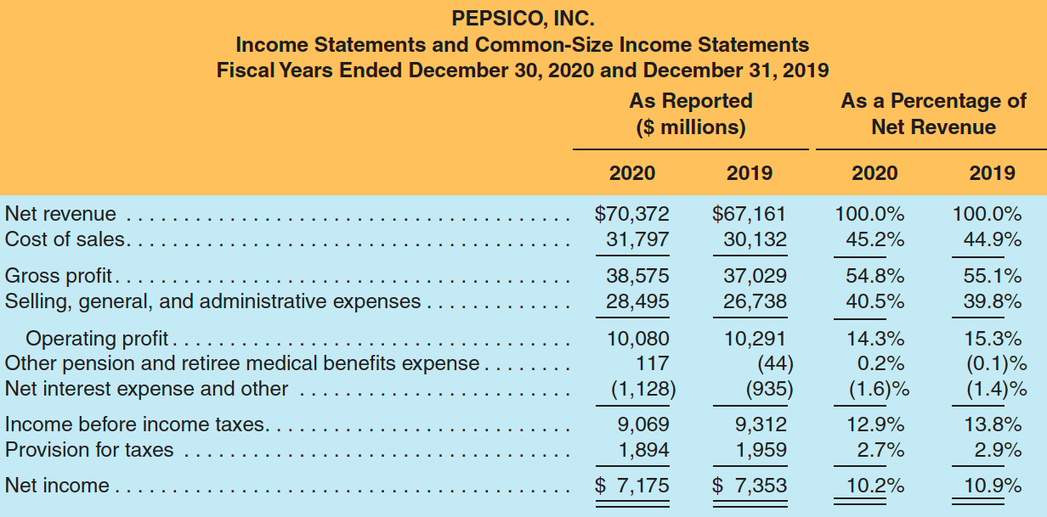
Vertical Analysis of Income Statement (Exhibit 5.2)


9.3 Horizontal Analysis
$31,797 / $70,372 = 0.452
- Compares financial data across periods (year-to-year or quarter-to-quarter).
- Shows trends over time in revenue, expenses, income, assets, etc.
- Useful for forecasting future performance based on historical trends.
- Expresses change in both:
- Dollar amount change (Current year − Prior year)
- Percentage change $(\frac{\text{Change}}{\text{Prior year}})×100$
- Key Considerations:
- Look at both % change and dollar change (a tiny base can create misleading % changes).
- Large % changes often occur when prior year amounts were very small or near zero.
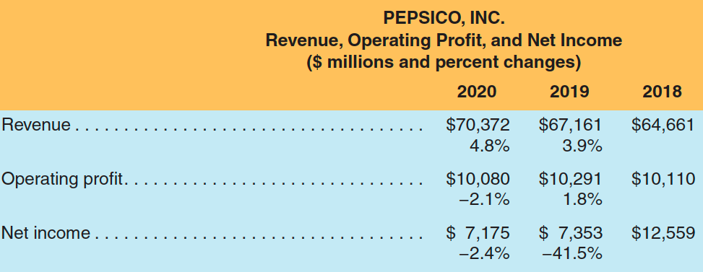
($70,372 - $67,161)
$67,161

Part 2: Return on Investment

9.4 ROE, ROA, and ROFL
Return on Equity (ROE)
$ROE= \frac{Net income}{\text{Avereage stockholder's equity}}$ or $ROE= \frac{Net income-Preferred stock dividends}{\text{Avereage }\text{common }\text{stockholder's equity}}$

- Measures how effectively a company generates profit from shareholders’ investment.
- It reflects 1) company profitability and 2) efficiency in using equity capital
- Why ROE matters?
- Used widely by analysts, investors, and managers
- Warren Buffett focuses on companies with:
  - High ROE
  - Low or reasonable debt (why? as high debt can increase ROE, to be discussed)
- High ROE suggests strong ability to generate returns from equity capital
- Cautions
- ROE can be boosted artificially by using more debt
- Excessive debt raises risk, including potential bankruptcy

 | Use the average balance (beginning and ending) from the balance sheet when comparing it to income statement amounts, instead of the year-end balance.
Return on Assets (ROA)
- ROA measures how efficiently a company uses its assets to generate profit.
- Focuses on operating and investing performance, regardless of financing method.
- Excludes the effect of interest since it relates to financing, not operations.
- Allows comparison across companies with different leverage levels.
- ROA Formula (de-levered ROA)
Income before int. exp
- int. expense
- tax expense
Net income
$$\text{ROA}=\frac{\text{Earnings}\text{ without interest expense (EWI)}}{\text{Average total assets}}$$
$$=\frac{\text{Net income}+\text{Interest expense}×(1-\text{Tax rate})}{\text{Average total assets}}$$
- Why do we add back after-tax interest expense? because:
  - Net income subtracts interest (financing cost)
  - ROA wants to measure performance before financing decisions
  - Interest is tax-deductible → add back interest net of tax
- ROA without considering the financing effects is often called de-levered ROA.
- Alternatively, ROA (Standard) can be computed as follows:
$$\text{ROA}=\frac{Net Income}{\text{Average total assets}}$$

Term | ROA (standard) | De-levered ROA (covered here)
Formula | $$\frac{Net Income}{\text{Average total assets}}$$ | $$\frac{Net Income+after tax effect}{\text{Average total assets}}$$
Includes Debt Impact? | Yes | No
What It Shows | - Profitability after interest cost | - Asset return from operations only before financing effects

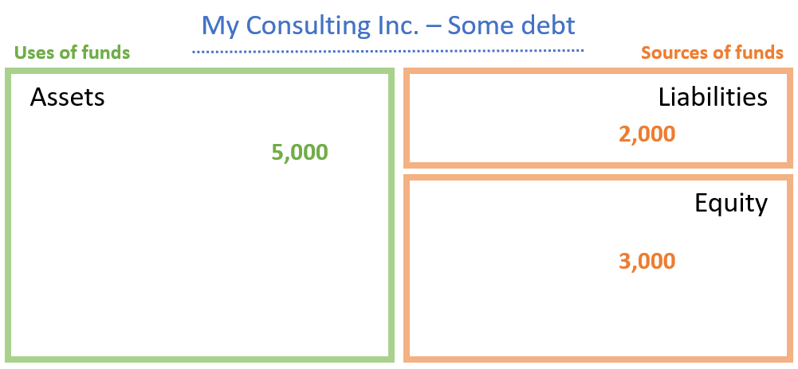
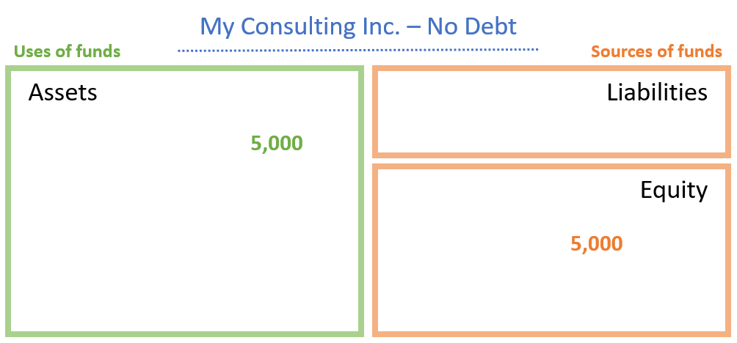
Illustration: How de-levering NI removes the effects of capital structure:
 | No debt | Some debt
Pretax, pre-interest income | $300 | $300
Interest expense | 0 | (50)
Pretax income | 300 | 250
Taxes (35%) | (105) | (87.5)
Net income | 195 | 162.5
De-levered Net Income | $195 | $195ª
ª after tax effect : NI+ Interest expense ×(1-Tax rate)= [162.5 + 50(1 - .35)] = $195

Return on Financial Leverage (ROFL)
- Measures how much of a company’s return on equity (ROE) is driven by financial leverage (use of debt).
- ROFL Formula: $\text{ROFL}=\text{ROE}-\text{ROA}$
- Shows the additional return earned for shareholders from using debt financing.
- Captures the portion of ROE that comes from leverage rather than operations.

Key Concepts
- ROE reflects returns after financing costs (includes debt).
- ROA reflects returns before financing costs (excludes debt).
- The difference (ROFL) shows how much financial leverage boosts (or reduces) shareholder returns.
Interpretation
- Positive ROFL: Leverage increases ROE — debt is being used effectively.
- Negative ROFL: Leverage reduces ROE — debt costs outweigh its benefits.
- Higher ROFL = Higher Risk: More leverage amplifies both gains and losses.
Example (PepsiCo 2020)
- $\text{ROFL}=50.5\%\left(ROE\right)-9.5\%(ROA)=41.0\%$
- About 41% of PepsiCo’s ROE was due to financial leverage.

9.5 ROA Disaggregation

Disaggregating ROA into Profit Margin × Asset Turnover
- ROA can be broken into two performance drivers:
Profit Margin
(Profitability)
X Asset Turnover
(Efficiency)
ROA =
$$\text{ROA}=\frac{\text{Earnings without interest expense (EWI)}}{\text{Average total assets}}=\frac{\text{EWI}}{\text{Sales revenue}}×\frac{\text{Sales revenue}}{\text{Average total assets}}$$

- This helps identify whether a company's asset performance comes from profitability or efficiency.

Profit Margin (PM) — Profitability
- Measures profit earned per dollar of sales (before financing costs)
- Higher PM = stronger pricing power and cost control
- Influenced by:
  - Gross profit (price vs. cost of goods sold)
  - Operating expenses (wages, marketing, R&D, depreciation)
  - Capacity costs and competitive environment
  - Strategy & discretionary spending (advertising, R&D)
Asset Turnover (AT) — Efficiency
- Measures sales generated per dollar of assets
- Higher AT = more efficient use of assets
- Driven by:
  - Inventory & receivables management
  - Asset intensity (industry characteristics)
  - Working capital efficiency
- Industry insight:
  - Retail firms: higher AT (low fixed asset base)
  - Capital-intensive firms (telecom, utilities): lower AT (<1.0)
- PepsiCo 2020 AT = 0.821
  - Each $1 of assets generated $0.82 in sales

Why This Matters
- ROA increases when a company:
  - Earns strong profits (high PM), or
  - Efficiently uses assets (high AT) — ideally both
- Helps diagnose whether performance changes are due to:
  - Margins falling or costs rising, or
  - Assets not generating enough sales

Trade-Off Between Profit Margin and Asset Turnover
ROA = Profit Margin × Asset Turnover
- A company can achieve the same ROA through different combinations of profitability and efficiency.
- Companies face a trade-off between earning higher profit margins and achieving higher asset turnover. Increasing one often means reducing the other.
Pepsi Co. Example
Year | ROA | Profit Margin | Asset Turnover
2019 | 10.50% | 12.22% | 0.860
2020 | 9.50% | 11.53% | 0.821
Why the Trade-Off Happens
- Profit Margin (PM)
- Influenced by pricing, costs, and competition.
→ Higher margins often come from premium pricing or lower costs, which may require larger investments (lower efficiency).
- Asset Turnover (AT)
- Measures how efficiently assets generate sales.
→ Higher turnover usually comes from low margins and high volume, common in mass-market or retail models.
- Industry Influence
  - High-margin, low-turnover → capital-intensive industries (e.g., tech, utilities).
  - Low-margin, high-turnover → high-volume industries (e.g., retail, consumer goods).
- Firms can target better ROA by
  - Improving profit margins through pricing or cost control, or
  - Increasing asset turnover through efficiency and faster asset utilization.
- The optimal mix depends on the business model, strategy, and industry structure.
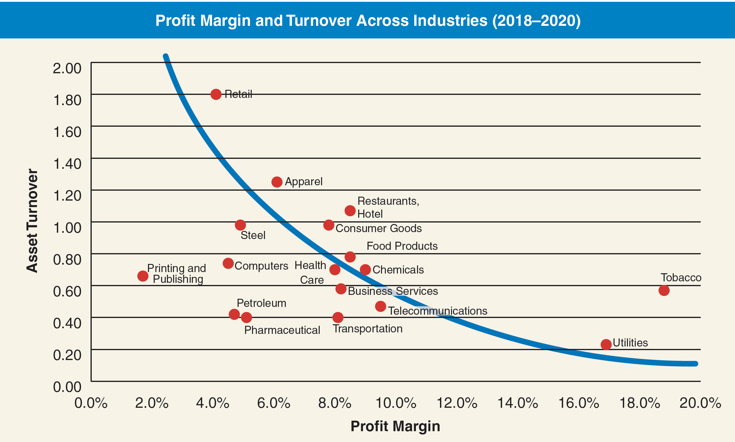
- Retail Industry: Intense competition leads to low profit margins, but high asset turnover due to large sales volume and efficient asset use.
- Utility Industry: Limited competition allows for high profit margins, but low asset turnover because of heavy capital investment requirements.

Further Disaggregation of Profit Margin and Asset Turnover
- Analysts often break down ROA into more detailed ratios to understand specific drivers of profitability and efficiency, which helps pinpoint why changes occur – whether due to cost management, pricing, or asset use.

Profit Margin (PM) Components
a. Gross Profit Margin (GPM)
$$\text{GPM}=\frac{\text{Sales revenue – Cost of goods sold}}{\text{Sales revenue}}$$
- Shows how much profit remains after covering the cost of goods sold (COGS).
- Reflects product pricing, production efficiency, and cost control.
- Higher GPM = more revenue retained to cover operating expenses.
- PepsiCo’s GPM (2020): 54.8% → About 55¢ of each sales dollar is gross profit.
b. Expense-to-Sales Ratio (ETS)
$$ETS=\frac{\text{SG\&A, R\&D, Advertising, and other expenses}}{\text{Sales revenue}}$$
- Indicates what portion of each sales dollar is spent on operating expenses.
- Includes selling, general & administrative (SG&A), marketing, R&D, and advertising.
- Helps track cost efficiency and spending trends.
- PepsiCo’s SG&A ETS (2020): 40.5% → About 41¢ of each sales dollar goes to marketing & administrative costs.

Asset Turnover (AT) Components
- To better understand how efficiently a company uses assets, analysts focus on specific turnover ratios:
a. Accounts Receivable Turnover (ART)
$$\text{ART}=\frac{\text{Sales revenue}}{\text{Average accounts receivable}}$$
- Measures how quickly receivables are collected.
- High ART = customers pay faster; low ART = slower collections.
- PepsiCo’s ART (2020): 8.7 times → ~42 days to collect payment.
- Indicates efficiency of credit and collection policies.
b. Inventory Turnover (INVT)
$$\text{INVT}=\frac{\text{Cost of goods sold}}{\text{Average inventory}}$$
- Measures how often inventory is sold and replaced.
- High INVT = strong inventory management, low holding costs.
- PepsiCo’s INVT (2020): 8.5 times → Inventory turns roughly every 43 days.
- Retailers (e.g., Walmart, Home Depot) usually have very high INVT ratios.

The DuPont Model
- Breaks down Return on Equity (ROE) into three components to explain why a company’s ROE is high or low.
DuPont ROE decomposition
Profit Margin
(Profitability)
Asset Turnover
(Efficiency)
Financial Leverage
(Use of debt)
$$\text{ROE}=\frac{\text{Net Income}}{\text{Sales}}×\frac{\text{Sales}}{\text{Average Total Assets}}×\frac{\text{Average Total Assets}}{\text{Average Stockholders’ Equity}}$$

- ROE increases when a firm:
  - Earns more profit per sales dollar (↑ profit margin)
  - Uses assets efficiently to generate sales (↑ asset turnover)
  - Employs more leverage to amplify returns (↑ financial leverage)
- Useful for identifying whether performance comes from:
  - Operational strength (profitability, efficiency)
  - Or financial structure (use of debt)
Limitation
- Uses net income, not earnings without interest expense (EWI).
→ So, financial leverage affects both margin and ROE, making it hard to isolate pure operating performance.
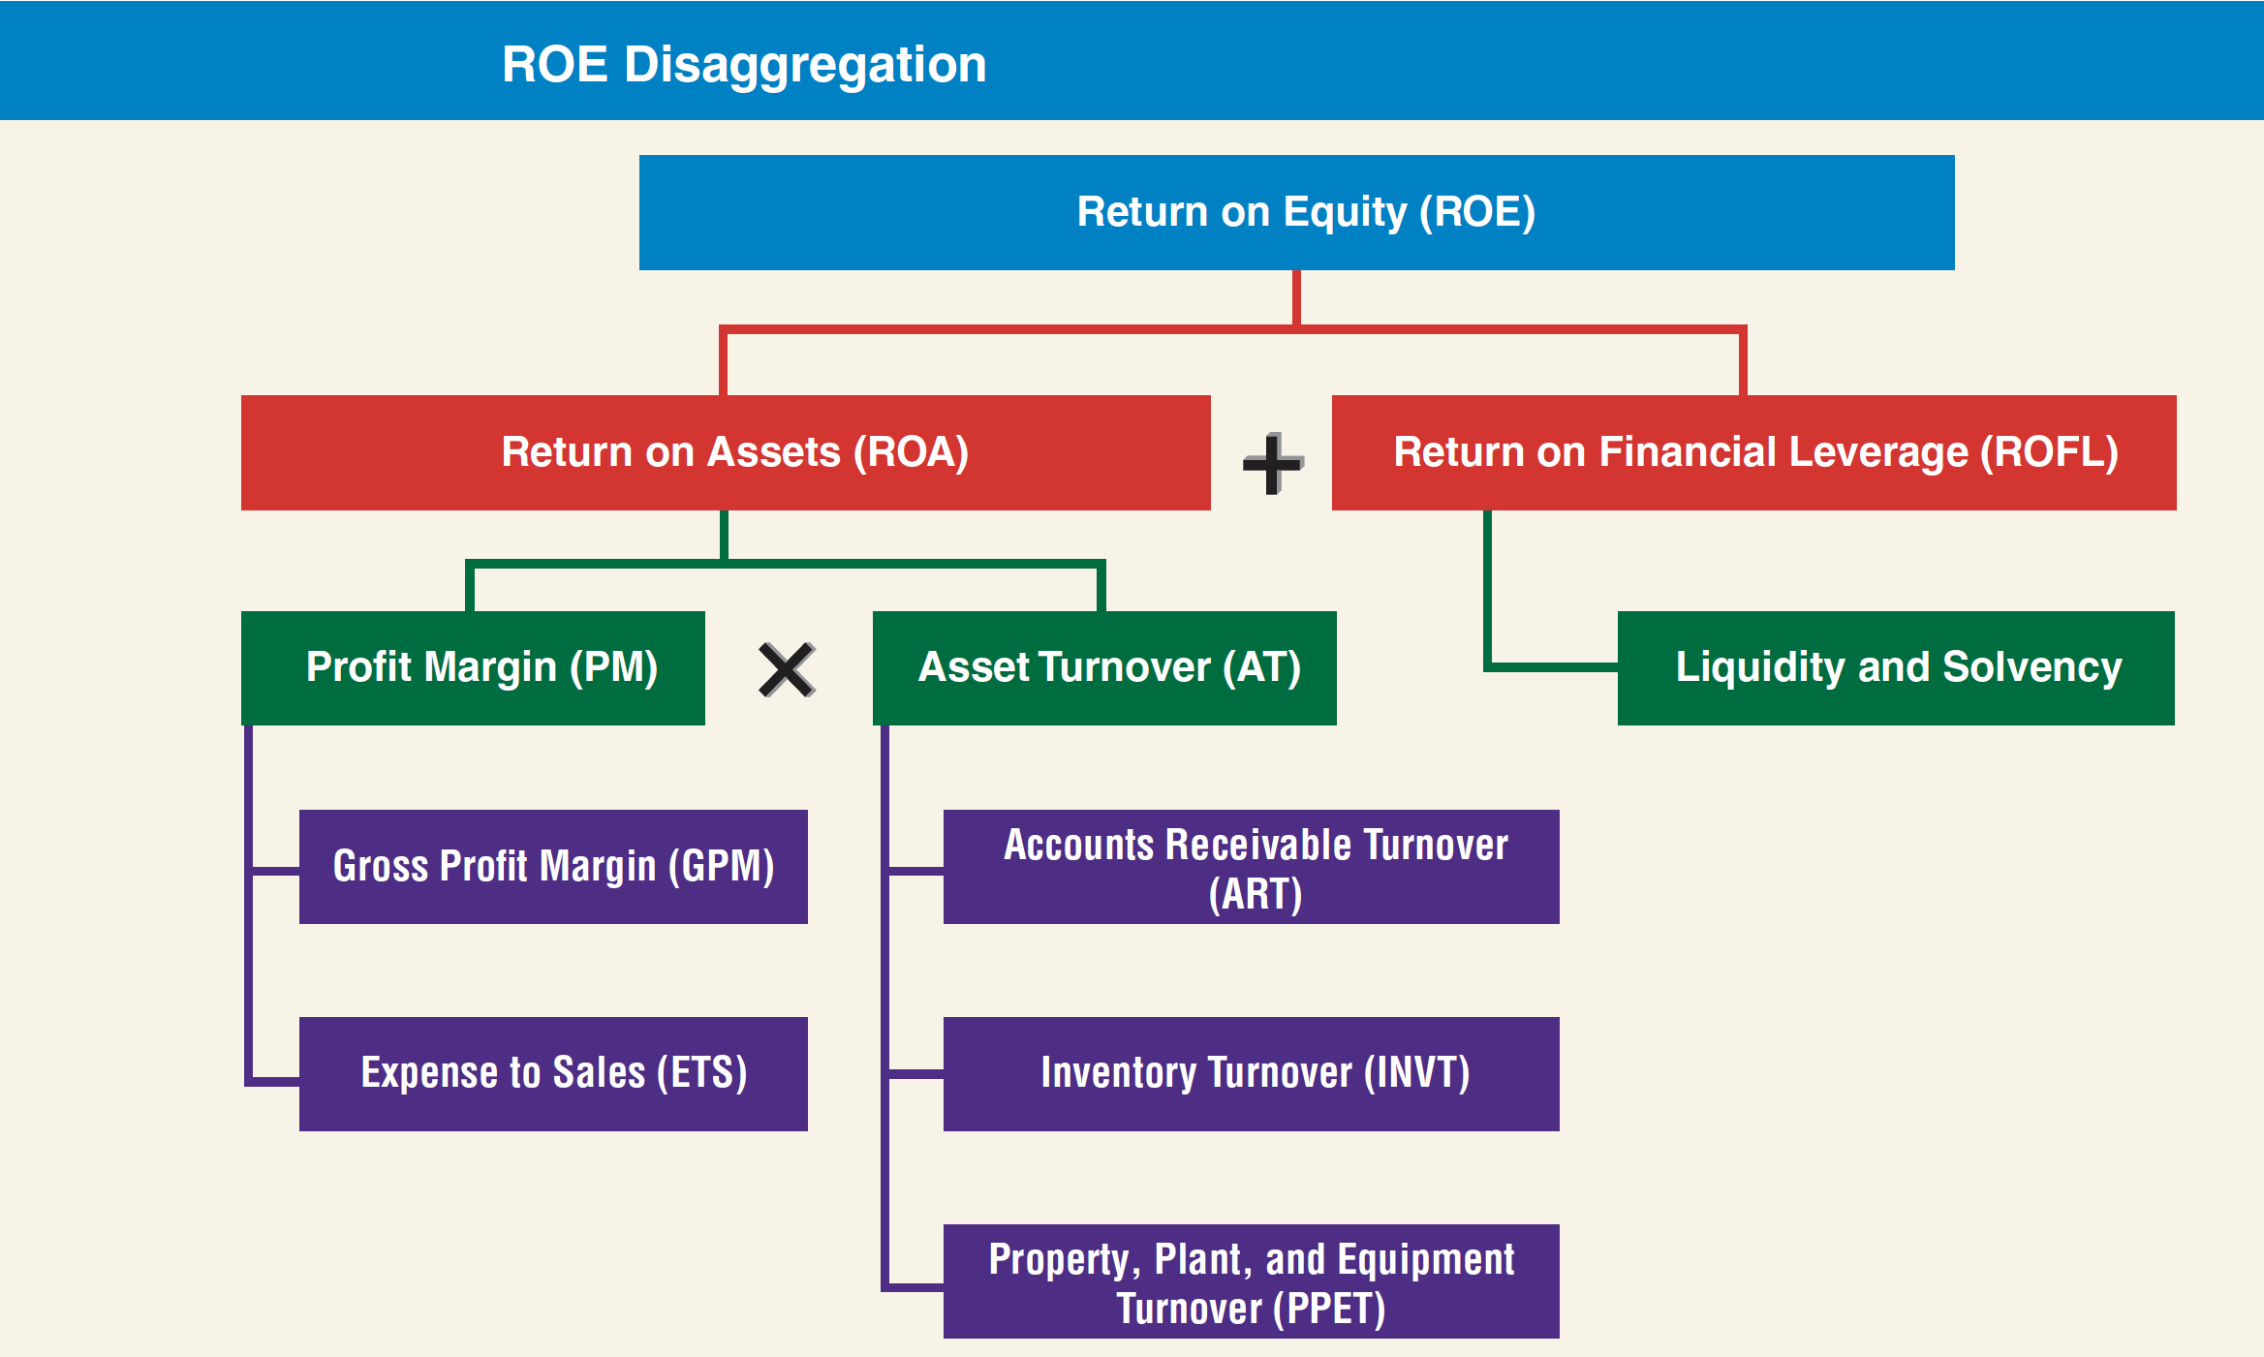
- Despite this, it remains a simple and widely used framework for analyzing ROE.

ROE disaggregation identifies the two primary components of ROE – ROA and ROFL

Review Problems 1 – DuPont ROE Decomposition

Q4.8 Identifying the Unknown Companies. Presented below are common-sized income statement data for three well-known companies representing three different industries:
- Pharmaceutical
- Food and beverage
- Equipment manufacturing
Identify which of the three companies goes with each of the common-size data profiles. Discuss the rationale for your choice.
 | Company 1 | Company 2 | Company 3
Net sales | 100.0% | 100.0% | 100.0%
Cost of goods sold | 28.8 | 29.7 | 45.4
Marketing, selling & admin. | 20.0 | 38.8 | 37.1
Research & development | 22.7 | 7.6 | 1.1
Other expenses | 6.6 | 8.4 | (3.0)
Net income | 21.8% | 15.5% | 19.4%

Suggested Answer

Q4.10 Evaluating the Return on Equity. Presented below are selected financial data for two competitors. Discuss why the return on equity decreased for each firm.
 | Return on Equity |  | Return on Sale |  | Asset Turnover |  | Financial Leverage
 | Year 1 | Year 2 | Year 1 | Year 2 | Year 1 | Year 2 | Year 1 | Year 2
Company X | 21.6% | 16.7% | 12.0% | 8.0% | 1.0 | 1.1 | 1.8 | 1.9
Company Y | 24.9% | 19.1% | 9.9% | 10.1% | 1.2 | 0.9 | 2.1 | 2.1

Suggested Answer

Part 3: Liquidity and Solvency

9.6 How Debt Financing Can Increase a Firm’s ROE
- Companies can use debt (financial leverage) to increase Return on Equity (ROE).
- This effect is measured by Return on Financial Leverage (ROFL)
- ROE rises when the return on assets (ROA) exceeds the cost of debt (interest rate).
Why Debt Boosts ROE?
- Interest payments to lenders are tax-deductible, reducing borrowing costs.
  - Example: At a 25% tax rate, a $1 interest costs the company only $0.75 after tax.
- Debt is cheaper than equity due to lenders’ payment priority (i.e. less risky).
- When used wisely, debt lets a firm generate more profit from shareholders’ investment without raising new equity.
Illustration: When Leverage Works for You – When the business is performing well.
 | Company A  (No Debt) | Company A’  (No Debt) | Company A’’  (50% Debt)
Assets (avg.) | $500 | $1,000 | $1,000
EWI (earnings before interest) | $50 | $100 | $100
Interest Expense (4%) | $0 | $0 | $20
Net Income | $50 | $100 | $80
Equity (avg.) | $500 | $1,000 | $500
ROA
ROE
ROFL
Explanation
- Company A’’ earns the same return on assets (10%) but uses half the equity.
- Its net income falls after interest, but because equity is smaller, its ROE rises to 16%.
- Thus, leverage magnifies shareholder returns.
When Leverage Works Against You – When the business underperforms.
- In other words, if the cost of debt exceeds ROA, leverage reduces ROE:
 | Company A’  (No Debt) | Company A’’  (50% Debt)
Assets (avg.) | $1,000 | $1,000
EWI (earnings before interest) | $30 | $30
Interest Expense (4%) | $0 | $20
Net Income | $30 | $10
Equity (avg.) | $1,000 | $500
ROA
ROE
ROFL
Explanation
- Because interest (4%) exceeds ROA (3%), Company B’s net income drops sharply.
- Leverage now hurts ROE, creating a negative ROFL.

Risk and Limitations of Debt Financing
- Higher debt increases default risk — the possibility that the firm cannot meet interest or principal payments.
- In downturns, leverage amplifies losses, making poor performance worse.
- Excessive debt can lead to financial distress or bankruptcy.
Debt Covenants
- Lenders often impose covenants—contractual restrictions to protect themselves.
  - Examples: limits on additional borrowing, dividend payments, or asset sales.
- These covenants act as an additional “cost” of debt financing.
Industry Differences
- Utilities: High debt tolerance (stable cash flows, regulated environment).
- Telecom, Chemicals: Moderate to high debt (large fixed-asset investment).
- Pharmaceuticals, Tech, Apparel: Lower debt (depend on intangible assets and R&D).
Liquidity vs. Solvency Analysis
- Liquidity analysis: Can the company generate enough cash now to pay its short-term obligations (interest, principal)?
- Solvency analysis: Can the company generate enough cash in the long run to stay out of bankruptcy?

9.7 Liquidity Analysis
- Liquidity measures how much cash a company has and how quickly it can raise cash to meet short-term obligations.
- Analysts use several ratios to evaluate liquidity:
  - Current Ratio (CR)
  - Quick Ratio (QR)
  - Operating Cash Flow to Current Liabilities (OCFCL)
  - Cash Burn Rate (CBR)
Current Ratio (CR)
$$\text{Current Ratio (CR)}=\frac{\text{Current Assets}}{\text{Current Liabilities}}$$
- Indicates whether current assets can cover current liabilities.
- A ratio above 1.0 suggests positive working capital (current assets > curr. liabilities).
- However, a ratio below 1.0 isn’t always bad—some efficient firms operate successfully with lower ratios.
- Retailers (e.g., Kroger, Walmart) often have low current ratios since they turn inventory quickly and manage payables efficiently.
- PepsiCo 2020: CR = 0.98 (up from 0.86 in 2019) → indicates sufficient liquidity
Quick Ratio (QR)
$$\text{Quick Ratio (QR)}=\frac{\text{Cash + Short-term Securities + Accounts Receivable}}{\text{Current Liabilities}}$$
- Excludes inventory and prepaids; focuses on assets that can be quickly converted to cash.
- A stricter measure of short-term liquidity than the current ratio.
- PepsiCo 2020: QR = 0.77 (up from 0.66 in 2019).
→ Below 1.0 but typical for large manufacturing firms with predictable cash flows.
Operating Cash Flow to Current Liabilities (OCFCL)
$$\text{OCFCL}=\frac{\text{Cash Flow from Operations}}{\text{Average Current Liabilities}}$$
- Shows whether a company’s operations generate enough cash to cover ST liabilities.
- A higher ratio means stronger ability to pay debts using internal cash flow.
- PepsiCo 2020: OCFCL = 0.48 (up slightly from 0.45 in 2019)
→ Reflects steady cash generation and improved efficiency, but long-term sustainability depends on future operations.
Cash Burn Rate (CBR)
$$\text{Cash Burn Rate (CBR)}=\frac{\text{Free Cash Flow in Period}}{\text{Number of Days}}$$
- Measures how quickly a company uses its cash when free cash flow is negative.
- Relevant for startups (e.g., Tesla in early years) or firms in financial distress (e.g., Sears).
- Blue Apron 2020:
  - Free cash flow = –$11.4M → burn rate = –$31K per day.
  - Indicates ongoing cash use, though improved from prior years.
Liquidity Analysis – Key Takeaways
- Liquidity ratios help assess whether a firm can meet short-term obligations without raising external funds.
- Firms must balance liquidity and profitability:
  - Too low liquidity → risk of default.
  - Too high liquidity → inefficient use of assets.
- A combination of CR, QR, OCFCL, and CBR provides a complete picture of short-term financial health.

9.8 Solvency Analysis
- Solvency measures a company’s ability to meet long-term debt obligations, including both periodic interest payments and repayment of principal.
- A company that cannot meet these obligations becomes insolvent (fails financially).
- Solvency analysis helps assess a firm’s long-term financial stability and credit risk.
- Two main approaches:
- Balance sheet approach: examines the proportion of debt versus equity financing.
- Income statement approach: examines how much profit is available to cover debt costs.
Debt-to-Equity Ratio (D/E)
$$\text{Debt-to-Equity Ratio}=\frac{\text{Total Liabilities}}{\text{Total Stockholders’ Equity}}$$
- Measures how much the company relies on debt financing relative to equity financing.
- A higher ratio → greater reliance on debt, lower solvency, and higher financial risk.
- A lower ratio → more conservative capital structure and greater financial stability.
Example – PepsiCo 2020:
- D/E = 5.9 ($79,366M ÷ $13,552M)
- Up from 4.3 in 2019 — reflects more borrowing and share buybacks amid low interest rates.
- Industry average ≈ 1.31 → PepsiCo uses substantially more debt than most large firms.

Times Interest Earned (TIE)
$$\text{Times Interest Earned (TIE)}=\frac{\text{Earnings Before Interest and Taxes (EBIT)}}{\text{Interest Expense}}$$
- Indicates how many times the firm’s operating income can cover its interest payments.
- A higher TIE means a company comfortably covers interest costs — lower risk of default.
- A lower TIE suggests potential difficulty meeting interest obligations.
Example – PepsiCo 2020:
- TIE = 8.24× = ($9,069M + $1,252M) ÷ $1,252M
- Down from 9.20× in 2019 but still strong, indicating ample capacity to pay interest.
Interpreting Solvency Ratios
- Debt-to-Equity (D/E): Evaluates capital structure — how much funding comes from creditors versus shareholders.
- Times Interest Earned (TIE): Evaluates interest coverage — whether operating income can meet debt costs.
- Analysts use both to assess financial leverage and long-term risk exposure.
- A strong solvency position means:
  - The company can sustain debt levels and meet obligations over time.
  - There’s lower credit risk and greater borrowing capacity.

9.9 Using Working Capital: A Source of Funds Perspective
This note reframes working capital not just as a measure of liquidity, but as a requirement for long-term funding that supports ongoing operations.
Traditional View – Working Capital and Liquidity
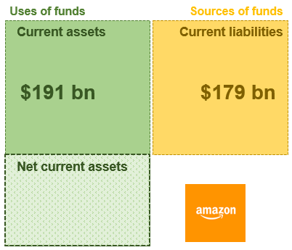
- Working capital management deals with efficient control of cash and current assets to maintain liquidity.
- Net Current Assets = Current Assets – Current Liabilities
- Interpretation:
  - A positive figure means the firm has enough current assets to pay current liabilities.
  - Indicates short-term solvency and operational stability.
  - Traditionally viewed as a liquidity measure, ensuring obligations can be met as they come due.
Source-of-Funds View – The Working Capital Requirement
- Concept Shift - Working capital can also be understood as the amount of long-term financing required to fund current operations.
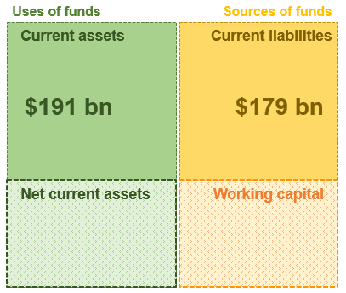
- Key Points
  - Net current assets create a working capital requirement [ $12 bn (= $191-$179) ] .
  - It represents the portion of current assets not financed by current liabilities.
  - Hence, the business must use long-term funds (equity or long-term debt) to cover this shortfall.
  - In summary, when current assets > current liabilities, the gap must be financed by long-term capital—this is the true “working capital requirement.”
Alternative Case – Net Current Liabilities
- Occurs when current liabilities exceed current assets.
- Implications
  - Short-term liabilities appear sufficient to fund current assets.
    - This can be seen as positive (to be elaborated a bit more later).
  - However, this position is often financially unhealthy and can signal liquidity risk.
  - The firm may struggle to meet short-term obligations.
- Remedies
  - Increase current assets by selling non-current assets, or
  - Raise additional long-term capital (equity or debt) to restore a positive working capital position.

The Working Capital Cycle – An Example :
Stage | Activity | Effect
Day 1 – Inventory Purchase | Buy $10K inventory on credit | ↑ Inventory (CA) and ↑ Payables (CL)
Day 12 – Sale | Sell inventory (cost $6K) for $8K | Inventory ↓, Receivables ↑, profit ↑
Day 38 – Collection | Customer pays invoice | Receivables ↓, Cash ↑
Day 60 – Payment | Pay supplier | Cash ↓, Payables ↓

- This continuous loop requires maintaining a stable amount of long-term funding to cover the timing gap between payments and receipts.
- That stable amount = the working capital requirement.

Summary – Key Points
- Positive working capital is healthy (but not always good):
- Having more current assets than current liabilities (a positive net current asset position) indicates good financial health and solvency.
- It suggests the company can comfortably meet its short-term obligations.
- Working capital is a funding requirement:
- Working capital represents the amount of long-term financing (through loans or equity) needed to bridge the gap between short-term assets and short-term liabilities.
- However, excessive positive working capital isn’t always ideal—it may signal that too much capital is tied up in low-return current assets.
- Negative working capital is risk (but not always bad):
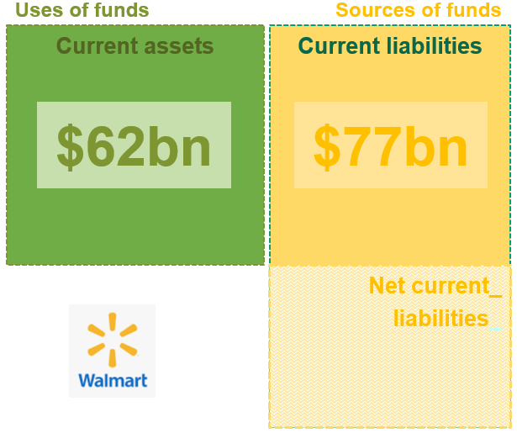
- When current liabilities exceed current assets, the company faces potential liquidity risk—it may struggle to pay its immediate bills.
- Yet, in some business models, negative working capital can be efficient.
- For example, companies like Walmart often operate with negative net current assets, which means they effectively use vendors’ capital to finance their operations.

9.10 Limitations of Ratio Analysis
GAAP Limitations
- Measurability: Financial statements include only items that can be reliably measured. Intangible but valuable assets such as brand reputation or employee expertise are often excluded.
- Non-capitalized Costs: Many expenditures that add long-term value, like research and development (R&D) and advertising, are expensed rather than capitalized, leading to understated assets.
- Historical Costs: Assets are recorded at their original acquisition cost, not their current market value, which can distort ratios when values have changed significantly.

Company Changes
- Frequent mergers, acquisitions, divestitures, and strategic shifts make it difficult to compare ratios across periods or between companies.
- Life cycle stages and seasonal effects can also cause variations in ratios.

Conglomerate Effects
- Large corporations often operate across multiple industries or subsidiaries. Consolidated statements can obscure differences among segments, making it challenging to interpret ratios without segment-level analysis.

Means to an End
- Ratios condense complex operations into single numbers that cannot capture qualitative factors such as management effectiveness, innovation, or strategy.
- Successful analysis requires looking beyond ratios to understand a company's overall performance and direction.

9.11 Using Ratios to Predict Bankruptcy — Altman Z-Score (FYI only)
- Developed by Professor Edward Altman (1968) to predict the likelihood of corporate bankruptcy.
- Combines several financial ratios into a single Z-score to measure a company’s credit risk and financial health.
Formula
$$Z=1.2(\frac{\text{Working Capital}}{\text{Total Assets}})+1.4(\frac{\text{Retained Earnings}}{\text{Total Assets}})+3.3(\frac{\text{EBIT}}{\text{Total Assets}})+0.6(\frac{\text{Market Value of Equity}}{\text{Total Liabilities}})+0.99(\frac{\text{Sales}}{\text{Total Assets}})$$
Interpretation of Variables
Variable | Measures | Meaning
Working Capital / Total Assets | Liquidity | Short-term financial flexibility
Retained Earnings / Total Assets | Profitability | Long-term reinvested earnings
EBIT / Total Assets | Efficiency | Operating profit relative to assets
Market Value of Equity / Total Liabilities | Leverage | Financial stability and capital strength
Sales / Total Assets | Turnover | Asset efficiency and revenue generation

Z-Score Interpretation
Z-Score Range | Financial Condition | Implication
> 3.0 | Healthy company | Low bankruptcy risk
1.8 – 3.0 | Gray zone | Moderate risk; needs monitoring
< 1.8 | Distressed | High likelihood of bankruptcy
- Originally 95% accurate one year before bankruptcy and 72% two years ahead.
- Still widely used by banks, investors, and credit analysts for assessing default risk.
- Modern credit scoring systems often incorporate Altman’s Z-model as a foundation.

9.12 Using Ratios Analyzing and Interpreting Core Operating Activities

Operating vs. Nonoperating Activities
- The analysis distinguishes between operating and nonoperating activities to better evaluate a company’s profitability and efficiency. Operating activities are central to value creation and long-term sustainability.
- Operating activities: Core transactions needed to produce and deliver goods or services — such as sales, production, R&D, marketing, and customer service.
- Nonoperating activities: Financing and investing activities are important but not the company’s primary value drivers.
Return on Net Operating Assets (RNOA)
- RNOA measures the return earned from operating activities relative to the capital invested in those operations.
$$RNOA= \frac{Net Operating Profit After Taxes (NOPAT)}{Average Net Operating Assets (NOA)}$$
- NOPAT focuses on after-tax profit from operations only, excluding financing and investing effects.
NOPAT = NI – [(Nonoperating revenues – Nonoperating expenses) × (1 – Tax rate)]
- NOA represents the net capital tied up in operations and is calculated as operating assets minus operating liabilities.
Reporting Operating Activities in the Income Statement
- Operating accounts include: sales revenue, cost of goods sold, SG&A, R&D, depreciation, rent, insurance, and wages.
- Nonoperating accounts: interest income and expense, and gains/losses on investments
- PepsiCo Example (2020)
NOPAT = $7,175 - [($117 - $1,128 ) × (1 - 0.25)] = $7,933.3
NOPAT($7,933.3) is higher than net income ($7,175) due to interest expenses.
Reporting Operating Activities in the Balance Sheet
  - Operating assets: Cash, receivables, inventories, PPE, and intangibles.
  - Operating liabilities: Acct payable, accrued expenses, and employee benefit liability.
  - Nonoperating items: Debt, investments in affiliates, and interest-bearing liabilities.
- PepsiCo Example (2020)
NOA = $55,843 = Operating assets ($91,059) – Operating liabilities ($35,216).
Interpreting RNOA
- RNOA = NOPAT / Average NOA = $7,933.3 ÷ (($55,843 + $46,322) ÷ 2) = 15.5%.
- PepsiCo’s RNOA of 15.5% indicates strong operating efficiency.
- Its ROE of 50.5% includes the effects of financial leverage, meaning 31% of total shareholder return comes from operating activities.

9.13 Key Ratios - Formula

RETURN MEASURES
Return on Equity (ROE) | $$= \frac{\text{Net income}}{\text{Average stockholders’ equity}}$$
Earnings without Interest Expense (EWI) | $=$ $\text{N}\text{.I.}+[\text{Interest expense}×(1-\text{Statutory tax rate})]$
Return on Assets (ROA) | $$= \frac{\text{Earnings without interest expense (EWI)}}{\text{Average total assets}}$$
Return on Financial Leverage (ROFL) | $$= \text{ROE}-\text{ROA}$$

PROFITABILITY RATIOS
Profit Margin (PM) | $$= \frac{\text{Earnings without interest expense (EWI)}}{\text{Sales revenue}}$$
Gross Profit Margin (GPM) | $$= \frac{\text{Sales revenue - Cost of goods sold}}{\text{Sales revenue}}$$
Expense-to-Sales (ETS) | $$= \frac{\text{Individual expense items}}{\text{Sales revenue}}$$

TURNOVER RATIOS
Asset Turnover (AT) | $$= \frac{\text{Sales revenue}}{\text{Average total assets}}$$
Accounts Receivable Turnover (ART) | $$= \frac{\text{Sales revenue}}{\text{Average accounts receivable}}$$
Inventory Turnover (INVT) | $$= \frac{\text{Cost of goods sold}}{\text{Average inventory}}$$
Property, Plant, and Equipment Turnover (PPET) | $$= \frac{\text{Sales revenue}}{\text{Average total assets}}$$

LIQUIDITY RATIOS
Current Ratio (CR) | $$= \frac{\text{Current assets}}{\text{Current liabilities}}$$
Quick Ratio (QR) | $$= \frac{\text{Cash + Short-term securities + Accounts receivable}}{\text{Current liabilities}}$$
Operating Cash Flow to Current Liabilities (OCFCL) | $$= \frac{\text{Operating cash flow}}{\text{Average current liabilities}}$$
Cash Burn Rate | $$= \frac{\text{Free cash flow in the period}}{\text{Number of days in the period}}$$

SOLVENCY RATIOS
Times Interest Earned (TIE) | $$=\frac{\text{Earnings before interest expense and taxes (EBIT)}}{\text{Interest expense}}$$
Debt-to-Equity (D/E) | $$=\frac{\text{Total liabilities}}{\text{Total stockholders’ equity}}$$

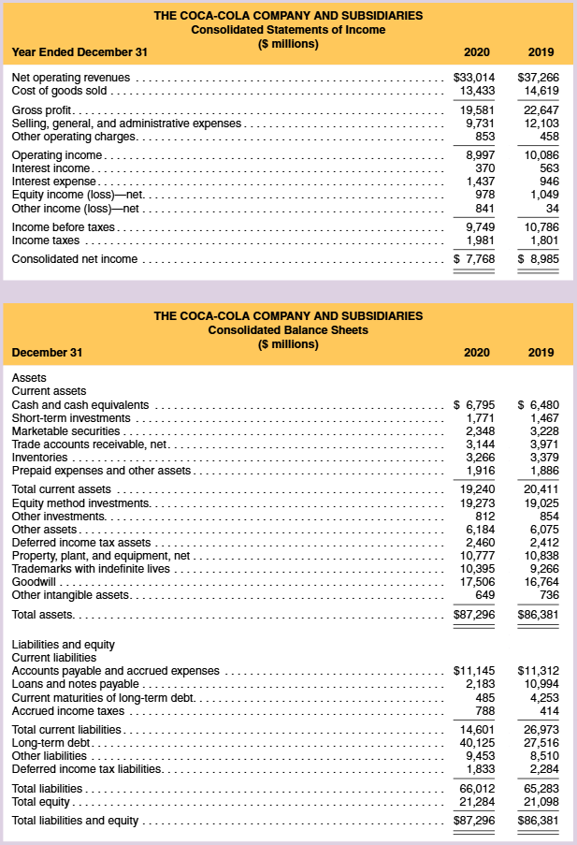
Review Problems 1-5 Ratio Exercise – The Coca-Cola Company
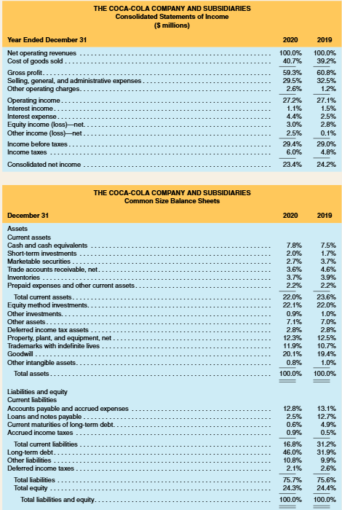
Review 5-1 Preparing Common-Size Income Statements and Balance Sheets
Above are summarized 2020 and 2019 income statements and balance sheets for The Coca-Cola Company, common-size income statements and balance sheets for Coca-Cola. Required: Comment on any noteworthy relationships that you observe.

Review 5-2 Calculating ROE, ROA, and ROFL
Required: Refer to the financial statements for the Coca-Cola Company presented in Review 5-1. Calculate Coca-Cola’s ROE, ROA, and ROFL for 2020. Assume a 25% statutory tax rate for this year.

Review 5-3 Disaggregating the Return on Equity Ratio into its Components
Required: Refer to the financial statements for the Coca-Cola Company
- Calculate Coca-Cola’s profit margin (PM) and asset turnover (AT) ratios for 2020.
- Show that ROA = PM × AT using Coca-Cola’s financial data.
- Calculate Coca-Cola’s gross profit margin (GPM), accounts receivable turnover (ART), inventory turnover (INVT), and property, plant, and equipment turnover (PPET) ratios for 2020.
- Evaluate Coca-Cola’s ratios in comparison to those of PepsiCo.

Review 5-4 Computing and Interpreting Liquidity and Solvency Ratios
Required: Refer to the income statements and balance sheets for the Coca-Cola Company.
Compute the following liquidity and solvency ratios for Coca-Cola.
- Current ratio
- Quick ratio
- Debt-to-equity ratio
- Times interest earned

Review 5-5 Measuring the Effects of Operating Activities on ROE
Required: Refer to the financial statements of the Coca-Cola Company. For 2020, calculate Coca-Cola’s return on net operating assets (RNOA) and then disaggregate RNOA into net operating profit margin (NOPM) and net operating asset turnover (NOAT). Assume a statutory tax rate of 25% and that equity method investments, other assets, and other liabilities are operating items.

In financial reporting, net income is the precise GAAP measure. The term earnings is often used interchangeably with net income, but in practice it can also refer to other profit measures—such as operating earnings or adjusted earnings—depending on context.
The traditional DuPont Model uses net income instead of earnings without interest expense (EWI) in the profit margin component. Because net income includes interest expense, the model does not clearly separate operating performance from financing effects. As leverage increases, interest expense rises—reducing net income and profit margin—while at the same time increasing the financial leverage ratio and boosting ROE. This overlap means the model blends operating and financing effects, making it difficult to tell whether a higher ROE results from stronger operations or greater debt use. In short, the DuPont Model can misstate true operating efficiency when firms differ in their leverage levels.

