4. Constructing Financial Statements (Ch 2)
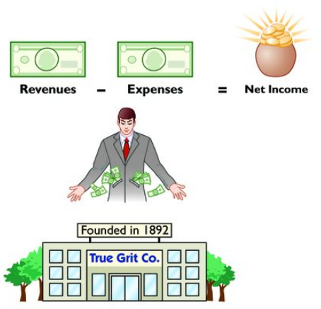
fC

Table of Contents
4.1 Balance Sheet – Reporting Finanical Condition 2
Assets – What they are and when to record 3
Categories of Assets 5
Liabilities and Equity 6
Categories of Liabilities 7
Stockholders’ Equity (residual interest of shareholders) 8
Market Value vs. Book Value 9
4.2 Income Statement – Reporting Financial Performance 11
General Structure of an Income Statement 11
Classification of Expenses 11
4.3 Single-Step vs. Multi-Step Income Statement 13
4.4 Accounting Cycle – Transactions to Financial Statements 15
A Summary of the Accounting Process 15
4.5 How Do Companies Record Transactions? 17
4.6 Homework Assignments 24

Balance Sheet – Reporting Finanical Condition
- Three sections in a Balance Sheet : Assets, Liabilities, Stockholders’ Equity.
- Purpose: Shows the resources a company controls (assets) and the claims on those resources by creditors (liabilities) and owners (equity).
- Timing: Reports financial position at a point in time (a snapshot on a specific date).
- Permanent accounts: Balance-sheet accounts carry forward from period to period—ending balance becomes next period’s beginning balance.
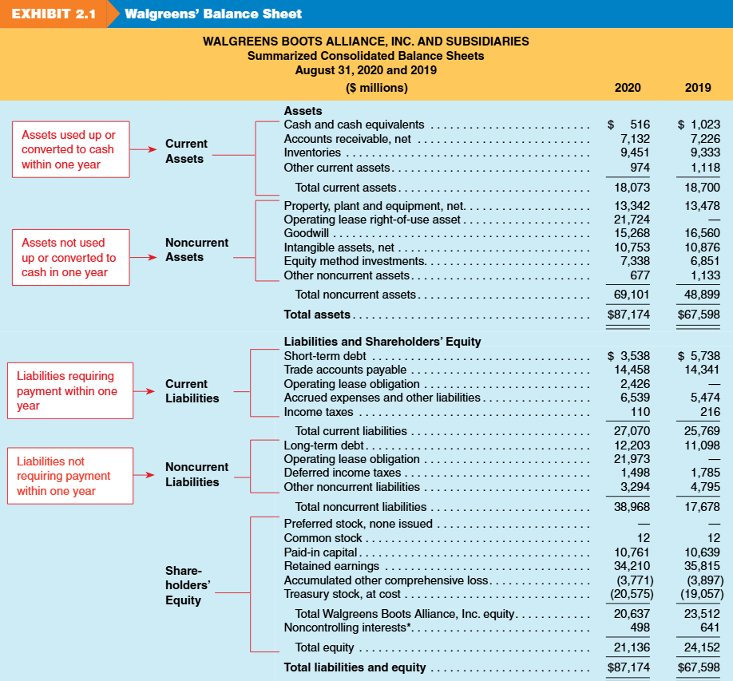

Assets – What they are and when to record
- Companies make expenditures to acquire resources, and these expenditures form part of the cost of those resources.
- These costs benefit 1) now or 2) later.
  - Immediate benefit → Expense now (hits the income statement).
  - Future benefit → Capitalize (record as an asset on the balance sheet).
- As the benefit is used up, we move cost (asset) to the income statement as expense.
  - Inventory (asset) → COGS-cost of goods sold (expense)
  - equipment (asset) → depreciation (expense)
  - prepaid expense (asset) → insurance expense.
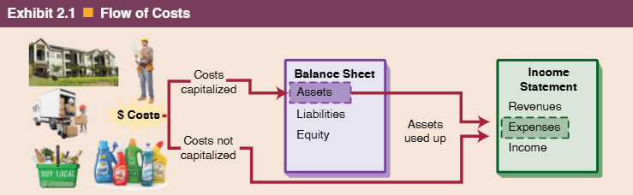

What is an asset?
- A resource the company owns or controls / that is expected to provide future economic benefits.
When do we record (capitalize) an asset ? , i.e., recognition criteria
- At acquisition or when control is obtained from a past transaction (buying, producing, exchanging, or assuming an obligation).
  - The Coca-Cola Company brand value is estimated to be $46 billion. Asset?
- If benefits are probable and measurable, record as asset at cost -historical cost principle.
What can “future benefits” look like?
- Cash inflows from selling the asset or products it helps produce (inventory → sales).
- Other assets received (e.g., accounts receivable created by a credit sale).
- Reduction of liabilities (using an asset to settle debt).
- Future services already paid for (prepaid insurance, rent).

When do we expense expenditures immediately (don’t record an asset)?
- When future benefits cannot be measured reliably or are not probable (e.g., advertising, most salaries).
- Then the cost goes straight to the income statement in the period incurred.

How do we measure assets (i.e., How do we report assets on balance sheet)?
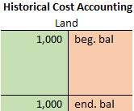
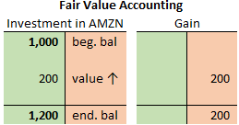
- Assets intended to be used are reported on the balance sheet at historical cost
  - Advantage: Historical cost is reliable
  - Disadvantage: Often significantly undervalued
- Some assets are reported at current fair value
  - Example: Marketable securities
    - Reliable and objective because obtained from real time stock quotes
Summary:
- All costs are eventually recognized as expenses —either immediately when there is no measurable future benefit, or later as the asset’s benefits are consumed or the asset is disposed of.

Review Problems 1 - Classifying Balance Sheet Accounts

For each scenario, decide whether it qualifies as an asset.
1. A tech firm spent $12 million on early-stage development of a wearable device, but the product concept is not yet proven to be commercially viable.

2. A company signed a $4 million purchase order and paid a $400,000 deposit to the vendor.

3. A company launched a $3 million promotional campaign for a new product line during the quarter.

4. A business acquired another company by issuing $3 million of its own preferred shares.

5. A healthcare firm reimbursed $1 million in tuition for employees pursuing professional certifications.

Categories of Assets
Current Assets:
- Assets expected to be used up, sold, or converted to cash within one year or the operating cycle, whichever is longer.
- Cash and Cash Equivalents: Currency, bank deposits, certificates of deposit, and other highly liquid investments readily convertible to cash.
- Marketable Securities: Short-term investments that can be quickly sold to raise cash.
- Accounts Receivable: Amounts owed to the company by customers for sales on credit.
- Inventory: Goods purchased or produced for sale, and supplies used in operations.
- Prepaid Expenses: Payments made in advance for services like insurance or rent
Noncurrent Assets:
- Assets that provide economic benefits over a period longer than one year and are not intended for quick conversion to cash.
- Long-term Financial Investments: Investments in debt or equity securities intended to be held for more than one year.
- Property, Plant, and Equipment (PPE): Long-term tangible assets such as land, buildings, machinery, and equipment used in operations.
  - Depreciation – recording a portion of the original cost of a long-term asset as an expense (“depreciation expense”) during each year of the asset’s useful life (usually several years).
  - Accumulated depreciation – a “contra-asset” account on the balance sheet that shows the total amount of depreciation recorded thus far for an asset.
- Operating Lease Right-of-Use Asset: The right to use an asset over the lease term, recognized under lease accounting rules.
- Intangible and Other Assets: Non-physical assets such as patents, trademarks, goodwill, and franchise rights that provide future value.

Liabilities and Equity
- Represent sources of capital to the company
- Used to finance the acquisition of assets

What is a liability?
- Probable future economic sacrifice from a current or past event.
- Can be cash payment to a creditor or obligation to deliver goods/services later.

Three conditions for recognizing a liability:
- Future sacrifice is probable.
- Amount is known or reasonably estimated.
- Transaction/event causing obligation has occurred.

Executory contract:
- When conditions (1) and (2) are met but (3) hasn’t occurred.
- No liability is reported.
- Example: purchase order for materials.
- Purchase commitments and executory contracts should be disclosed in notes to financial statements if material.

Categories of Liabilities
Current Liabilities (due within 1 year or 1 operating cycle)
- Accounts payable: Amounts owed to suppliers for goods/services purchased on credit.
- Accrued liabilities
  - Expenses already incurred but not yet paid.
  - Examples: Accrued interest (interest expense owed but unpaid).
- Short-term borrowings
  - Debt payable within 1 year.
  - Typically bank loans or other short-term credit.
- Operating lease obligation (current portion)
  - Lease payments due within the next year.
  - Reported on a discounted basis.
- Deferred (unearned) revenues :
  - Obligation to provide goods/services in the future when cash has already been received.
  - Example: Air Fare collected in advance (Airline Industry)
- Current maturities of long-term debt
  - The part of long-term debt due within the next year.
  - Reclassified from long-term to current liability.

Noncurrent Liabilities (due after 1 year)
- Long-term debt: Borrowings from creditors payable beyond 1 year.
  - Any portion due within 1 year is classified as current maturities of long-term debt.
- Operating lease obligation (noncurrent portion)
  - Lease payments due after 1 year.
  - Reported on a discounted basis.
- Other long-term liabilities
  - Various obligations that extend beyond 1 year.
  - Examples: warranty liabilities, deferred compensation liabilities, and long-term tax liabilities.

Stockholders’ Equity (residual interest of shareholders)
- Represents shareholder-provided capital.
- Stockholders have claim on assets after creditors are paid.

Key Components:
- Common stock – capital from issuing shares; each share = ownership unit.
Contributed Capital
- Preferred Stock – capital from issuing shares that have priority over common stock in dividends and liquidation, but usually no voting rights.
- Additional paid-in capital – amounts received above par/stated value of stock.
- Treasury stock – company’s own shares repurchased; reduces contributed capital.
- Retained earnings – accumulated profits not paid as dividends.
Earned Capital
- Accumulated other comprehensive income (AOCI) – equity changes not reported in net income (e.g., foreign currency, pension adjustments).
Retained Earnings Equation

Retained earnings (Beginning, Jan 1 2028)
+ Net income (or – Net loss)
- Dividends
= Retained earnings (Ending, Dec 31 2028)
- Tracks changes in retained earnings from year to year.
- Connects income statement (net income) to balance sheet (equity).

Review Problems 2 – Retained Earnings Balance Calculation
Sunnyvale Services, Inc. reported retained earnings of $85,000 at the beginning of 2028. During the year, the company earned revenues of $150,000 and incurred expenses of $110,000. In December, the company declared and paid cash dividends of $12,000 to its shareholders. What is the ending balance of retained earnings?

Market Value vs. Book Value
- Book Value is the "value" of a company determined by Generally Accepted Accounting Principles (GAAP) and is often referred to as a company's book value of equity or stockholders' equity.
  - Example: Apple’s book value of equity (Sept 24, 2022) = $50,672 million.
- Market Value (or market cap) is calculated by multiplying the number of outstanding common shares by the company's stock price.
  - Example: Apple’s market cap (Sept 24, 2022) = $2.4 trillion ($150.43 × 15.6 billion shares).
  - Typically, a company’s market value is much larger than its book value.

Why a Firm’s Market and Book Value Differ?
    - This is because
      - not all assets are recorded on the balance sheet, and
      - many are reported at historical cost, which does not reflect their current appreciated market value.
- i.e., GAAP does not capture future performance; market values attempt to predict it.

Market-to-Book Ratio
- Median market-to-book ratio for U.S. firms in the S&P 500 Index:
  - 3.38 (2022)
  - 2.91 (2025)
- Market-to-book ratio > 1 typically reflects intangible value (e.g. innovation, leadership) and future growth.
- Over time, market value and book value converge as assets are sold and liabilities settled.

Review Problems 3 - Classifying Balance Sheet Accounts
Assume Schaefer’s Pharmacy, Inc., has the following detailed accounts as part of its accounting system. Enter the letter of the balance sheet category A through E in the space next to the balance sheet items numbered 1 through 20. Enter an X in space if the item is not reported on the balance sheet.
A. Current assets B. Noncurrent assets C. Current liabilities
D. Noncurrent liabilities E. Equity X. Item not reported on balance sheet

 | Account |  |  |  | Account
1. _____________ | Accounts receivable | 11._____________ |  | Cash
2. _____________ | Land | 12._____________ |  | Buildings
3. _____________ | Retained earnings | 13._____________ |  | Accounts payable
4. _____________ | Intangible assets | 14._____________ |  | Prepaid insurance
5. _____________ | Common stock | 15._____________ |  | Inventories
6. _____________ | Repairs expense | 16._____________ |  | Unearned revenue
7. _____________ | Equipment | 17._____________ |  | Operating lease right-of-use asset
8. _____________ | Treasury stock | 18._____________ |  | Borrowings (due 25 yrs)
9. _____________ | ST notes payable | 19._____________ |  | Additional paid-in capital
10. ____________ | Investments (noncurrent) | 20._____________ |  | Marketable securities (current)

Income Statement – Reporting Financial Performance
- Income statement reports the results of operations for a business for a given time period.
- Revenues → increases in net assets from delivering goods/services.
- Expenses → decreases in net assets from revenue-generating activities (COGS, wages, advertising, depreciation, interest, taxes).
- Net income → when revenues exceed expenses.
- Net loss → when expenses exceed revenues.

General Structure of an Income Statement
Amounts more central to a company’s core operations
are reported first.
Less
Persistence
Greater
Persistence
 |  | Revenues
 | – | Cost of goods sold (or cost of sales)
 |  | Gross profit
 | – | Operating expenses
 |  | Operating profit
 | – | Nonoperating expenses (+ Nonoperating revenues)  Tax expense applies to Income from continuing operations
 |  | Tax Expense
Income from continuing operations
Transitory items - not expected to recur; reported ‘net of tax’
 | +/–  +/– | Nonrecurring items, net of tax  Extraordinary items, net of tax
 |  | Net income

Classification of Expenses
Operating Expenses
- Usual and necessary costs to support main activities.
- Include: COGS, wages, depreciation, amortization, R&D.
Nonoperating Revenues and Expenses
- Relate to financing and investing activities (e.g., interest revenue, interest expense).
- Separated from operating activities for better performance insights.

Importance of Separating Income Types
- Income from continuing operations vs. nonrecurring items.
- Helps forecast future company performance.
- Nonrecurring items unlikely to persist → less relevant for predictions.
Transitory Items – Nonrecurring
- Discontinued operations
- Gains or losses (and net income or loss) from business segments that are being sold or have been sold in the current period.
- Extraordinary items
- Gains or losses from events that are both unusual and infrequent.
Gross Profit Margin
- A widely used profitability measure;
- Gross profit margin = Gross profit ÷ Sales
- Reflects selling price of products vs. cost to make or buy them.
- Example: Sell for $10, cost $6 → gross profit margin = 40%.
- Analysis involves comparing over time and against peers.
- High/increasing margin = positive sign (less competition, product strength).
- Low/declining margin = potential issues (intense competition, rising costs).

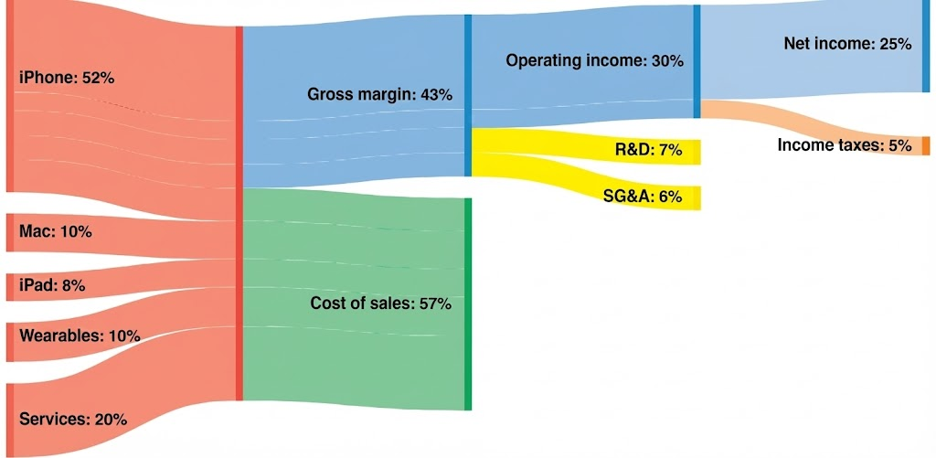
- Visualizing Apple Inc (2022) common-size income statement with Sankey Diagram

Single-Step vs. Multi-Step Income Statement
Single-Step Income Statement
 | Company A | Company B | Company C
Revenues
Net Sales | 401,244 | 401,244 | 4,363
Other Revenues | 4,363 | 4,363 | 401,244
 | 405,607 | 405,607 | 405,607
Expenses
Cost of goods sold | 306,158 | 76,651 | 306,158
Selling, general and admin expense | 76,651 | 306,158 | 76,651
Interest expense | 1,900 | 1,900 | 1,900
Other expense | 353 | 353 | 353
Income taxes | 7,145 | 7,145 | 7,145
 | 392,207 | 392,207 | 392,207
Net Income | 13,400 | 13,400 | 13,400

Multiple-step Income Statement
 | Company A | Company B | Company C
Net Sales | 401,244 | 401,244 | 4,363
Cost of Goods Sold |  | 76,651 | 306,158
Gross Profit |  | 324,593 | (301,795)
Operating Expenses
Selling, general and admin expense |  | 306,158 | 76,651
Income from Operations | 18,435 | 18,435 | (378,446)
Other revenues and gains
Other Revenues |  | 4,363 | 401,244
Other expenses and losses
Interest Expense |  | 1,900 | 1,900
Other Expense |  | 353 | 353
Income before income taxes | 20,545 | 20,545 | 20,545
Income tax expense | 7,145 | 7,145 | 7,145
Net Income | 13,400 | 13,400 | 13,400

Required :
- Please fill in the blank.
- If you have to choose one company to invest in, which company would you choose and why?

Concept Quiz 1

1. Net income is $15,000, operating expenses are $20,000, and net sales total $75,000. What is
gross profit?
a. $60,000
b. $40,000
c. $35,000
d. $15,000

2. Gross profit is $50,000, operating expenses are $15,000, and net sales total $75,000. What is
net income?
a. $10,000
b. $25,000
c. $35,000
d. $80,000

3. Net income is $15,000, operating expenses are $20,000 and net sales total $75,000. What is
cost of goods sold?
a. $60,000
b. $40,000
c. $35,000
d. $15,000

Accounting Cycle – Transactions to Financial Statements

A Summary of the Accounting Process
- Financial statements report on the financial performance and condition of a business. Those statements are tied to a period or point in time.
- The period of time is referred to as the accounting cycle.
- A business first records all transactions during the accounting cycle in a book called the journal.
- The information in the journal is then posted to the ledger.
- Based on the balances in the ledger, the financial statements are prepared.
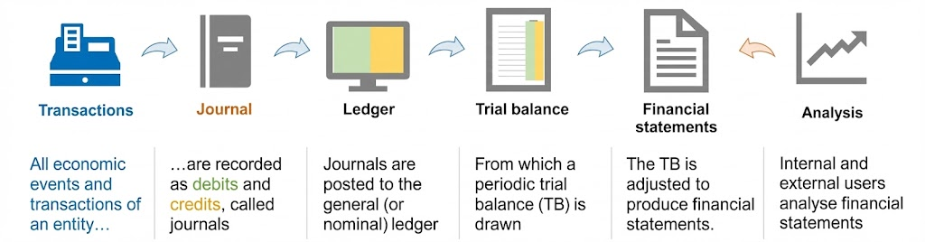
- This is an accounting cycle diagram from transactions to financial statements although the last step, analysis comes later.

Accounting information systems
  - System of collecting and processing transaction data and communication financial information to decision makers.

Historical perspective
  - Accounting today is dominated by computerized systems, but the terms and processes in use still largely reflect traditional manual accounting methods. It is therefore useful to consider their historical context to gain a clearer understanding of the fundamental concepts of accounting.

Accounting transactions
  - Among business events only transactions are recorded in the company’s accounting information system.
  - Not all activities (or events) represent transactions.
  - Transactions cause a change in the company’s assets, liabilities, or owners’ equity.

The Accounting Equation
    - A firm can be described as
Resources | = | Obligations to creditors + Obligations to Invesors
Assets | = | Liabilities + Shareholders’ Equity

  - This is the same idea as
Investing | = | Financing
Resources | = | Sources of Resources
Resources | = | Claims on Resources
  - Dual effect on the accounting equation.
    - All transactions with external parties involve an exchange where the business entity gives up something but receives something in return.

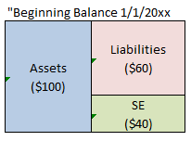
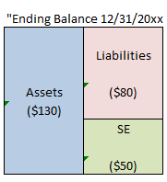
Illustration: How “transactions” are recorded :

Concept Quiz 2
1. Which of the following events is not recorded in the accounting records? (i.e. which events do not affect the assets,liabilities or equity?)
- An employee is terminated.
- Equipment is purchased on account.
- A cash investment is made into the business.
- The owner withdraws cash for personal use.

How Do Companies Record Transactions?
The recording process involves three steps:
- Analyze one or more documents for information about the transaction.
- Record the transaction in a journal.
      - Book of original entry.
      - Transactions recorded in chronological order.

A Journal - Global Books, Inc
Date  Jan 2  Jan 3  Jan 31 | Account Titles and Explanation  Cash Increases  Loan Increases  (Borrow money from lender – put into business bank account.)  Cash Increases  Equity Increases  (Owner contributes funds – put into business bank account. Not a loan.)  Loan Decreases  Cash Decreases  (Repaid Part of Loan) | Debit (Green)  30,000  20,000  5,000 | Credit (Orange)  30,000  20,000  5,000

 | However, in this class, we will stay away from the use of terms ,“debit (Dr) or credit (Cr)” until later. Instead, I will use terms “green” side for “debit ” and “orange” side for credit” of T-accounts to keep track of the impact of each transaction on the five elements: Assets, Liabilities, Equity, Revenue and Expenses.

What is a ledger account?
    - A record that summarizes all transactions related to a specific item over time.
    - Think of it as a “running total” for each category in the financial statements.
    - Each account tracks increases, decreases, and current balance for one specific asset, liability, equity, revenue, or expense.
What is a T-account?
    - A T-account visually shows how transactions affect accounts.
    - Accounts are often shown in the form of a “T” as follows.
    - “T” accounts like these have three parts: (1) the title of the account (e.g., cash, office equipment, accounts payable), (2) the left side, also called the “debit”(green) side, and (3) the right side, also called the “credit” (orange) side
Cash |  |  | Office Equipment |  |  | Accounts Payable
Debit  $20,000 ↑ | Credit  $3,000 ↓ |  | Debit  $3,000 ↑ |  |  | Debit | Credit  $700 ↑
$10,000 ↑
$27,000 |  |  | $3,000 |  |  |  | $700

How to summarize transactions in (ledger) accounts.
- To do this you transfer information about the transaction from the journal to the appropriate accounts in the general ledger.
- Ledger account is often called account (ledger account = account)
- General ledger is ofen called ledger. (general ledger = ledger )
- This process is called “posting”.
General Ledger - Global Books, Inc
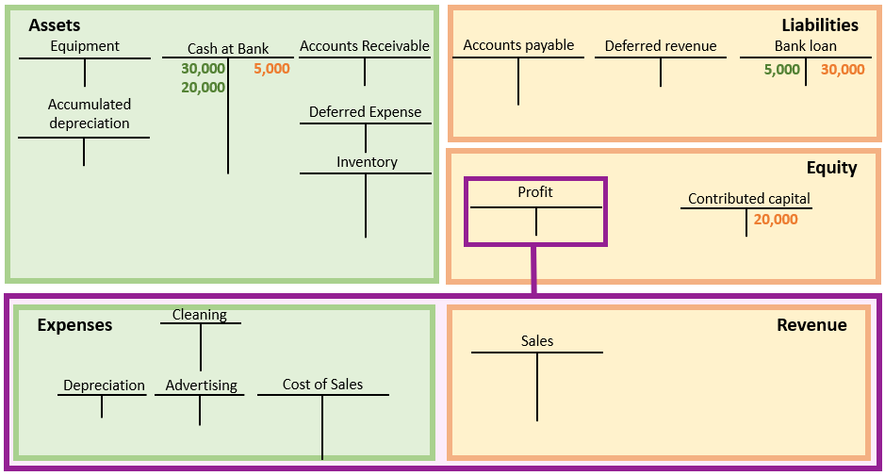

Trial balance – Optional Steps
- Periodically, each ledger account is listed individually and the balances that are “in debit (LHS or Green Side)” are recorded in one column (on the left of course) and the balances that are “in credit (RHS or Orange Side)” are recorded in another column to the right.
- This was a traditional method for checking that double-entry integrity had been maintained as the total of the debit column should equal the total of the credit column, hence the name “trial balance”.

Financial statement preparation
- From the trial balance, each account (or group of accounts) is summarized and disclosed within the correct part of the financial statements.
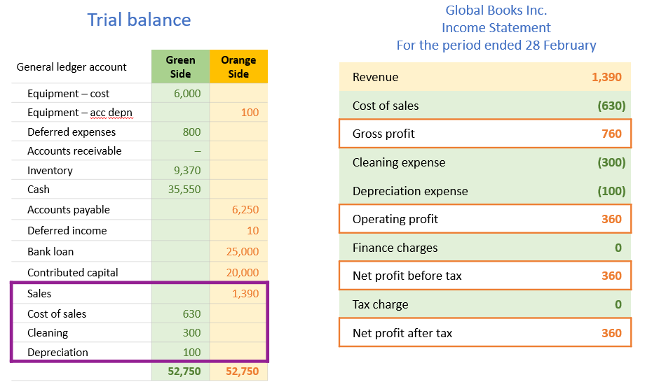

Review Problems 4 (R2-R6) M.E. Carter Financial Transactions
Assume that the following accounts appear in the ledger of M.E. Carter, a financial consultant to companies in the retail sector: Cash; Accounts Receivable; Office Equipment; Prepaid Subscriptions; Accounts Payable; Note Payable; Common Stock; Retained Earnings; Fees Earned; Salaries Expense; Rent Expense; Interest Expense; and Utilities Expense. For each of the following 11 transactions:
Required: a) Analyze and enter each into the financial statement effects template, and b) post all transactions to each account in the general ledger. (You will find the template on the next page).
Transactions:
- M.E. Carter started the firm by contributing $15,500 cash to the business in exchange for common stock.
- The firm purchased $10,400 in office equipment, issuing a long-term note payable for $4,400 with the remainder on account.
- Paid $700 cash for this period’s office rent (on a short-term lease).
- Paid $9,600 cash for subscriptions to online financial databases covering the next three periods.
- Billed clients $11,300 for services rendered.
- Made $1,000 cash payment on account for the equipment purchased in transaction 2.
- Paid $2,800 cash for assistant’s salary for this period.
- Collected $9,400 cash from clients previously billed in transaction 5.
- Received $180 invoice for this period’s utilities; it is paid early in the next period.
- Paid $1,500 cash for dividends to shareholders.
- Paid $225 cash for interest on the note payable for the period.

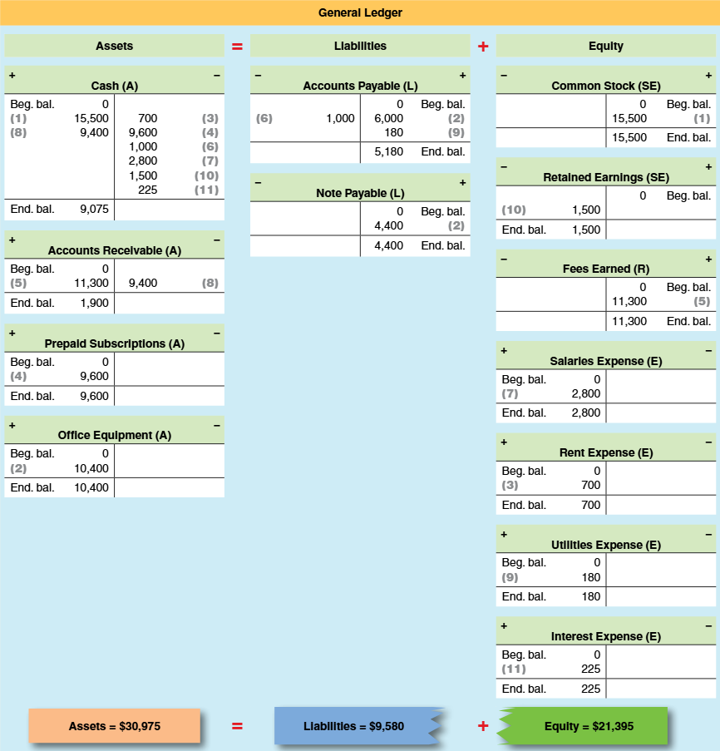

Concept Quiz 3
1. Retained earnings (or Profit Account) is decreased by?
- assets.
- owner's investments.
- expenses.
- revenues.

2. Genesis Company buys equipment for $900 machine on credit (i.e. cash is not paid yet). This transaction will immediately affect the
- income statement and retained earnings statement
- income statement, retained earnings statement, balance sheet.
- income statement only.
- balance sheet only.

3. If an expense is paid with cash,
- expenses will decrease.
- retained earnings will increase.
- assets will decrease.
- liabilities will increase.

---------------------------------------------- The End of Chapter 2 -----------------------------------------------

Homework Assignments

Q2-1. The balance sheet consists of assets, liabilities, and equity. Define each category and provide two examples of accounts reported within each category.

Q2-5. What are the two essential characteristics of an asset?

Q2-9. Identify three intangible assets that are likely to be excluded from the balance sheet because they cannot be reliably measured.

M2-14. Determining Retained Earnings and Net Income Using the Balance Sheet
The following information is reported for Kinney Corporation at the end of the year:
Accounts receivable | $46,000
Accounts payable | 22,000
Cash | 16,000
Common stock | 220,000
Retained earnings | ?
Supplies inventory: $18,000; Equipment: $276,000
a. Compute the amount of retained earnings reported at the end of the year.
b. If the amount of retained earnings at the beginning of the year was $60,000, and $24,000 in cash dividends were declared and paid during the year, what was the company’s net income for the year?

M2-20. Computing Net Income
Healy Corporation recorded service revenues of $200,000 during the year, of which $140,000 were for credit and $60,000 were for cash. Moreover, of the $140,000 credit sales, it collected $40,000 cash on those receivables before year-end. The company also paid $120,000 cash for current year’s wages.
a. Compute the company’s net income for the year.
b. Suppose you discover that employees had earned an additional $20,000 in wages during the year, but this amount had not been paid. Would annual net income change? If so, by how much?

M2-22. Classifying Items in Financial Statements
For each of the following items, indicate whether it is most likely reported on the balance sheet (B), the income statement (I), or the statement of stockholders’ equity (SE).
a. Accounts receivable
b. Prepaid insurance
c. Net income
d. Stockholders’ equity
e. Notes payable
f. Supplies expense
g. Land
h. Supplies

M2-26. Analyzing the Effect of Transactions on the Balance Sheet
Following the example in a below, indicate the effects of transactions b through i on assets, liabilities, and equity, including identifying the individual accounts affected.
a. Paid cash to acquire a computer for use in office.
ANSWER: Increase assets (Office Equipment); Decrease assets (Cash)
b. Rendered services and billed client
c. Paid cash to cover rent for this period
d. Rendered services to client for cash
e. Received amount due from client in b
f. Purchased an office desk on account
g. Paid cash to cover this period’s employee salaries
h. Paid cash to cover desk purchased in f
i. Declared and paid a cash dividend

P2-49. Comparing Operating Characteristics Across Industries
Review the following selected income statement and balance sheet data for fiscal years ending in 2019.
Company | Sales ($ millions) | Cost of Sales | Gross Profit | Net Income | Assets | Liabilities | Equity
Comcast Corp. | $108,942 | $34,400 | $74,542 | $13,323 | $268,414 | $178,168 | $85,246
Apple Inc. | 260,174 | 161,782 | 98,392 | 55,256 | 338,516 | 248,028 | 90,488
Nike Inc. | 39,117 | 21,643 | 17,474 | 4,029 | 23,717 | 14,677 | 9,040
Target Corp. | 78,112 | 54,864 | 23,248 | 3,281 | 42,779 | 30,946 | 11,833
Harley-Davidson Inc. | 4,573 | 3,230 | 1,343 | 424 | 10,528 | 8,724 | 1,804
- REQUIRED
a. Compare and discuss how these companies finance their operations.
b. Which companies report the highest ratio of income to assets (net income/total assets)? Suggest a reason for this result.
c. Which companies have the highest estimated ROE? Is this result a surprise? Explain.

The journal book was completed daily to record every transaction that occurred using the double entry system: ”Debit (left-hand or green side of T-accounts) this / Credit (right-hand or orange side of T-accounts) that”. It is the daily task of recording transactions that gives us the word “journal”, which is routed in the Latin word diurnus meaning "that which takes place daily". Accountants still use the term “journal” to describe any transaction written using the double entry method and all modern computerized systems store transactions in a journal format.

