5. Accrual vs. Cash Basis Accounting (Ch 3)
(Adjusting Accounts for Financial Statements)

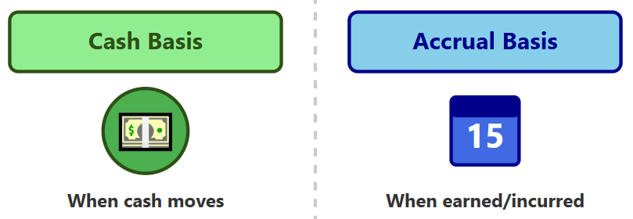

Table of Contents
Part 1: Cash Basis vs. Accrual Basis of Accounting 2
5.1 Reporting Issues when the Business Cycle ≠ Reporting Cycle 2
5.2 Illustration 1: Recognizing Revenue and Expense under the Accrual Basis 3
5.3 Illustration 2: Cash vs. Accrual Basis Accounting - Case Study 4
5.4 Cash vs. Accrual Basis Accounting 5
5.5 Accrual Accounting Process: From Facts to Financial Statements 6
Part 2: Adjusting Entries 8
5.6 Why Adjustments are Needed? 8
5.7 Four Types of Adjustments 9
5.8 Deferred Expenses are Assets 10
5.9 Accrued Expenses are Liabilities 14
Review Problems 1 16

Part 1: Cash Basis vs. Accrual Basis of Accounting

5.1 Reporting Issues when the Business Cycle ≠ Reporting Cycle
The Accounting Period (or Reporting Cycle)
- The time interval over which a company measures, records, and reports its financial results.

- The time between two balance sheets.

- It can be a month, quarter, or year.
Business Operating Cycles
- The business operating cycle is the average time it takes for a company to:
- Buy or produce inventory → sell it → and collect cash from customers.
- They never really “stop.”, and it is continuous.
The Periodicity Assumption (or Period Principle)
- GAAP assumes that a company's economic life can be divided into artificial time periods for reporting purposes (i.e., a month, quarter or year).

- This allows stakeholders to evaluate performance over manageable, comparable intervals.

- The periodicity assumption lets accountants “cut” continuous activity into shorter, consistent intervals to report performance and financial position regularly.

Reporting Issues when the Business Cycle ≠ Reporting Cycle
- If a firm’s reporting cycle and its operating cycle perfectly aligned, there will be no reporting issues.

- However, reporting cycle rarely match the operating cycle, which creates a critical reporting issue.

- In other words, income generating activity occurs continuously, but financial statements need to be prepared at the end of the reporting period during the specific period.

- The two examples below illustrate the difficulty of measuring a firm’s performance when its operating cycle and reporting cycle are not aligned.

5.2 Illustration 1: Recognizing Revenue and Expense under the Accrual Basis
- On Dec 1, 2027, a firm purchases merchandise intended for resale and pays $100 cash.
- On Dec 20, 2027, the firm sells the same merchandise for $180 on credit.
- On Jan 15, 2028, the firm collects $180 in cash from the customer for the prior year’s sale.
- This company’s accounting period ends on December 31. i.e., financial statements are prepared each year end.
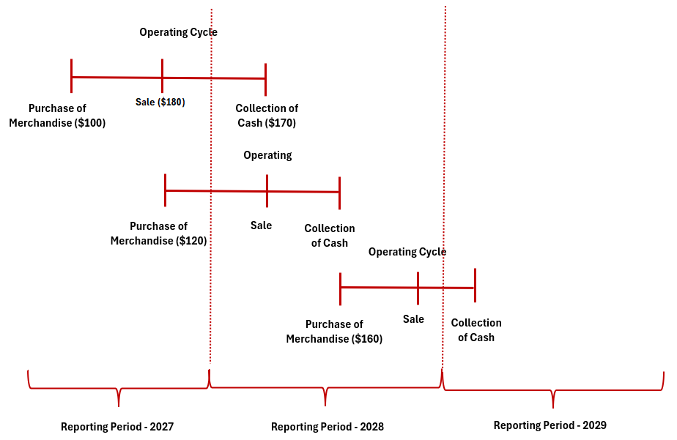
What amounts of revenue, expense, assets should the firm recognize in 2027?
Accounts | 2027
Revenue | $180
Expense | $100
Profit (Net Income) | $ 80
Assets (Inventory) | $120

5.3 Illustration 2: Cash vs. Accrual Basis Accounting - Case Study
Background
Summit Publishing Company specializes in magazine publication and distribution. The company operates on a quarterly publication schedule.

Subscription Information
- Publication Frequency : Quarterly (4 issues per year)
- Price per Issue : $25
- Number of Subscribers : 1,000
- Subscription Length : 3 years

Cash Collection
- Total subscription related cash collection for 3-year subscription in 2025: $300,000
- Calculation: $25 × 4 issues × 1,000 subscribers × 3 years = $300,000

Operating Costs
- Annual magazine production and delivery cost: $60,000

Financing Costs
- Loan Amount: $100,000
- Loan Term: 3 years
- Payment Terms: Principal and interest due at loan maturity
- Annual Interest Rate: 10% ($10,000 per year)

Required
1. Calculate the company's total income for the three-year period (2025-2027)
2. Determine the annual income for each year (i.e., 2025, 2026, and 2027)

Notes for Analysis
- What is the best way of calculating Summit Publishing Company’s annual income?
- Note : Income = Revenue – Expenses

Summit Publishing: Cash-basis summary
 | Total | 2025 | 2026 | 2027
Cash inflows
Cash outflows for production and distribution
Cash outflow for loan interest
Net Income(loss)-Cash Basis

Summit Publishing: Accrual-basis summary
 | Total | 2025 | 2026 | 2027
Subscriptions
Deferred to future years
Revenues recognized (earned)
Expenses:
Magazine costs
Interests accrued
Net Income

5.4 Cash vs. Accrual Basis Accounting
Cash Basis of Measuring Operating Performance
- No accruals or deferrals are recorded
- Revenue Recognition:
Revenues are recorded only when cash is received, regardless of when the sale actually occurs.
- Expense Recognition:
Expenses (such as costs of merchandise, salaries, and taxes) are recorded only when cash is paid, even if the expense was incurred in a prior period.
- Focus:
The cash basis focuses on cash inflows and outflows, offering a simple view of liquidity but not necessarily an accurate reflection of financial performance.

Accrual Basis of Measuring Operating Performance
- Recognition is based on economic activity
- Revenue Recognition:
Revenues are recognized when goods are sold or services rendered, not when cash is collected.
- Expense Recognition:
Expenses are recognized in the same period as the related revenues or when the asset’s benefits expire. This ensures a proper matching of costs with revenues.
- Focus:
The accrual basis records the economic substance of transactions, not just their cash effects, resulting in more accurate financial reporting.
Advantages of the Accrual Basis
- Provides a clearer picture of profitability for each period.
- Better matches expenses with the revenues they help generate.
- Reflects the firm’s true operating performance, independent of cash timing.
- Measures changes in net assets, offering a more comprehensive financial view.
Limitations of the Cash Basis
- Delayed Recognition:
Revenues may be recorded after the key business activity has occurred, leading to timing distortions.
- Poor Matching:
Expenses are not aligned with related revenues, making performance less meaningful.
- Long Operating Cycles:
The longer the business cycle, the greater the mismatch between efforts (expenses) and benefits (revenues), reducing the usefulness of cash-based results.
Accrual Accounting Process: From Facts to Financial Statements
INPUT
(FACTS)

Cash Receipts
Cash Disbursements
Other Information

OUTPUTS -GAAP
(ESTIMATES)
Revenues
Expenses
Receivables
Prepaid Expenses
Deferred Charges
Payables
Accrued Expenses
Unearned Revenue
Accrual/Deferral Accounting System
(JUDGMENT)

Concept Quiz 1
1. In a service company, revenue is recorded at the time when:
a. a customer requests services.
b. a customer pays for the services.
c. the services are performed for the customer.
d. a customer pays a nonrefundable deposit before the services are performed.

2. Drake’s Lawn Care Company mows and fertilizes several customers’ lawns on June 27, but
the customers don’t pay Drake until July 8, at which time he receives a total of $250. Prepare
Drake’s journal entries for (1) June 27, and (2) July 8.

Date Account Titles Debit Credit

3. Delta Airline’s employees are paid once per month on the 15th. From December 16 to
December 31, 20x1, employees earned $220,000 for which they weren’t paid until January 15, 20x2. Prepare the journal entry for (1) December 31, 20x1 to record employees’ wages earned between December 16 and December 31, and (2) January 15, 20x2 to pay employees’ wages.
Date Account Titles Debit Credit

4. If revenues are recognized only when a customer pays, what method of accounting is being used?
a. Matching basis
b. Accrual-basis
c. Cash-basis
d. Recognition basis

5. In 20x3, Costello Company performs work for a customer and bills the customer $10,000; it also pays expenses of $3,000. The customer pays Costello in 20x4. If Costello uses the accrual-basis of accounting, then Costello will report
- expenses of $3,000 in 20x4.
- net income of $7,000 in 20x4.
- revenue of $10,000 in 20x3.
- revenue of $10,000 in 20x4.

Part 2: Adjusting Entries

5.5 Why Adjustments are Needed?
  - Accounting systems are designed to record most recurring daily transactions, particularly any involving cash.

  - However, cash is not always received in the period in which revenue is earned, nor is cash always paid in the period in which an expense is incurred. As a result, these transactions are not automatically recorded in the accounting system in the period they occur, even though they should be.

  - Example: December utility expense is typically not recorded in December because the bill is received in the following month. Unless the December utility expense is intentionally recorded, expenses and liabilities for the period will be understated.

  - Solution: Adjustments are made to the accounting records at the end of the period to state assets, liabilities, revenues, and expenses at appropriate amounts.

  - Income Statement:
    - Revenues are recorded when earned (Revenue Recognition Principle).
    - Expenses are recorded in the same period as the revenues to which they relate (Expense Recognition Principle).

  - Balance Sheet
    - Assets are reported at amounts representing the economic benefits that remain at the end of the period.
    - Liabilities are reported at amounts owed at the end of the period.

  - Key Takeaway
Adjustments ensure that:
    - Income is not overstated or understated due to cash timing,
    - Assets and liabilities are properly stated at period end, and
    - Financial statements are consistent with accrual accounting.

5.6 Four Types of Adjustments

    - We will only focus on 1) deferred expenses and 2)accrued expenses in this chapter.



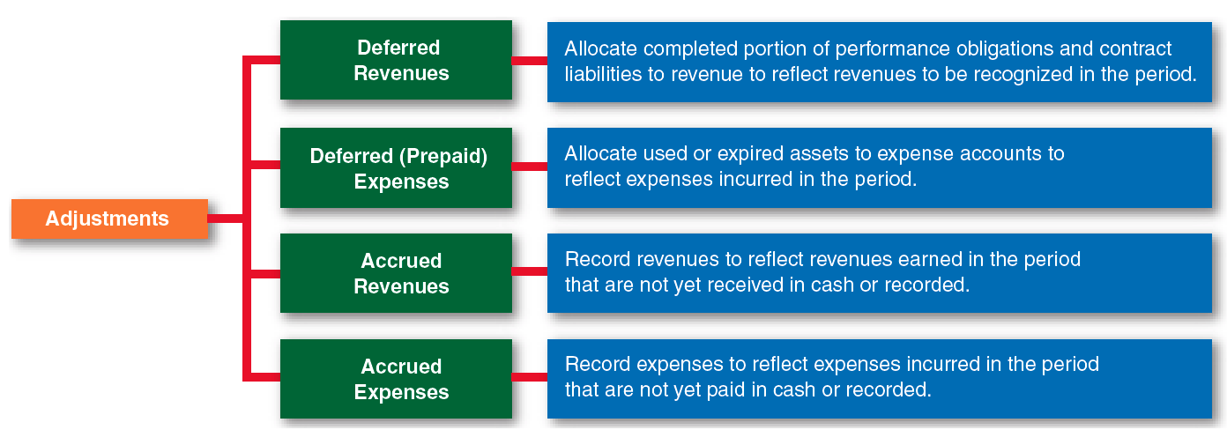

 | Cash Paid BEFORE Activity | Cash Paid AFTER Activity
Expense | Deferred Expenses  (Assets) | Accrued Expenses  (Liabilities)
Revenue | Deferred Revenue  (Liabilities) | Accrued Revenue  (Liabilities)

5.7 Deferred Expenses are Assets
- Remember that one aspect of accrual accounting is that expenses are recognized when the activity takes place, not when cash is paid.
  - When a cash payment benefits multiple accounting periods, the amount is first recorded as an asset (i.e. deferred expenses).
  - At the end of each period, the portion that has expired is transferred to an expense account.
  - Common examples include buildings, equipment, supplies, prepaid advertising, insurance, and rent that cover more than one period.
  - These items are often referred to as prepaid expenses.

 | Don’t be fooled by the name –– “Deferred expenses” are assets.

Illustration 1 – When services or goods are consumed during the accounting period
On February 28, Global Books, Inc. received an $800 invoice from BBB Inc. for an advertising campaign conducted during February.
February 28 | Green Ticket (debit) | Orange Ticket (credit)
Advertising expense [expenses] | 800
Accounts payable [liabilities] |  | 800

Illustration 2 – When services or goods will be consumed in future accounting periods and cash payments are paid in advance.
On February 28, Global Books, pays BBB Inc. $800 for an advertising campaign to be conducted for March, April, May and June.
This transaction is recorded as follows:
February 28 | Green Ticket (debit) | Orange Ticket (credit)
Deferred expense [assets] | 800
Cash [assets] |  | 800
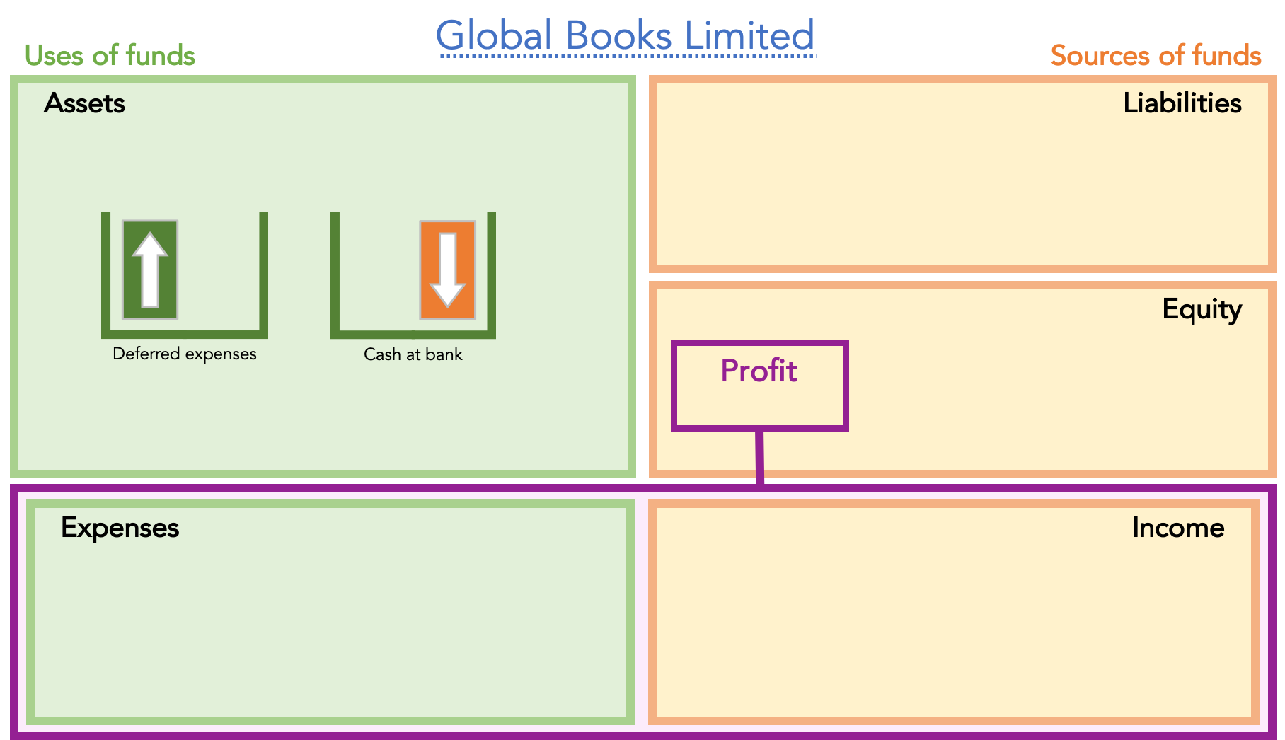

Explanation:
- It might seem confusing because there has been expenditure out of the bank account –– but we learned that expenditure of cash is not necessarily an expense.
- We learned that an expense is activity that uses up or consumes value. This is a subtle point but worth thinking about: an expense is not a loss of value, but the activity that leads to a loss of value.
- Using the example of advertising might make this clearer. Remember this transaction is on February 28th and Global Books is buying an advertising campaign that will run in March through to June. The expense – the advertising campaign – will not start until next month.
- So, in February, there is no activity that uses up or consumes value – there is no expense.
- What Global Books has bought is the right to receive advertising in the future. The right to receive something is an asset, which we call deferred expenses.

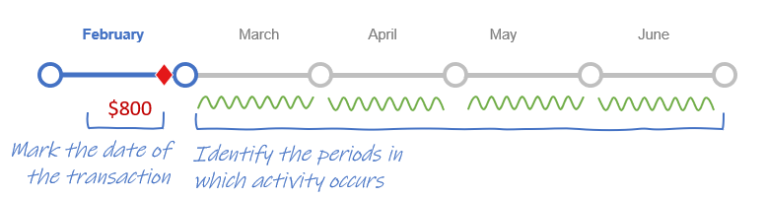
Deferred expenses get used up…

- Let’s see what happens when time moves into March and the advertising campaign starts: this was Classic Transaction 15.
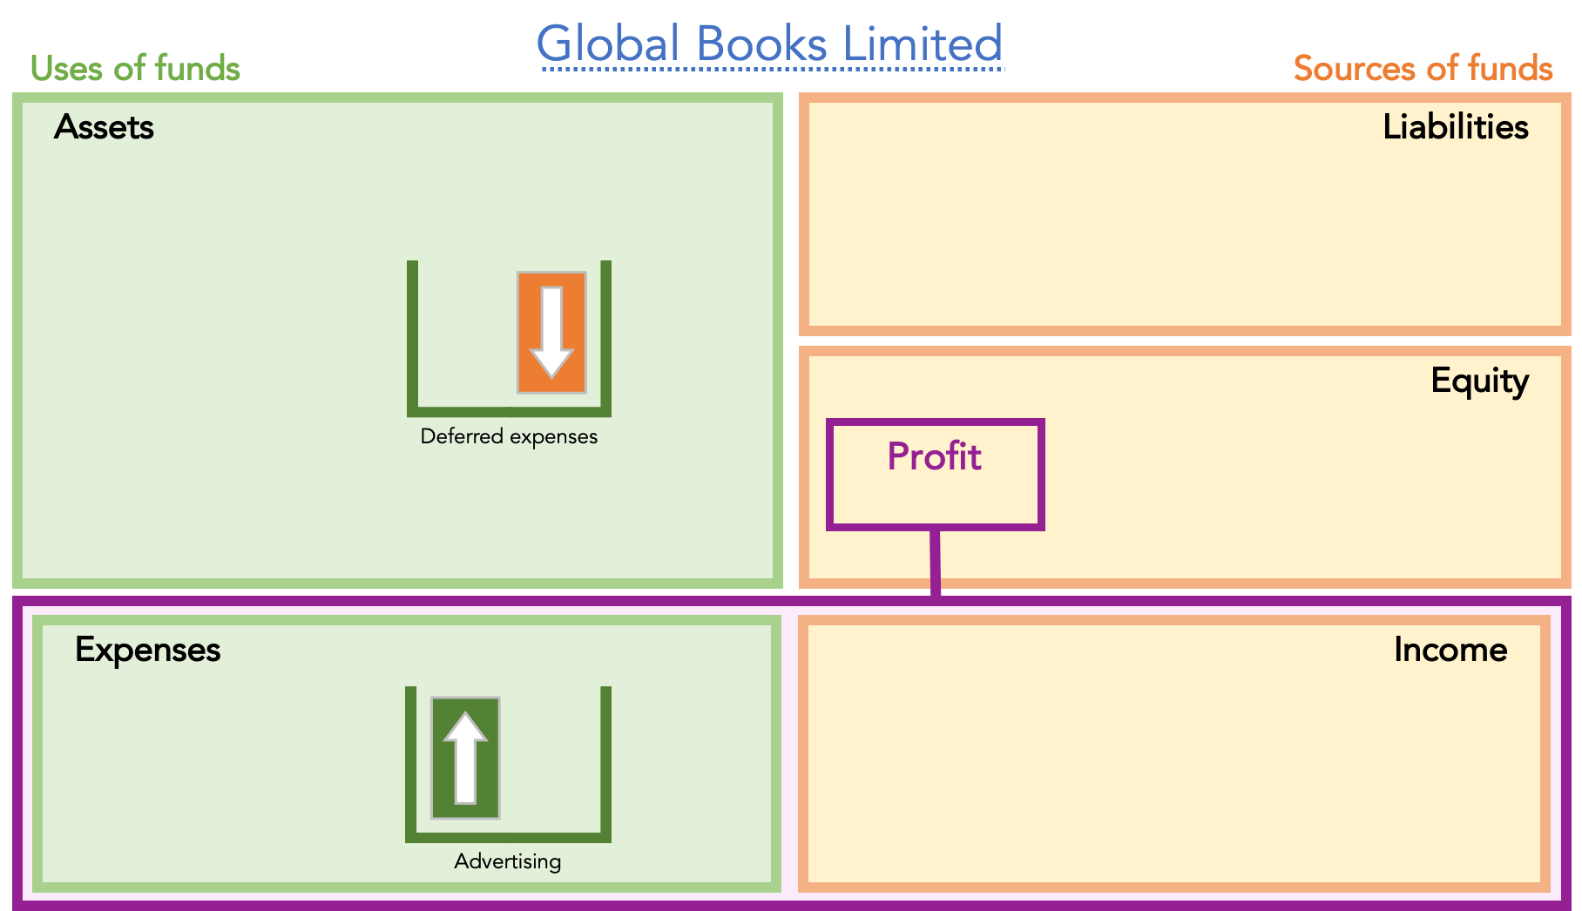

- Some of the advertising has been used up so now we record the loss of value by reducing the asset account deferred expenses and we recognize the activity of advertising by increasing expenses.
- More specifically, adjusting Entries to recognize $200 monthly advertising expenses for the next 4 months.

March 31 | Green Ticket (debit) | Orange Ticket (credit)
Advertising expense [expenses] | 200
Deferred expense [assets] |  | 200

Apr 30, May 31 and Jun 30 | Green Ticket (debit) | Orange Ticket (credit)
Advertising expense [expenses] | 200
Deferred expense [assets] |  | 200
The impact on accounts for each accounting period is as follows:
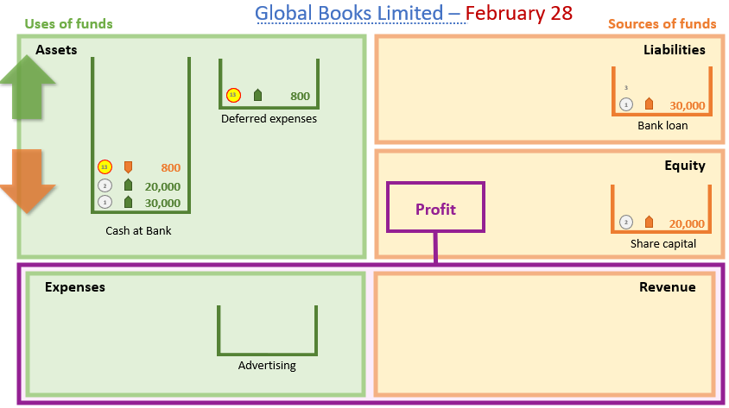
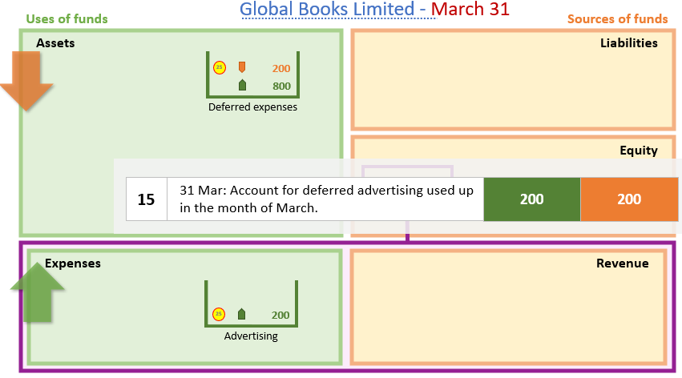
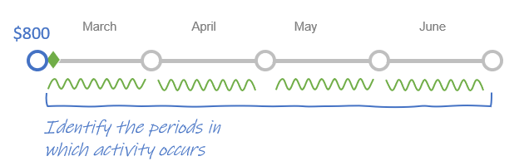
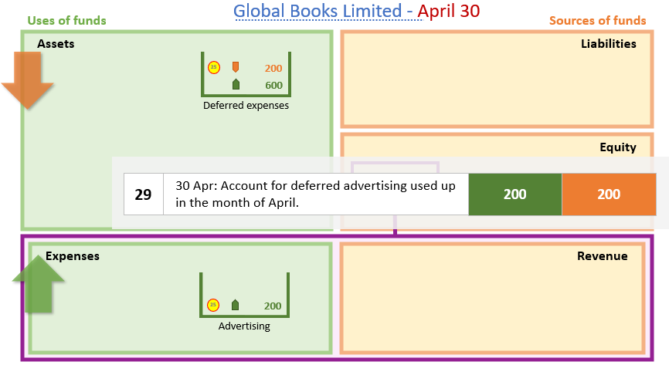

 | March | April | May | June
Deferred Expenses (Assets) | $600 | $400 | $200 | $––
Advertising Expenses | $200 | $200 | $200 | $200

5.8 Accrued Expenses are Liabilities
    - We have learned that an expense is activity that uses up or consumes value.

    - Using accruals accounting we recognize expenses when the activity takes place, not when the supplier invoices the entity, nor when cash is paid to the supplier.

    - In the previous section, we saw examples of expenses paid before the related activity period. Using Transaction 13, Global Books bought advertising on February 28 for March–June. What Global Books bought was the right to receive advertising in the future. The right to receive something is an asset, which we call deferred expenses.

    - Now we cover the opposite situation: what happens when the entity uses up or consumes value but no charge is made by the supplier in that period.

    - For example, on March 31,

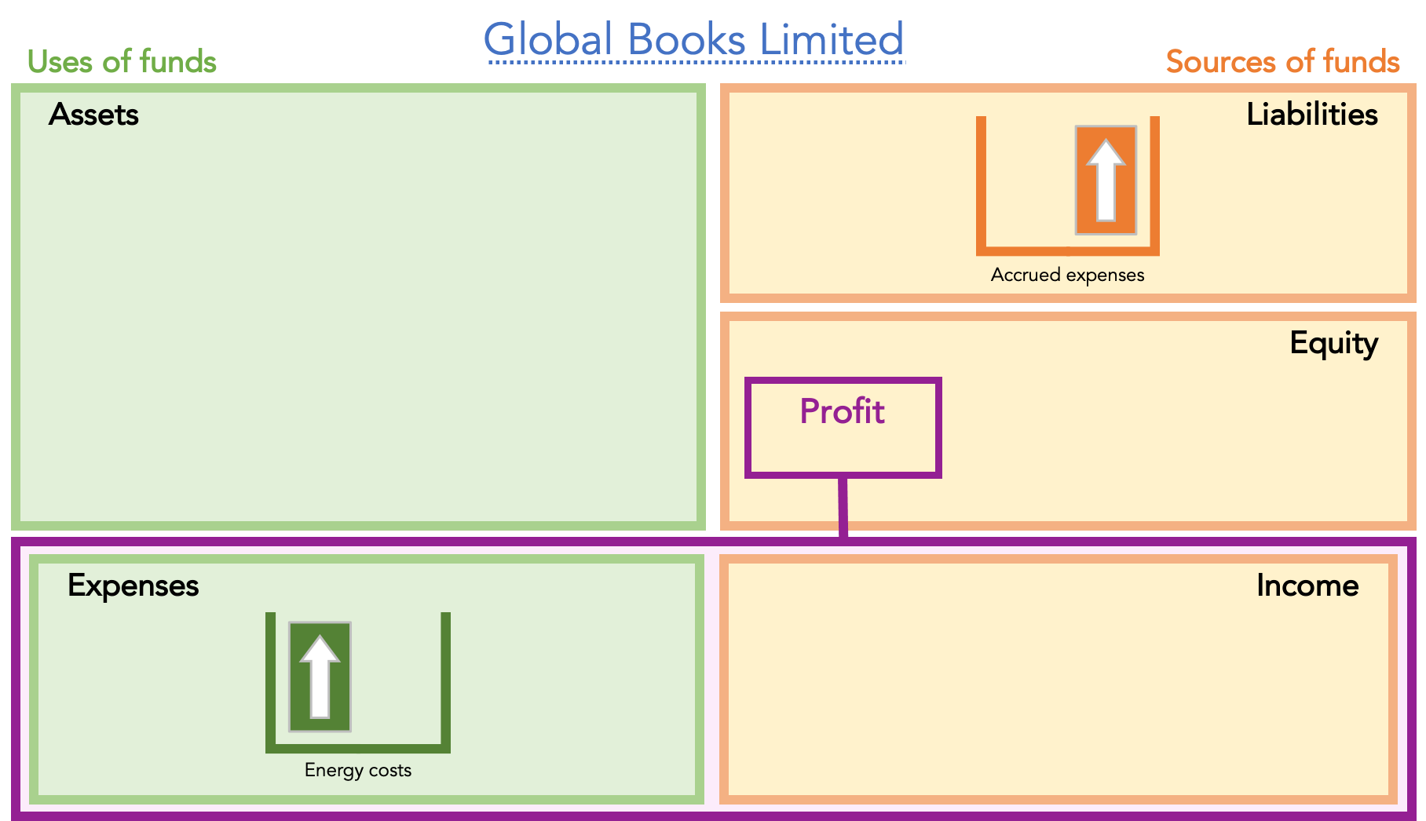




    - In this scenario, Global Books will recognize the energy cost as an expense in March—or in the period when it is used—even if the cash payment will not be made until April.
    - In March, Global Books records an energy expense and a liability, because payment for March utilities has not yet been made.
    - This liability is called an accrued expense.
    - Important: an accrued expense represents liability on the balance sheet.

Purchase of fixed assets as a Deferred Expense
- A purchase of fixed assets (such as equipment or buildings) can be viewed as a form of deferred expense.
- At the time of purchase, the asset provides future economic benefits, so the cost is capitalized (i.e., recorded as assets) rather than immediately expensed.
- Over time, as the asset is used up in operations, its cost is allocated to expense through depreciation.
- In essence, depreciation spreads the deferred cost of the asset over the periods that benefit from its use—matching cost with revenue.

Illustration:
On January 1, Natural Beauty Supply purchased fixtures and equipment for $18,000 on account. The equipment is expected to last four years. Using straight-line depreciation, record the journal entries for:
- The purchase of the equipment.
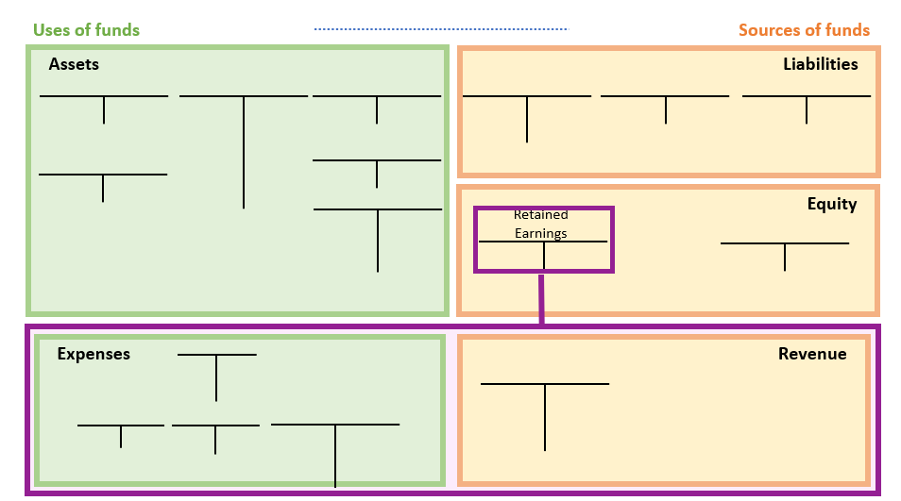
- The year-end depreciation adjustment on December 31.
Natural Beauty Supply
$\text{Annual Depreciation}=\frac{\$18,000}{4}=\$4,500\text{ per year}$
Depreciation Expense
4,500
12/31
Accumulated Depreciation
Equipment
1/1
18,000
12/31
4,500
Date Account Titles Debit Credit
Jan 1 Equipment (+ A) 18,000 ↑
Accounts Payable (+ L) 18,000 ↑

Dec 31 Depreciation Expense ( + X) 4,500 ↑
Accumulated Depreciation (+ Contra A) 4,500 ↑
Each year, part of the deferred cost is recognized as an expense as the asset is used.

Review Problems 1

  - On August 1, Natural Beauty Supply paid $5,400 for six months’ rent on a building. The rent payment is for the period August 1 thru January 31. The fiscal year ends on December 31.

Required:

Record the above events in the general ledger below. You need to label your t-accounts used. Alternatively you can make required journal entries on August 1 and December 31.
12/31 ------------------------------
12/31
12/31
8/1
8/1
5,400
4,500
900
4,500
5,400
Rent Expense
Natural Beauty Supply
Cash
Prepaid Rent

Solution:
On August 1, you would make the following journal entry (this is not an adjusting entry):

Date Account Titles Debit Credit
Aug 1 Prepaid rent (+ A) 5,400 ↑
Cash ( - A) 5,400 ↓
On December 31, before you prepare the December 31 financial statements, you’d need to recognize that 5 of the 6 months’ rent has expired
Date Account Titles Debit Credit
Dec 31 Rent Expenses (+ EXP) 4,500 ↑
Prepaid Rent ( - A) 4,500 ↓
Note: Adjusting entries for prepaid expenses that have expired or been used up will involve an increase in an expense account (debit) and a decrease in an asset account (credit). 5,400 x 5 months/6 months = $4,500.
  - Yard Processionals, Inc. experience the following events in Year 1, its fist year of operation:
- On September 1 : Performed service for $35,000 cash.
- On October 1 : Purchase $6,000 of supplies on account.
- On December 31: A physical count found that there was $1,800 of supplies on hand.
Required:
    - Record the events in account in the general ledger below. You need to label your t-accounts used.
    - Prepare an income statement and balance sheet for the Year 1 accounting period.


Yard Professionals, Inc.
Accounts Payable
Cash
6,000
35,000

6,000
Supplies
1,200
4,800

Service Revenue
Supplies Expense
35,000
48,000

Yard Professionals Inc.
Income Statement
For the Year Ended December 31, Year 1
 | Revenue | $35,000
 | Expense | (4,200)
 | Net Income | $30,800

Yard Professionals Inc.
Balance Sheet
As of December 31, Year 1
 | Assets
 | Cash | $35,000
 | Supplies | 1,800
 | Total Assets |  | $36,800
 | Liabilities
 | Accounts Payable | $ 6,000
 | Total Liabilities |  | $ 6,000
 | Stockholders’ Equity
 | Retained Earnings | 30,800
 | Total Stockholders’ Equity |  | 30,800
 | Total Liab. and Stockholders’ Equity |  | $36,800

Concept Quiz 2
1. Cash received before services are performed are recorded as
- liabilities.
- expenses.
- equity.
- revenues.
2. At December 31, 2018, before any year-end adjustments, MaCarthy Company's Prepaid Insurance account had a balance of $2,700. It was determined that $1,500 of the Prepaid Insurance had expired. The adjusted balance for Insurance Expense for the year would be
- $2,700
- $1,900
- $1,500
- $1,200

3. On September 1 the Petite-Sizes Store paid $12,000 to the Mega-Mall Co. for 3 months’ rent beginning September 1. Prepaid Rent was debited for the payment. If Petite-Sizes Store prepares financial statements on September 30, the appropriate adjusting journal entry to make on September 30 would be
- Dr. Prepaid Rent ↑$8,000 Cr. Rent Expense ↑$8,000
- Dr. Prepaid Rent ↑$4,000 Cr. Rent Expense ↑ $4,000
- Dr. Rent Expense ↑ $8,000 Cr. Prepaid Rent ↓ $8,000
- Dr. Rent Expense ↑$4,000 Cr. Prepaid Rent ↓ $4,000

  - On July 1, 2027, your company borrowed $100,000 from a bank. The loan matures in three years and carries an annual interest rate of 6%. The company’s fiscal year ends on December 31. The annual interest payments are dude on June 30, 2028, 2029 and 2030.

Required: Prepare all appropriate journal entries related to this loan.

Solutions


Yard Professionals, Inc.
Interest Payable
Notes Payable
Cash
100,000
100,000
3,000
3,000

Interest Expense

Date Account Titles Debit Credit

07/01/2027 Cash 100,000 ↑
Notes Payable 100,000 ↑

12/31/2027 Interest Expense 3,000 ↑
Interest Payable 3,000 ↓

(Interest Expense = $100,000 x 6% x 6/12 = $3,000)
Note: Adjusting entries to record accrued expenses will always involve an increase in an expense account (income statement account) and an increase in a liability account (balance sheet account).

