6. Statement of Cash Flows (Ch 4)

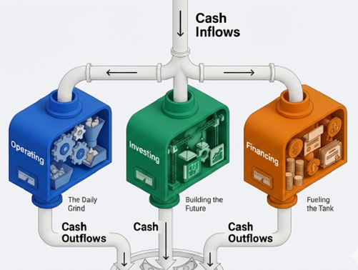

Table of Contents
Part 1: The Content and Value of the Statement of Cash Flows 2
6.1 Objectives and Utility of Cash Flow Reporting 2
6.2 Classification of Cash Inflows and Outflows 2
6.3 Direct Method vs. Indirect Method – Cash Flows from Operating Activities 5

Part 1: The Content and Value of the Statement of Cash Flows

Objectives and Utility of Cash Flow Reporting
- Primary purpose:
- To provide information about a company’s cash receipts and cash payments during a period.
- Secondary objective:
- To provide cash-basis information about the company’s operating, investing, and financing activities.
- Usefulness of the Statement of Cash Flows - To provide information to help assess:
- the entity’s ability to generate future cash flows
- the entity’s ability to pay dividends and meet obligations
- the reasons for the difference between net income and net cash flow from operating activities
- the investing and financing transactions during the period

Classification of Cash Inflows and Outflows
- The statement of cash flows classifies cash receipts and cash payments by operating, investing, and financing activities
Classification | General Guidelines | Examples
Operating activities | Involves income statement items | Cash inflows from:
 |  | - Sales of goods or services
 |  | - Interest revenue from notes receivable
 |  | - Dividends from equity Investments
 |  | Cash outflows to:
 |  | - Suppliers for inventory
 |  | - Employees for services
 |  | - Government for taxes
 |  | - Lenders for interest expense
 |  | - Others for expenses
Investing activities | Involves cash flows from changes in investments and long-term asset items | Cash inflows from:
 |  | - Sale of property, plant, and equipment
 |  | - Sale of debt or equity investments
 |  | - Collection of principals on loans to other entitles (notes receivable)
 |  | Cash outflows to:
 |  | - Purchase property, plant, and equipment
 |  | - Purchase debt or equity investments
 |  | - Make loans to other entitles (notes receivable)
Financing activities | Involves cash flows from changes in long-term liability and stockholders’ equity Items | Cash inflows from:
 |  | - Sale of common and preferred stock
 |  | - Issuance of debt (bonds and notes)
 |  | Cash outflows to:
 |  | - Stockholders as dividends
 |  | - Lenders to pay off long-term debt
 |  | - Stockholders to repurchase common stock (treasury stock)

UNITED BRANDS CORPORATION
Statement of Cash Flows
For Year Ended December 31, 2021
Cash Flows from Operating Activities | ($ in millions)
Cash inflows:
From customers | $ 98
From investment revenue | 3
Cash outflows:
To suppliers of goods | (50)
To employees | (11)
For interest | (3)
For insurance | (4)
For income taxes | (11)
Net cash flows from operating activities |  | $ 22
Cash Flows from Investing Activities
Purchase of land | (30)
Purchase of short-term investment | (12)
Sale of land | 18
Sale of equipment | 5
Net cash flows from investing activities |  | (19)
Cash Flows from Financing Activities
Sale of common shares | 26
Retirement of bonds payable | (15)
Payment of cash dividends | (5)
Net cash flows from financing activities |  | 6
Net increase in cash |  | 9
Cash balance, January 1 |  | 20
Cash balance, December 31 |  | $29
Note X:
Noncash Investing and Financing Activities
Acquired $20 million of equipment by issuing a 12%, 5-year note | $20
Reconciliation of Net Income to Cash Flows from Operating Activities:
Net income | $12
Adjustments for noncash effects:
Gain on sale of land | (8)
Depreciation expense | 3
Loss on sale of equipment | 2
Changes in operating assets and liabilities:
Increase in accounts receivable | (2)
Decrease in inventory | 4
Increase in accounts payable | 6
Increase in salaries payable | 2
Discount on bonds payable | 2
Decrease in prepaid insurance | 3
Decrease in income tax payable | (2)
Net cash flows from operating activities | $22

Primary Elements of the Statement of Cash flows
    - Operating activities
    - Investing activities
    - Financing activities
    - The reconciliation of the net increase or decrease in cash
    - Noncash investing and financing activities

Cash Flows from Operating Activities
- Net income and its components, measured by the accrual concept, generally provides a better indication of current operating performance than does information about current cash receipts and payments.

- However, the cash effects of earning activities also provide useful information that is not directly accessible from the income statement (operating activities).

- This classification of cash flows includes the elements of net income but reported on a cash basis.

Concept Quiz #1
For each of the following transactions, indicate which section of the Statement of Cash Flows
would be affected:
a. Issued common stock for $300,000. __________________
b. Purchased equipment for $35,000. __________________
c. Paid employees’ salaries of $17,000. __________________
d. Sold a delivery truck for $8,000. __________________
e. Sold inventory for $11,000. __________________
f. Paid a $100,000 cash dividend to stockholders. __________________
g. Received a $50,000 cash dividend __________________

U.S. GAAP vs. IFRS
- Classification of the payment/receipt of dividend and Interest is different under the U.S. GAAP and the IFRS.
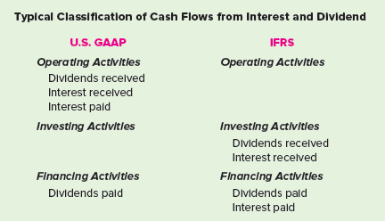

Direct Method vs. Indirect Method – Cash Flows from Operating Activities

- Cash flows from operating activities section can be prepared by direct vs. indirect method.

- Direct method: the statement of cash flows reports net cash flow from operating activities into two major classes: (Illustration in earlier page used the direct method)
- Cash Receipts
- Examples include cash collected from customers and cash received from interest and dividends.
- Cash Disbursements
- Examples include cash paid to suppliers for goods, to employees for services, to creditors for interest, and to government authorities for taxes.

- Indirect Method: Net cash increase or decrease from operating activities is derived indirectly by
- Starting with reported net income (e.g., $12) and
- Working backwards to convert that amount to a cash basis (e.g., $22)
- In the indirect method we adjust net income that don’t affect cash

- 21-4 Relation between the I/S and Cash Flow from Operating Activities (Direct Method)
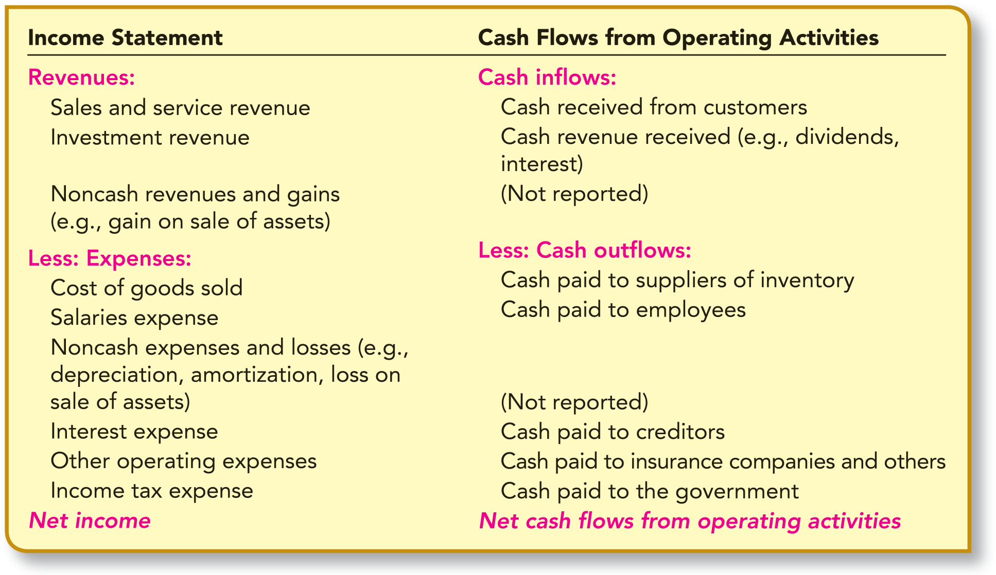

Cash Flows from Operating Activities: Direct Method
Cash Flows from Operating Activities | ($ in millions)
Cash inflows:
From customers | $ 98
From investment revenue | 3
Cash outflows:
To suppliers of goods | (50)
To employees | (11)
For interest | (3)
For insurance | (4)
For income taxes | (11)
Net cash flows from operating activities |  | $ 22

Cash Flows from Operating Activities: Indirect Method
Net income | $12
Adjustments for noncash effects:
Gain on sale of land | (8)
Depreciation expense | 3
Loss on sale of equipment | 2
Changes in operating assets and liabilities:
Increase in accounts receivable | (2)
Decrease in inventory | 4
Increase in accounts payable | 6
Increase in salaries payable | 2
Discount on bonds payable | 2
Decrease in prepaid insurance | 3
Decrease in income tax payable | (2)
Net cash flows from operating activities | $22

Analysing United Brands Corporation’s Performance Using Statement of Cash Flows
- Operating Cash Flows: +$22M
- It is positive and strong as cash flow ($22M) > NI ($12M).
- The company’s earnings quality is considered high.

- Investing Cash Flows: -$19M
- It is negative. i.e., net cash outflow.
- Company is in growth mode, purchasing land and investments, not liquidating assets.

- Financing Cash Flows: +$6M
- It is positive. i.e., net cash inflow.
- Raising capital via stock ($26M) while responsibly retiring ($15M) and paying dividends.
- Summary
  - United Brands Corporation is a healthy, growing company funded by strong operations and new equity.
Noncash Investing and Financing Activities
- Noncash investing and financing activities are reported in a separate disclosure schedule or note.
- Examples of noncash transactions
- Acquiring an asset by incurring a debt payable to the seller
- Acquiring use of an asset by entering into a lease agreement
- Converting debt into common stock or other equity securities
- Exchanging noncash assets or liabilities for other noncash assets or liabilities
- Illustration: UBC acquired $20 million of new equipment by issuing a $20 million long-term note payable in a single transaction.
- Reported in a separate disclosure schedule or note.
- UBC reported this transaction in the following manner:
Noncash Investing and Financing Activities:
Acquired $20 million of equipment by issuing a 12%, 5-year note.

