7. Revenue Recognition and Receivable Valuation (Ch 6)

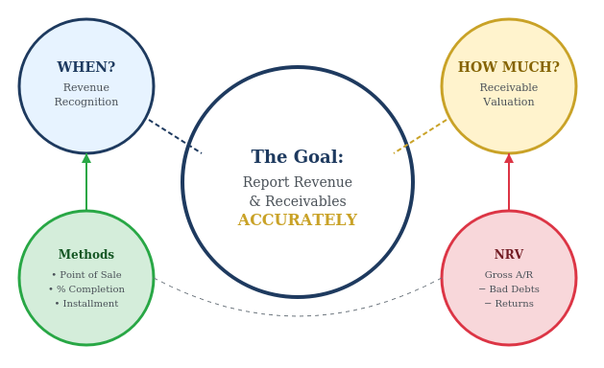

Table of Contents
Part 1: Revenue Recognition 2
7.0 Operating Cycle 2
7.1 What is revenue? Value Generating Activities 2
7.2 The Disconnet between Performance and Payment 3
7.3 Sales Returns 5
7.4 Revenue Recognition Complications – Case Examples 6
Part 2: Valuing and Reporting Account Receivable 8
7.5 Account Receivables 8
7.6 Recognition of Uncollectible Accounts 9
Part 3: Alternative Methods of Revenue Recognition 12
7.7 Alternative Timing of Revenue Recognition 12
7.8 Discussion Questions 14

Part 1: Revenue Recognition

7.0 Operating Cycle
- What is an operating cycle?
- A repetitive cycle of events that occurs in the ongoing operations of a business.
- Why is it important to know a business’s operating cycle?
- The operating cycle directly impacts when revenue should be recorded. Companies must understand their complete cycle to determine the appropriate point for revenue recognition - whether at sale, delivery, or collection.

7.1 What is revenue? Value Generating Activities
    - The inflow of assets (not necessarily cash) to a business that occurs as a direct consequence of providing goods or services to customers.

- Conditions required to recognize revenue
  - There has been a transfer of goods or services
- Seller must satisfy obligations under sale agreement
  - Entitled to consideration from the customer
- Seller must have been paid or reasonably expect to be paid

- Transferring control does not imply that payment for the purchase has been made and it is not necessary to receive cash to recognize revenue

- “Recognize” means report on the income statement
Illustration - Pfizer’s Revenue Recognition Policy
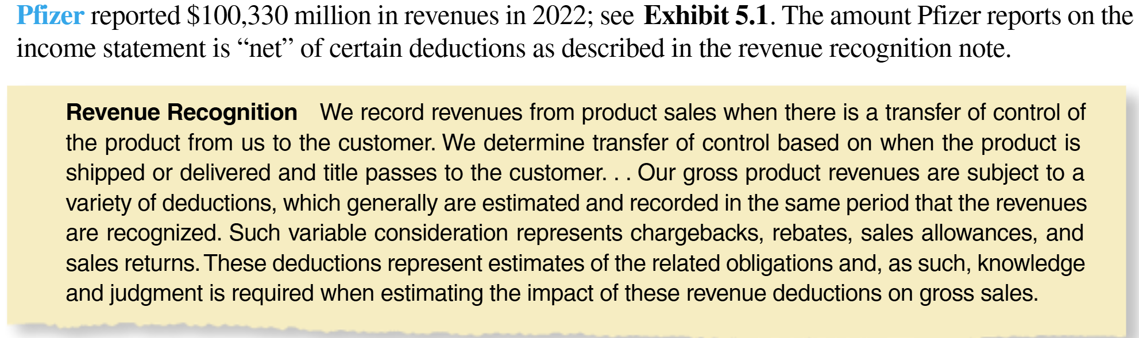

The revenue recognition highlights several important issues:
- Timing of revenue recognition: Determining when revenue should be recognized—at order placement, shipment, payment, or over the term of a long-duration contract.
- Deferred revenue vs. Accrued Revenue: Deciding whether advance payments should be recognized immediately or only when the related goods or services are earned.
- Sales returns: Accounting for situations in which customers return products.
- Warranty services: Recognizing the obligation to provide promised warranty services to customers.
- Uncollectible accounts: Considering that some customers may not pay the amounts they owe.

7.2 The Disconnet between Performance and Payment
- In accrual accounting, cash flow and revenue recognition often occur at different times.
t=1
t=2
Scenario A: Cash First, Work Later
Work Performed
Cash Received
Result: Deferred Revenue (Liability)
- You owe the customer goods/services.
- Revenue is recognized only when earned (at t=2).
- Example: Magazine subscription paid in advance

t=2
t=1
Scenario B: Work First, Cash Later
Work Performed
Cash Received
Cash Received
Result: Accrued Revenue (Asset)
- Customer owes you cash.
- Revenue is recognized when earned (at t=1), not when cash is collected.
- Example: Credit sale to a customer (=accounts receivable)
Summary | Scenario A: Cash First | Scenario B: Work First
B/S Account | Liability (Deferred Revenue) | Asset (Accrued Revenue)
Revenue Recognized | When work is done | When work is done
Cash Received | Before earning | After earning

Concept Quiz 1

1. Magazine World received $60,000 on October 1, 2026, for 12-month subscriptions (October 2026 – September 2027). How much revenue should Magazine World recognize in its 2026 income statement, and what is the Deferred Revenue balance on December 31, 2026?
a) Revenue $60,000; Deferred Revenue $0
b) Revenue $15,000; Deferred Revenue $45,000
c) Revenue $45,000; Deferred Revenue $15,000
d) Revenue $20,000; Deferred Revenue $40,000

2. Legal Services Inc. provided $25,000 of consulting services to clients during December 2026. By December 31, 2026, the company had collected $10,000 in cash and expects to collect the remaining $15,000 in January 2027. How much revenue should Legal Services recognize in 2026, and what is the Accounts Receivable balance on December 31, 2026?
a) Revenue $10,000; Accounts Receivable $0
b) Revenue $10,000; Accounts Receivable $15,000
c) Revenue $25,000; Accounts Receivable $0
d) Revenue $25,000; Accounts Receivable $15,000

Answer:

7.3 Sales Returns
- Customers are often given the right to return merchandise they purchase.
- To avoid overstating revenue and net assets (e.g., accounts receivable) in the year of sales, the seller should reduce revenue for both actual returns of current-period sales and the estimated returns expected to occur in future periods.
Illustration
- During 2026, its first year of operations, the Hawthorne Manufacturing Company sold merchandise for $2,000,000 cash. This merchandise cost Hawthorne $1,200,000 (60% of the selling price). Industry experience indicates that 10% of all sales will be returned, which equals $200,000 ($2,000,000 × 10%) in this case. Customers returned $130,000 of sales during 2026.
Sales Revenue |  |  | Sales Return |  |  | Cost of Goods Sold
(1) | 2,000,000 |  |  |  |  | 1,200,000 | (1)
 |  |  | 130,000 | (2) |  | (2) | 78,000
 |  |  | 70,000 | (3) |  | (3) | 42,000
 | 2,000,000 |  | 200,000 |  |  | 1,080,000
You can focus on “Sales” only in this class.
Income Statement for 2026 (Partial)
Sales Revenue | 2,000,000
Sales Return | (200,000)
Net Sales Revenue | 1,800,000
CGS | 1,080,000
Gross Profit | 720,000

Concept Quiz 2

1. Riverdale Company started operations in 2027 and had cash sales of $500,000. The merchandise cost was $300,000 (60% of selling price). Based on industry experience, the company estimates that 8% of all sales will be returned. Actual customer returns during 2027 were $25,000. What is the Net Sales Revenue that Riverdale should report on its 2027 income statement?
a) $500,000
b) $475,000
c) $460,000
d) $440,000
Answer:

7.4 Revenue Recognition Complications – Case Examples
Revenue is usually recognized when control of a good or service transfers to the customer. While retail sales are straightforward, other cases are more complex:
1. Gift Cards: Revenue recognized when the card is redeemed.
Company A sells a $500 gift card in May 2025. The customer redeems $100 of it in June 2025.
Type of Account | May 2025 | June 2025
Revenue
Liability (Deferred Revenue)

2. Right of Return: Estimate returns and deduction from gross sales.
Company B sells $10,000 of products in July 2025 with an expected return rate of 10%.
Type of Account | July 2025 | Aug 2025 (depends)
Revenue
Liability (Refund Liability)

3. Nonrefundable Up-front Fees: Recognized when future goods/services are delivered, not when paid.
Company C charges a $600 setup fee in January 2025 for a 12-month service contract.
Type of Account | January 2025 | Each Month (Feb25 – Jan26)
Revenue
Liability (Deferred Revenue)

4. Bill-and-Hold: Revenue delayed until goods are shipped to the customer.
Company D bills and received $5,000 in March 2025 for goods to be shipped in June 2025.
Type of Account | March 2025 | June 2025
Revenue
Liability (Deferred Revenue)

5. Consignment Sales: Recognize only commission if acting as an agent.
Company E sells another firm’s product in April 2025 sales price $10,000 and inventory cost $7,000 and earns a $500 commission.
Type of Account | April 2025
Revenue
Liability
6. Multiple-Element Contracts
Company F sells a bundle for $1,000: $700 software (delivered now), $300 support (over 1 year).
Type of Account | At Sale | Monthly (Support)
Revenue
Liability (Deferred Revenue)

7. Variable Consideration
Company G sells $50,000 in goods in August 2025, expecting $5,000 in volume discounts, which will be known for sure by December 2025. In December 2025, the actual volume discounts turn out to be $6,000.
Type of Account | August 2025 | December 2025 | 2025 – Total
Revenue
Liability
(Refund/Discount Estimate)

Review Problems 1 - Revenue Recognition
Indicate how revenue should be recognized for each of the following independent situations.

- A clothing store sells goods to customers who use the store’s proprietary (captive) credit card. The store estimates that 2% of the clothes will be returned.
Answer:

- A customer purchases a copy machine whose purchase price includes an agreement under which the seller will provide monthly service of the machine for two years at no additional cost.
Answer:

- A health club charges an up-front fee to join. Customers are entitled to use the club for one year.
Answer:

- A company lists products of other companies on its website and receives a commission equal to a percentage of the selling price when the goods are sold.
Answer:

- A franchisor sells products for sale to a franchisee and provides accounting services on a monthly basis.
Answer:

Part 2: Valuing and Reporting Account Receivable

7.5 Account Receivables
- Extending credit to customers is a necessary part of doing business.
- Reality of credit sales: Some customers or entities will fail to pay their debts when allowed to purchase on credit.
- Credit sales come with a cost, such as bad debts and returns.
- Reporting objective: Accounts receivable should be reported at net realizable value—the amount the company expects to collect in cash.
  - This is calculated as:
Gross receivables
Less: Estimated uncollectible accounts
Less: Expected customer returns
Net Realizable value

- Example: A company has $100,000 in accounts receivable. It estimates that $5,000 will be uncollectible and expects $3,000 in customer returns.
Accounts Receivable
Gross amount ................................................ $100,000
Less: Allowance for doubtful accounts .......... (5,000)
Less: Estimated returns .................................. (3,000)
Net realizable value .........................................$92,000

Concept Quiz 2

  - What is the primary reporting objective regarding how Accounts Receivable should be presented on the balance sheet?

a) They should be reported at the total gross amount of all invoices sent.
b) They should be reported at the amount the company actually expects to collect in cash.
c) They should be reported at the cost of the goods sold, ignoring the profit margin.
d) They should be reported as cash equivalents immediately upon sale.

  - ABC Company has gross accounts receivable of $250,000. The company estimates that $12,500 will be uncollectible and expects $7,500 in customer returns. What is the net realizable value of accounts receivable?
a) $250,000 b) $237,500 c) $230,000 d) $242,500

7.6 Recognition of Uncollectible Accounts
- When should the firm recognize the loss from uncollectible accounts?
  - In the year it deems the particular accounts to be uncollectible? (direct write-off method)
  - In the year of the sale? (allowance method)

- Direct write-off method
- Write off when receivable is clearly uncollectible
  - Bad debt expense potentially does not match revenue. Make the following entry to write-off specific customers’ accounts:
      - Increase Bad Debt Expense and Decrease Accounts Receivable
  - Opportunity to manipulate earnings
  - The accounts receivable balance does not reflect the amount of cash expected to collect.
  - GAAP do not allow firms to use the direct write-off method for financial reporting.
  - Firms may use the direct write-off method for income tax reporting.

- Allowance method [GAAP]
  - Estimate the amount of uncollectible accounts in connection with the sales of each period.
  - Reduce income and reduce assets accordingly in the year of sales.

- Advantages of allowance method
  - Required by GAAP
  - Matches bad debt expense against sales revenue.
  - Reduces (but does not eliminate!) management's opportunity to manipulate earnings through the timing of write-offs.
  - The balance sheet reports receivables at the expected realizable value.

Illustration
Consider the following scenario:
- A/R beginning balance is $35,000. 2025 sales result in $20,000 in accounts receivable at the end of the year. Company estimates $1,000 will be uncollectible (allowance method). 2024 estimated ending uncollectible amount (or allowance) is $200. In 2026, a customer declares bankruptcy, and $600 is actually known to be uncollectible.
Increase : $800
Accounts Receivable |  |  | Bad Debt Expense |  |  | Allowance for doubtful account
35,000 |  |  |  |  |  |  | 200
 | 15,000
 |  |  | 800 |  |  |  | 800
20,000 |  |  |  |  |  |  | 1,000

Balance Sheet – Beginning (1/1/26) |  |  | Balance Sheet – Ending (12/31/26)
A/R | 35,000 |  | A/R
Allowance for DA | (200) |  | Allowance for DA
Net Realizable A/R | 24,800 |  | Net Realizable A/R

Method | Account | 2025 | 2026
Allowance (GAAP) | Bad Debt Expense
 | A/R (NRV)
Direct write-off (NonGAAP) | Bad Debt Expense
 | A/R

a. $800 (Bad Debt Expense in 2025 under Allowance Method)
The desired ending balance in the Allowance for Doubtful Accounts is $1,000
The existing balance from 2024 is $200
So, the company must record $800 more as bad debt expense in 2025:
$1,000 desired − $200 existing = $800
This ensures the allowance account is correctly adjusted to reflect expected uncollectible from 2025 sales.
a’. $0: When a customer reports in 2026 that $600 will not be paid, it does not impact 2026 expenses because the related bad debt expense was already recognized in 2025 as part of the estimated uncollectibles.
b. $19,000 (A/R NRV in 2025 under Allowance Method)
Gross accounts receivable at end of 2025 = $20,000
Less: Estimated uncollectible accounts = $1,000
Net realizable value = $20,000 − $1,000 = $19,000
This is the amount the company expects to collect, reported on the balance sheet under GAAP.
c. $600 (Bad Debt Expense in 2026 under Direct Write-off Method)
$600 is recognized only when it is actually known as bad debt expense in 2026
c’. Bad debt expense is recognized only when the amount is confirmed to be uncollectible.
d. $20,000 (A/R in 2025 under Direct Write-off Method)
Under the Direct Write-off Method, no allowance is recorded in 2025.
Thus, gross accounts receivable stays at $20,000 and is not adjusted for expected losses.
This overstates assets because it doesn’t reflect expected uncollectibles.
e. $19,400 (A/R in 2026 under Direct Write-off Method)
In 2026, customer default leads to a $600 write-off
$20,000 gross A/R − $600 uncollectible = $19,400

Concept Quiz 2

  - Which of the following best explains why GAAP prohibits the direct write-off method for financial reporting?
a) It violates the cash basis of accounting
b) It overstates expenses in early periods
c) It does not properly match expenses with related revenues
d) It increases taxable income
  - Beta Corp. reported an accounts receivable balance of $800,000 at December 31, 2025. Based on past experience, the company estimates that 2% of the outstanding accounts receivable balance will be uncollectible. The Allowance for Doubtful Accounts had a credit balance of $2,000 on January 1, 2025 (no write-offs occurred during the year). Using the allowance method (percentage of receivables approach), how much bad debt expense should Beta Corp. recognize in 2025, and what is the net realizable value of accounts receivable at December 31, 2025?
a) Bad Debt Expense $16,000; NRV $784,000
b) Bad Debt Expense $14,000; NRV $784,000
c) Bad Debt Expense $16,000; NRV $782,000
d) Bad Debt Expense $14,000; NRV $786,000
e) Bad Debt Expense $18,000; NRV $782,000

Answer:

Part 3: Alternative Methods of Revenue Recognition

7.7 Alternative Timing of Revenue Recognition
- When significant uncertainty exists at the time of delivery about the events remaining to complete the transactions, firms must delay revenue recognition until the uncertainties resolve to the level of reasonable statistical certainty.
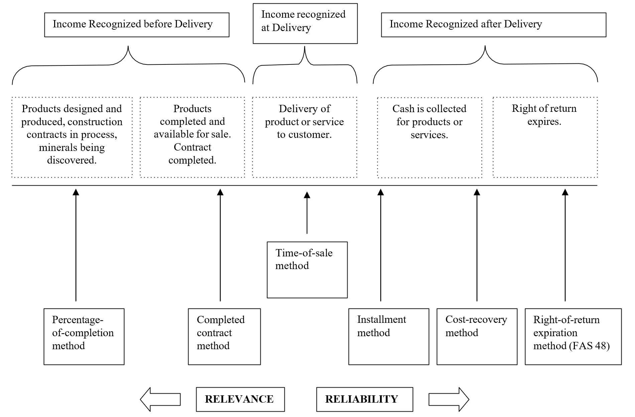

Unifying Principle for Revenue Recognition

A firm can recognize revenue when it has delivered products or services to customers so long as the firm can estimate with reasonable certainty the events remaining to complete the transaction (such as collecting cash, accepting returns, making warranty repairs and replacements).
“Before” Sale
- Long-term projects (planes, ships, buildings)
  - Production covers several accounting periods and firms can reasonably estimate future costs
  - Price set in advance and periodic payments are often made
  - “Percentage of completion” method
    - Revenue and expenses recognized as work performed
  - “Completed contract” method
    - Revenue and expenses recognized when work finished
“After” Sale
- Long-term services or payments (insurance, franchisees)
- Firm must perform substantial services after sale
- Uncertainty over costs of future services or collection of future cash
  - “Installment method”
    - Revenue and expenses recognized as cash collected, with expense recognition based on proportion of cash collected
  - “Cost recovery first method”
    - Revenues and expenses recognized as cash collected, but in equal amounts until all costs are covered
- Illustration: Installment method versus point-of-sale method
Assume that the dealer sold a car for $15,000 that had a cost basis to the dealer of $12,000. Under the terms of the purchase agreement, the customer made an initial down payment of $1,500 (10 percent of the purchase price) and signed a promissory note receivable requiring nine additional monthly payments of $1,500.

      - Installment Method used when the receipt of the entire $15,000 is in doubt because of the customer’s poor credit history, the dealer appropriately only recognizes revenues and costs to the extent of the cash received.

Installment method | Now | Month 1 | Month 2 | Month 3-8 | Month 9 | Total
Revenue . . . . . . . . . . | $1,500 | $1,500 | $1,500 | $1,500 | $1,500 | $15,000
COGS. . . . . . . . . . . . | (1,200) | (1,200) | (1,200) | (1,200) | (1,200) | (12,000)
Gross profit . . . . . . . . | $ 300 | $ 300 | $ 300 | $ 300 | $ 300 | $ 3,000

      - Point of Sale Method

Point-of-sale method | Now
Revenue . . . . . . . . . . . . . | $15,000
COGS. . . . . . . . . . . . . . . | (12,000)
Gross profit . . . . . . . . . . . | $ 3,000

Concept Quiz 3

1. Galaxy Motors sold a vehicle for $20,000 with a cost of $14,000. The customer made a down payment of $4,000 and signed a note for four additional monthly payments of $4,000 each. Due to uncertainty about collection, Galaxy Motors uses the installment method. What is the gross profit recognized in Month 1 (first payment after down payment)?
a) $6,000 b) $4,000 c) $2,800 d) $1,200

2. What is the gross profit recognized at the time of sale (Month 0)?
a) $6,000 b) $4,000 c) $2,800 d) $1,200
Answer:

7.8 Discussion Questions
Q5.4 Revenue Recognition, the Matching Principle, and the Bad Debt Expense.
Urcarco, Inc., was a publicly held used-car dealer that had defined its market niche as customers with a low or no credit rating. In some years, Urcarco’s repossession rate had run as high as 40 percent of all vehicles sold. Discuss how Urcarco should recognize revenue from vehicle sales and how it should estimate its bad debt expense.

Suggested Solutions:

Q5.5 Revenue Recognition in the Air Transportation Industry.
Airline Ticket Revenue Recognition at Delta Air Lines
Delta Air Lines is the largest airline in the world when measured by almost any metric: total revenue, fleet size, passenger miles flown, and number of passengers. The company is based in Atlanta, Georgia, the location of its primary hub, and it has helped make Atlanta’s Hartsfield-Jackson International Airport the busiest in the world.
The sale of an airline ticket may seem straightforward from the consumer-perspective: buy a ticket, sometimes months in advance, then take the flight. But from Delta’s perspective the sale involves other factors to consider regarding how much and when to record revenue. According to the company’s foot- notes to its financial statements, when tickets are sold a portion is initially recorded as a component of “air traffic liability,” a current liability on the balance sheet (equivalent to unearned revenue); and, if the passenger has a frequent flyer account, a portion is allocated to “Loyalty program deferred revenue.” Delta’s 2023 annual 10-K report filing with the U.S. Securities and Exchange Commission reports the amount of recognized revenue and deferred revenue for 2023 and 2022 was as follows:
(in millions) | December 31
 | 2023 | 2022
Income Statement
Revenues . . . . . . . . . . . . . . . . . . . . . . . . . . . . . . . . . . . . . . . . . . . . . . . . . . . . . . . . . . . . . | $58,048 | $50,582
Balance Sheet (liabilities)
Air traffic liability . . . . . . . . . . . . . . . . . . . . . . . . . . . . . . . . . . . . . . . . . . . . . . . . . . . . . . . . | $7,044 | $ 8,160
Loyalty program deferred revenue—current . . . . . . . . . . . . . . . . . . . . . . . . . . . . . . . . . . . | 3,908 | 3,434
Loyalty program deferred revenue—noncurrent . . . . . . . . . . . . . . . . . . . . . . . . . . . . . . . . | 4,512 | 4,448
These deferred revenue liability accounts are quite significant to Delta, ranging from 26.6 percent to 31.7 percent of total revenues for each year.
What do you think the Air traffic liability and Loyalty program deferred revenue is?
When should Delta recognize revenue?

Suggested Solutions:

Q5.9 Revenue Recognition by Software Companies.
An article in the October 10, 2019, issue of Forbes discussed revenue recognition under the standard ASU 2014-09. Some companies had little impact from the standard (e.g., US Steel). On the other hand, companies in certain industries were greatly impacted (e.g., software firms). The issue with software firms is that the initial sale includes the software along with agreements for items like technical support and upgrades (when to recognize the latter revenues is the issue). The new rules often result in these revenues being recognized up front instead of being deferred. The article provides the example of Verint Systems and its 2018 financial statements. As a result of the adoption of ASU 2014-09, in 2018 Verint’s income grew by $48 million, which was 50 percent of the growth in revenue in that year. Why might it make sense to recognize the revenues from upgrades and technical support later? Will the bump in Verint’s revenues be permanent or transitory? Should they affect Verint’s share price?

Suggested Solutions:

Revenue Allocation Example – Oracle (Extra Problem)
Revenue for obligations fulfilled over time is recognized progressively.
To illustrate how revenue is recognized when multiple products and/or services are sold for one purchase price, assume that Oracle sells business software to a customer for $100,000 in 2025. Oracle agrees to provide product support and on-site user training for two years. Assume that Oracle values the stand-alone products as follows:

Product or Service | Stand-Alone Fair Value | Allocation Percentage | Revenue Recognized
Software | $105,000 | 84% ($105,000/$125,000) | $84,000 ($100,000 × 84%)
Product support | $20,000 | 16% ($20,000/$125,000) | $16,000 ($100,000 × 16%)
Totals | $125,000 |  | $100,000
Oracle allocates revenue based on the relative fair value of each product or service. It recognizes $84,000 for software upon installation and spreads the $16,000 support revenue evenly over two years. The unearned portion is recorded as deferred revenue, starting at $16,000, decreasing to $8,000 after one year, and reaching $0 by the end of the second year.
Type of Account | 2025 | 2026
Revenue
Liability (Deferred Revenue)

---------------------------------------------- The End of Chapter 6 ----------------------------------------------

More formally to recognize revenue, companies follow these five steps (US GAAP and IFRS): - Identify the contract with the customer, including terms and payment. - Identify the performance obligations—each good or service promised. - Determine the transaction price, including estimates if variable. - Allocate the price to each obligation based on fair value. - Recognize revenue when the obligation is satisfied—typically when control transfers to the customer.

