8. Reporting and Analyzing Inventory (Ch 7)

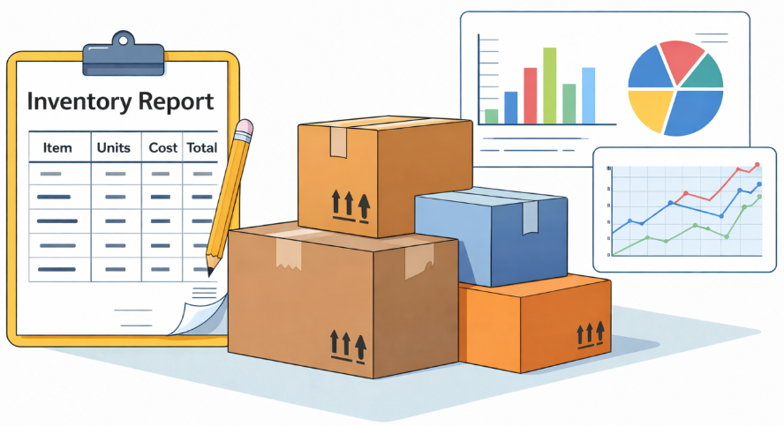

Table of Contents
8.1 Inventroy Classification – Merchandising vs. Manufacuring Companies 2
8.2 Recording Inventory Transactions 3
8.3 Recording Inventory Transactions – Product vs. Period Costs 5
8.4 Recording Inventory Transactions – Periodic vs. Perpetual System 7
8.5 Determining Ownership of Inventory 9
8.6 Different Costing Methods in Determining COGS and Ending Inventory 10
8.7 What Effect Will My Cost Flow Assumptions Have on My Financial Statements? 14
8.8 Lower of Cost or Net Realizable Value (LCNRV) 15
8.9 How Do I Know if I Have Too Much Inventory or Not Enough? 17

8.1 Inventroy Classification – Merchandising vs. Manufacuring Companies
Inventories are:
- Asset items held for sale in the ordinary course of business, or
- Goods to be used in production of goods to be sold.

Service companies sell services and has
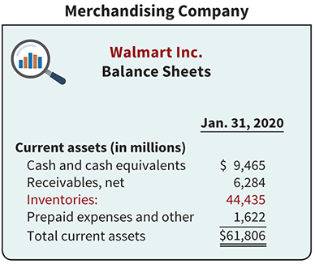
- No invetroy

Merchandising companies have
  - Merchandise Inventory
    - It is in a form ready for sale to customers.

Manufacturing companies have
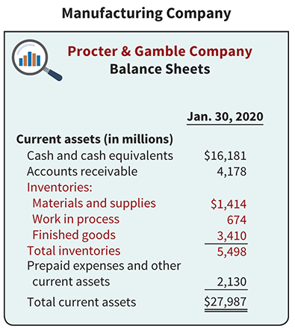
  - Raw Materials
    - Consist of the basic parts that will be used in production but have not yet been placed into production.
  - Work in Process
    - The portion of inventory that has been placed into the production process but is not yet complete.
  - Finished Goods
    - Items that are completed and ready for sale.

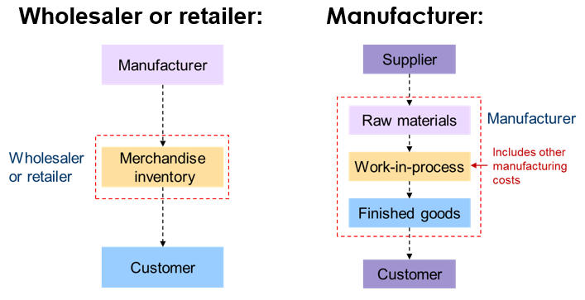

8.2 Recording Inventory Transactions

How to record purchase of inventory
- Purchases should be recorded when you receive the goods from the seller. Under the perpetual system when goods are recevied, you increase (debit) “Inventory” at cost, and increase (credit) Accounts Payable (or decrease cash).

Increase Inventory (Dr.) | $500
Increase A/P (or decrease Cash, Cr.) |  | $500

How to record sale of inventory (perptual Inventory system)
  - Under the perpetual system, when inventory is sold, two journal entries are required.
  - First, let’s assume you sold goods to a customer – Bryan Black– for $1,000; Mr. Black didn’t pay right away and the payment terms are 2/10; net 30.

Date | Account Titles | Debit | Credit
July 10

  - Second, since you no longer have the inventory — you just sold it and the customer now has it — you need to decrease your inventory account and increase an account called “Cost of Goods Sold (expense).” Let’s assume you originally paid $600 for the inventory:
Date | Account Titles | Debit | Credit
July 10
- Common mistakes - DON’T DO THE FOLLOWING.
Date | Account Titles | Debit | Credit
July 10

Review Problems 1
On July 1, you sold inventory to a customer, on account, for $3,000; credit terms were 2/10, n/30. The inventory cost you $2,000. On July 6, the customer returned $200 of the inventory to you; your cost of the inventory returned by the customer was $130. Using the perpetual inventory system, prepare the appropriate journal entries for July 1 and July 6.
Date | Account Titles | Debit | Credit
July 1
July 1
July 6
July 6

8.3 Recording Inventory Transactions – Product vs. Period Costs

What should be included in the cost of inventory (Product vs. Period Costs)?
  - Following costs should be included as part of the inventory cost:
    - All costs incurred to acquire goods and prepare them for sale
    - All costs incurred to manufacture and prepare them for sale
      - Materials, Labor, Manufacturing Overhead
      - Full Absorption Costing (i.e., fixed overhead included) under the US GAAP
llustration 1: On December 20, 2027, Office Depot purchased 10 HP printers from its supplier at a cost of $50 each, totaling $500. The company also paid $100 for shipping (freight-in) and $50 for insurance related to the delivery. Office Depot, as the buyer, is responsible for these additional costs. What is the total inventory cost to be recorded or any expenses?
Purchase cost | $500
Shipping (Freight-in) | $100
Insurance | $50
Total Inventory cost | $650

Increase Inventory (Dr.) | $650
Increase A/P (or decrease Cash, Cr.) |  | $650
Illustration 2: On December 25, 2027, Office Depot sold one HP printer for $100. The company also paid $10 for shipping to deliver the product to the customer. What is the net profit from this sale?
Sales Price | $100
Cost of Goods Sold | $65ª
Shipping (Freight-out) | $10
Gross Profit | $25
ª$650 for 10 units⇒$650÷10=$65 per unit)
Product Costs
- Costs directly connected with bringing the goods to the buyer’s place of business and converting such goods to a salable condition.
- Included in the inventory asset account in the balance sheet
- Freight charges on goods purchased , Unpacking and unloading costs, Insurance costs incurred by buyer while goods are in transit

Period Costs
- Indirectly related to the acquisition of goods and are generally more difficult to assign to specific inventory
- items Expensed as incurred in the income statement
- Ex. Selling expenses related to inventory, interest costs to finance inventory purchases

Review Problems 2
1. On 12/20/20x7, Office Depot purchased $500 worth of HP printers from its supplier (10 units x $50/unit) and paid $100 for the shipping (i.e., the buyer pays for the shipping). Prepare a journal entry for the transaction.

2. On 12/23./20x7, Office Deport sold 5 units of HP printers for $80 per unit and collected $400 cash. Office Depot delivered printers and incurred delivery expense of $50. Prepare a journal entry for the transaction.

8.4 Recording Inventory Transactions – Periodic vs. Perpetual System

Basic Inventory Equation
Beginning Inventory (BI) + Net Purchases = Cost of Goods Sold + Ending Inventory (EI)
Unknown
Known

  - The following examle shows that the company starts with $4,800 invenotry at start of the period, and purchase $10,000 inventory during the period.
  - Merchandising companies use one of two systems to account for inventory (ending inventory) and calculate the cost of goods sold: a perpetual system or a periodic system.

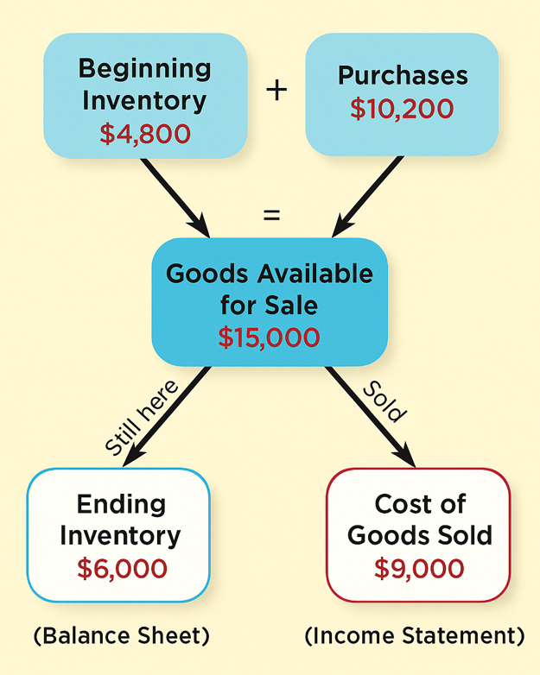
Unknown
Known
???
???

Perpetual Inventory System – We will focus on this method only.
- Record Cost of Goods Sold (COGS) and inventory at the point of sale; therefore, COGS is known throughout the period as it’s recorded with each transaction.
- Derive ending inventory from the inventory equation (or in real time).
- Requires a continuous update of inventory records.
- At the end of each year, company employees make a count of physical inventory to verify the accuracy of the inventory records (not required step, though).
- Below is an illustration of how ending inventory is computed as a residual value.

Beginning Inventory + | Net Purchases | - COGS = | Ending Inventory
(Known) | (Known) | (Recorded) | (Derived)
$4,800 | $10,200 |  | $6,000

Periodic Inventory System
  - Purchases of inventory are recorded, but decreases in inventory due to sales are not tracked as they happen.
  - As a result, the cost of goods sold and the ending inventory balance are unknown until a physical inventory count is completed.
- In other words, periodic systems require a physical inventory count at the end of the period to determine (1) the cost of inventory on hand (“ending inventory”) (2) COGS can only be known after the inventory count is completed.
- Below is an illustration of how COGS is computed as a residual value.

Beginning Inventory + | Net Purchases | - Ending Inventory | = COGS
(Known) | (Known) | (Through Counting) | (Derived)
$4,800 | $10,200 |  | $9,000

Summary – Periodic and Perpetual Inventory System

Aspect | Periodic System | Perpetual System
What's counted/known first? | Ending Inventory | COGS/Ending Inventory
What's derived? | COGS
When is COGS known? | After period-end count | Throughout the period
Record keeping | Updated periodically | Updated continuously
Interim reporting | Requires COGS estimates | COGS readily available

  - We will skip the detailed accounting procedures for the periodic inventory system. However, be sure you understand clearly the difference between perpetual and periodic systems.

8.5 Determining Ownership of Inventory
  - To determine ownership of goods, two questions must be answered:
(1) Do all of the goods included in the physical count belong to the company?
(2) Does the company own any goods that were not included in the count?
  - To arrive at an accurate count, ownership of goods in transit (on board a truck, train, ship, or plane) must be determined.
    - Goods in transit can include either:
      - Goods you’ve ordered (purchased) but have not yet received, or
      - Goods you’ve sold but have not yet delivered to the customer.
  - Goods in transit belong in the inventory of the company that holding legal title.
  - Legal title is determined by the freigh terms of the shipment.
  - Freight Terms
    - FOB Shipping Point – When the terms are FOB (free on board) shipping point, the buyer owns the goods while they are in transit.
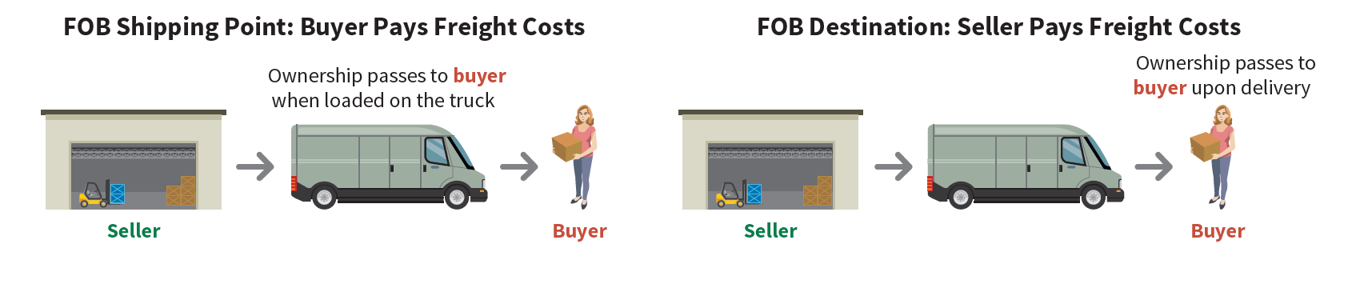
    - FOB Destination – When the terms are FOB destination, the seller owns the goods while they are in transit.
  - Consigned Goods – Goods held for sale by one party although ownership of the goods is retained by another party.

Concept Quiz 1
1. The annual report of Kellogg Company states, “The company recognizes sales upon delivery of its product to customers.” What does this policy imply about goods in transit shipped by Kellogg?
The terms of sales are FOB destination

2. When is a physical inventory usually taken?
- When goods are not being sold or received
- For Perpetual Inventory system, never.
- For Periodic Inventory system, at the beginning of the fiscal year
- At the end of the company’s fiscal year

3. Cecil gives goods on consignment to Jerry who agrees to try to sell them for a 25% commission. At the end of the accounting period, which of the following parties includes in its inventory the consigned goods?
a) Jerry b) Both Cecil and Jerry c) Neither Cecil nor Jerry d) Cecil

8.6 Different Costing Methods in Determining COGS and Ending Inventory

Illustration - Cost Flow Assumption
  - Company AAA purchased three additional units of a gadget at different times and prices during the year, and later sold three units at $20 each.
 |  | Units | Unit Cost
Jan. 1 | Beg Inventory | 1 | $10
Apr. 15 | Purchase | 1 | $11
Aug. 24 | Purchase | 1 | $12
Nov. 27 | Purchase | 1 | $13
Units Sold: 3 for $20 each unit
- Compute Sales Revenue, Cost of Goods Sold and Gross Profit.
Sales Revenue:
COGS :
Gross Profit: $
- Compute the Ending Inventory (i.e., the inventory value to be reported on B/S).

Ending Inventory:

 | FIFO | Average Cost | LIFO
Sales
COGS
Gross Profit
Ending Inventory

- As a manager, you have some discretion in choosing which cost flow assumption to apply. Depending on your choice (e.g., FIFO, LIFO, or other permitted methods), your COGS and, consequently, your Net Income will differ.

- The United States is the only advanced economy that permits the LIFO method—primarily due to its tax-saving advantages (to be discussed later).

Cost Flow Assumptions
  - Determining ending inventory can be complicated if the units on hand for a specific item of inventory have been purchased at different times and at different prices. We must make a cost flow assumption about which inventory items were sold in order to allocate the costs to COGS and EI: FIFO, LIFO, Weighted Average.
  - There are four ways (“cost flow assumptions”) of determining the cost of ending inventory:
(1) Specific Identification method – identifies the cost of each particular unit sold and those still remaining in ending inventory.
(2) First-in, First-out (FIFO) method – assumes that the earliest goods purchased (first in) are the first goods sold (first out). Under FIFO, ending inventory consists of the most recent purchases.
    - For example, suppose you open a bicycle store in Charlotte on November 1. Your beginning inventory is zero, but during the months of November and December, you make the following purchases of bicycles:

Purchases: | Quantity | Unit Cost | Total Cost
11/2 | 5 | $100 | $500
12/8 | 4 | $125 | $500
12/20 | 6 | $130 | $780
Goods Available for Sale | 15 |  | $1,780

During November and December, you sold 7 bicycles. EI = 8 bikes
Calculate the following:
- The cost of goods sold and (b) The cost of ending inventory

Note: FIFO gives the same results regardless of whether a periodic or perpetual inventory system is used. The same is not true for LIFO, which is discussed next.
(3) Last-in, First-Out (LIFO) method – assumes that the last goods purchased (last in) are the first goods sold (first out). Under LIFO, ending inventory consists of the first goods purchased.
    - The cost of goods sold
    - The cost of ending inventory

(4) Average Cost method – assumes that all the goods available for sale are similar in nature. The average cost of goods available for sale is computed and is used to determine the cost of goods sold and the cost of ending inventory.
Using the data provided previously related to your bicycle shop to calculate the following under the average cost method in a periodic system:
The average cost of bike = Goods available for sale ($1780) / # of bikes available for sale (15) = $118.67 / bike
The cost of goods sold 7 x $118.67 = 831
The cost of ending inventory 8 x $118.67 = 949

Review Problems 3
- Goods Cost of goods purchased is $540,000, ending inventory is $20,000, and cost of goods sold is $560,000. How much is beginning inventory?
  - $20,000
  - $0
  - $20,000
  - $40,000

- Inventory costing methods place primary reliance on assumptions about the flow of
- goods.
- resale prices.
- values.
- costs.

- In a period of rising prices which inventory method will result in the greatest amount of income tax expense?
- LIFO
- Specific identification
- Average cost

Review Problems 4
Do this problems after “Section 7.6 – What effect my cost flow assuptiosn have on my financial statements”

1. In a period of inflation, the cost flow method that results in the lowest income taxes is:
  - FIFO method.
  - LIFO method.
  - average cost method.

2. The cost flow method that often parallels the actual physical flow of merchandise is the:
- FIFO method.
- LIFO method.
- average cost method.
3. In a period of inflation, the cost flow method resulting in the highest ending inventory is:
- FIFO method.
- LIFO method.
- average cost method.

8.7 What Effect Will My Cost Flow Assumptions Have on My Financial Statements?

  - In period of rising prices, FIFO reports:
 |  | FIFO | Average | LIFO
 | Sales | $20,000 | $20,000 | $20,000
Lowest | Cost of Goods Sold | 7,500 | 8,307 | 9,050
 | Gross Profit | 12,500 | 11,693 | 10,950
 | Admin & Selling Expenses | 7,700 | 7,700 | 7,700
 | Income before Taxes | 4,800 | 3,993 | 3,250
 | Income Tax Expense | 960 | 800 | 650
Highest | Net Income | $3,840 | $3,193 | $2,600
 | Inventory Balance at Year-End | $10,300 | $9,493 | $8,750

  - In periods of increasing prices, FIFO reports the highest income, LIFO the lowest net income, and average cost falls in the middle

  - In periods of decreasing prices, the opposite is true. FIFO will report the lowest net income, LIFO the highest, with average cost in the middle.

  - Once a company has chosen which inventory method to use, the company should use that method consistently from year to year. Although consistency is preferred, a company may change its inventory costing method (any change must be disclosed in the notes to the financial statements).
    - Note: In a period of rising prices, LIFO results in the lowest income taxes. U.S. tax rules require that a company using LIFO for tax purposes must also use LIFO for financial reporting purposes.
    - Note: In a period of rising prices, LIFO also resuls in the lowest reported inventory amount at year-end. Accounting standards require firms using LIFO to report the amount by which inventory would be increased (or on occasion decreased) if the firm had instead been using FIFO. This amount is referred to as the LIFO reserve. Reporting the LIFO reserve enables analysts to make adjustments to compare companies that use different inventory methods.

8.8 Lower of Cost or Net Realizable Value (LCNRV)
  - Illustration: MTP Inc. has been selling typewriters and fax machine to local vendors past 50 years. However, due to recent technological advancement, they begin to notice typewriters and fax machines becoming more obsolete every year. The total inventory cost of their product was recorded at $300,000 at year end 12/31/1998. However, they know the actual value of such old office machine is only worth $100,000 in the current market.
Inventory
$300,000
??
Question 1: What should you do as an accountant of MTP, Inc. In other words, on MTP’s 1998 balance sheet, how much inventory should you report? And Why?

Loss increases (Dr.) | $200,000
Inventory decreases (Cr.) |  | $200,0000
Inventory
$300,000
$200,000
$100,000

Question 2: For some unknown reason, there was a huge demand for typewriters, and you cannot keep up with the demand. Consequently, it is worth a lot more than $300,000 (like $400,000). Now what do you do?

Lower of Cost or Net Realizable Value (LCNRV)
- To ensure that inventory is not overstated on the balance sheet, companies must report inventory at the loswer amoutn between:
    - Cost — what the company originally paid to purchase or produce the inventory, and
    - Net Realizable Value (NRV) — the amount the company expects to receive from selling the inventory, minus any costs to complete, sell, or transport it.
  - This is one example of the conservatism principle in accounting.

Lower Cost or NRV – Illustration
- Assume that Starbucks Corporation has unfinished inventory with a cost of $950, a sales value of $1,000, estimated cost of completion of $50, and estimated selling costs of $200. Starbucks net realizable value is computed as follows.

Inventory value-(Estimated Selling Price) |  | $1,000
Less: Estimated cost of completion | $50
Estimated selling costs | $200 | $250
Net realizable value |  | $750

- Inventory cost is $950 and Net Realizable Value is $750. The lower of the two is $750.
- Therefore, Starbucks reports inventory at $750.
- In its income statement, Starbucks reports a Loss Due to Decline of Inventory to NRV of $200 ($950 − $750).
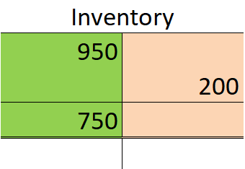
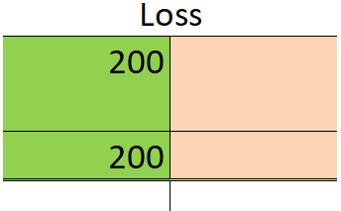

Concept Quiz 2
1. If NRV rises after an inventory write-down, how does IFRS differ from U.S. GAAP?
a. IFRS also prohibits reversals
b. IFRS allows reversals up to the original cost
c. IFRS allows unlimited upward revaluations
d. IFRS requires immediate recognition of any gain above cost
Answer : b.
IFRS permits writing inventory back up but only to original cost, not higher.

8.9 How Do I Know if I Have Too Much Inventory or Not Enough?
  - Managing inventory levels so that neither too much nor too little is on hand is critical to a company’s success, but it can be complex.
  - The Inventory Turnover Ratio can help in managing inventory levels:
    - Inventory Turnover Ratio = [Cost of Goods Sold / Average Inventory]
    - “Average Inventory” is computed by adding together the beginning and ending inventories of the year and dividing the sum by 2.
    - Example:
Cost of Goods Sold during the year $80,000
Beginning Inventory, Jan. 1 $14,000
Enging Inventory, Dec. 31 $18,000
Average Inventory is $16,000

Inventory Turnover Ratio

This means that the company sells its entire inventory about five times years year.

  - Days in Inventory can also help in managing inventory levels:
    - Days in Inventory = 365 / Inventory Turnover Ratio
    - Example:
If your Inventory Turnover Ratio is 5, then
Days in Inventory =

This means that it takes the company about 73 days to sell its inventory. It can also be interpreted as the average age of the inventory.

  - A high Inventory Turnover Ratio (i.e. low Days in Inventory) may indicate the company has minimal inventory on hand at any one time. Although minimzing inventory levels is efficient, it may lead to list sales due to inventory shortages.

  - On the other hand, a low Inventory Turnover Ratio (high Days in Inventory) may indicate the company is incurring unnecessary, avoidable costs associated with having too much inventory, such as storage and insurance costs, or losses from damage or obsolescence.

Review Problems 5
1. What accounting concept is employed when using the lower-of-cost-or net realizable value?
- Revenue recognition
- Conservatism
- Expense recognition
- Full disclosure

2. The following information came from the income statement of the Wilkens Company at December 31, 2014: sales revenue $1,800,000; beginning inventory $160,000; ending inventory $240,000; and gross profit $600,000. What is Wilkens' inventory turnover ratio for 2014?

- 6.0 times
- 2.5 times
- 3.75 times
- 3.0 times

Extra Problems for Discussion

Assume Oahu Kiki’s uses a periodic inventory system, which shows the following for the month of January. Sales totaled 240 units.
 | Date | Units | Unit Cost | Total Cost
Beginning Inventory | Jan. 1 | 120 | $8 | $960
Purchase | Jan. 15 | 380 | $9 | $3,420
Purchase | Jan. 24 | 200 | $11 | $2,200
Required:
- Calculate the number and cost of goods available for sale.
- Calculate the number of units in ending inventory.
- Calculate the cost of ending inventory and cost of goods sold using the
- FIFO, (b) LIFO, and (c) weighed average cost methods.

Solutions:

---------------------------------------------- End of Chapter 7 Notes --------------------------------------------
Prepared by Professor Philip K. Hong

