Chapter 3 — Adjusting Accounts
Adjusting Accounts for Financial Statements · Homework Week #2 · Student Copy
Name __________________________________ Date ____________________
Part 1 · Discussion Questions

Q3-4
What is the nature and purpose of a general journal?

Answer

Q3-5
Explain the process of posting.

Answer

Q3-6
What is an adjusting journal entry?

Answer

Q3-10
On January 1, Prepaid Insurance was debited with the cost of a two-year premium, $2,448. What adjusting entry should be made on January 31 before financial statements are prepared for the month?

Answer

Q3-11
What is a contra account? What contra account is used in reporting the book value of a depreciable asset?

Answer

Q3-13
The publisher of International View, a monthly magazine, received two-year digital subscriptions totaling $12,600 on January 1.
(a) What entry should be made to record the receipt of the $12,600?
(b) What entry should be made at the end of January before financial statements are prepared for the month?

Answer

Part 2 · Problems

M3-23 / M3-24 (a). Journal Entries — Minute Maid, April
M3-23 / M3-24 · Minute Maid
Minute Maid, a firm providing housecleaning services, began business on April 1. The following transactions occurred during the month of April.
April 1 A. Falcon invested $13,500 cash to begin the business in exchange for common stock.
April 2 Paid $4,200 cash for six months’ lease on a van for the business.
April 3 Borrowed $15,000 cash from the bank and signed a note payable agreeing to repay it in one year plus 10% interest.
April 3 Purchased $8,200 of cleaning equipment; paid $3,800 cash with the remainder due within 30 days.
April 4 Paid $6,400 cash for cleaning supplies.
April 7 Paid $500 cash for advertisements to run in the newspaper during April.
April 21 Billed customers $5,500 for services performed.
April 23 Paid $4,400 cash on account to cleaning equipment suppliers (see April 3).
April 28 Collected $4,000 cash from customers on their accounts.
April 29 Paid $1,500 cash for dividends.
April 30 Paid $2,600 cash for April wages.
April 30 Paid $1,480 cash to service station for gasoline used during April.

Required
M3-23. Record the above transactions for April using the financial statement effects template (or journal entries).
M3-24 (a). Record the transactions in journal entry form using these accounts: Cash; Accounts Receivable; Supplies; Prepaid Van Lease; Equipment; Accounts Payable; Notes Payable; Common Stock; Retained Earnings; Cleaning Fees Earned; Van Fuel Expense; Advertising Expense; Wages Expense.
M3-24 (b). Set up T-accounts for each ledger account and post the entries, keying each amount by date.

Answer

M3-24 (b). T-Account Ending Balances
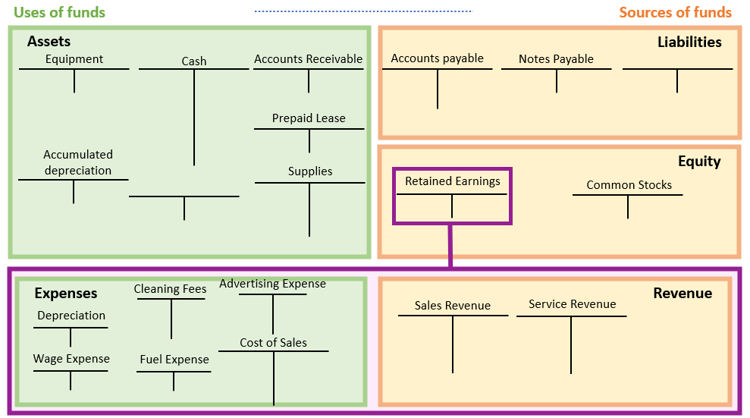
Reference framework — Uses of funds (green) and Sources of funds (orange)

