'Glass hold' reveals personality
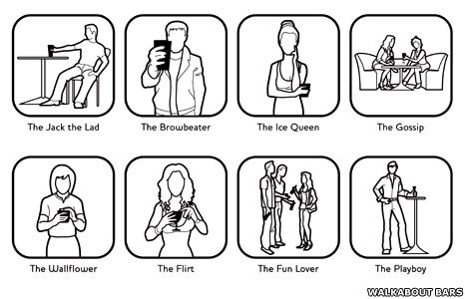
Which type are you?

The way you hold your glass can reveal much more than you might realise, a psychologist has warned.
Dr Glenn Wilson, a consultant psychologist, observed the body language of 500 drinkers and divided them into eight personality types.
These were the flirt, the gossip, fun lover, wallflower, the ice-queen, the playboy, Jack-the-lad and browbeater.
Dr Wilson, who carried out the work for the Walkabout bar chain, said glass hold "reflected the person you are".
The types of drinker are:
THE FLIRT
This is usually a woman, who holds her glass with dainty, splayed fingers and uses it in a provocative way.
She may position it over her cleavage so as to draw attention to her attributes or peer over the rim to make eye contact when taking a sip - and she may "tease" the rim of the glass with her finger, perhaps dipping it into the drink and sucking it dry.
THE GOSSIP
Again, usually a woman who clusters together with her friends. She may be talking about other people, and can be critical. She holds a wine glass by the bowl and uses it to gesticulate and make points in conversation.
She is inclined to lean over her drink, in towards others so as to speak confidentially. This person already has a close-knit social group with little inclination to extend it, therefore advances from outsiders are not usually welcome.
THE FUN-LOVER
This type of drinker could be a man or a woman. They tend to be sociable and convivial and "like a laugh".
They take short swigs from bottled drinks so they don't miss out on chipping in with the conversation.
The bottle is held loosely at its shoulder for ease. This type of person is always happy to extend their social circle. The best way to approach them therefore is to leap directly into light, good-humoured conversation and make them laugh.
THE WALLFLOWER
Usually a shy, submissive person who holds the glass protectively, not letting go, as though afraid somebody will take it away.
Palms are kept hidden and the glass is used as a social crutch - the drink is never quite finished, with a mouthful left in case of emergency. The drink is small - maybe half a pint of lager for a man.
When you're in a crowded bar, often all you have to go on is body language
Dr Glenn Wilson
It may be drunk through a straw, which is fidgeted with, and used to stir the drink between sips.
The style and pace of drinking is an echo of those around them - very little is initiated.
This individual needs to be approached in a gentle, sensitive way, with perhaps a few understated compliments to build self-confidence, but may eventually warm to overtures.
THE ICE-QUEEN
This is a mainly female type whose natural style is cold and defensive.
She drinks from a wine glass, or a short glass, which is held firmly in a barrier position across the body so as to deter intimate approaches.
It is usually a waste of time approaching this woman; she may be ready with a castrating put-down.
THE PLAYBOY
This man is active and self-confident; a "Don Juan"-type seducer.
He uses his, usually long, glass or bottle as a phallic prop, playing with it suggestively. He is inclined to be possessive, and can be tactile with his female companions.
THE JACK-THE-LAD
This "peacock" is conscious of his image and will drink a bottled beer, or cider.
He is inclined to be confident and arrogant, and can be territorial in his gestures, spreading himself over as much space as possible, for example, pushing the glass well away from himself and leaning back in his chair.
If he is drinking with friends, he would be unlikely to welcome approaches from outside the group, unless sycophantic and ego-enhancing.
THE BROWBEATER
Again usually male, he prefers large glasses, or bottles, which he uses as symbolic weapons, firmly grasped, and gesticulating in a threatening, "in the face" kind of way.
Something of a know-it-all, he can come across as slightly hostile, even if only through verbal argument, or jokes targeted at others. He should be approached with great care, or not at all.
'An unconscious thing'
Dr. Wilson said: "The simple act of holding a drink displays a lot more about us than we realise - or might want to divulge.
"When you're in a crowded bar, often all you have to go on is body language.
"To a large extent, it's an unconscious thing and just reflects the person you are and the type of social relationships you have."
But he warned: "The next time you're in a bar, it might be worth thinking about what you're saying to the people around you, just by the way you're holding your glass."

