Project 2
Keely Grice
November 17, 2025
Table of Contents
Function 1
Plot 1
CO and O3 Concentration by Month 1
PM2.5 Concentration by Month 2

Function

Plot

CO and O3 Concentration by Month
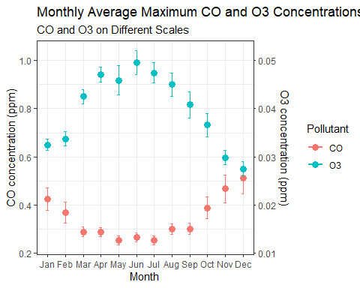

PM2.5 Concentration by Month
