TABLE OF CONTENTS
1. Introduction
2. Objectives
3. Application Design and Architecture
4. Interface Components
5. Event Handling and Application Logic
6. Complete Source Code
7. Compilation and Execution
8. Conclusion

1. Introduction
This document presents the design, implementation, and operation of a Java Swing desktop application. Swing is part of the Java Foundation Classes and provides platform-independent graphical user interface (GUI) components. The application demonstrates the use of a JFrame, labels, buttons, layout managers, event listeners, and dynamic interface updates.
The main window is fixed at 800 × 800 pixels, cannot be resized, opens in the centre of the screen, and uses the Tahoma typeface for a consistent appearance. GridBagLayout is used to position the main content, while a vertical Box layout groups the controls in a simple top-to-bottom arrangement.

2. Objectives
- Create a desktop GUI using Java Swing and AWT.
- Configure a fixed-size 800 × 800 JFrame and centre it on the screen.
- Use Tahoma typography and organized layout managers.
- Display a label containing HTML-formatted text.
- Allow the user to toggle the displayed message.
- Allow the user to cycle through a predefined set of background colours.
- Demonstrate event-driven programming through ActionListener callbacks.

3. Application Design and Architecture

3.1 Main Window Configuration
The JFrame acts as the top-level container. Its content pane holds a central panel managed by GridBagLayout. A vertical Box groups the label and buttons. The window uses EXIT_ON_CLOSE so that closing the frame terminates the application.

3.2 Architecture Diagram
+------------------------------------------------------+
| JFrame (800 x 800) |
| Title: Java Swing |
| |
| Main JPanel |
| GridBagLayout |
| |
| +---------------------+ |
| | Vertical Box | |
| | | |
| | HTML Message JLabel | |
| | [Toggle Message] | |
| | [Change Background] | |
| +---------------------+ |
| |
+------------------------------------------------------+

ActionListener events update the label text or panel background.

3.3 Layout Strategy
GridBagLayout provides flexible positioning within the main panel. A vertical Box is used to stack the message label and interactive buttons in a predictable order. This combination keeps the interface readable and makes the controls easy to locate.

4. Interface Components
The following table summarizes the principal components and their responsibilities.
Component | Purpose | Key configuration
JFrame | Top-level application window | 800 × 800; non-resizable; centred
JPanel | Holds the interface elements | GridBagLayout
Box | Arranges content vertically | Box.createVerticalBox()
JLabel | Displays the message | HTML markup supports line breaks and formatting
JButton — Toggle Message | Changes the label message | ActionListener updates label state
JButton — Change Background | Changes the panel colour | Cycles through four predefined colours
ActionListener | Responds to button clicks | Event-driven state updates
Tahoma Font | Maintains consistent typography | Applied to GUI components

GUI SCREEEN:
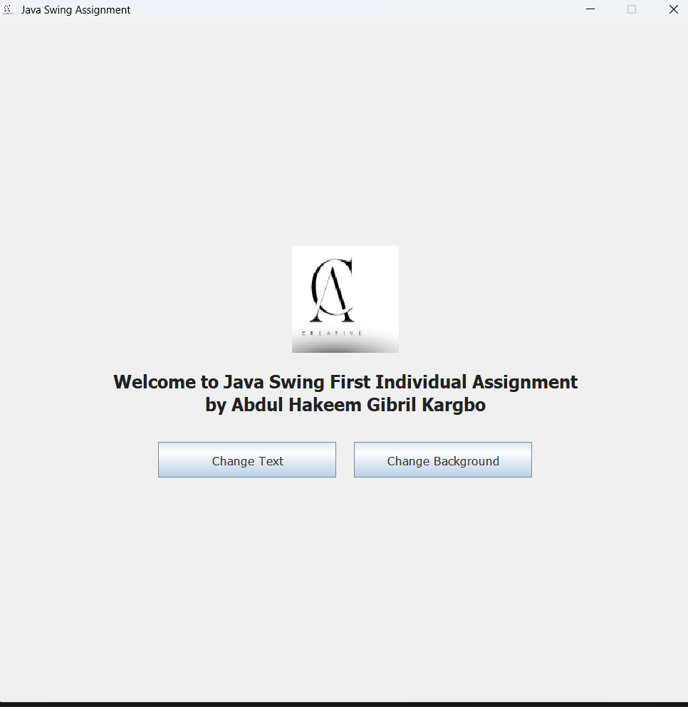

Icon Used:


Figma Wireframe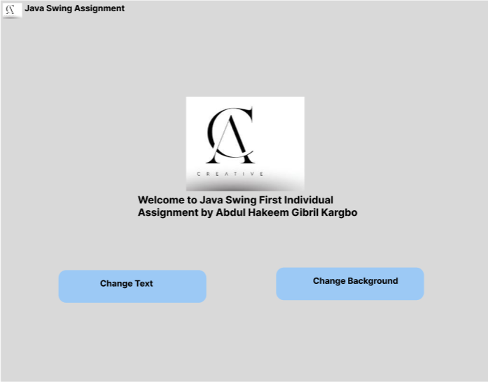:

4.1 HTML-Formatted Label
Swing labels can render a subset of HTML when their text begins with the <html> tag. This allows the message to contain line breaks, bold text, and simple formatting without introducing a separate text component. The HTML text is wrapped in a JLabel, which remains a lightweight display component.

4.2 Background Colour Options
The Change Background button cycles through these colours in order:
- #F0F0F0 — light neutral grey
- #E3F2FD — pale blue
- #E8F5E9 — pale green
- #FFF3E0 — pale orange

5. Event Handling and Application Logic

5.1 Toggle Message
The message toggle uses a Boolean state variable. When the button is clicked, the state is inverted and the JLabel text is updated to the corresponding HTML-formatted message. This demonstrates how Swing components can be updated in response to user input.

5.2 Change Background
The background button uses an integer index to track the current colour. Each click advances the index and wraps it back to zero after the last colour. The selected colour is then applied to the main panel, and repaint() is called to ensure that the updated background is displayed.

5.3 Event-Driven Programming
Each button registers an ActionListener. Swing dispatches an action event when the user activates a button, and the associated callback executes the relevant logic. The interface therefore responds to events rather than continuously checking for user actions.

6. Complete Source Code
Save the following program as JavaSwingAssignment.java. The public class name and file name must match.
import java.awt.Color;
import java.awt.Font;
import java.awt.GridBagLayout;
import java.awt.Dimension;
import javax.swing.Box;
import javax.swing.BoxLayout;
import javax.swing.JButton;
import javax.swing.JFrame;
import javax.swing.JLabel;
import javax.swing.JPanel;
import javax.swing.SwingConstants;
import javax.swing.SwingUtilities;
import java.awt.event.ActionEvent;
import java.awt.event.ActionListener;

public class JavaSwingAssignment {
private static final Color[] BACKGROUND_COLORS = {
new Color(0xF0F0F0),
new Color(0xE3F2FD),
new Color(0xE8F5E9),
new Color(0xFFF3E0)
};

private static int backgroundIndex = 0;
private static boolean alternateMessage = false;

public static void main(String[] args) {
SwingUtilities.invokeLater(new Runnable() {
@Override
public void run() {
createAndShowGUI();
}
});
}

private static void createAndShowGUI() {
JFrame frame = new JFrame("Java Swing Individual Assignment");
frame.setDefaultCloseOperation(JFrame.EXIT_ON_CLOSE);
frame.setSize(800, 800);
frame.setResizable(false);
frame.setLocationRelativeTo(null);

JPanel mainPanel = new JPanel(new GridBagLayout());
mainPanel.setBackground(BACKGROUND_COLORS[backgroundIndex]);
mainPanel.setFont(new Font("Tahoma", Font.PLAIN, 14));

Box content = Box.createVerticalBox();
content.setPreferredSize(new Dimension(460, 250));

JLabel messageLabel = new JLabel(
"<html><div style='text-align:center;'>"
+ "<h2>Welcome to Java Swing</h2>"
+ "This interface demonstrates a simple event-driven GUI.<br/>"
+ "Use the buttons below to interact with the application."
+ "</div></html>",
SwingConstants.CENTER
);
messageLabel.setFont(new Font("Tahoma", Font.PLAIN, 14));
messageLabel.setAlignmentX(java.awt.Component.CENTER_ALIGNMENT);
messageLabel.setHorizontalAlignment(SwingConstants.CENTER);

JButton toggleButton = new JButton("Toggle Message");
toggleButton.setFont(new Font("Tahoma", Font.PLAIN, 14));
toggleButton.setAlignmentX(java.awt.Component.CENTER_ALIGNMENT);

JButton backgroundButton = new JButton("Change Background");
backgroundButton.setFont(new Font("Tahoma", Font.PLAIN, 14));
backgroundButton.setAlignmentX(java.awt.Component.CENTER_ALIGNMENT);

toggleButton.addActionListener(new ActionListener() {
@Override
public void actionPerformed(ActionEvent e) {
alternateMessage = !alternateMessage;
if (alternateMessage) {
messageLabel.setText(
"<html><div style='text-align:center;'>"
+ "<h2>Message Updated</h2>"
+ "You clicked the toggle button.<br/>"
+ "Click it again to return to the welcome message."
+ "</div></html>"
);
} else {
messageLabel.setText(
"<html><div style='text-align:center;'>"
+ "<h2>Welcome to Java Swing</h2>"
+ "This interface demonstrates a simple event-driven GUI.<br/>"
+ "Use the buttons below to interact with the application."
+ "</div></html>"
);
}
}
});

backgroundButton.addActionListener(new ActionListener() {
@Override
public void actionPerformed(ActionEvent e) {
backgroundIndex = (backgroundIndex + 1) % BACKGROUND_COLORS.length;
mainPanel.setBackground(BACKGROUND_COLORS[backgroundIndex]);
mainPanel.repaint();
}
});

content.add(messageLabel);
content.add(Box.createVerticalStrut(30));
content.add(toggleButton);
content.add(Box.createVerticalStrut(15));
content.add(backgroundButton);
mainPanel.add(content);

frame.setContentPane(mainPanel);
frame.setVisible(true);
}
}

7. Compilation and Execution
The Java Development Kit (JDK) must be installed. Open a terminal or command prompt in the directory containing JavaSwingAssignment.java, then run the following commands:
javac JavaSwingAssignment.java
java JavaSwingAssignment
The first command compiles the source file and creates Java class files. The second command starts the application. If the commands are not recognized, verify that the JDK is installed and that its bin directory is available through the system PATH.

8. Conclusion
This assignment demonstrates fundamental Java Swing GUI concepts: configuring a JFrame, organizing components with layout managers, styling interface elements, rendering HTML-formatted label text, and responding to user actions through ActionListener. The message toggle and background colour cycle show how application state can be changed dynamically while the program is running.

