INTERNSHIP PROJECT REPORT
DIGITAL LITERACY
& CYBER SAFETY
A Data Analytics Study of Online Practices and Safety Awareness among College Students
Prepared by
KEEMTI KUSHWAH
Roll Number: 24118187
ACADEMIC DETAILS | INFORMATION
Course | Bachelor of Arts (BA)
College | Government P.G. College, Dholpur
University | Maharaja Surajmal Brij University
Programme | IBM SkillsBuild Data Analytics with AI Academic Internship (project format)

Submitted for academic review
Academic year: 2026–2027

CERTIFICATE (MENTOR / INSTITUTION TO COMPLETE)
This is to certify that the project report titled “Digital Literacy & Cyber Safety: A Data Analytics Study of Online Practices and Safety Awareness among College Students” has been prepared by Keemti Kushwah (Roll Number: 24118187), a student of Bachelor of Arts (BA), Government P.G. College, Dholpur, affiliated with Maharaja Surajmal Brij University, as part of the stated academic internship project format.
The report presents an educational analysis workflow using a clearly labelled synthetic dataset. It should be reviewed by the designated mentor before certification or final submission.
Mentor / Supervisor Name: __________________________________________
Designation: _______________________________________________________
Signature: __________________________ Date: _____________________
Institution Seal (if applicable): ______________________________________

DECLARATION
I, Keemti Kushwah (Roll Number: 24118187), student of Bachelor of Arts (BA) at Government P.G. College, Dholpur, affiliated with Maharaja Surajmal Brij University, declare that this report has been assembled for educational purposes and that the analytical steps, limitations, and use of data are described transparently.
The dataset supplied with this project is synthetic and was generated for demonstrating data analytics methods. It is not a record of an actual survey of college students, and no finding in this report should be represented as a measured fact about a real institution or population. Any certification, mentor review, or required first-person additions must be completed by the student and supervisor before submission.
Student Signature: ______________________________ Date: __________________

ACKNOWLEDGEMENT
I would like to express my gratitude to Government P.G. College, Dholpur, and Maharaja Surajmal Brij University for providing an academic setting in which I can develop research, critical thinking, and digital skills. I am also thankful to the mentor or faculty member who reviews this work and provides guidance on its improvement.
This project helped me connect a social issue—digital literacy and online safety—with practical data analysis skills. The work demonstrates how structured data, clear visualizations, and cautious interpretation can support awareness planning. Since the attached dataset is synthetic, the report treats the results as a learning exercise rather than evidence about actual students.

ABSTRACT
This project demonstrates a reproducible data analytics workflow for studying digital literacy and online safety practices in a college-student context. A synthetic survey-style dataset of 1,500 records was created to illustrate how demographic context, device access, internet-use patterns, digital-payment use, and self-reported safety practices can be summarised using Python. The five-item online-safety practice score has a mean of 2.33 out of 5. In this simulated sample, 44.7% of records fall into the “Higher awareness” group under the project’s operational definition (score of at least 3), while 55.3% fall into “Needs support.” Awareness of the cybercrime helpline number 1930 is 48.7% in the simulated records, and digital-payment use is 67.7%.
The notebook performs data-quality checks, descriptive analysis, grouped comparisons, visualisation, and a demonstration logistic-regression classification workflow. The model’s held-out accuracy is 0.565 and F1 score is 0.548; these scores are illustrative and do not demonstrate real-world predictive validity because the data are simulated. The project concludes that accessible workshops, short explainer videos, phishing simulations, and practical guidance on strong passwords, multi-factor authentication, app permissions, and privacy settings can be useful content for a future real-world awareness programme. A genuine survey with suitable consent and sampling is needed before making claims about actual students.
Keywords: digital literacy, cyber safety, data analytics, online privacy, phishing awareness, Python, exploratory data analysis, synthetic data.

TABLE OF CONTENTS
SECTION | PAGE (APPROX.)
Certificate (template) | 2
Declaration | 3
Acknowledgement | 4
Abstract | 5
Chapter 1 — Introduction | 8
Chapter 2 — Conceptual Background | 10
Chapter 3 — Objectives and Research Questions | 12
Chapter 4 — Dataset and Data Dictionary | 14
Chapter 5 — Methodology and Workflow | 16
Chapter 6 — Exploratory Analysis and Findings | 18
Chapter 7 — Predictive Modelling Demonstration | 21
Chapter 8 — Discussion and Recommendations | 23
Chapter 9 — Limitations, Ethics and Future Scope | 25
Chapter 10 — Conclusion | 27
References | 28
Appendix A — Reproducibility Guide | 29
Appendix B — Sample Questionnaire for a Future Real Study | 30

Pagination may shift slightly between Microsoft Word and Google Docs. Update the contents page after any editing or institution-specific formatting changes.

LIST OF TABLES AND FIGURES
Tables: Project objectives; research questions; dataset field dictionary; data-quality checks; descriptive overview; safety-practice rates; residence-group comparison; model performance summary; suggested action plan.
Figures: Safety-awareness grouping; adoption of online-safety practices; average practice score by residence type; preferred learning channels; illustrative model confusion matrix.
Abbreviations: AI — Artificial Intelligence; EDA — Exploratory Data Analysis; MFA — Multi-Factor Authentication; 2FA — Two-Factor Authentication; PII — Personally Identifiable Information; ROC-AUC — Area Under the Receiver Operating Characteristic Curve; CSV — Comma-Separated Values.

CHAPTER 1 — INTRODUCTION

1.1 Background
Digital services are increasingly woven into education, communication, banking, shopping, and public-service access. College students may use smartphones and online platforms daily, but frequent use does not automatically mean that a person can recognise phishing attempts, manage privacy settings, create strong unique passwords, or activate multi-factor authentication. Digital literacy therefore includes more than operating a device: it also involves evaluating online information, understanding risks, protecting personal information, and making informed choices.
Online safety is both a technical and a social issue. People’s decisions are shaped by access to devices, prior learning, peer advice, interface design, language accessibility, and confidence in asking for help. A clear awareness programme should not blame users for every incident. It should instead combine practical skills, easy-to-follow reporting routes, accessible resources, and supportive institutional practices.

1.2 Problem statement
A college may wish to know which safety practices are less familiar to learners and which formats could make awareness sessions easier to access. Without structured information, awareness planning may rely on assumptions. Data analysis can help organise responses, compare groups cautiously, and communicate patterns through charts. However, analysis can only be as reliable as the data and sampling process behind it.

1.3 Rationale for choosing the topic
The topic connects the social-science perspective of a BA programme with practical data skills. It encourages consideration of inequality in digital access, age and education differences, user behaviour, public awareness, and the ethical use of data. It is suitable for an introductory analytics project because the variables can be explained in plain language and the findings can be translated into practical educational suggestions.

1.4 Scope
This project demonstrates a workflow rather than reporting a real community survey. It covers synthetic survey-style records, data cleaning checks, descriptive statistics, visual analysis, a simple classification demonstration, and recommendations for a future institution-led study. It does not identify real individuals, assess the security of any system, or claim to measure the actual awareness of Government P.G. College, Dholpur students.

1.5 Key terms
TERM | WORKING MEANING IN THIS REPORT
Digital literacy | Ability to use digital tools safely, thoughtfully, and effectively.
Phishing | A deceptive message or site designed to trick a person into revealing information or taking an unsafe action.
Two-factor authentication | A sign-in method that uses a second verification step in addition to a password.
App permissions | Access an application requests for functions or device data, such as location, contacts, or camera.
Synthetic dataset | Artificially generated records designed to demonstrate analysis; not actual responses from people.

1.6 Conceptual framework
The project links digital access and everyday internet use with a set of observable safety practices. Context variables such as device access, residence, course, and study year provide a way to describe the simulated records. Practice indicators provide a more direct view of what a learner reports doing. The derived score summarises the five indicators, while the separate helpline-awareness question represents knowledge of a possible support route. These measures are related but not interchangeable.
The conceptual framework is intentionally simple: context and access may be associated with learning opportunities; learning opportunities may be associated with knowledge and safety habits; and targeted training may help participants practise specific behaviours. This project does not test a causal chain. It provides a structure for questions that a properly designed real study could investigate.

1.7 Why measurement matters
A practical awareness programme should distinguish exposure to information from the ability to apply it. For example, a participant might recognise the term “two-factor authentication” but still be unsure how to enable it. A future assessment could therefore combine a short knowledge check with a task-based exercise. The same principle applies to phishing awareness: recognising a warning sign in a quiz is useful, but a safe, simulated exercise may provide a better view of applied skill.

CHAPTER 2 — CONCEPTUAL BACKGROUND

2.1 Digital literacy as a practical capability
Digital literacy is a set of related capabilities: finding information, evaluating credibility, communicating responsibly, creating and managing content, and protecting identity and devices. For students, these capabilities can support learning and access to services. Gaps may arise when guidance is overly technical, available only in one language, or delivered without time to practise.

2.2 Common online-safety practices
- Use a strong, unique password for each important account and avoid sharing passwords in messages or with peers.
- Enable two-factor or multi-factor authentication on accounts that support it, especially email and financial services.
- Pause before opening links, attachments, QR codes, or login pages received unexpectedly; verify the sender through another channel.
- Review whether an application genuinely needs requested permissions, and remove permissions that are unnecessary.
- Review social-media and account privacy settings periodically, particularly after apps introduce new features.
- Know how to preserve evidence and reach official reporting channels when cybercrime or financial fraud is suspected.

2.3 Digital inclusion and context
Digital access can vary between rural, semi-urban, and urban settings and between users with a personal smartphone, a shared phone, or a computer. These categories are not measures of ability. They can, however, help planners ask whether training opportunities are convenient, affordable, understandable, and compatible with the devices people use.

2.4 Responsible awareness communication
Awareness content works best when it is concrete and actionable. A short demonstration of identifying a suspicious message, a practice exercise for reviewing app permissions, and a simple explanation of two-factor authentication may be more useful than a list of abstract warnings. Communication should avoid fear-based language and explain both prevention and recovery steps.

2.5 Relationship to data analytics
Analytics provides a structured way to summarise patterns and distinguish observations from assumptions. Frequency tables answer “how many”; averages compare numeric measures; visualisations reveal differences; and predictive models test whether selected inputs contain useful signals for a defined target. None of these methods proves causation. In this project, all findings are demonstrations based on synthetic data and must be validated with real data before use in policy decisions.

2.6 Common risk categories
Online risk can include credential theft, fake customer-support messages, impersonation, unsafe downloads, oversharing of personal information, and misleading offers. These risks should not be presented as if all users face the same exposure or have the same resources to respond. A useful learning activity explains how to pause, verify the source, avoid sharing one-time codes, and seek help through official channels when appropriate.

2.7 Accessibility and language
An awareness programme should use examples that make sense to the intended audience and should explain specialist words. Short bilingual materials, demonstrations on common mobile interfaces, captions, readable font sizes, and low-bandwidth options can make the material easier to access. These are planning principles; their actual effectiveness should be evaluated rather than assumed.

CHAPTER 3 — OBJECTIVES AND RESEARCH QUESTIONS

3.1 Main objective
To demonstrate how data analytics can be used to organise and explore information about digital access and online-safety practices in a student-like population, and to show how results can inform a practical awareness plan.

3.2 Specific objectives
- To prepare a structured, documented synthetic dataset for an educational analytics workflow.
- To check the dataset for missing values, duplicate records, invalid ranges, and inconsistent categories.
- To describe digital-device access, internet use, and digital-payment use in the simulated records.
- To summarise five basic online-safety practices and a derived practice score.
- To compare average practice scores across residence categories without treating differences as causal.
- To examine preferred learning channels for a future awareness programme.
- To build and evaluate a simple logistic-regression model as a demonstration, with an explicit warning about synthetic data.
- To propose ethical, accessible, and testable recommendations for a future real survey.

3.3 Research questions
ID | QUESTION | ANALYTICAL APPROACH
RQ1 | What share of simulated records are in each safety-awareness group? | Frequency and percentage table
RQ2 | Which of the five selected safety practices are more and less common? | Yes-rate by practice
RQ3 | Do average practice scores differ across residence categories in this simulated dataset? | Grouped mean and bar chart
RQ4 | Which learning channels are most often preferred? | Frequency ranking
RQ5 | Can demographic and digital-use variables provide a modest classification signal? | Train/test split and logistic regression

3.4 Expected outputs
The expected outputs are a clean CSV file, a reproducible Jupyter notebook, charts and summary tables, a written interpretation of results, model evaluation metrics, a data dictionary, and a README that explains how to run the project. A real study would additionally need a sampling plan, consent process, instrument testing, and approved data-collection procedures.

3.5 Analytical framework and assumptions
The analysis is organised around three layers: (1) describe the simulated records, (2) compare the distribution of selected indicators, and (3) demonstrate a predictive workflow. Each layer answers a different question. Descriptive summaries establish what is present in the file; comparisons identify patterns worth discussing; modelling tests whether predictors carry signal for one operationally defined target. The layers should not be blended into a claim of proof.
The project assumes that each synthetic row is internally consistent, that categorical values use the documented labels, and that the score is computed from the five specified indicators. These assumptions are checked in the notebook where practical. They would need to be reconsidered for real survey data, where non-response, inconsistent interpretation of questions, sampling bias, and data-entry errors may occur.

3.6 Interpreting the research questions responsibly
The research questions are descriptive and exploratory. RQ1 and RQ2 are answered with counts and percentages; RQ3 uses grouped averages; RQ4 ranks preferred training formats; and RQ5 demonstrates a predictive pipeline. These approaches were selected because they match the question type and are understandable to a broad academic audience. The project does not claim that the variables exhaust the concept of digital literacy or that the categories are universally applicable.
For a real study, analysis choices should be agreed before looking for a preferred result. If subgroup comparisons are reported, include the number of responses behind each estimate and avoid interpreting small differences as important without considering uncertainty. Where answers are missing, explain the denominator used. If categories are combined for reporting, document the reason and preserve the original values securely where retention is approved.

CHAPTER 4 — DATASET AND DATA DICTIONARY
The supplied CSV contains 1,500 synthetic records and 19 fields. Each row represents an artificial survey-style record. The seed used to generate the dataset is fixed so the result can be reproduced. The field Response_ID is an artificial identifier with no link to a real person.
FIELD | DESCRIPTION | TYPE
Response_ID | Artificial record ID | Identifier only
Age | Age in whole years | Numeric
Gender | Self-description category | Categorical
Course | Course category | Categorical
Year_of_Study | Study-year category | Categorical
Residence_Type | Rural, semi-urban, or urban | Categorical
Device_Access | Primary access arrangement | Categorical
Daily_Internet_Hours | Estimated hours per day | Numeric
Uses_Digital_Payments | Whether digital payments are used | Yes/No
Digital_Payment_Frequency | Frequency category | Categorical
Aware_of_Cybercrime_Helpline_1930 | Awareness indicator | Yes/No
Uses_Strong_Unique_Passwords | Practice indicator | Yes/No
Uses_Two_Factor_Authentication | Practice indicator | Yes/No
Can_Recognize_Phishing | Practice/knowledge indicator | Yes/No
Checks_App_Permissions | Practice indicator | Yes/No
Reviews_Privacy_Settings | Practice indicator | Yes/No
Safety_Practice_Score | Sum of five practice indicators, 0–5 | Derived numeric
Safety_Awareness_Level | Higher awareness if score >=3, else needs support | Derived category
Preferred_Learning_Channel | Preferred format for learning | Categorical

4.1 Operational definition of the safety score
The Safety_Practice_Score is calculated by assigning one point for each “Yes” response in five fields: strong unique passwords, two-factor authentication, ability to recognise phishing, checking app permissions, and reviewing privacy settings. The score ranges from 0 to 5. A record is categorised as “Higher awareness” when the score is at least 3; otherwise it is categorised as “Needs support.” This is a project-specific teaching definition, not a validated psychological or cybersecurity assessment.

4.2 Data-quality checks
CHECK | RESULT | INTERPRETATION
Number of rows | 1,500 | One row per synthetic record
Number of columns | 19 | Includes raw and derived fields
Missing cells | 0 | No missing cells in generated dataset
Duplicate full rows | 0 | No duplicate full rows detected
Age range | 17–28 years | Within generator’s intended range
Safety score range | 0–5 | Within the defined 0–5 scale

4.3 Data handling assumptions
The data contain no names, telephone numbers, email addresses, exact addresses, or account identifiers. The record identifier is artificial and exists only to distinguish rows during analysis. The project deliberately uses broad categories rather than fine-grained personal information. In a real survey, only fields required to answer the research questions should be collected, and the need for each field should be documented before collection begins.
The field values are constrained by the data-generation script. That controlled origin makes the dataset suitable for testing a workflow, but it also means that its patterns are partly determined by the generator. No statistical test can turn synthetic records into evidence about an actual student population. This limitation remains even when the code runs without error and charts are correctly produced.

4.4 Validation checklist for a future collected dataset
- Confirm that all required questions have defined response options and that options do not overlap unintentionally.
- Check whether skip logic has produced expected blank values and document how missing responses will be handled.
- Validate numeric ranges, category labels, duplicate submissions, and impossible combinations without silently overwriting the original file.
- Keep a read-only copy of the raw export and record each cleaning decision in a short data log.
- Check that tables and graphs use the correct denominator and are consistent with the cleaned dataset.

CHAPTER 5 — METHODOLOGY AND WORKFLOW

5.1 Overall approach
The project follows a quantitative, descriptive analytics workflow. Because no real survey data were provided, the analysis uses a simulated dataset designed for learning. The appropriate language is therefore “in this synthetic sample” rather than “students at the college do…” or “the population shows…”.

5.2 Tools and technologies
TOOL | ROLE IN THE PROJECT
Python | Main programming language and reproducible workflow
Pandas | Tabular data loading, validation, grouping, and summaries
NumPy | Deterministic data generation and numeric operations
Matplotlib | Charts and visual summaries
Scikit-learn | Train/test split, preprocessing pipeline, logistic regression, evaluation metrics
Jupyter Notebook | Interactive documentation and reproducible execution
Microsoft Word / compatible editor | Report authoring and review

5.3 Workflow stages
- Problem framing: define a practical question about online-safety practices and awareness communication.
- Dataset creation: generate synthetic records using a fixed random seed and document field definitions.
- Loading and validation: read the CSV, inspect dimensions, types, missing values, duplicates, and ranges.
- Feature creation: sum five practice indicators to form a 0–5 score and apply a clearly defined grouping threshold.
- Descriptive analysis: calculate frequencies, percentages, mean values, group summaries, and learning-channel counts.
- Visualisation: create simple charts with readable titles, labels, and captions.
- Modelling demonstration: train a logistic-regression pipeline using a stratified train/test split and predictors that do not directly include the five score components.
- Interpretation: report evaluation measures, discuss limitations, and translate descriptive patterns into a cautious awareness plan.

5.4 Model evaluation metrics
Accuracy is the proportion of predictions that match the held-out labels. Precision measures the share of predicted positive records that are positive; recall measures the share of actual positive records detected; F1 is the harmonic mean of precision and recall. ROC-AUC measures ranking performance across thresholds. Metrics should be interpreted together, especially when classes are imbalanced. Since both the patterns and labels in this project come from a synthetic generator, the metrics are a code demonstration only.

5.5 Reproducibility
The notebook reads the CSV from the same project folder. Install the packages listed in requirements.txt, open the notebook in Jupyter or Google Colab, and run cells from top to bottom. All random operations used for modelling have fixed seeds to improve repeatability. Results may differ slightly if the environment or package versions are materially changed.

5.6 Quality assurance and validation
A reliable workflow should include checks before and after analysis. Before analysis, confirm that the expected file is present, row and column counts are plausible, types have loaded correctly, score values stay within the defined range, and categories match the data dictionary. After analysis, verify that percentages use the intended denominator, derived scores agree with component fields, plots carry titles and units, and model evaluation is performed on records kept separate from training.
For a real questionnaire, additional validation would include reviewing item wording, testing the questionnaire with a small group, checking whether answer options are understandable, documenting incomplete responses, and confirming that analysis choices align with the original research questions. A chart should be revised if it is misleading or difficult to interpret, rather than retained simply because it looks attractive.

CHAPTER 6 — EXPLORATORY ANALYSIS AND FINDINGS

6.1 Sample overview
The synthetic dataset contains 1,500 records. The median age is 21 years, and the mean reported daily internet-use value is 2.97 hours. 67.7% of generated records indicate digital-payment use. These are properties of the artificial sample and should not be cited as estimates of any real group.
MEASURE | VALUE IN THE SYNTHETIC SAMPLE
Records | 1,500
Median age | 21 years
Mean daily internet use | 2.97 hours
Use of digital payments | 67.7%
Awareness of cybercrime helpline 1930 | 48.7%
Mean five-item safety practice score | 2.33 / 5
Higher awareness group | 670 (44.7%)
Needs support group | 830 (55.3%)

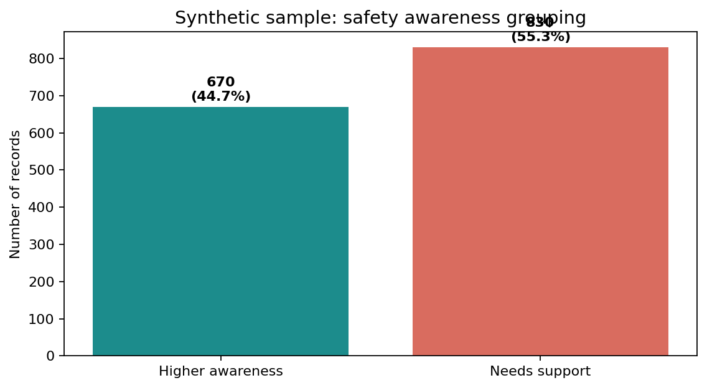
Figure 1. Safety-awareness grouping in the synthetic dataset.

6.2 Online-safety practices
The five practices are reported separately rather than hidden inside a single average. This matters because an overall score can conceal the particular behaviours for which awareness support may be useful. The chart below makes the synthetic “Yes” rate visible for each component.
PRACTICE | YES RATE
Strong, unique passwords | 49.5%
Two-factor authentication | 37.7%
Recognizes phishing | 55.1%
Checks app permissions | 46.5%
Reviews privacy settings | 43.9%

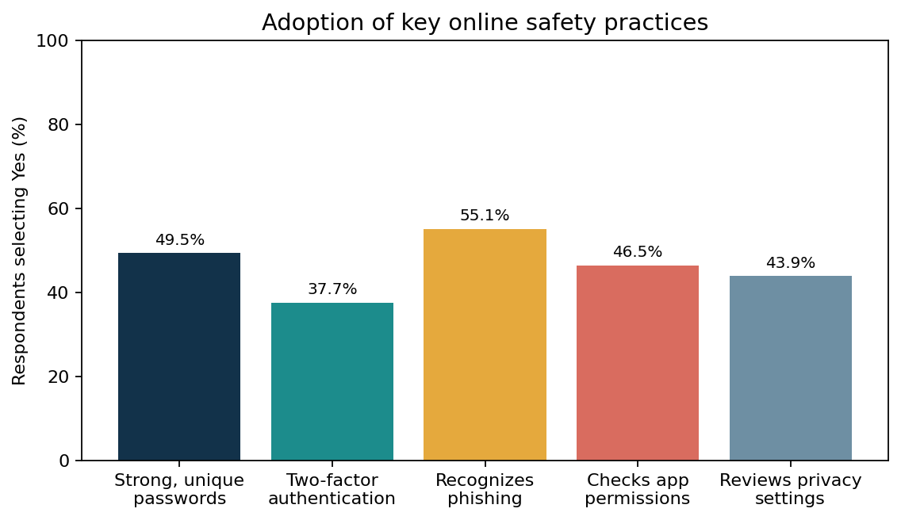
Figure 2. Yes-rate for five selected safety practices (synthetic records).

6.3 Digital-payment use and support channels
In the simulated records, digital-payment use is 67.7% and awareness of the cybercrime helpline 1930 is 48.7%. The two measures are distinct: someone may use digital payments without being familiar with a reporting route. A future genuine survey should assess whether students know where to report a suspected incident and what evidence to preserve, without asking respondents to disclose personal incidents or account details.
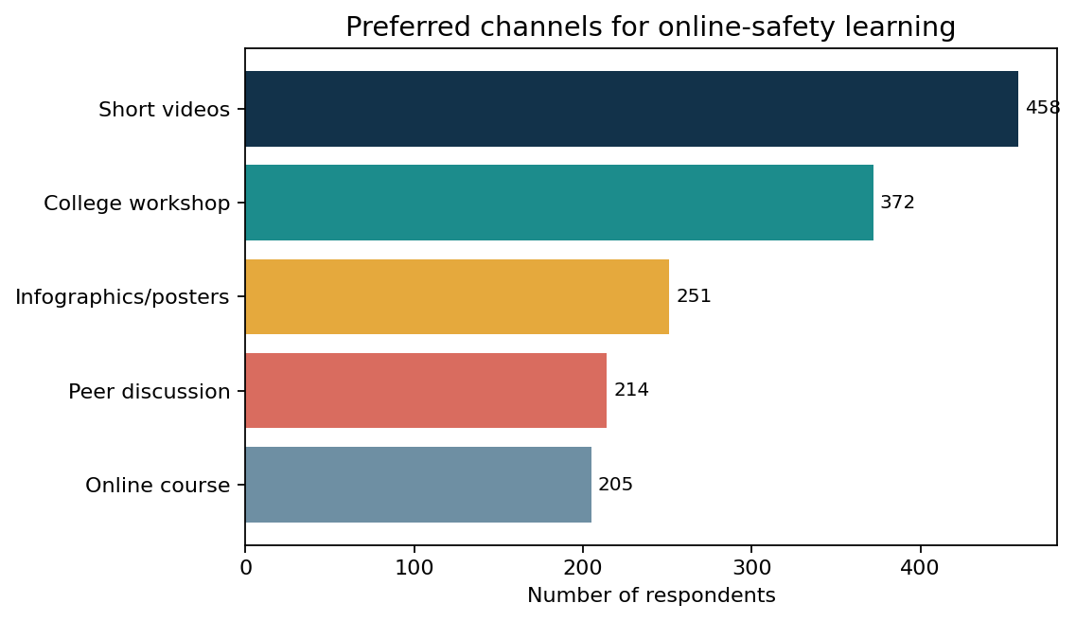
Figure 3. Preferred learning channels selected in the synthetic dataset.

6.4 Residence-group comparison
The next chart compares the average five-item score across the three residence categories. These are group averages generated by the simulation process, not evidence that residence causes stronger or weaker awareness. A real analysis should report group sizes, confidence intervals, potential confounders, and whether differences are practically meaningful.
RESIDENCE CATEGORY | RECORDS | MEAN SCORE
Rural | 543 | 2.18 / 5
Semi-urban | 476 | 2.34 / 5
Urban | 481 | 2.48 / 5

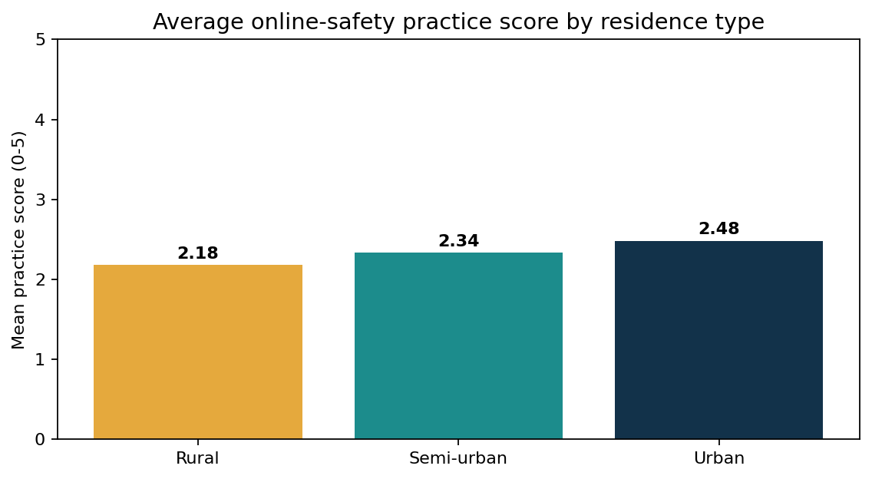
Figure 4. Average safety-practice score by residence category.

6.5 Interpretation principles
- Descriptive differences should be treated as prompts for investigation, not proof of underlying ability or motivation.
- Percentages need denominators; a rate should be interpreted alongside the number of records and its category definition.
- The score compresses several practices into one number and should always be accompanied by component-level rates.
- The simulation structure can generate relationships by construction. Patterns observed here may not appear in real observations.

CHAPTER 7 — PREDICTIVE MODELLING DEMONSTRATION

7.1 Purpose and target
A logistic-regression classifier is included to demonstrate a common machine-learning workflow. The target is the project-defined “Higher awareness” group. Predictors include age, gender, course, year of study, residence, device access, daily internet hours, digital-payment use and frequency, helpline awareness, and preferred learning channel. The five practice fields used to calculate the target score are deliberately excluded from model inputs to reduce direct target leakage.

7.2 Preprocessing and training
Numeric variables are imputed with the median and standardised. Categorical variables are imputed with the most frequent category and one-hot encoded. The data are split into training and test partitions using stratification so the class balance is approximately preserved. Logistic regression is trained with balanced class weights as a simple baseline. All preprocessing is placed in a Scikit-learn pipeline to reduce the risk of inconsistent transformations between training and testing.

7.3 Held-out evaluation
METRIC | VALUE | PLAIN-LANGUAGE INTERPRETATION
Accuracy | 0.565 | Share of all held-out predictions that match the labels.
Precision | 0.510 | Among predicted higher-awareness records, share labelled higher awareness.
Recall | 0.593 | Among higher-awareness records, share detected by the model.
F1 score | 0.548 | Combined summary of precision and recall.
ROC-AUC | 0.612 | How well the scores rank positive records above negative ones.

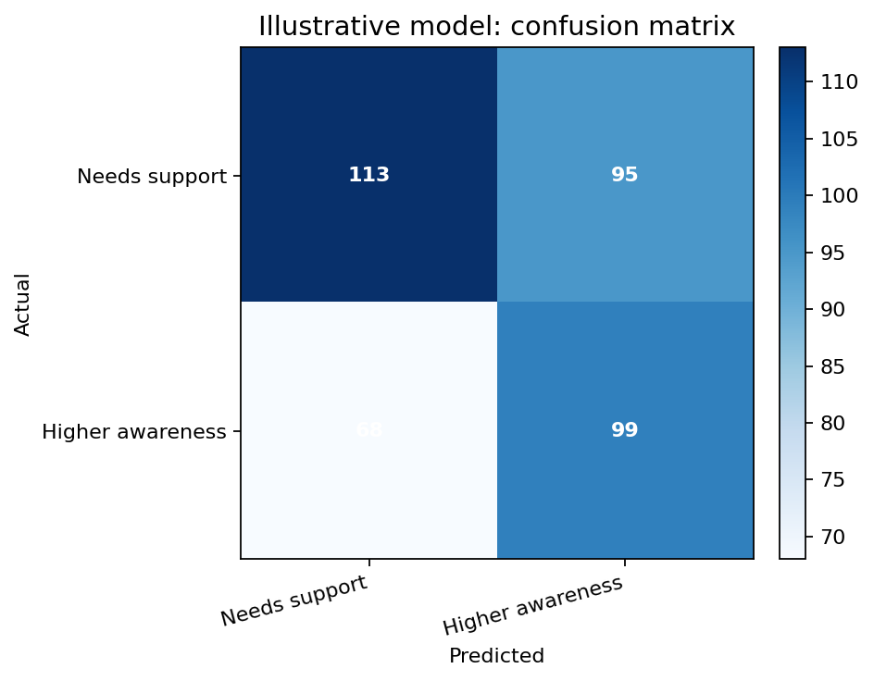
Figure 5. Confusion matrix for the illustrative logistic-regression model.

7.4 What the model can and cannot tell us
The model shows that a project can build a consistent preprocessing and evaluation pipeline from mixed numeric and categorical fields. However, the data are synthetic, the target is a simple threshold over simulated behaviours, and the generator itself creates dependencies between variables. Therefore, the model is not a validated assessment tool and should not be used to screen, rank, or make decisions about real students. A real predictive study would require representative data, pre-registered evaluation choices, leakage checks, subgroup analysis, calibration review, and a clear justification for why prediction is needed.

CHAPTER 8 — DISCUSSION AND RECOMMENDATIONS

8.1 Main learning from the demonstration
The central learning is methodological: data can help a team replace broad assumptions with clearly defined indicators, but the credibility of conclusions depends on how the data were gathered. A five-item practice score is easy to explain; it is not a complete measure of digital literacy. Helpline awareness is useful as a separate indicator; it does not prove that a person knows how to report safely. A chart may make a pattern easy to see, but it cannot validate the data source by itself.

8.2 Suggested awareness action plan
ACTION | HOW IT COULD WORK | POSSIBLE INDICATOR
Password and MFA clinic | A short hands-on demo using test accounts and generic examples; never collect real passwords. | Share of participants able to explain unique passwords and MFA after the session.
Phishing spotting exercise | Learners compare example messages and discuss suspicious URLs, urgency, and sender verification. | Correct identification rate on a short practice quiz.
Privacy-settings walk-through | Show where permissions and privacy controls are located on common device types. | Share of participants who can locate one relevant setting.
Cybercrime reporting information | Provide verified official contact/reporting routes and steps for suspected digital fraud. | Share of participants who can identify a reporting route.
Accessible learning formats | Offer short videos, posters, peer sessions, and practical workshops in accessible language. | Attendance, completion, and post-session feedback by format.
Follow-up evaluation | Use a voluntary before/after quiz that does not request identifying or sensitive details. | Change in quiz score and retention at follow-up.

8.3 Principles for a student-friendly programme
- Keep activities practical, short, and relevant to typical student tasks.
- Use inclusive language and explain technical terms in plain language.
- Provide information about both prevention and what to do after a suspected incident.
- Do not require students to reveal private messages, passwords, financial information, or personal experiences.
- Offer more than one format so that limited devices, bandwidth, or confidence do not exclude participants.
- Evaluate whether learners can perform a task, not merely whether they attended a session.

8.4 Advice for a future real study
A real study at a college should begin by defining the study population, obtaining required institutional approval, preparing a short accessible questionnaire, testing it with a small group, and explaining voluntary participation and data use. The sampling method and response rate should be documented. Avoid collecting names, phone numbers, exact addresses, account handles, or details of financial incidents unless there is a justified and approved need. Keep data securely and delete them according to a defined retention plan.

8.5 Suggested evaluation indicators
A future awareness programme can be evaluated with a small set of pre-defined indicators: participation and completion rates, change in a short knowledge quiz, ability to demonstrate one or two safety tasks, self-reported confidence, and feedback on accessibility. Indicators should be reported together rather than cherry-picked. A rise in confidence without improved practical skill may suggest that the session needs more guided practice. A low attendance rate may indicate timing, access, or communication barriers rather than a lack of interest.
Where feasible, use an anonymous identifier to match pre- and post-session answers without retaining names. Report aggregate results and explain missing responses. The aim of evaluation should be to improve learning materials, not to label individual participants as safe or unsafe.

8.6 A practical implementation sequence
PHASE | ACTIVITY | OUTPUT
1. Prepare | Confirm learning objectives, review official guidance, adapt examples, and check accessibility. | Reviewed slides, practice examples, and resource sheet.
2. Deliver | Run a brief session with demonstrations and safe practice exercises. | Attendance summary and anonymous feedback.
3. Evaluate | Use a short, voluntary knowledge check and a task-based activity. | Aggregate pre/post summary and list of improvements.
4. Improve | Revise content using feedback and keep resources current. | Updated training material and review date.

The implementation sequence should remain flexible. A college can pilot one small session before scaling to a larger audience. Participants should be able to ask questions privately, and instructors should never request live passwords, verification codes, or access to personal accounts during demonstrations.

CHAPTER 9 — LIMITATIONS, ETHICS AND FUTURE SCOPE

9.1 Limitations
- Synthetic observations: all records were generated by code; they are not responses from real students.
- Generator assumptions: correlations and group differences may arise from the programmed probabilities rather than real-world processes.
- Construct validity: the five-item score is a teaching device and has not been validated as a measure of cyber-safety competence.
- Self-report framing: the simulated variables resemble self-report questions and would be subject to recall and social-desirability bias in a real survey.
- No causal identification: group averages and model outputs cannot establish that a demographic or access variable causes a practice difference.
- Limited model generalisability: performance on the generated hold-out set should not be transferred to another college or population.

9.2 Ethical considerations
Although synthetic data do not contain responses from real people, the project is designed to model ethical practice. If the work is extended to real participants, obtain the required permissions and informed consent, minimise data collection, avoid coercion, remove direct identifiers, protect the raw dataset, and communicate results only at an appropriate aggregate level. Do not use the classifier to judge individuals or make consequential decisions.

9.3 Responsible use of public guidance
The final awareness material should point students to official and current resources rather than relying solely on social-media posts. Verify reporting instructions, helpline details, and organisational webpages close to the time of publication because procedures may change. Do not ask participants to click live suspicious links during a demonstration; use inert examples instead.

9.4 Future scope
- Collect voluntary, anonymised responses through an institutionally approved survey and replace the synthetic CSV with real, ethically collected data.
- Use a validated digital-literacy questionnaire or define and test indicators with subject-matter review.
- Compare pre-training and post-training knowledge scores using appropriate methods and transparent sampling.
- Conduct focus groups or short interviews to understand barriers that a table cannot explain.
- Examine accessibility, language, device-sharing, and bandwidth needs without stigmatising any group.
- Use cross-validation and subgroup checks if predictive modelling remains justified after obtaining real data.

9.5 Data retention and participant rights
For a future real survey, collect the minimum amount of information needed to answer the questions. Explain who will access the data, how long the data will be retained, how results will be reported, and how a participant can ask a question or withdraw where applicable. Keep contact details separate from response data if they are required for follow-up, and restrict access to the raw file. Do not publish row-level responses where combinations of fields could identify a person.
The principle of fairness also matters when presenting differences between groups. Findings should not stereotype rural or urban learners, any gender, or any course category. Discuss the limits of the sample and consider structural factors such as device sharing, connectivity, time, and access to training before interpreting group averages.

9.6 Governance of the analysis workflow
A future project should maintain a simple audit trail: the date the data were collected, the version of the questionnaire, the raw-file location, changes made during cleaning, software versions, and a copy of the code used to generate tables. The report should distinguish planned analysis from exploratory analysis and disclose any changes made after seeing the results. An independent review of the code and data dictionary can reduce avoidable mistakes.
Data security controls should match the sensitivity of the information. Restrict access to raw data, store working copies in approved locations, avoid public repository uploads of identifiable responses, and remove temporary exports when no longer needed. Publicly sharing the synthetic dataset is reasonable for reproducibility; publicly sharing sensitive real survey responses is not automatically appropriate and requires a separate privacy review.

CHAPTER 10 — CONCLUSION
This project presents a complete educational workflow for analysing digital literacy and online-safety practices with Python. It combines dataset documentation, data-quality checks, descriptive summaries, visualisations, a transparent score definition, and a baseline classification model. The report also stresses the distinction between a technically correct analysis and a valid real-world conclusion.
Within the synthetic sample, the average five-item practice score is 2.33/5, digital-payment use is 67.7%, and helpline awareness is 48.7%. The distribution of safety-awareness categories and the practice-level rates show how a future survey could reveal which educational topics need more attention. These values are intentionally reported as features of the synthetic dataset only, not as estimates for Government P.G. College, Dholpur or any real population.
The main practical recommendation is to develop short, inclusive, hands-on awareness activities and evaluate whether participants can apply the practices taught. The main research recommendation is to collect and analyse real data only with suitable approval, consent, and privacy safeguards. Used this way, data analytics can support thoughtful education planning while respecting the limits of the evidence.

Key takeaways
- Define each indicator before creating charts or models.
- Use practice-level results as well as a summary score.
- Keep synthetic examples clearly separated from real survey evidence.
- Use a model as a demonstration unless it has been independently validated for a justified use.
- Convert findings into accessible actions and measure their effectiveness.

REFERENCES AND FURTHER READING
1. Indian Cyber Crime Coordination Centre / National Cyber Crime Reporting Portal. Government of India. https://cybercrime.gov.in/ (Accessed for background; verify current instructions before use).
2. Indian Computer Emergency Response Team (CERT-In). Cyber security advisories and awareness resources. https://www.cert-in.org.in/ (Verify current resources before publication).
3. Reserve Bank of India. Financial education and safe digital banking information. https://www.rbi.org.in/ (Use the latest relevant public guidance).
4. UNESCO. Media and Information Literacy: resources and learning materials. https://www.unesco.org/en/media-information-literacy
5. Python Software Foundation. Python documentation. https://docs.python.org/3/
6. pandas development team. pandas documentation. https://pandas.pydata.org/docs/
7. NumPy developers. NumPy documentation. https://numpy.org/doc/
8. Matplotlib development team. Matplotlib documentation. https://matplotlib.org/stable/
9. scikit-learn developers. User Guide: preprocessing, pipelines, logistic regression, and model evaluation. https://scikit-learn.org/stable/user_guide.html
10. Project dataset note: Synthetic survey-style data generated specifically for this educational project; it has no external research provenance and should not be cited as an empirical survey.

APPENDIX A — REPRODUCIBILITY GUIDE

A.1 Project folder contents
FILE | PURPOSE
KeemtiKushwah_Digital_Literacy_Analytics.ipynb | Main analysis notebook with runnable code, charts, and a baseline model.
digital_literacy_cyber_safety_dataset.csv | Synthetic dataset used by the notebook.
requirements.txt | Python dependencies needed to run the notebook.
README.md | Project overview, setup instructions, fields, and limitations.
KeemtiKushwah_ProjectReport.docx | Full project documentation.
KeemtiKushwah_ProjectReport_with_Dataset.docx | Optional Word report with the complete CSV appended in table form.

A.2 Run instructions
- Keep the notebook and CSV in the same folder.
- Install packages using: python -m pip install -r requirements.txt
- Open the .ipynb file in Jupyter Notebook, JupyterLab, or Google Colab.
- Run the cells from the beginning to the end and check that chart outputs appear.
- Before replacing the synthetic data, review column names and confirm that no real personal identifiers are included.

A.3 Interpreting results responsibly
All percentages and model scores in this report are generated from the supplied artificial dataset. When real data are later collected, rerun the notebook and update the tables and interpretation. Do not simply retain the current results while changing only the dataset name.

APPENDIX B — SAMPLE QUESTIONNAIRE FOR A FUTURE REAL STUDY
The questions below are a draft only. They should be reviewed, piloted, and approved through the relevant institutional process before being used with real participants. Participation should be voluntary, and respondents should not be asked for passwords, account names, phone numbers, exact addresses, or other unnecessary identifiers.
NO. | QUESTION | RESPONSE OPTIONS
1 | Which age band best describes you? | 17–18 / 19–20 / 21–23 / 24 or older / Prefer not to say
2 | Which study level or course category applies to you? | Options defined by the institution / Prefer not to say
3 | How do you usually access the internet for study or everyday tasks? | Personal phone / Shared phone / Computer or tablet / Multiple devices / Other
4 | Do you use digital payment services? | Yes / No / Prefer not to say
5 | Do you know how to enable two-factor authentication on an important account? | Yes / No / Not sure
6 | Can you identify at least one warning sign of a phishing message? | Yes / No / Not sure
7 | Do you review permissions requested by applications? | Often / Sometimes / Rarely / Not sure
8 | Have you reviewed the privacy settings of a social or online account in the past six months? | Yes / No / Not sure
9 | Do you know where to find official guidance for reporting cybercrime or digital payment fraud? | Yes / No / Not sure
10 | Which format would help you learn online safety? | Short videos / Practical workshop / Posters / Peer discussion / Online course / Other
11 | Which topic would you most like to learn about? | Passwords and MFA / Phishing / Privacy settings / Digital payment safety / Reporting routes / Other
12 | Would you like to share optional feedback about the learning material? | Optional free text; do not include personal account details.

Suggested consent statement: “Participation is voluntary. The purpose of this survey is to understand general learning needs. Do not include names, passwords, financial details, or specific information that could identify you. You may skip any question or stop at any time. Responses will be reported in aggregate and handled under the institution’s approved data policy.”

