1. Importing the necessary libraries and webdriver for the specific browser.

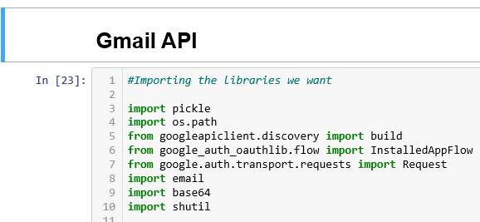

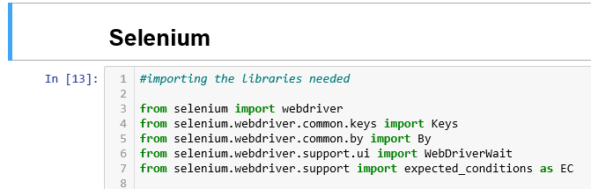

1. Using Gmail API for accessing the emails and downloading the attachment subjected .

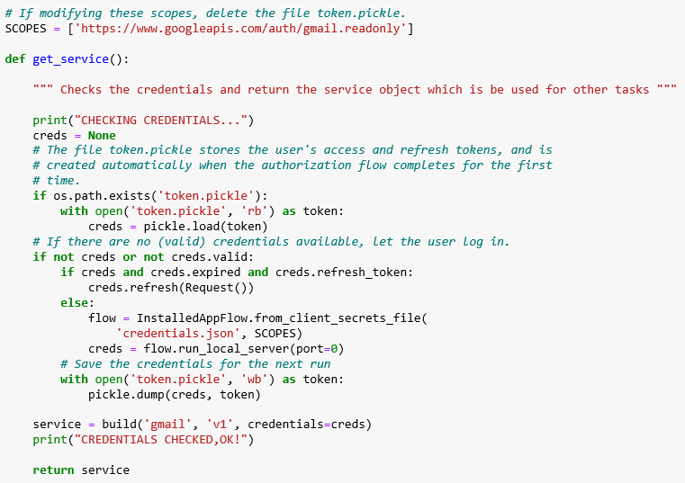

1. The above function checks the credentials and return the service object which is used for other tasks.
2. The above function searches the message by using search string and returns the messages ids. 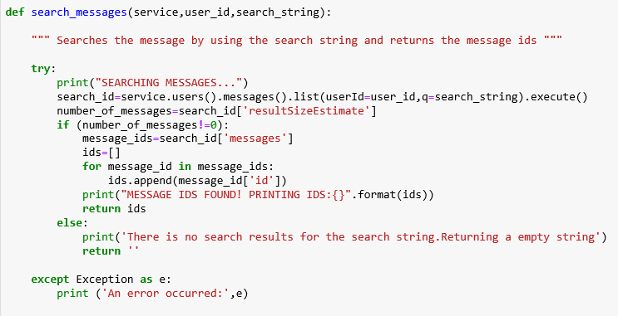

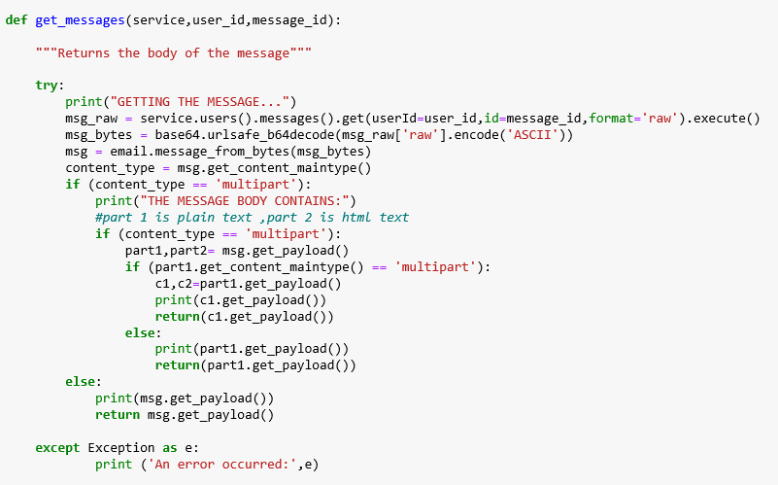

1. The above function return the message body provided the service object and message id.

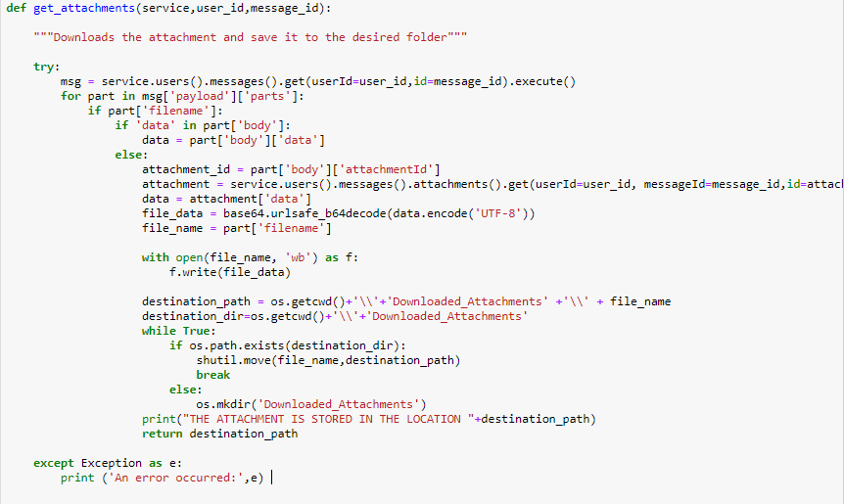

6.The above function downloads the attachment and save that to the desired folder.

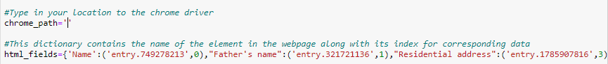

7.The location of the chrome driver and the html elements are provided.

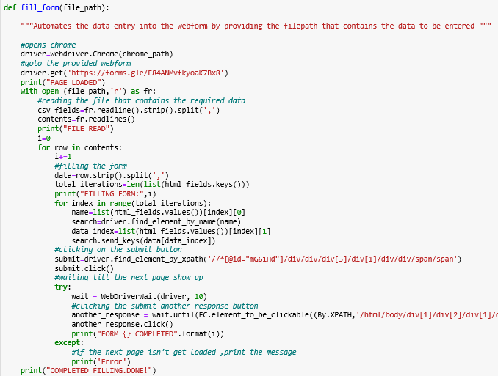

8.The above function automates the data entry into the web form provided.

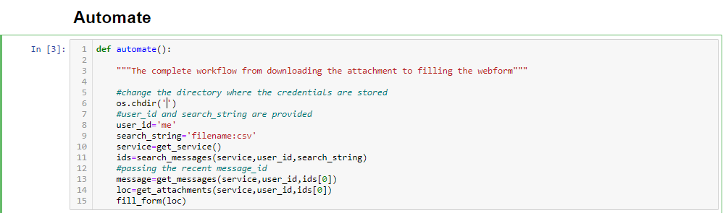

9.The above function contains the complete workflow from downloading the attachment to filling the webform.

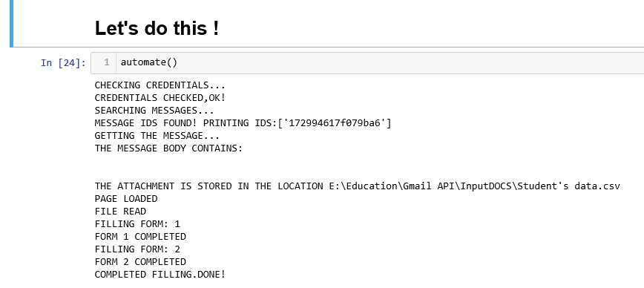

10. The above picture contains the actual output and it prints the messages to the user about the whole process.