KeenKids STEAM Enrichment
Build Day — Instructor Manual
August 2025 · Motion & Transportation · Simple Machines
Mattos Elementary & Sinnott Elementary
Grades 1–2 | Grades 3–4 | 2 Build Days

How to Use This Manual
This manual covers all 4 Build Day sessions for August across both grade tracks. Each session is 70 minutes. Every build is individual — all 13 kids make their own project. Each section includes a colour-coded demo guide so you can build a working model before class.

CRITICAL: Read the Instructor Prep note AND build your demo BEFORE kids arrive. A working demo in your hands is the single most important thing you bring to Build Day.

SESSION FORMAT: Intro & Demo (8 min) → Build (25–32 min) → Test (12–15 min) → Fix & Improve (8–10 min) → Share Out (8 min) = 70 min

August Build Day Overview
Week | Date | Grades 1–2 | Grades 3–4 | Simple Machine
1 | Mon Aug 18 | Cable Car | Well Pulley | Pulley / Wheel & Axle
2 | Mon Aug 25 | Seesaw | Balance Scale | Lever (Class 1)

Master Materials List — Get Everything Before Aug 18
Item | Quantity | Notes
Corrugated cardboard sheets | 26+ sheets | 2 per G3-4 kid for well body + 1 for base + bucket
Cardstock sheets | 50+ sheets | Seesaw, balance base, cable car, crank handles
Popsicle sticks | 1 box (100+) | Well uprights + balance scale post and beam
Wooden skewers | 15+ | Well pulley axle
Wide striped straws | 15+ | One per kid for cable car — wide enough to slide freely on string
String / twine | 2 rolls | Cable car zip lines + well pulley + balance cradle
Paper cups (small) | 30+ | Cable car cabin + balance base
Small rocks | 1 bag | Cable car cargo — test minimum weight before class
Clay or playdough | 2 tubs | Balance scale base weight
Masking tape | 4 rolls | All builds
Scissors | 13 pairs | One per kid
Small objects for weighing | 1 tray | Coins, erasers, rocks, buttons for seesaw and balance

WEEK 1 — MONDAY AUGUST 18
Grades 1–2: Cable Car
Simple Machine: Pulley | Duration: 70 minutes | Individual build — 13 kids

KEY SCIENCE MOMENT: Empty cup stops in the middle — that is correct! This is gravity vs friction. Adding rocks gives gravity enough force to overcome friction and the car slides all the way. Kids discover this through testing — do not explain it upfront.

Instructor Prep — Do This BEFORE Kids Arrive
⚠ PREP: Set up 2 zip lines BEFORE class. HIGH end: tie string to the very top of the tall brown dining chair back. LOW end: tie string to the seat of the small pink kids chair — big height difference is essential. String must be pulled tight with no sag. Thread 7 wide straws onto each line BEFORE tying the far end. Test with small rocks: find the minimum number of rocks that makes the cup slide all the way — note this number as your class threshold. Have your demo cable car ready.

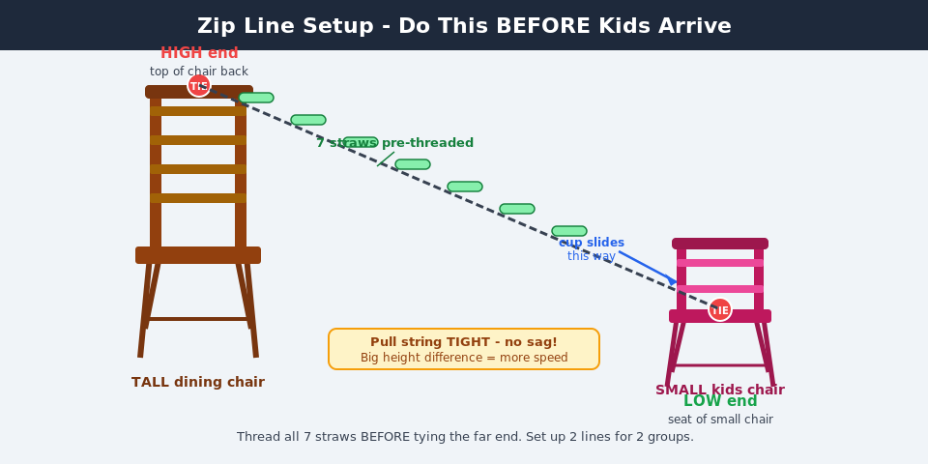
Materials
Per Kid  - 1 paper cup (cabin)  - 1 wide striped straw (pre-threaded on zip line)  - 2 pieces of string (30cm each — for cup cradle)  - Masking tape  - Scissors | Shared / Class Setup  - 2 zip lines: string from tall brown chair (HIGH) to small pink chair (LOW)  - Bag of small rocks (cargo)  - 2 groups of 6-7 kids per zip line  - Class chart: Name | Min rocks to slide | Max rocks carried

Instructor Demo Guide — Build This Before Class
INSTRUCTOR DEMO GUIDE — Build this before class (Method B: hole + inside knot)
1. Set up zip line: tie HIGH end to very top of tall chair back, LOW end to seat of small pink chair. Pull tight — no sag. Thread 7 straws onto EACH line before tying the far end.
2. Cut two pieces of string about 30 cm each.
3. Use a pencil tip to punch one small hole on each side of the cup rim (left and right, directly opposite).
4. Push one end of String 1 through the LEFT hole from OUTSIDE to INSIDE. Tie a big double knot on the inside end. Tug from outside to confirm it holds.
5. Push one end of String 2 through the RIGHT hole from OUTSIDE to INSIDE. Tie a big double knot on the inside end. Tug to confirm.
6. Tie the outside end of String 1 to the LEFT end of the straw — double knot at the very tip. Repeat for String 2 on the RIGHT end. Cup should now hang level below the straw like a gondola.
7. Test slide: push cup — straw must slide freely. If tilting: adjust the inside knot on the low side (pull less string through, re-knot).
8. Test with rocks: add rocks one at a time until cup slides all the way to the LOW end. Note the minimum count — this is your class threshold.
9. Practice asking: "Why does adding rocks make it slide?" Guide toward: more weight = more gravitational force = overcomes friction.
Build Steps — Step by Step
Step 1 — 🚡 Meet your materials
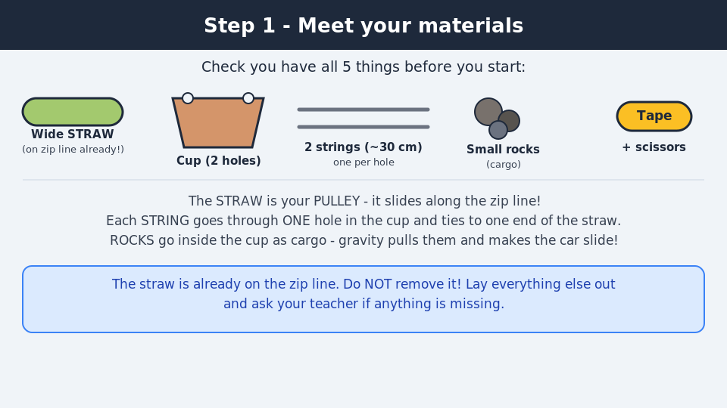
Check you have all 5 things: 1 paper cup (pre-punched with 2 holes in the rim), 1 wide striped straw (already on the zip line!), 2 pieces of string (~30 cm each), small rocks, masking tape and scissors.
💡 A PULLEY is a simple machine. Each string goes through ONE hole in the cup and ties to one end of the straw.

Step 2 — ✂️ Cut two strings (30 cm each)
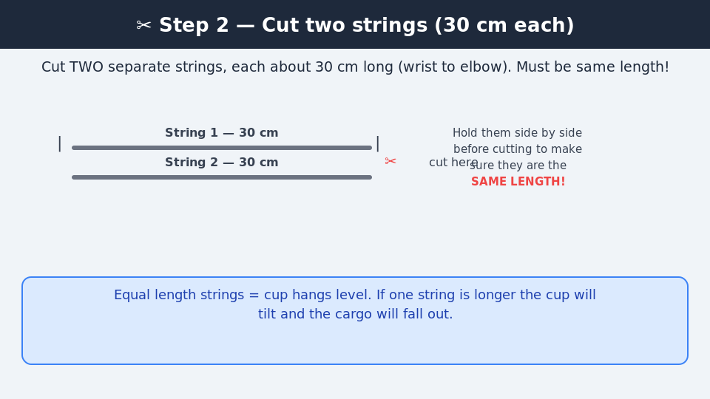
Cut TWO separate pieces of string, each about 30 cm long (wrist to elbow). Hold them side by side before cutting — they must be the SAME length so the cup hangs level.
💡 Equal length strings = cup hangs level. If one string is longer the cup will tilt and rocks will fall out.

Step 3 — 🔵 Punch 2 holes in the cup rim
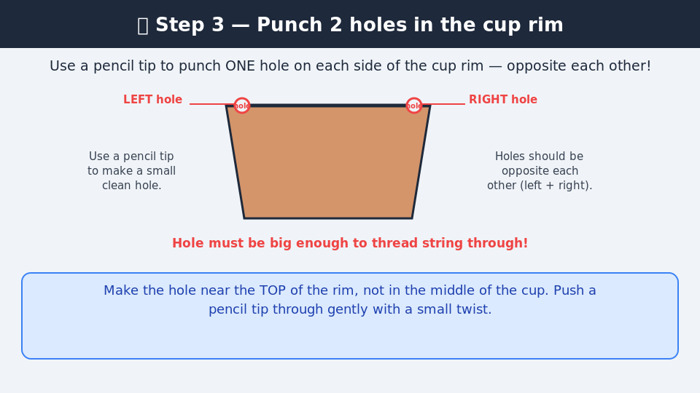
If not pre-punched: use a pencil tip to punch ONE small hole on each side of the cup rim — directly opposite each other (left and right). The hole must be big enough to thread the string through.
💡 Make the hole near the TOP of the rim. Push a pencil tip through gently with a small twist.

Step 4 — 🧵 Thread String 1 — left hole, knot inside
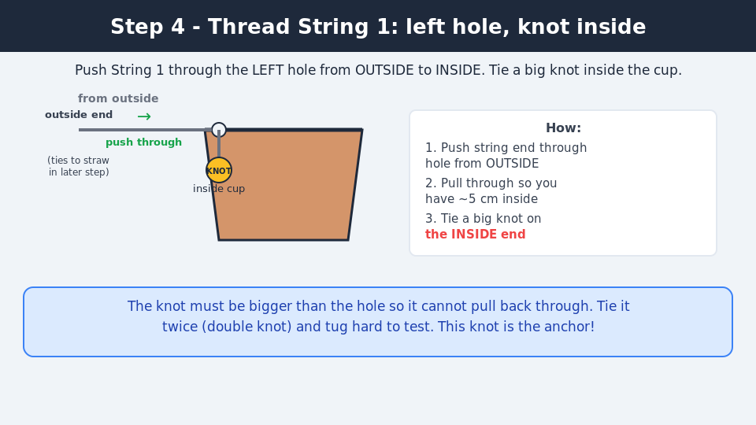
Push one end of String 1 through the LEFT hole from OUTSIDE to INSIDE. Pull through ~5 cm inside the cup. Tie a big double knot on the INSIDE end — must be bigger than the hole. Tug hard from outside to confirm it holds.
💡 The knot must be bigger than the hole. Tie twice (double knot) and tug hard. This knot is the anchor!

Step 5 — 🧵 Thread String 2 — right hole, knot inside
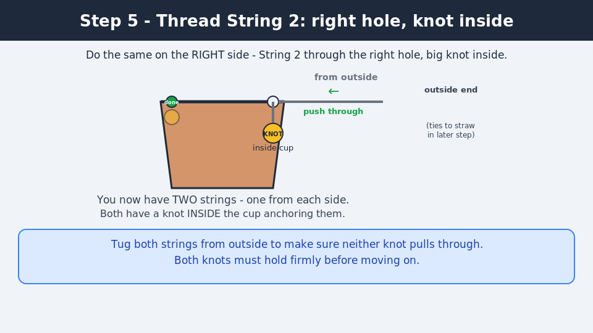
Do the same on the RIGHT side: push String 2 through the RIGHT hole from outside to inside, pull through ~5 cm, tie a big double knot inside. Tug hard. You now have TWO strings — one anchored on each side inside the cup.
💡 Tug both strings from outside. Both knots must hold firmly before you proceed.

Step 6 — 🎪 Tie String 1 to the LEFT end of the straw
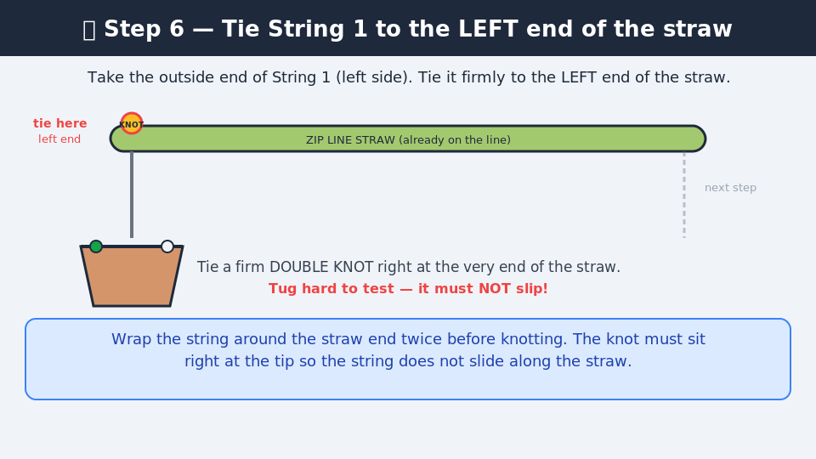
Take the outside end of String 1 (left side). Tie it to the LEFT end of the straw with a double knot right at the very tip. Pull TIGHT and tug — it must not slip or slide along the straw.
💡 Wrap the string around the straw end twice before knotting. Knot must sit at the very tip so it does not slide.

Step 7 — 🎪 Tie String 2 to RIGHT end — gondola done!
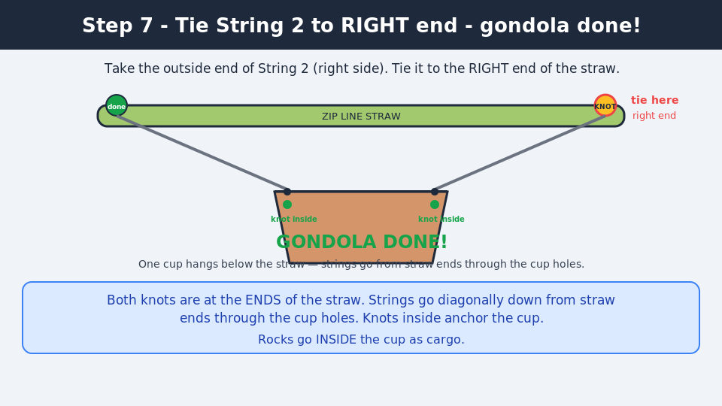
Tie the outside end of String 2 to the RIGHT end of the straw — double knot at the very tip. The cup now hangs level below the straw with one string on each side. Interior clear for rocks!
💡 Strings run straight: straw tip → through cup hole → double knot inside. Cup interior stays completely clear for cargo.

Step 8 — ⚖️ Check the cup hangs level
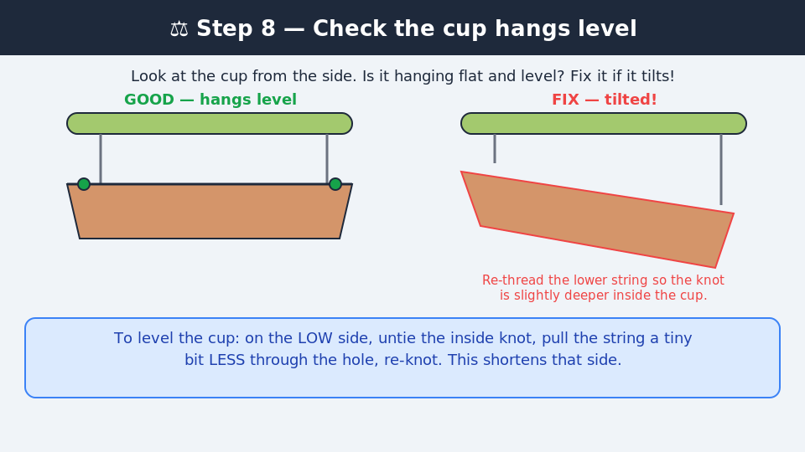
Look at the cup from the side — is it hanging flat and level? If it tilts: on the LOW side, untie the inside knot, pull the string slightly LESS through the hole, and re-knot. Repeat until level.
💡 On the LOW side: untie inside knot, pull less string through, re-knot. Repeat until level.

Step 9 — 🚦 Slide test — does it move freely?
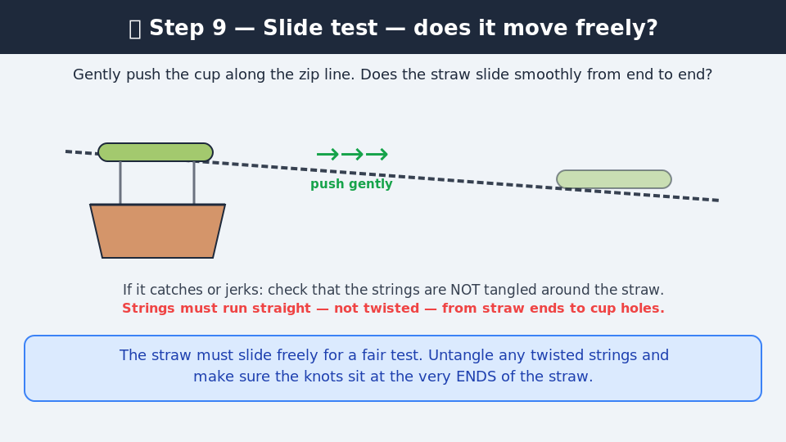
Gently push the cup along the zip line. Does the straw slide smoothly? If it catches, check strings are NOT twisted — they must run straight from straw ends down to the cup holes.
💡 Untangle any twisted strings. Knots must sit at the very ENDS of the straw.

Step 10 — 🧪 Round 1 — release the empty cup
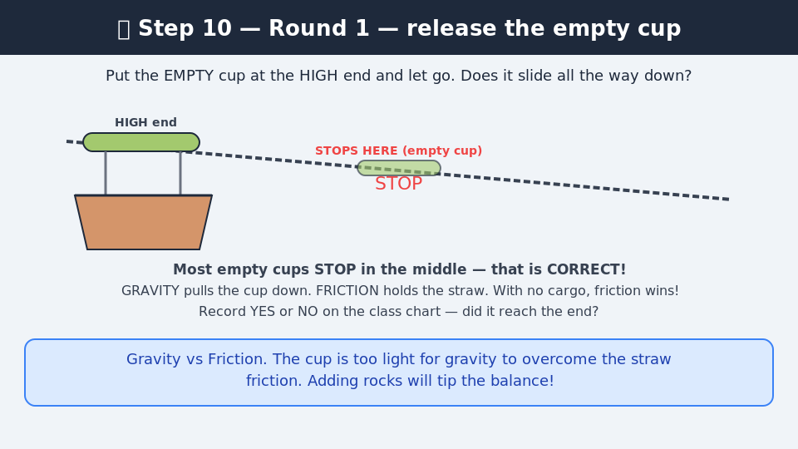
Put the empty cup at the HIGH end and let go. Does it slide all the way? Most empty cups STOP in the middle — that is CORRECT! Gravity vs Friction. Record YES/NO on the class chart.
💡 GRAVITY pulls down. FRICTION holds the straw. With no cargo, friction wins. Key discovery — do not explain upfront!

Step 11 — 📊 Round 2 — find your minimum
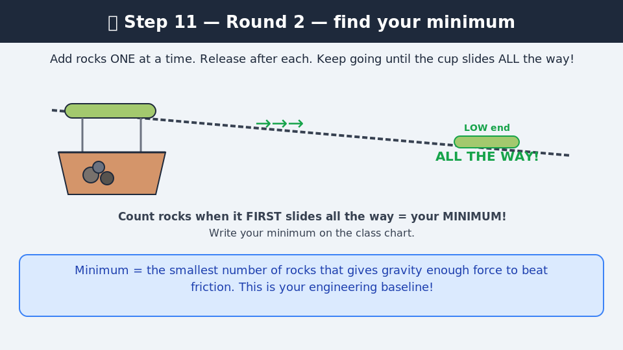
Add rocks ONE at a time. Release from the HIGH end after each rock. Keep going until the cup slides ALL THE WAY. That rock count = your MINIMUM! Record on the class chart.
💡 Minimum = smallest number of rocks where gravity overcomes friction. This is your engineering baseline.

Step 12 — 📈 Round 3 — maximum + share out!
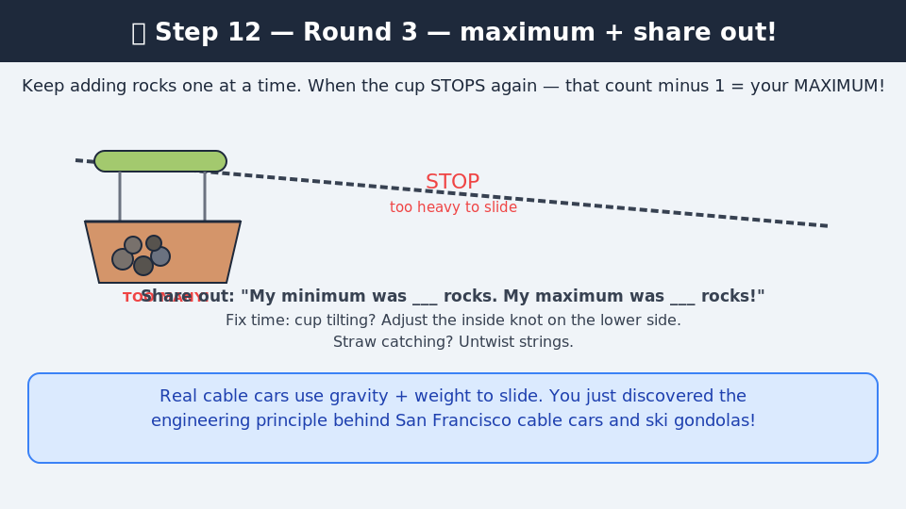
Keep adding rocks one at a time. When the cup STOPS again (too heavy), the count before it stopped = your MAXIMUM. Record on chart. Share out: "My minimum was ___ rocks. My maximum was ___ rocks!"
💡 Real cable cars in San Francisco, ski gondolas, and aerial tramways all use the same pulley principle!

Step-by-Step 70-Minute Session Plan
TIME | PHASE | WHAT TO DO / SAY
0–8 min | Intro & Demo | Show your working cable car. Release the empty cup — it stops in the middle. Ask: 'Why did it stop?' Take answers. Now add rocks one at a time until it slides all the way. Ask: 'What changed? Why does more weight help?' Let kids reason it out. Read the challenge: (1) find the minimum rocks to make it slide all the way, (2) find the maximum rocks it can carry. Split into 2 groups — one per zip line.
8–30 min | Build | STEP 1 (2 min): Take your pre-threaded straw and paper cup (2 holes pre-punched in rim). STEP 2 (5 min): Cut two 30 cm strings — same length. STEP 3 (8 min): Thread String 1 through the LEFT hole (outside → inside), tie a big double knot inside. Thread String 2 through the RIGHT hole, double knot inside. Tug each string from outside to confirm knots hold. STEP 4 (8 min): Tie the outside end of String 1 to the LEFT tip of the straw (double knot). Tie the outside end of String 2 to the RIGHT tip of the straw. Cup now hangs as a gondola! STEP 5 (4 min): Level check — cup must hang flat. If tilting: adjust the inside knot on the low side. Slide test — straw must move freely. INSTRUCTOR CHECK: every cup hangs level and straw slides freely before test runs.
30–48 min | Test Runs | GROUP A at Line 1, GROUP B at Line 2 — kids form queues. ROUND 1 (empty): Does the empty cup slide? Record YES/NO — most will say NO. ROUND 2 (find minimum): Each kid adds rocks one at a time until cup slides all the way. Record minimum rock count on class chart. ROUND 3 (find maximum): Keep adding rocks — at what point does it stop again or rocks fall out? Record maximum. Kids waiting fill in class chart while watching.
48–62 min | Fix & Improve | Ask: 'What stopped working?' Common fixes: (1) too few rocks — add more, (2) cup tilting — redistribute rocks evenly, (3) straw catching — untwist strings. Each kid makes ONE change and retests. Ask: 'What would make it carry even more rocks?' Guide toward: steeper angle, smoother string, wider cup, lighter cup itself.
62–70 min | Share Out | Review class chart. Ask: 'Who carried the most rocks? What made their design better?' Discuss the science: gravity vs friction — the weight of rocks creates downward force that overcomes string friction. Vocab: PULLEY, GRAVITY, FRICTION, LOAD, FORCE. Real world: cable cars in San Francisco, ski gondolas, ziplines, aerial tramways. Clean up — collect all rocks.

WEEK 1 — MONDAY AUGUST 18
Grades 3–4: Well Pulley
Simple Machine: Wheel & Axle | Duration: 70 minutes | Individual build — 13 kids

Build Steps — Step by Step
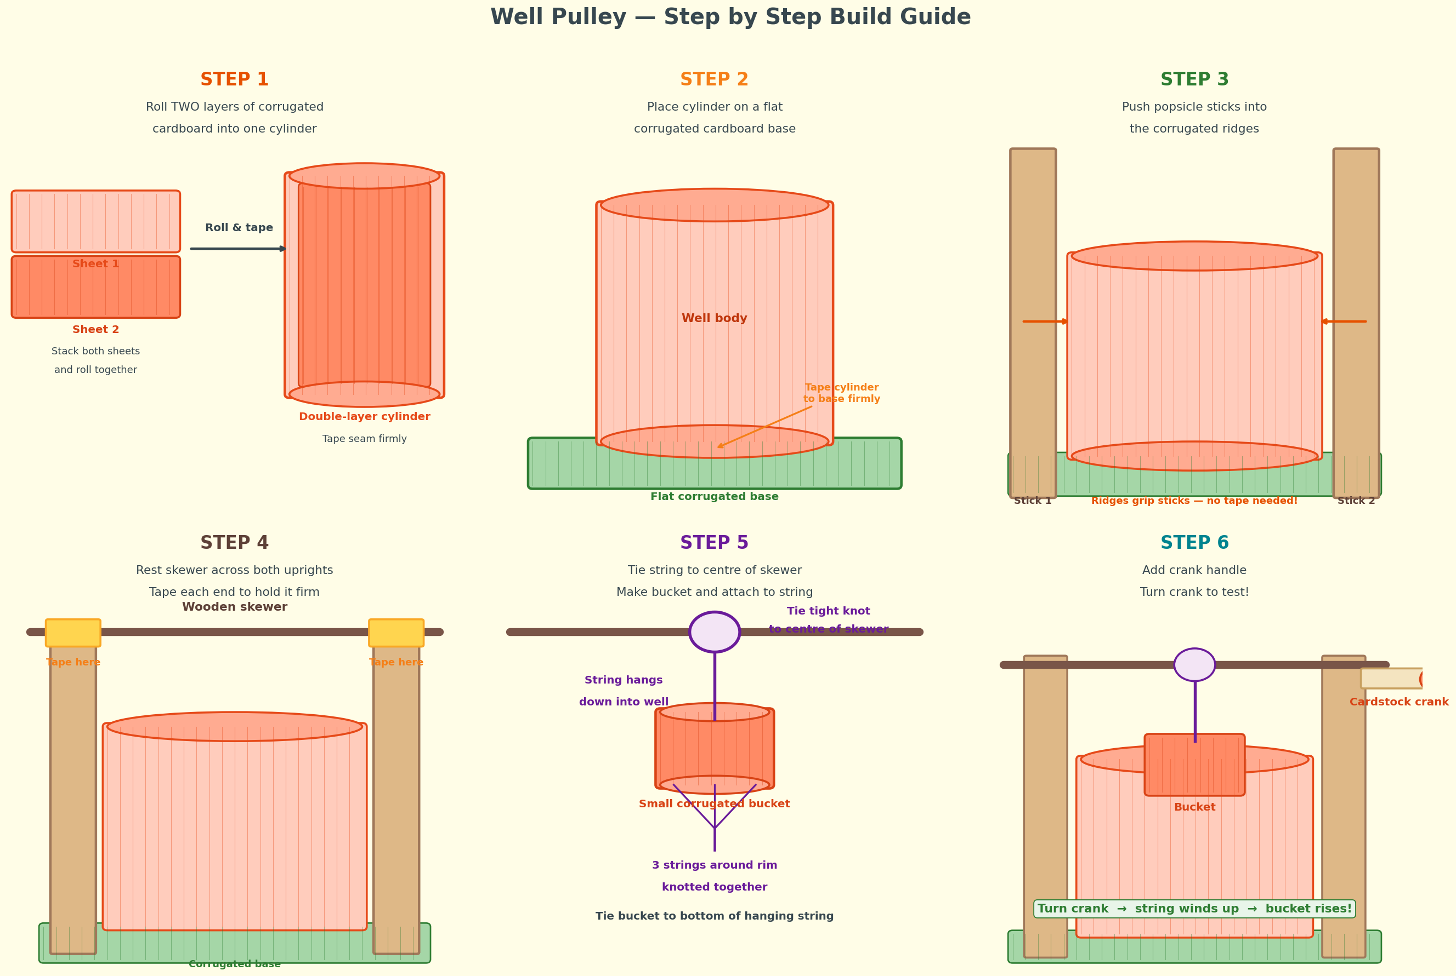

Instructor Prep — Do This BEFORE Kids Arrive
⚠ PREP: Pre-cut corrugated cardboard: 2 large pieces per kid for the double-layer cylinder, 1 flat square per kid for the base, 1 small piece per kid for the bucket. Have your demo well fully assembled and working. Test it yourself: turn the skewer crank and confirm the bucket rises and lowers smoothly without the string tangling.

Materials
Per Kid  - 2 large corrugated cardboard pieces (well cylinder — double layer)  - 1 flat corrugated cardboard square (base)  - 1 small corrugated piece (bucket)  - 2 popsicle sticks (uprights)  - 1 wooden skewer (axle)  - 50cm string  - 1 small cardstock strip (crank handle)  - Masking tape | Shared / Class Setup  - Demo well (instructor's, fully working)  - Extra corrugated cardboard for repairs  - Extra skewers  - Class chart: Name | Cranks to raise bucket | After improvement

Instructor Demo Guide — Build This Before Class
INSTRUCTOR DEMO GUIDE — Build this before class
- WELL BODY: Stack two large corrugated cardboard pieces together. Roll them tightly into a double-layer cylinder — this makes it thick and rigid. Tape the seam firmly along the full length. Test: squeeze the cylinder — it should hold its shape firmly.
- BASE: Place the cylinder upright on the flat corrugated square. Tape around the outside base edge firmly. Test: push the cylinder sideways — it must not tip over.
- UPRIGHTS: Push one popsicle stick deep into the corrugated ridges on the LEFT side of the cylinder. The ridges grip it naturally — no tape needed. It should stand firmly upright extending 8-10cm above the top. Repeat on the RIGHT side.
- SKEWER AXLE: Rest the wooden skewer horizontally across the top of both uprights. Tape each end lightly to the upright — skewer must still rotate freely. Test by spinning it with your fingers.
- STRING: Tie one end of the string to the centre of the skewer with a tight knot. Wind the string around the skewer 3-4 times. Leave a free end hanging down into the well.
- BUCKET: Roll the small corrugated piece into a small cylinder. Tape the seam. Tie 3 short strings around the rim of the bucket equally spaced. Knot all 3 together at the top. Tie this knot to the free hanging string end.
- CRANK: Tape a small cardstock strip to one end of the skewer as a handle. Test: turn the crank — skewer rotates — string winds up — bucket rises. Turn other way — bucket lowers. Practice until smooth.

Step-by-Step 70-Minute Session Plan
TIME | PHASE | WHAT TO DO / SAY
0–8 min | Intro & Demo | Show your working well. Lower the bucket in, then crank it back up. Ask: 'What simple machine is the skewer acting as?' (wheel and axle — the crank is the wheel, skewer is the axle). 'Where do you see this in real life?' (water wells, winches, fishing reels). Challenge: build your own well — how few cranks does it take to raise the bucket fully? Hand out pre-cut materials.
8–40 min | Build | STEP 1 (8 min): Stack two corrugated sheets and roll into double-layer cylinder. Tape seam firmly. STEP 2 (5 min): Stand cylinder on base square. Tape base firmly — push sideways to test stability. STEP 3 (8 min): Push popsicle sticks into ridges on each side — ridges grip them naturally. Test each stands firm. STEP 4 (7 min): Rest skewer across both uprights. Tape each end lightly — skewer must still rotate. Spin test. STEP 5 (7 min): Tie string to skewer centre. Wind 3-4 times. Roll small corrugated piece into bucket, tie 3 strings around rim, attach to hanging string. STEP 6 (3 min): Tape crank handle to one end of skewer. Test: turn crank — does bucket rise? INSTRUCTOR: check every well — skewer must rotate freely and string must wind without tangling.
40–52 min | Test | ROUND 1: How many full cranks to raise bucket from bottom to top? Count and record on class chart. ROUND 2: Add 3 small rocks to bucket as cargo. How many cranks now? ROUND 3: Whose bucket rises with fewest cranks? Compare across the class — what design differences explain the results?
52–62 min | Fix & Improve | Challenge: reduce the number of cranks needed to raise the bucket. Guide kids to discover: making the crank handle longer gives more leverage — fewer cranks needed. Winding more string around the skewer at the start also helps. Kids make one change and retest. Record new crank count on class chart.
62–70 min | Share Out | Each kid: 'It took ___ cranks before and ___ cranks after my change.' Discuss: what made the biggest difference? Connect to real world: water wells, fishing reels, winches, cranes, window blinds. Vocab: WHEEL, AXLE, CRANK, MECHANICAL ADVANTAGE, LOAD, ROTATION. Clean up.

WEEK 2 — MONDAY AUGUST 25
Grades 1–2: Seesaw
Simple Machine: Lever — Class 1 | Duration: 70 minutes | Individual build — 13 kids

Build Diagram
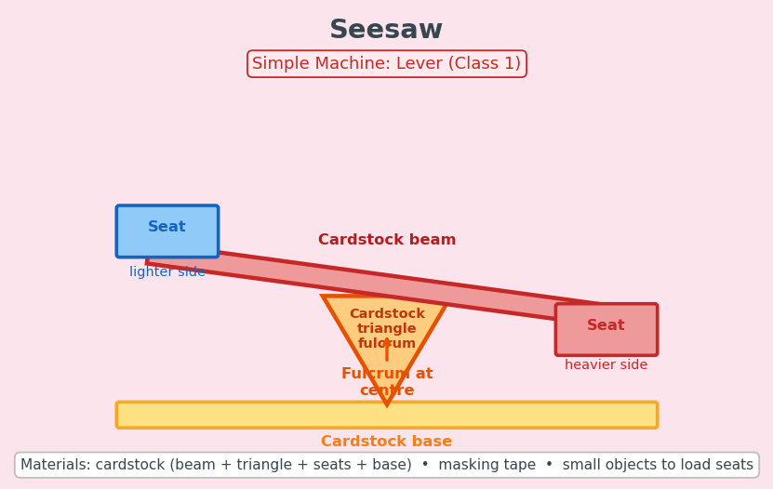

Instructor Prep — Do This BEFORE Kids Arrive
⚠ PREP: Pre-cut cardstock beams (30cm x 5cm), fulcrum triangles (8cm base x 10cm tall, scored at base), seat squares (5cm x 5cm — two per kid), and base rectangles (20cm x 15cm). Have your demo seesaw fully built before class. Test that the beam pivots freely on the triangle fulcrum.

Materials
Per Kid  - 1 cardstock beam (pre-cut 30cm x 5cm)  - 1 cardstock triangle (pre-cut, pre-scored at base)  - 2 cardstock seat squares (pre-cut 5cm x 5cm)  - 1 cardstock base rectangle (pre-cut 20cm x 15cm)  - Masking tape  - Small objects to load seats | Shared / Class Setup  - Demo seesaw (instructor's, pre-built)  - Weighing objects tray: coins, erasers, rocks, buttons, paperclips  - Class chart: Name | Which side went down? | What balanced it?  - Extra cardstock for repairs

Instructor Demo Guide — Build This Before Class
INSTRUCTOR DEMO GUIDE — Build this before class
- BASE: Lay the large cardstock rectangle flat on the table as the stable platform.
- FULCRUM: Fold the scored base flap of the triangle flat. Tape this flap firmly to the centre of the base. The triangle stands upright. Press firmly and add extra tape around the base fold. Test: push sideways — must not tip.
- BEAM: Lay the long cardstock strip across the top of the triangle at the centre mark. Must tip freely left and right — do NOT tape it down. If it slides off, fold a tiny V-notch at the beam centre to grip the triangle tip.
- SEATS: Fold each small cardstock square into a shallow box seat (fold up 1cm on each side). Tape one seat to each end of the beam.
- TEST: One coin per seat — stays level. Three coins on one side — drops. Practice this demo moment until it works smoothly every time.
- Practice the key discovery question: can you balance two unequal objects without removing either? Slide beam left or right on the fulcrum to find the balance point.

Step-by-Step 70-Minute Session Plan
TIME | PHASE | WHAT TO DO / SAY
0–8 min | Intro & Demo | Show your seesaw. Place equal coins on both seats — stays level. Add more coins to one side — drops. Ask: 'What is the triangle called?' (fulcrum). 'What simple machine is a seesaw?' (lever). Let 2 kids try. Tell the group: 'Today you build your own seesaw and discover the rules of balance.' Hand out pre-cut pieces.
8–35 min | Build | STEP 1 (5 min): Fold scored triangle base flap flat. Tape firmly to centre of base rectangle. Test stability — must not wobble. STEP 2 (5 min): Lay beam across fulcrum at centre mark. Check it tips freely left and right. Do NOT tape the beam down. STEP 3 (8 min): Fold each seat square into a shallow box. Tape one seat to each end of the beam. STEP 4 (4 min): Test with one coin per side — should balance roughly level. INSTRUCTOR CHECK: beam must pivot freely. If stuck, pinch the fulcrum tip to a sharper point.
35–50 min | Weighing Challenge | Kids test 4 pairs of objects. For each: predict which is heavier, place one object per seat, record which side went down. Pairs: coin vs eraser, rock vs button, 3 paperclips vs 1 coin, pencil cap vs small rock. Circulate asking: 'Were you surprised? Why is the cotton ball lighter even though it looks bigger?'
50–62 min | Explore | Challenge: can you balance two unequal objects WITHOUT removing either? Kids slide the beam left or right on the fulcrum to find the balance point. Ask: 'What direction do you move the beam to help the lighter side?' Let kids discover the rule themselves — beam moves toward the heavier side to balance.
62–70 min | Share Out | Each kid shares one surprising result. Class: 'Where do you see levers in real life?' (seesaw, scissors, crowbar, bottle opener). Vocab: LEVER, FULCRUM, BALANCE, LOAD, FORCE. Clean up — return all objects to tray.

WEEK 2 — MONDAY AUGUST 25
Grades 3–4: Balance Scale
Simple Machine: Lever — Class 1 | Duration: 70 minutes | Individual build — 13 kids

Build Diagram
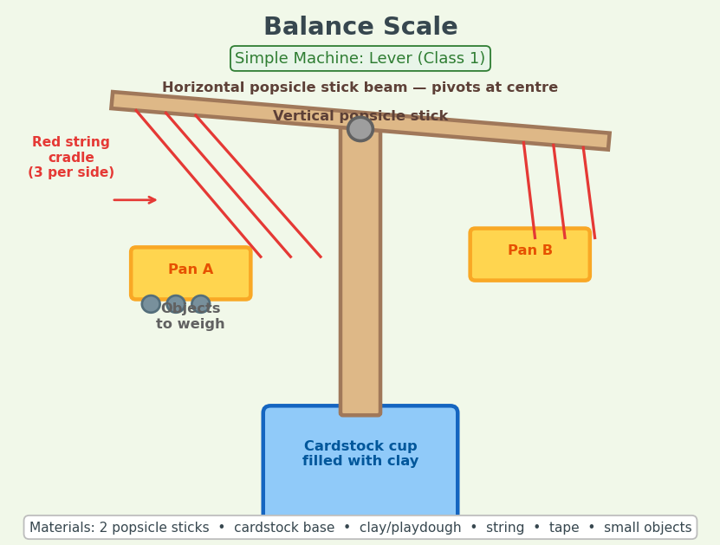

Instructor Prep — Do This BEFORE Kids Arrive
⚠ PREP: Pre-roll cardstock into small cylinders for bases — one per kid. Fill each with clay or playdough and let set. Pre-cut 6 string pieces per kid (15cm each). Have two small cardstock circles ready per kid as pans. Build your demo scale before class and confirm it swings freely and levels when empty.

Materials
Per Kid  - 2 popsicle sticks (1 vertical post, 1 horizontal beam)  - 1 cardstock cylinder base (pre-rolled, filled with clay)  - 6 string pieces (15cm each — 3 per pan)  - 2 small cardstock circles (pans)  - Masking tape  - Small objects for weighing | Shared / Class Setup  - Demo balance scale (instructor's, fully working)  - Weighing objects tray: coins, rocks, erasers, nuts, buttons  - Class chart: Name | Object A | Object B | Which heavier? | Surprised?  - Extra popsicle sticks for repairs

Instructor Demo Guide — Build This Before Class
INSTRUCTOR DEMO GUIDE — Build this before class
- BASE: Roll cardstock into a cylinder about 5cm diameter. Tape seam. Fill bottom half with clay through the top — heavy base stops the scale tipping. Let clay set.
- VERTICAL POST: Push one popsicle stick vertically into the clay through the top of the base. Should stand firm and upright. Tape around the base of the stick.
- HORIZONTAL BEAM: Find the exact centre of the second popsicle stick by balancing it on your finger. Mark the true centre with a pen dot.
- PIVOT: Lay the horizontal beam across the top of the vertical post at the centre dot. Secure with a tiny tape loop — just enough to keep it on top but still able to swing freely. Test: flick one end — it should swing and return to level.
- PANS: For each pan, tie 3 strings equally spaced around the edge of the cardstock circle. Gather the 3 string ends together and tie in a knot. Repeat for second pan.
- ATTACH PANS: Tie the gathered knot from each pan to each end of the horizontal beam at equal lengths. Both pans should hang at the same height.
- TEST: Same object in each pan — beam stays level. More in one side — drops. If pivot is stuck, loosen the tape loop slightly.

Step-by-Step 70-Minute Session Plan
TIME | PHASE | WHAT TO DO / SAY
0–8 min | Intro & Demo | Show your balance scale. Equal coins in each pan — level. Add 3 coins to one side — drops. Ask: 'What simple machine is this?' (lever). 'Where is the fulcrum?' (pivot at top of post). Let 2 kids add objects. Challenge: build your own precision balance scale that can detect even tiny weight differences. Hand out materials.
8–40 min | Build | STEP 1 (8 min): Roll cardstock into cylinder base. Tape seam. Fill bottom half with clay. Let sit. STEP 2 (5 min): Push vertical stick into clay — must stand firm. Tape around base. STEP 3 (8 min): Find true centre of horizontal beam by balancing on finger. Mark with pen dot. STEP 4 (5 min): Lay beam across post at centre dot. Secure with tiny tape loop — beam must swing freely. Test by flicking one end. STEP 5 (8 min): Tie 3 strings equally around each pan circle, gather and knot together. STEP 6 (4 min): Tie one pan to each beam end at equal length. Test — swings freely and levels when empty. INSTRUCTOR CHECK: if beam is stuck the tape loop is too tight — loosen it.
40–55 min | Weighing Challenge | Kids test objects from the tray. Challenge 1: find two objects that balance exactly — beam stays perfectly level. Challenge 2: find 3 small objects that together equal one big object. Challenge 3: can your scale detect the difference between one paperclip and two? Record all results on class chart.
55–62 min | Fix & Improve | Challenge: make your scale MORE sensitive. Guide toward: longer beam arms, lighter pans, more precise centre pivot. Kids try one improvement and retest with a single paperclip difference.
62–70 min | Share Out | Each kid shares most surprising weighing result. Discuss: 'Where do we use precision scales in real life?' (pharmacies, gold merchants, chemistry labs, postal services). Vocab: LEVER, FULCRUM, BEAM, PAN, PIVOT, BALANCE, PRECISION. Clean up all objects into tray.

Quick Reference — All 4 Builds
Wk | Date | G1–2 Build | G3–4 Build | Key Vocab
1 | Aug 18 | Cable Car | Well Pulley | Pulley, gravity, friction, load, force, wheel, axle, crank, rotation, mechanical advantage
2 | Aug 25 | Seesaw | Balance Scale | Lever, fulcrum, beam, balance, load, force, pivot, precision, Class 1 lever

Instructor Tips — Every Build Day
- Build your demo before every class. A working model in your hands is worth more than any explanation.
- Circulate constantly during build time — every kid needs at least one personal check-in from you.
- The explore and fix phase is where the deepest learning happens — never cut it short.
- Early finishers: challenge them to improve their design, add more load, or explain their build to a neighbour.
- When a build completely fails: celebrate it out loud. This is exactly what real engineers experience.
- The share-out builds public speaking confidence — make it non-negotiable every single session.
- Keep the class chart visible on the whiteboard all session — kids love comparing their results.
- Cable Car: test your zip line with small rocks BEFORE class to find the minimum rock threshold — tell kids this number at the start of the challenge.

SAFETY: All pre-cutting done by instructor before class. Scissors for kids only when trimming tape or string. No heat tools. Clay and playdough are non-toxic but keep away from mouths for younger kids. Skewer tips are sharp — pre-blunt with a small tape cap.

