JAVA Point of Sale (POS) System

*Note: Sub-titles are not captured in Xplore and should not be used

Mayuga, Keenan Eliot L.   
BS – Computer Engineering *organization   
(of Affiliation)*line 4: City, Country  
keenan_mayuga@dlsu.edu.ph

line 1: 4th Given Name Surname  
line 2: *dept. name of organization*  
*(of Affiliation)*  
line 3: *name of organization   
(of Affiliation)*line 4: City, Country  
line 5: email address or ORCIDCabrera, Rafael  
BS – Computer Engineering  
LBYCPEI EQ1  
rafael_cabrera@dlsu.edu.ph

line 1: 5th Given Name Surname  
line 2: *dept. name of organization   
(of Affiliation)*  
line 3: *name of organization   
(of Affiliation)*line 4: City, Country  
line 5: email address or ORCIDline 1: 3rd Given Name Surname  
line 2: *dept. name of organization   
(of Affiliation)*  
line 3: *name of organization   
(of Affiliation)*line 4: City, Country  
line 5: email address or ORCID

line 1: 6th Given Name Surname  
line 2: *dept. name of organization   
(of Affiliation)*  
line 3: *name of organization   
(of Affiliation)*line 4: City, Country  
line 5: email address or ORCID

***Abstract*** — A Point of Sale (POS) System developed in Object-Oriented programming (OOP) with Java. Serve retailers a way to operate through digital and technological. Features include: login system, menu GUI with buttons, receipt printing, and login credentials changing.

Keywords—java, pos, oop, javafx, sceneBuilder

# Introduction (*Heading 1*)

COVID-19 has created an economic crisis.  Many retailers and businesses are shifting to the digital world thus the dependency on technology. “Adjusting to the New Normal”, transferring to the digital world means also needing a system that will aid in the management of buying and selling of products. In relation to this, a point of sale system is developed in furtherance to sustain smooth operations and organization for retailers to have a digital store. This would be constructed and designed using Object-Oriented Programming (OOP) with Java.

## Significance

Ideally, a POS system should be:

* User-friendly
* Encrypted
* Convenient
* Straight-forward

Currently POS systems in this day and age, have an interface that is usually cluttered with unnecessary elements that doesn’t contribute to the current business transaction. In restaurants, it wouldn’t be an uncommon sight for a new employee to call over a senior to help with navigating through the POS system. Aside from that, in terms of security, most current POS systems are protected through a card system, in which a higher ranked employee would be in possession of a card that activates the administrator controls. Although this is a secure system, for smaller businesses, this may lead to unnecessary complications as the production of the cards could prove to be nuisance. In our POS we aim to simplify this by opting for a username and password system instead of the card system to alleviate that problem.

## Technical Difficulty

The difficulty in creating a POS system is that there are many ways to do it which depends on what the retailer is trying to achieve. Object-oriented programming allows you to break down the program into smaller divisions which you then could solve. JavaFX in combination with sceneBuilder was used to create a sleek and user-friendly UI. There are a lot of interactions in each scene. Managing data, especially the receipt data, through different methods and classes, effective usage of data is a challenge. The login system heavily utilizes file handling of text files. This gives the opportunity for the user to edit the application logins without actually editing the code itself, user-friendly for the people who don’t code.

Majority of minor businesses don’t even have a POS system and opt to manually manage the transactions. This is because small businesses may have a hard time implementing new technology into their system. Most of the POS systems are created specifically for big businesses.

## Social Impact

The goal of this program is to create a Point of Sale system that is easily manageable. Business owners can come from different backgrounds with different understandings of computers. If these business owners were to upgrade their businesses, they would want a POS that is not hard to understand and easy to use. Especially in these trying times, during the COVID Pandemic, a lot of people are looking to start a simple business. This program can be used by a wide audience of business owners, with or without technical expertise.

# METHODOLOGY

## UML Class Diagram

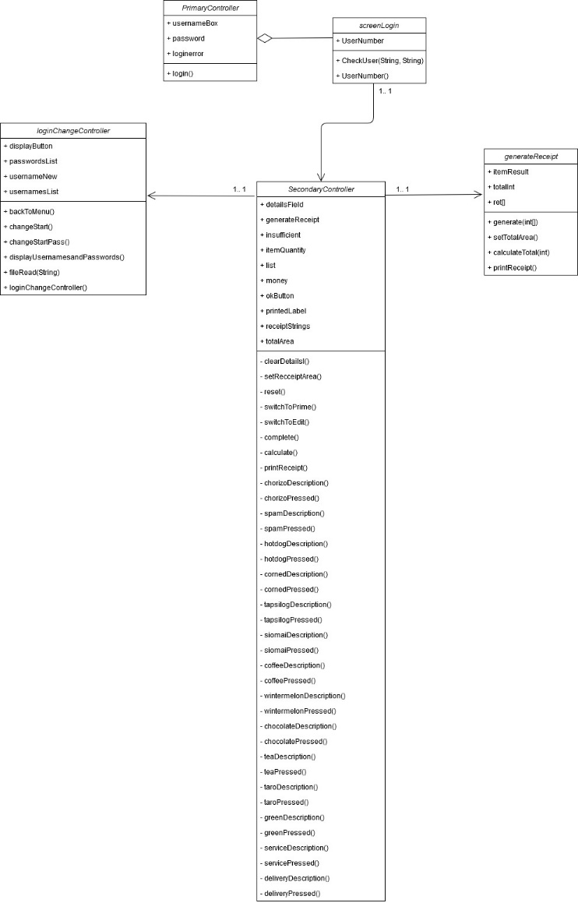

Fig. 1 Class Diagram

The UML Class Diagram of this program has 5 classes. PrimaryController, screenLogin, SecondaryController, generateReceipt, and loginChangeController.

## Results

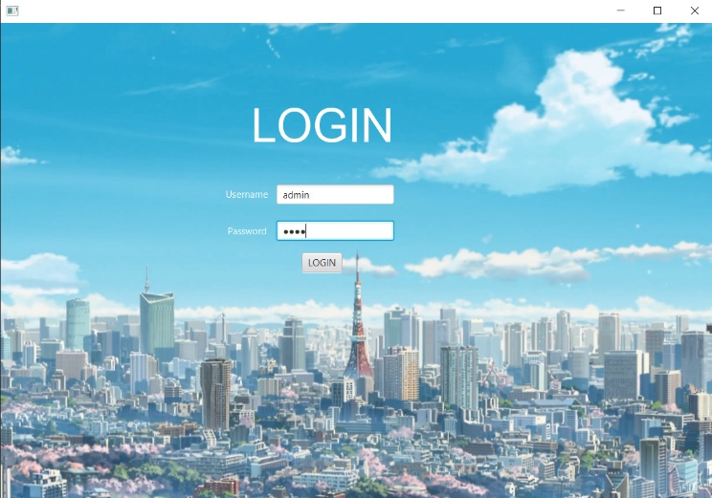

Fig. 2 Login Screen

Upon running the program, the user will be led to a login screen. This login screen keeps the POS secure and exclusive to the owners of the business.

Currently there are three logins:

Username:        Password:

Admin        1234

User1            pass1

User2            pass2

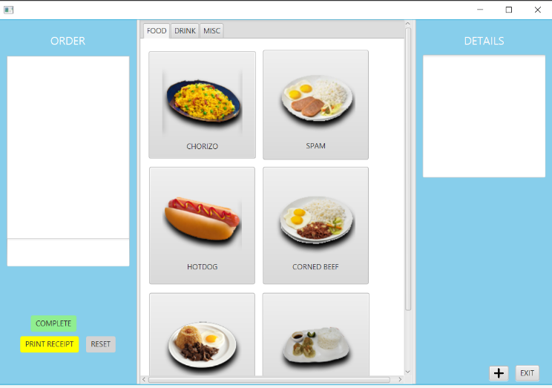

Fig. 3 Menu Screen, Food Tab

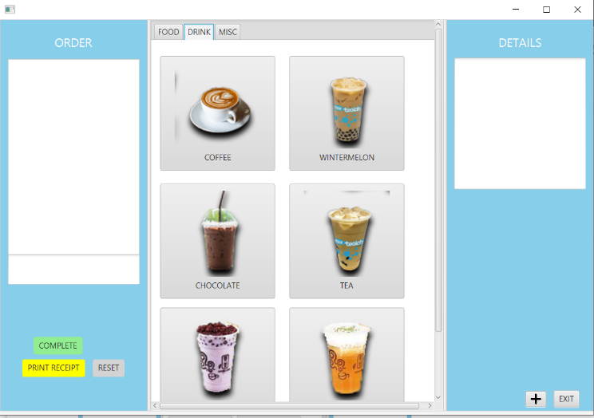

Fig. 4 Menu Screen, Drink Tab

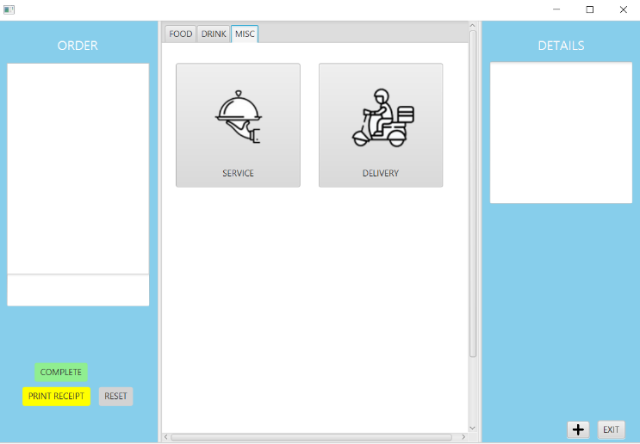

Fig. 5 Menu Screen, Misc Tab

This is the main ordering screen. On the center of the screen, the menu items are presented.  The menu is organized into three tabs, food, drink, and misc.

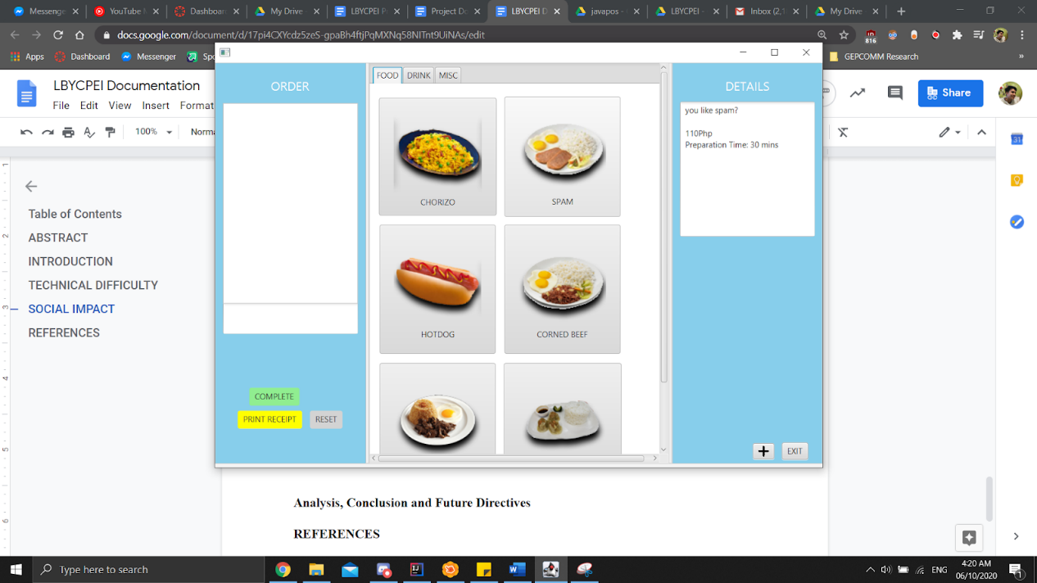

Fig. 6 Details on the right side

When the user hovers their cursor over an item, the details of the item are displayed on the left side. This would include a small description, the price and the preparation time.

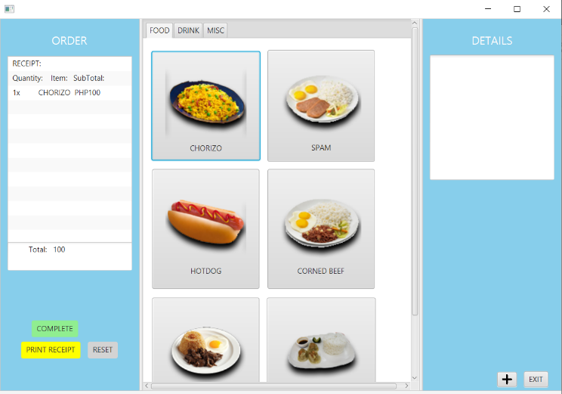

Fig. 7 Order Information

When a menu item is clicked, it is added to the right side of the program, it displays the quantity of the item (how many times it was selected), the item name, and the subtotal. At the bottom of the list, the total is displayed, this side of the screen will automatically update as you select items for the transaction.

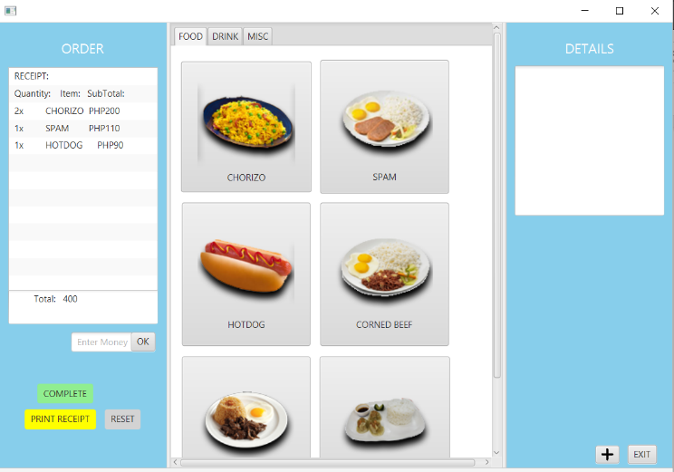

Fig. 8 Enter Money Prompt below the Order

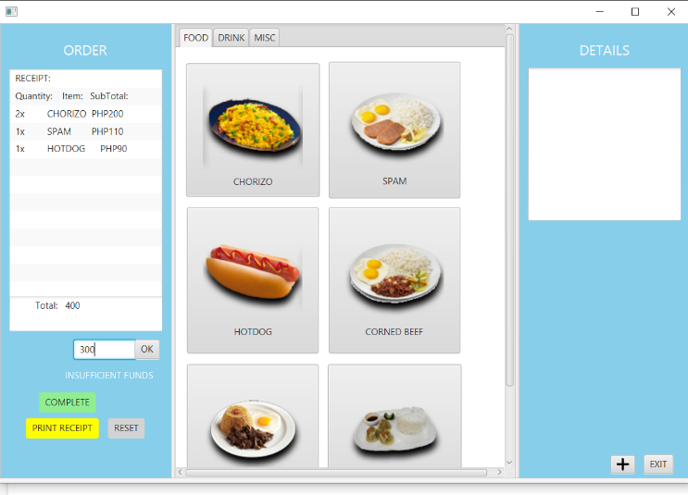

Fig. 9 Insufficient Funds prompt below the money prompt

Once the ordering has been completed, the user can click the green COMPLETE button. This will bring up the “Enter Money” prompt along with the OK button. The user will type the amount of money the customer will give. If the entered amount is less than the total it will display “INSUFFICIENT FUNDS” and then clear the textbox for the user to input again.

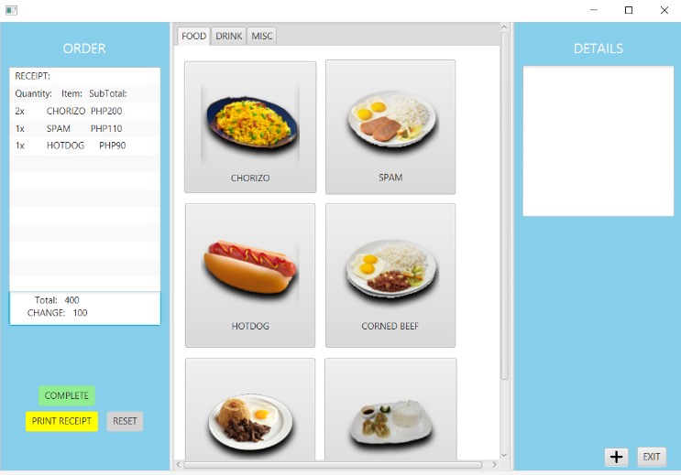

Fig. 10 Change Calculation

When the user enters an amount greater or equal to the total, it will calculate for the change. The “Enter Money” prompt and the ok button disappears.

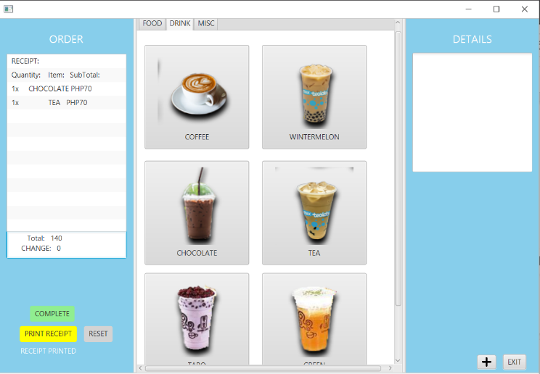

Fig. 11 Receipt Printed

The yellow Print Receipt takes all of the text on the right side and puts it into a text file for the purposes of the business owner.

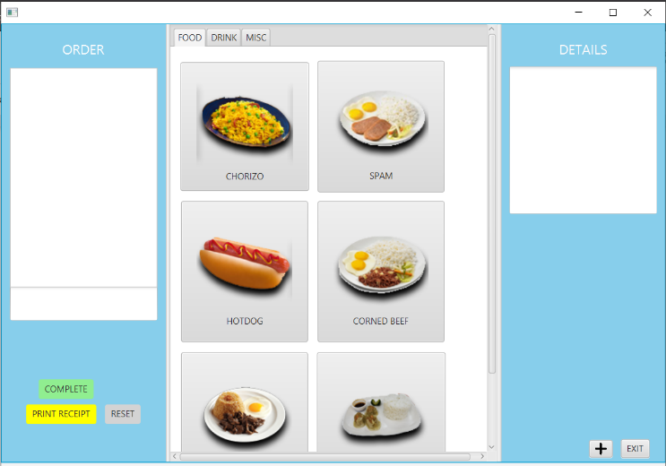

Fig. 12 Reset Button

The gray RESET button resets all the fields and the receipt area, for a fresh new order.

On the bottom right there are two buttons, the EXIT button brings the user back to the login screen. The cross button sends the user to the settings screen.

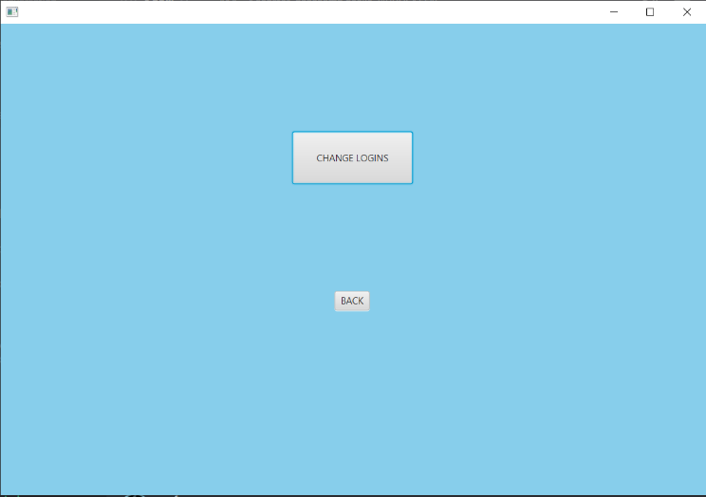

Fig.13 Settings Screen

The back Button sends the user back to the menu screen the Change Logins button sends the user to the screen where they can change the usernames and passwords.

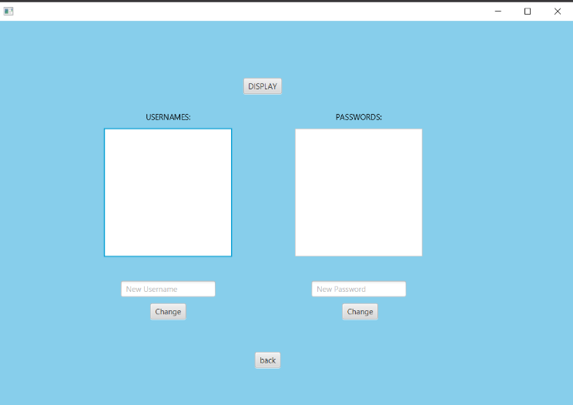

Fig.14 Change Logins Screen

Once in the Change Login screen the user should press the DISPLAY button on top, to reveal the usernames and passwords in their respective lists, on the left and right.

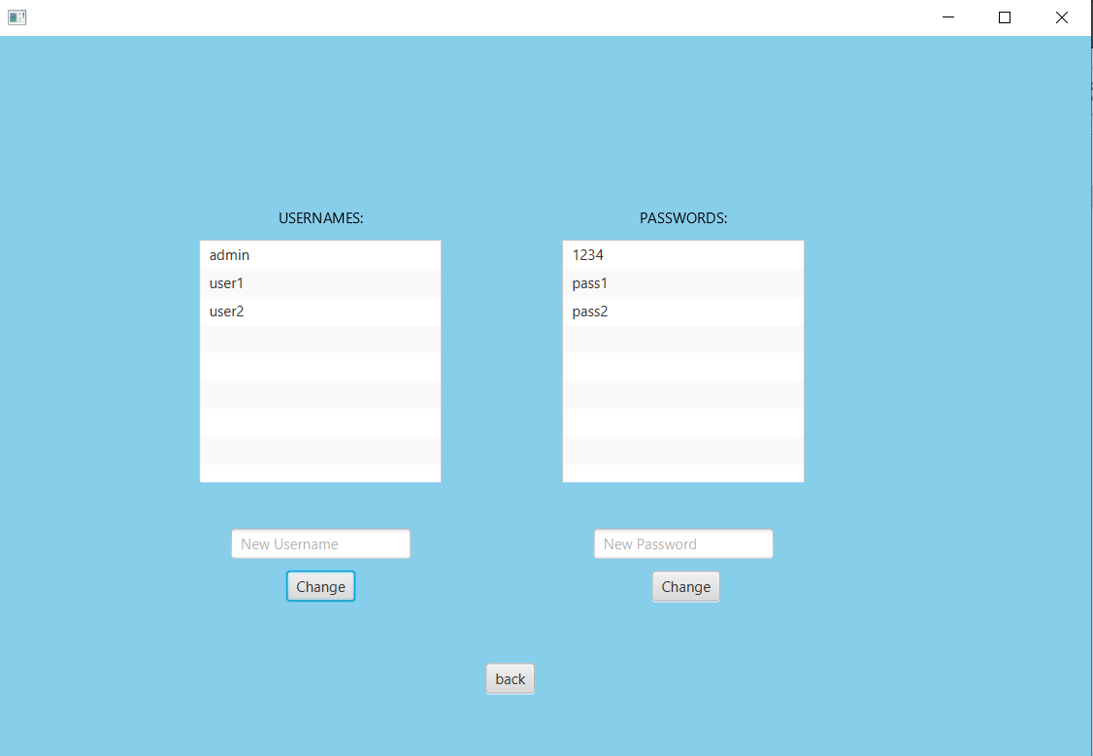

Fig.15 Usernames and Passwords Displayed

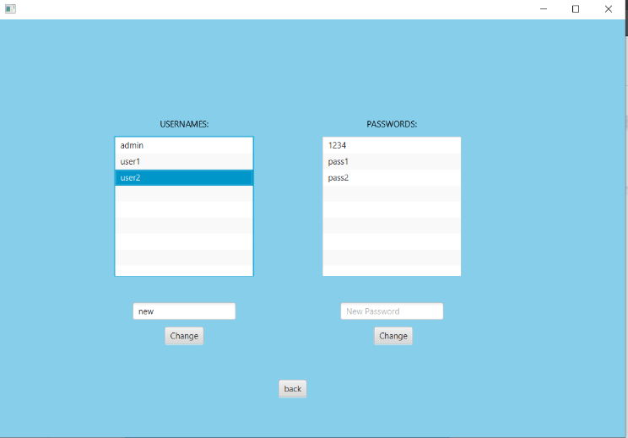

Fig.16 Usernames Selected

The user will select the username or password they would like to change and then put the new username or password in their respective textfield below each list. Once the user finalizes the new username/password, click change.

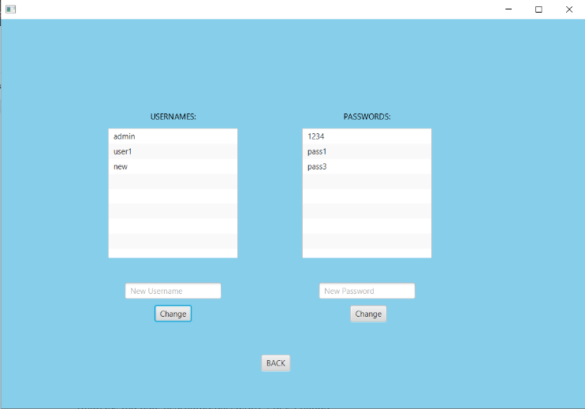

Fig.17 Usernames Changed

“user2” was selected and replaced with “new”. The changes get reflected right away. Since this is through txt file handling, the changes are permanent, so when the user exits out of the program, they will be able to use their new logins.

# APPENDICES

## Source Code

## REFERENCES

The template will number citations consecutively within brackets [1]. The sentence punctuation follows the bracket [2]. Refer simply to the reference number, as in [3]—do not use “Ref. [3]” or “reference [3]” except at the beginning of a sentence: “Reference [3] was the first ...”

Number footnotes separately in superscripts. Place the actual footnote at the bottom of the column in which it was cited. Do not put footnotes in the abstract or reference list. Use letters for table footnotes.

Unless there are six authors or more give all authors’ names; do not use “et al.”. Papers that have not been published, even if they have been submitted for publication, should be cited as “unpublished” [4]. Papers that have been accepted for publication should be cited as “in press” [5]. Capitalize only the first word in a paper title, except for proper nouns and element symbols.

For papers published in translation journals, please give the English citation first, followed by the original foreign-language citation [6].

1. Stubbs, Agnes The. *What Is a Point of Sale (POS) System?* 22 Sept. 2019, www.softwareadvice.com/resources/what-is-a-point-of-sale-system/.