**KSHITIJ DHYANI 18BIT0131**

**ASSESSMENT 2 (WEB TECHNOLOGIES)**

1. A parking garage charges a $2.00 minimum fee to park for up to three hours. The garage charges an additional $0.50 per hour for each hour or part thereof in excess of three hours. The maximum charge for any given 24-hour period is $10.00. Assume that no car parks for longer than 24 hours at a time. Write a script that calculates and displays the parking charges for each customer who parked a car in this garage yesterday. You should input from the user the hours parked for each customer. The program should display the charge for the current customer and should calculate and display the running total of yesterday's receipts. The program should use the function calculate-Charges to determine the charge for each customer. Use a prompt dialog to obtain the input from the user.

CODE:

<html>

<head>

<title></title>

<script type="text/javascript">

function cal_charge(n)

{

var charge = (n<=3)? n*2 : (n-3)*0.50 + 6;

if(charge < 10)

{

alert("The charges are : " + charge.toString() + "$");

}

else

{

alert("The out standing charges are 10$");

}

}

var no_of_hr = prompt("ENTER THE NUMBER OF HOURS PARKED :");

cal_charge(no_of_hr);

</script>

</head>

<body>

<h1>QUESTION 1</h1>

</body>

</html>

OUTPUT:

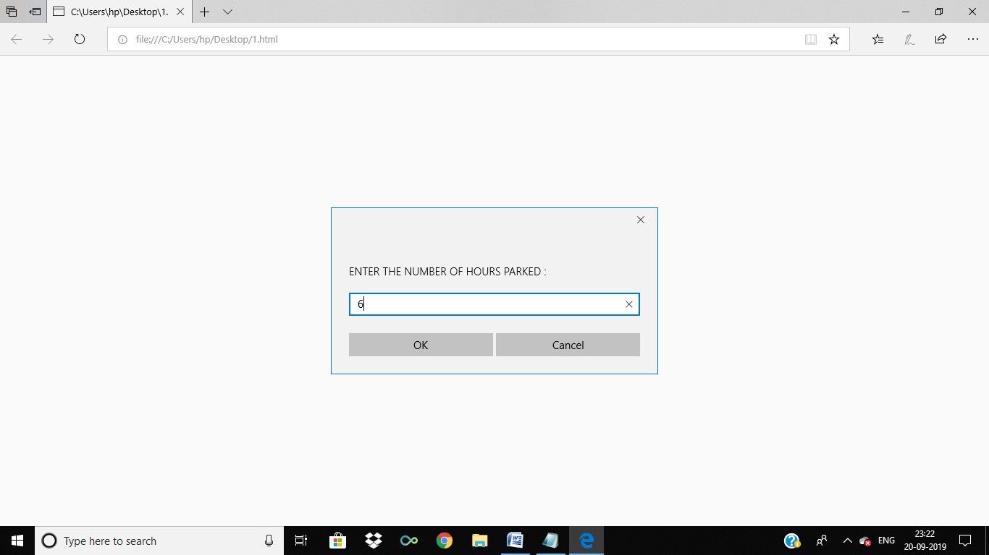

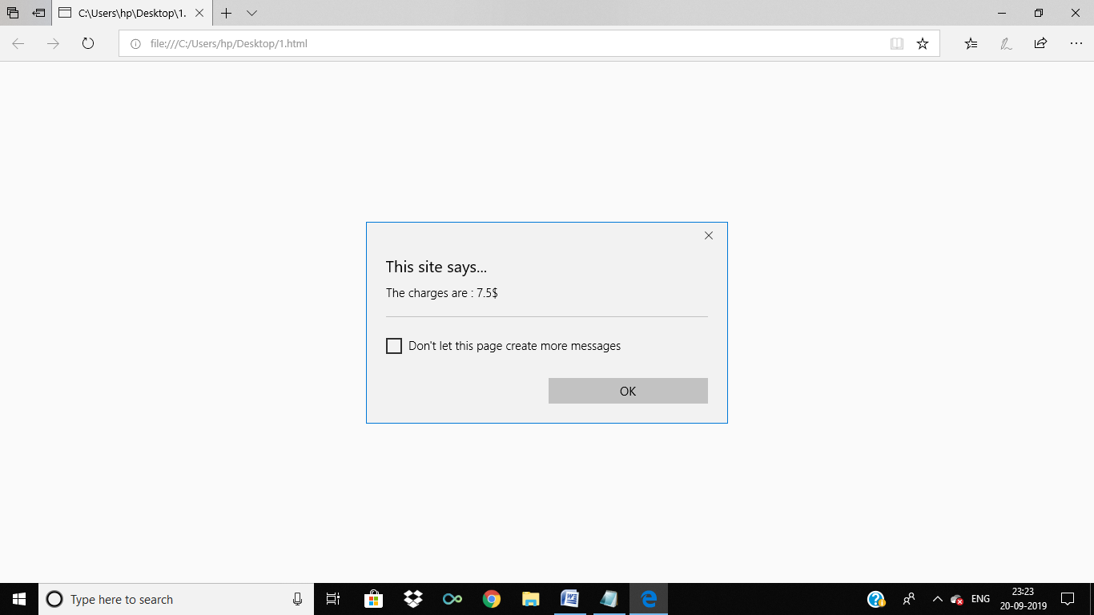

2. Create a web page containing three divisions. a) The first division displays a digital clock on the rightmost end. b) The width of the first division is 100%.The second division and third division lay side by side. c) The second division has an image slider and third division has a colour picker and two list box having font-family and size and a button. When a button is clicked the background colour, font and font size should change for a whole page. Use JavaScript to implement the above.

CODE:

<!DOCTYPE html>

<html>

<head>

<title>QUESTION 2</title>

<link rel="stylesheet" href="https://stackpath.bootstrapcdn.com/bootstrap/4.3.1/css/bootstrap.min.css" integrity="sha384-ggOyR0iXCbMQv3Xipma34MD+dH/1fQ784/j6cY/iJTQUOhcWr7x9JvoRxT2MZw1T" crossorigin="anonymous">

<style type="text/css">

html, body, div, span, applet, object, iframe,

h1, h2, h3, h4, h5, h6, p, blockquote, pre,

a, abbr, acronym, address, big, cite, code,

del, dfn, em, img, ins, kbd, q, s, samp,

small, strike, strong, sub, sup, tt, var,

b, u, i, center,

dl, dt, dd, ol, ul, li,

fieldset, form, label, legend,

table, caption, tbody, tfoot, thead, tr, th, td,

article, aside, canvas, details, embed,

figure, figcaption, footer, header, hgroup,

menu, nav, output, ruby, section, summary,

time, mark, audio, video {

margin: 0;

padding: 0;

border: 0;

font-size: 100%;

font: inherit;

vertical-align: baseline;

}

/* HTML5 display-role reset for older browsers */

article, aside, details, figcaption, figure,

footer, header, hgroup, menu, nav, section {

display: block;

}

body {

line-height: 1;

}

ol, ul {

list-style: none;

}

blockquote, q {

quotes: none;

}

blockquote:before, blockquote:after,

q:before, q:after {

content: '';

content: none;

}

table {

border-collapse: collapse;

border-spacing: 0;

}

*

{

margin: 0;

padding: 0;

}

#clock_div

{

background-color: #85C1E9 ;

width: 100%;

height: 40vh;

}

#clock_box

{

border:4px solid black;

font-family: impact;

font-size: 60px;

padding-top: 100px;

padding-left: 28%;

}

#test

{

background-color : #85C1E9;

border : 10px solid blue;

width: 50%;

height: 100%;

float:left;

}

#test2

{

background-color: #85C1E9;

width:50%;

height: 100%;

float:right;

}

#parent

{

display: inline-block;

border: 2px solid red;

width: 100%;

height: 100vh;

}

#img_box

{

border :5px solid green;

max-height: 100%;

}

#img_it_is

{

max-width: 100%;

max-height: 500px;

object-fit: contain;

}

</style>

</head>

<body onload= "gettime()"" >

<div id="clock_div" class =row>

<h2 id="clock_box" class="container">

The time is loading..

</h2>

</div>

<div id="parent">

<div id="test">

<button onclick="img_slide(1)">CLICK ME</button>

<div id="img_box">

<img src="1.jpg" id="img_it_is">

</div>

</div>

<div id="test2">

<input type="color" value="#85C1E9" id="color">

</div>

</div>

</body>

<script type="text/javascript">

var bro = document.querySelector("#color");

console.log(bro);

var color1 = document.querySelector("#clock_div");

console.log(color1);

var color2 = document.querySelector("#test");

console.log(color2);

var color3 = document.querySelector("#test2");

console.log(color3);

bro.addEventListener("change",function (event)

{

console.log(event.target.value);

console.log("check");

color1.style.background=event.target.value;

color2.style.background=event.target.value;

color3.style.background=event.target.value;

});

var last_n=0;

function img_slide(n)

{

var img_list = ["1.jpg","2.jpg","3.jpg","4.jpg"];

console.log(img_list);

// console.log(last_n);

// console.log(n);

var imgobj = document.querySelector("#img_it_is");

// console.log(img_list[last_n]);

console.log(imgobj);

var random =

Math.floor(Math.random() * (+4 - +0)) + +0;

console.log(random);

imgobj.setAttribute("src",img_list[random]);

}

function gettime()

{

var today = new Date();

var h = today.getHours();

var m = today.getMinutes();

var s = today.getSeconds();

var time = document.querySelector("#clock_box");

time.textContent= h +" : "+ m + " : " + s;

// console.log(time.textContent);

var t= setTimeout(gettime,500);

}

for(var i=0;i<5;i++)

{

var time = document.querySelector("#prac");

}

</script>

</html>

OUTPUT:

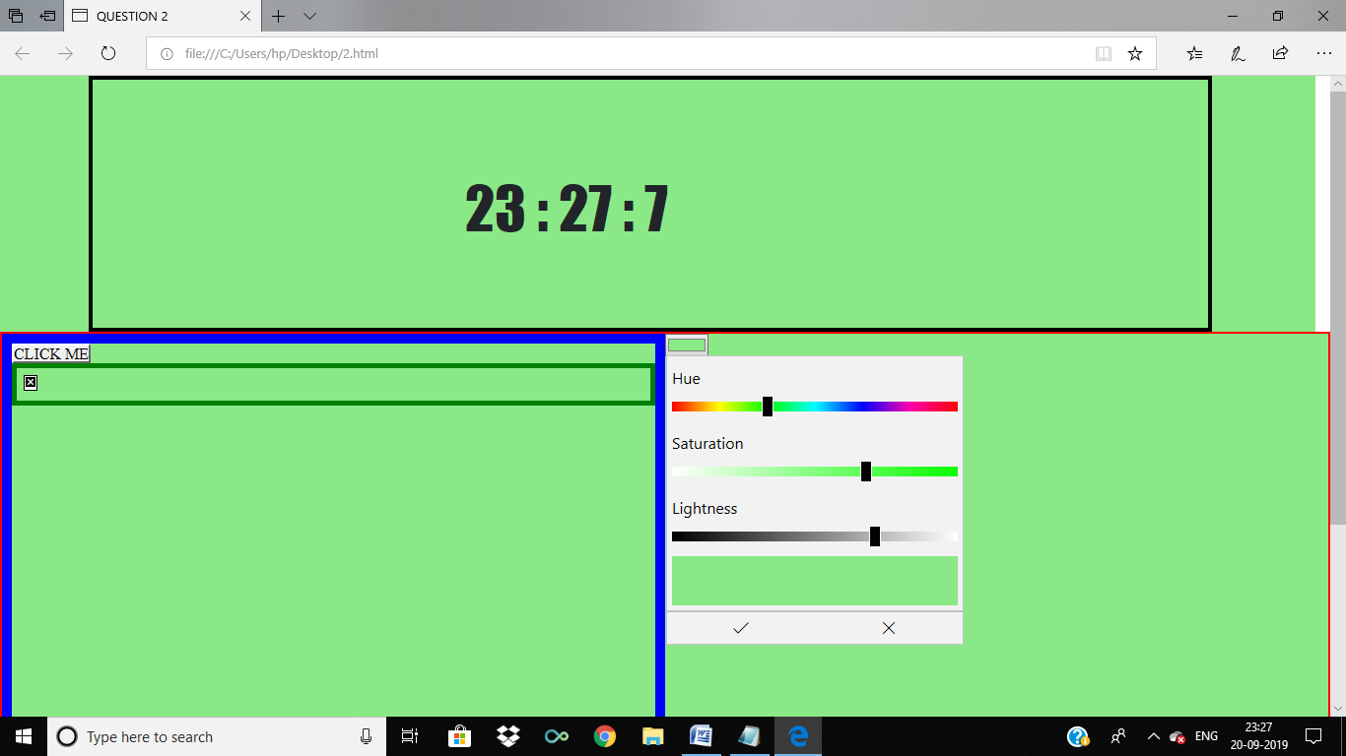

3. Design a student registration form which takes student name, register number, DOB, program, email id, temporary address, permanent address, phone number. Validate the following using JavaScript: a) Mobile number should be exactly 10 digits. b) Register number should have alphabets and numbers only. c) Name should not exceed 30 characters and can be only alphabets. d) Email validation. e) Provide a checkbox saying “Permanent address is same as temporary address”. If checked, the value of permanent address should be added automatically from temp address and should be in disabled mode.

CODE:

<!DOCTYPE html>

<html>

<head>

<title>QUESTION 3</title>

<link href="https://fonts.googleapis.com/css?family=Anton&display=swap" rel="stylesheet">

<style type="text/css">

html, body, div, span, applet, object, iframe,

h1, h2, h3, h4, h5, h6, p, blockquote, pre,

a, abbr, acronym, address, big, cite, code,

del, dfn, em, img, ins, kbd, q, s, samp,

small, strike, strong, sub, sup, tt, var,

b, u, i, center,

dl, dt, dd, ol, ul, li,

fieldset, form, label, legend,

table, caption, tbody, tfoot, thead, tr, th, td,

article, aside, canvas, details, embed,

figure, figcaption, footer, header, hgroup,

menu, nav, output, ruby, section, summary,

time, mark, audio, video {

margin: 0;

padding: 0;

border: 0;

font-size: 100%;

font: inherit;

vertical-align: baseline;

}

/* HTML5 display-role reset for older browsers */

article, aside, details, figcaption, figure,

footer, header, hgroup, menu, nav, section {

display: block;

}

body {

line-height: 1;

}

ol, ul {

list-style: none;

}

blockquote, q {

quotes: none;

}

blockquote:before, blockquote:after,

q:before, q:after {

content: '';

content: none;

}

table {

border-collapse: collapse;

border-spacing: 0;

}

*

body

{

background-color: #5D6D7E ;

padding-right: 10%;

padding-left: 10%;

}

#form

{

background-color: #45B39D ;

height: 100vh;

}

#heading

{

font-family: 'Anton', sans-serif;

font-weight: bold;

font-size: 30px;

}

#head_box

{

text-align: center;

padding-top: 30px;

}

#mobile_box

{

text-align: center;

}

#regno_box

{

text-align: center;

}

#name_box

{

text-align: center;

}

#email_box

{

text-align: center;

}

#perm_box

{

text-align: center;

}

#check_box

{

text-align: center;

}

#temp_box

{

text-align:center;

}

#submit_box

{

text-align: center;

}

#mobile_error

{

color: red;

font-weight: bolder;

}

#reg_error

{

color: red;

font-weight: bolder;

}

#name_error

{

color: red;

font-weight: bolder;

}

#email_error

{

color: red;

font-weight: bolder;

}

</style>

<script type="text/javascript">

function myform()

{

var form = document.querySelector("#form_id");

var submit_b = document.querySelector("#submit_b");

console.log((form.mobile_no.value).toString().length);

submit_b.addEventListener("click",function(event)

{

event.preventDefault();

});

if((form.mobile_no.value).length!==10)

{

var mobile_error = document.querySelector("#mobile_error");

console.log(mobile_error);

mobile_error.textContent = "The Mobile No should be 10 digits long";

}

if(!(form.reg_no.value).match(/^[0-9a-z]+$/))

{

var reg_error = document.querySelector("#reg_error");

console.log(reg_error);

reg_error.textContent = "The Registration number should only be alphanumeric";

}

if((form.name.value).length>30)

{

var name_error = document.querySelector("#name_error");

console.log(name_error);

name_error.textContent = "The name should be less than 30 letters long";

}

if(!(form.email.value).match(/^[a-z0-9]+$/i))

{

var name_error = document.querySelector("#email_error");

console.log(email_error);

email_error.textContent = "This is not a valid email";

}

}

function check_check()

{

var check = document.querySelector("#check");

console.log(check);

var temp_add = document.querySelector("#temp_add");

check.addEventListener("change",function()

{

if(this.checked)

{

console.log(temp_add);

var perm_add = document.querySelector("#perm_add");

console.log(perm_add.value);

temp_add.setAttribute("value",perm_add.value);

}

else

{

console.log("#");

temp_add.setAttribute("value","");

}

})

}

</script>

</head>

<body >

<div id="form">

<div id="head_box">

<h1 id="heading">STUDENT REGISTRATION FORM</h1>

</div>

<br>

<br>

<br>

<br>

<div id="form_box">

<form id="form_id">

<div id="mobile_box">

Phone :

<input type="text" name="mobile_no">

<div id="mobile_error_box">

<p id="mobile_error"></p>

</div>

</div>

<br>

<br>

<div id="regno_box">

RegNo:

<input type="text" name="reg_no">

<div id="reg_error_box">

<p id="reg_error"></p>

</div>

</div>

<br>

<br>

<div id="name_box">

Name :

<input type="text" name="name">

<div id="name_error_box">

<p id="name_error"></p>

</div>

</div>

<br>

<br>

<div id="email_box">

Email :

<input type="text" name="email">

<div id="email_error_box">

<p id="email_error"></p>

</div>

</div>

<br>

<br>

<div id="perm_box">

Permanent Address :

<input type="text" name="perm_add" id="perm_add">

</div>

<br>

<br>

<div id="check_box">

Permanent Address Same as Temporary Address

<input type="checkbox" name="check" id="check" onclick="check_check()">

</div>

<br>

<br>

<div id="temp_box">

Temporary Address :

<input type="text" name="temp_add" id="temp_add">

</div>

<br>

<br>

<div id="submit_box">

<input onclick="myform()" type="button" name="submit" id="submit_b" value="Submit">

</div>

</form>

</div>

</div>

</body>

</html>

OUTPUT:

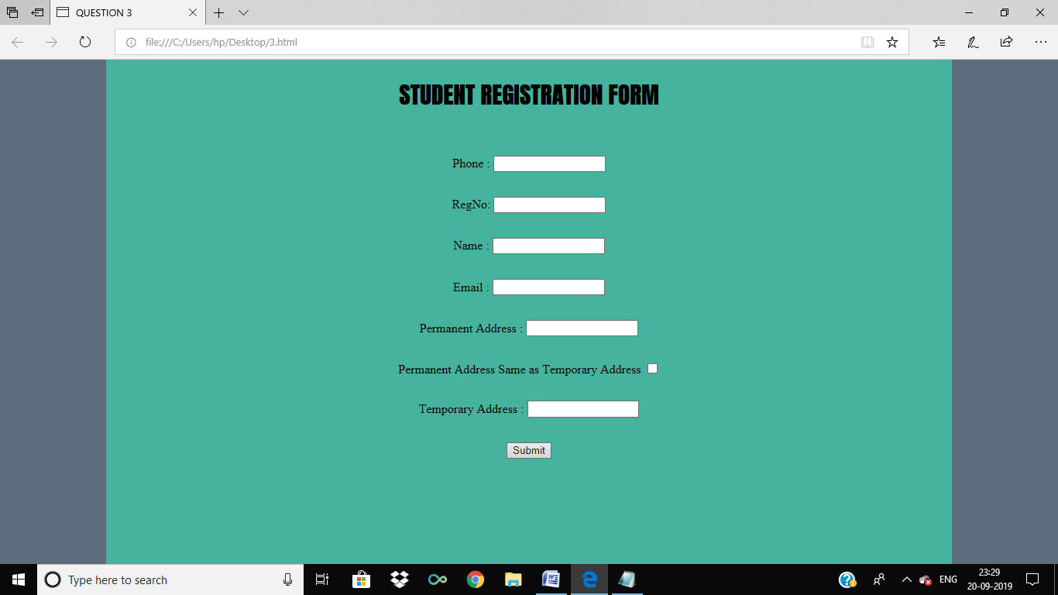

4. Write the JavaScript code to add behaviour to the following page for manipulating strings. a) The page UI allows the user to type a phrase into a text box. The user can click the "Go!" button to display the words in that phrase in reverse order. Each word in the phrase should be inserted as a span with a class of word, inside a div with the id of words. Every other word (the first, third, fifth, etc.) should also be underlined b) The user can optionally specify a "filter" text by typing into a text box with the id of filter. If a non-blank filter is specified, you should exclude any words from the phrase that contain that filter text, case-insensitively. For example, if the filter text is "abc", exclude any words containing abc, ABC, aBc, etc. c) If any words are excluded, under the list of words you should modify the div with id of count to display text of the form, "5 word(s) filtered out". The code should work for multiple clicks of the button. On each click it should clear any previous information you injected. You may assume that words in the phrase are separated by single spaces. d) These screenshots show the initial state, and after phrases have been typed and "Go!" is clicked.

CODE:

<!DOCTYPE html>

<html>

<head>

<title>Question 4</title>

<link href="https://fonts.googleapis.com/css?family=Anton&display=swap" rel="stylesheet">

<style type="text/css">

html, body, div, span, applet, object, iframe,

h1, h2, h3, h4, h5, h6, p, blockquote, pre,

a, abbr, acronym, address, big, cite, code,

del, dfn, em, img, ins, kbd, q, s, samp,

small, strike, strong, sub, sup, tt, var,

b, u, i, center,

dl, dt, dd, ol, ul, li,

fieldset, form, label, legend,

table, caption, tbody, tfoot, thead, tr, th, td,

article, aside, canvas, details, embed,

figure, figcaption, footer, header, hgroup,

menu, nav, output, ruby, section, summary,

time, mark, audio, video {

margin: 0;

padding: 0;

border: 0;

font-size: 100%;

font: inherit;

vertical-align: baseline;

}

/* HTML5 display-role reset for older browsers */

article, aside, details, figcaption, figure,

footer, header, hgroup, menu, nav, section {

display: block;

}

body {

line-height: 1;

}

ol, ul {

list-style: none;

}

blockquote, q {

quotes: none;

}

blockquote:before, blockquote:after,

q:before, q:after {

content: '';

content: none;

}

table {

border-collapse: collapse;

border-spacing: 0;

}

body

{

background-color: #45B39D;

}

#heading

{

font-family: 'Anton', sans-serif;

font-size: 100px;

background-color: #FFFF6C;

padding: 30px;

text-align: center;

}

#phrase_box

{

text-align: center;

margin: 30px;

}

#filter_box

{

text-align: center;

margin: 30px;

}

#go_box

{

text-align: center;

margin: 30px;

}

li

{

border: 2px solid red;

padding: 20px;

}

ul

{

margin-top: 50px;

}

#yo

{

font-weight: bold;

border: 4px solid yellow;

}

</style>

<script type="text/javascript">

function rev()

{

var form = document.querySelector("#form");

// console.log(form.phrase.value);

var phrase_list= form.phrase.value.split(/\s+/);

console.log(phrase_list);

var filter_list= form.filter.value.split(" ");

console.log(filter_list);

console.log(phrase_list);

var ul = document.querySelector('#my_list');

ul.innerHTML = "";

console.log(ul)

for(var i=0 ;i<phrase_list.length ; i++)

{

for(var j=0 ;j<filter_list.length ; j++)

{

console.log(phrase_list[i]);

console.log(filter_list[j]);

console.log(phrase_list[i]===filter_list[j] );

if(phrase_list[i]!=="" && !(phrase_list[i]===filter_list[j] ))

{

console.log(phrase_list[i]);

var li = document.createElement('li');

li.innerHTML = phrase_list[i].toString();

ul.appendChild(li);

}

}

}

}

</script>

</head>

<body>

<div id="heading">

Sentence Reverser

</div>

<div>

<form id="form">

<div id="phrase_box">

Phrase:<input type="text" name="phrase" id="phrase">

</div>

<div id="filter_box">

Filter : <input type="text" name="filter" id="filter">

</div>

<div id="go_box">

<input type="button" onclick="rev()" name="submit" value="Go" id="go">

<ul id = "my_list">

</ul>

</div>

</form>

</div>

</body>

</html>

OUTPUT:

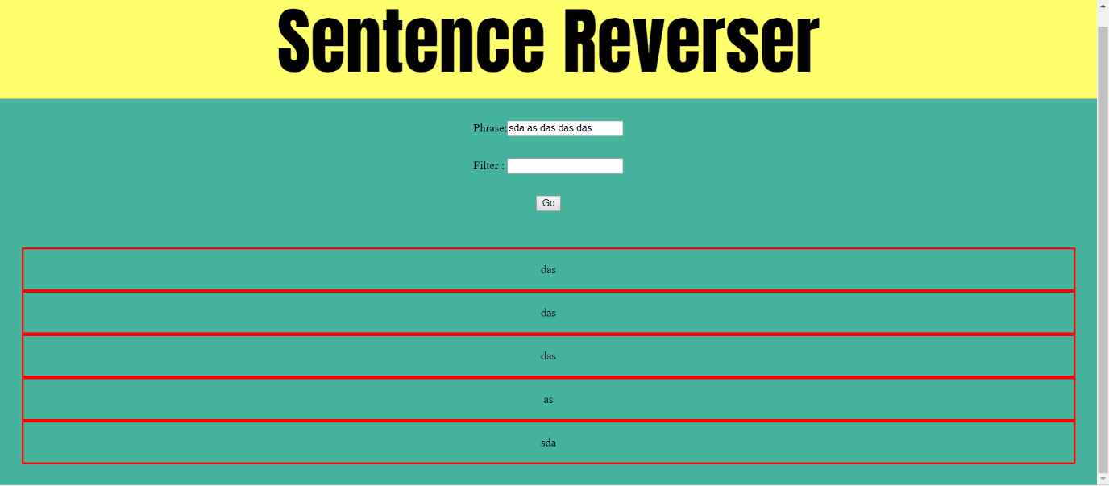

5. Develop an online Railway Reservation application. a) It has top frame with the name “Online Railway Reservation System” in the middle, there is a logo/image in the left corner using suitable CSS styles and the left frame with the links for Ticket booking and availability checking; for each link the target should be the right frame. b) Create a Ticket Booking form which should have From and To in a text box, Train Names in a drop down box, Coach Number in a list box, Date in a date field, Timing in a text box, Passengers Male and female in a dropdown menu showing the count number and Submit and Reset button. c) Assume availability of tickets already declared in the script. Create a DOM event to display the ticket confirmation details on any HTML element when ticket is available otherwise display “tickets not available” by invoking any other DOM event.

CODE:

MAIN:

<!DOCTYPE html>

<html>

<head>

<title>question 5</title>

<style type="text/css">

html, body, div, span, applet, object, iframe,

h1, h2, h3, h4, h5, h6, p, blockquote, pre,

a, abbr, acronym, address, big, cite, code,

del, dfn, em, img, ins, kbd, q, s, samp,

small, strike, strong, sub, sup, tt, var,

b, u, i, center,

dl, dt, dd, ol, ul, li,

fieldset, form, label, legend,

table, caption, tbody, tfoot, thead, tr, th, td,

article, aside, canvas, details, embed,

figure, figcaption, footer, header, hgroup,

menu, nav, output, ruby, section, summary,

time, mark, audio, video {

margin: 0;

padding: 0;

border: 0;

font-size: 100%;

font: inherit;

vertical-align: baseline;

}

/* HTML5 display-role reset for older browsers */

article, aside, details, figcaption, figure,

footer, header, hgroup, menu, nav, section {

display: block;

}

body {

line-height: 1;

}

ol, ul {

list-style: none;

}

blockquote, q {

quotes: none;

}

blockquote:before, blockquote:after,

q:before, q:after {

content: '';

content: none;

}

table {

border-collapse: collapse;

border-spacing: 0;

}

#top_row

{

width: 100vw;

height: 50vh;

border: 2px solid red;

}

#top_frame

{

width: 100%;

height: 100%;

object-fit: cover;

}

#left_frame

{

height: 50vh;

width: 50%;

border: 2px solid red;

float:left;

}

#left

{

object-fit: cover;

width: 100%;

height: 100%;

}

#right_frame

{

width: 48%;

height: 50vh;

border: 2px solid red;

float:right;

}

#right

{

height: 100%;

width: 100%;

object-fit: cover;

}

</style>

</head>

<body>

<div id="top_row">

<iframe name="top" src="question5.1.html" id="top_frame"></iframe>

</div>

<div id="left_frame">

<iframe name='left' src="question5.2.html" id="left"></iframe>

</div>

<div id="right_frame">

<iframe src="" id="right" name="right"></iframe>

</div>

</body>

</html>

TOP FRAME:

<!DOCTYPE html>

<html>

<head>

<title>top</title>

<style type="text/css">

html, body, div, span, applet, object, iframe,

h1, h2, h3, h4, h5, h6, p, blockquote, pre,

a, abbr, acronym, address, big, cite, code,

del, dfn, em, img, ins, kbd, q, s, samp,

small, strike, strong, sub, sup, tt, var,

b, u, i, center,

dl, dt, dd, ol, ul, li,

fieldset, form, label, legend,

table, caption, tbody, tfoot, thead, tr, th, td,

article, aside, canvas, details, embed,

figure, figcaption, footer, header, hgroup,

menu, nav, output, ruby, section, summary,

time, mark, audio, video {

margin: 0;

padding: 0;

border: 0;

font-size: 100%;

font: inherit;

vertical-align: baseline;

}

/* HTML5 display-role reset for older browsers */

article, aside, details, figcaption, figure,

footer, header, hgroup, menu, nav, section {

display: block;

}

body {

line-height: 1;

}

ol, ul {

list-style: none;

}

blockquote, q {

quotes: none;

}

blockquote:before, blockquote:after,

q:before, q:after {

content: '';

content: none;

}

table {

border-collapse: collapse;

border-spacing: 0;

}

#img_box

{

max-height: 50vh;

max-width: 40%;

float :right;

}

#text_box

{

max-width: 60%;

max-height: 50vh;

float:left;

}

#logo

{

width: 100%;

object-fit: contain;

max-height: 350px

}

</style>

</head>

<body bgcolor="yellow">

<div id="text_box">

<p>ONLINE RAILWAY RESERVATION SYSTEM</p>

</div>

<div id="img_box">

<img src="5.png" id="logo">

</div>

</body>

</html>

LEFT FRAME:

<!DOCTYPE html>

<html>

<head>

<title>question5.2</title>

<style type="text/css">

body

{

padding: 60px;

}

</style>

</head>

<body bgcolor="turquoise">

<ul>

<li><a href="question5booknow.html" target='right'>BOOK TICKET</a> </li>

<li><a href="question5about.html" target="right">ABOUT US</a> </li>

</ul>

</body>

</html>

ABOUT ME:

<!DOCTYPE html>

<html>

<head>

<title>ABOUT US</title>

<style type="text/css">

body

{

padding: 33px;

}

</style>

</head>

<body bgcolor="#25AB82">

<p>Lorem ipsum dolor sit amet, consectetur adipisicing elit, sed do eiusmod

tempor incididunt ut labore et dolore magna aliqua. Ut enim ad minim veniam,

quis nostrud exercitation ullamco laboris nisi ut aliquip ex ea commodo

consequat. Duis aute irure dolor in reprehenderit in voluptate velit esse

cillum dolore eu fugiat nulla pariatur. Excepteur sint occaecat cupidatat non

proident, sunt in culpa qui officia deserunt mollit anim id est laborum.

</p>

</body>

</html>

BOOK NOW:

<!DOCTYPE html>

<html>

<head>

<title>question 5 book</title>

<style type="text/css">

#con

{

color: #FF5656 ;

}

</style>

<script type="text/javascript">

function ticket()

{

var con = document.querySelector("#con");

// console.log(con.textContent);

var form = document.querySelector("#form");

// console.log(form.to.value);

// console.log(form.from.value);

// console.log(form.train_name.value);

// console.log(form.coach.value);

// console.log(form.date.value);

// console.log(form.time.value);

// console.log(form.gender.value);

if(form.train_name.value=="chennai express" || form.train_name.value=="delhi express")

{

confirm.value = "CONGRATULATIONS";

con.textContent = "YOUR TICKET IS CONFIRM";

}

else

{

confirm.value= "SORRY";

con.textContent = "SORRY SELECT ANOTHER TRAIN";

}

}

</script>

</head>

<body bgcolor="#2591AB">

<center><h3>BOOK YOUR TICKET HERE</h3></center>

<br>

<br>

<div id="from_box">

<form id="form">

<div>

To:<input type="text" name="to" value="chennai">

</div>

<div>

From:<input type="text" name="from" value="delhi">

</div>

Name of the train :

<select name="train_name">

<option value="chennai express">chennai express</option>

<option value="delhi express">delhi express</option>

<option value="agra express">agra express</option>

<option value="banaras express">banaras express</option>

</select>

<br>

Coach :

<select name="coach">

<option value="A1">A1</option>

<option value="A2">A2</option>

</select>

<br>

Date:

<input type="date" name="date">

Time:

<input type="time" name="time">

Gender:

<select name="gender">

<option value="Male">Male</option>

<option value="Female">Female</option>

</select>

<br>

<br>

<center>

<input onclick="ticket()" type="button" name="submit" value="submit">

</center>

</form>

<center>

<p id="con">RESERVATION STATUS PENDING</p>

</center>

</div>

</body>

</html>

OUTPUT:

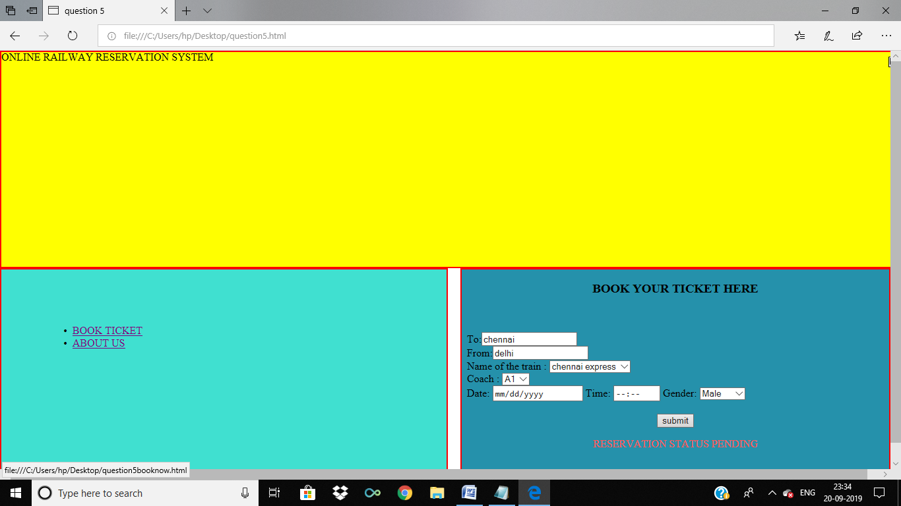

6. i) Design a table in the format given below using HTML and JQuery selectors.

ii) Apply different background for odd and even rows of the table.

iii) Apply different CSS for table header using JQuery selectors.

CODE:

<!DOCTYPE html>

<html>

<head>

<title>QUESTION 6</title>

<script type="text/javascript" src="lib/jquery.js"></script>

<style type="text/css">

table

{

border: 3px solid black;

width: 100%;

}

tr,th,td

{

border : 1px solid red;

}

tr:nth-child(even)

{

background: #FAE5D3 ;

}

tr:nth-child(odd)

{

background: #D5F5E3 ;

}

</style>

</head>

<body>

<table>

<tr>

<th id="first_name">FIRST NAME</th>

<th id="last_name">LAST NAME</th>

<th id="city">CITY</th>

<th id="state">STATE</th>

</tr>

<tr>

<td>asdda</td>

<td>asdda</td>

<td>asdda</td>

<td>asdda</td>

</tr>

<tr>

<td>asdda</td>

<td>asdda</td>

<td>asdda</td>

<td>asdda</td>

</tr>

<tr>

<td>asdda</td>

<td>asdda</td>

<td>asdda</td>

<td>asdda</td>

</tr>

<tr>

<td>asdda</td>

<td>asdda</td>

<td>asdda</td>

<td>asdda</td>

</tr>

<tr>

<td>asdda</td>

<td>asdda</td>

<td>asdda</td>

<td>asdda</td>

</tr>

<tr>

<td>asdda</td>

<td>asdda</td>

<td>asdda</td>

<td>asdda</td>

</tr>

</table>

</body>

<script type="text/javascript">

console.log($("#first_name"));

console.log($("#first_name"));

console.log($("#first_name"));

console.log($("#first_name"));

$("#first_name").css({

fontSize : "30px",

color : "#E74C3C",

padding : "30px",

});

$("#last_name").css({

fontSize : "30px",

color : "#8E44AD ",

padding : "30px",

});

$("#city").css({

fontSize : "30px",

color : "#3498DB ",

padding : "30px",

});

$("#state").css({

fontSize : "30px",

color : "#F1C40F ",

padding : "30px",

});

</script>

</html>

OUTPUT:

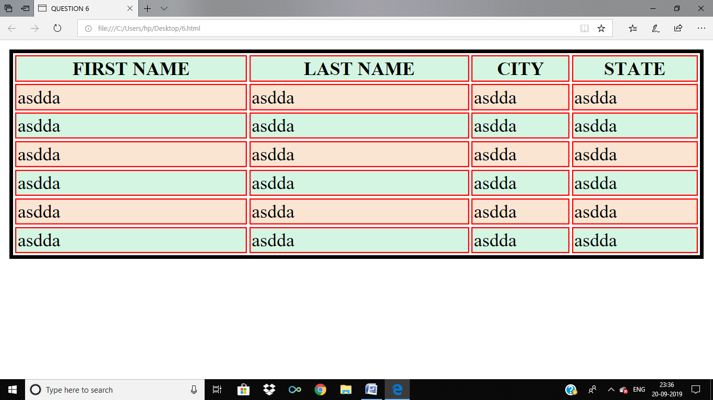

7. Write the JQuery code, so that when the Delete button is clicked, any button whose text value is divisible by the number written in the text field is removed from the page. You may assume that a valid number has been typed in the text field. The HTML code is the following: These screenshots show the initial page and its new appearance after typing 2 into the text field and pressing Delete:

CODE:

<!DOCTYPE html>

<html>

<head>

<title>QUESTION 7</title>

<script type="text/javascript" src="lib/jquery.js"></script>

</head>

<body bgcolor="#566573 ">

<form >

DEVISIBLE BY :<input id="dev" type="text" name="dev">

<input type="button" name="delete" value="DELETE" onclick="del()">

</form>

<br>

<br>

<form>

<input id="11" type="button" name="11" value="11">

<input id="22" type="button" name="22" value="22">

<input id="34" type="button" name="34" value="34">

<input id="42" type="button" name="42" value="42">

<input id="50" type="button" name="50" value="50">

<input id="63" type="button" name="63" value="63">

<input id="71" type="button" name="71" value="71">

<input id="85" type="button" name="85" value="85">

<input id="94" type="button" name="94" value="94">

<input id="103" type="button" name="103" value="103">

</form>

</body>

<script type="text/javascript">

function del()

{

var val = $("#dev").val();

if(parseInt($("#11").val())%parseInt(val)==0)

{

$("#11").remove();

}

if(parseInt($("#22").val())%parseInt(val)==0)

{

$("#22").remove();

}if(parseInt($("#34").val())%parseInt(val)==0)

{

$("#34").remove();

}if(parseInt($("#42").val())%parseInt(val)==0)

{

$("#42").remove();

}if(parseInt($("#50").val())%parseInt(val)==0)

{

$("#50").remove();

}if(parseInt($("#63").val())%parseInt(val)==0)

{

$("#63").remove();

}if(parseInt($("#71").val())%parseInt(val)==0)

{

$("#71").remove();

}if(parseInt($("#85").val())%parseInt(val)==0)

{

$("#85").remove();

}if(parseInt($("#94").val())%parseInt(val)==0)

{

$("#94").remove();

}if(parseInt($("#103").val())%parseInt(val)==0)

{

$("#103").remove();

}

}

</script>

</html>

OUTPUT:

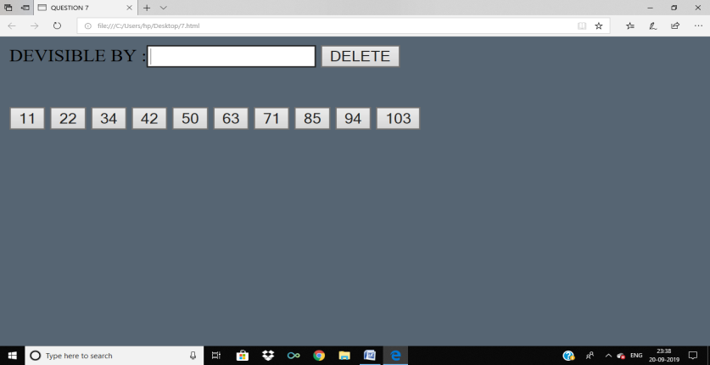

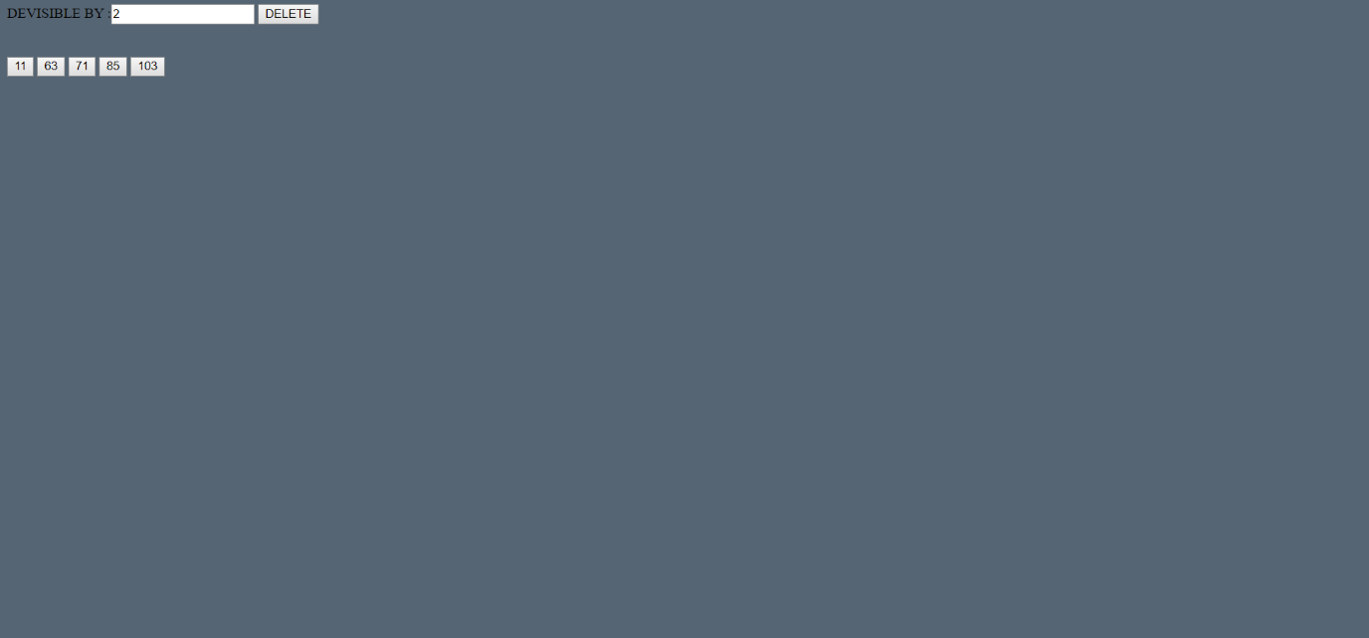

8. Write the JQuery code to add behavior to the following page for keeping track of a todo-list.

a) The page UI allows the user to type an item into a text box. The user can click the "add" button to add the item to the bottom of the list. Each word in the phrase should be inserted as a li, inside an ul with the id of list.

b) If the user wishes to remove an item he or she can type the text of the item he or she wishes to remove in the text box and click the “remove” button. This should be case insensitive. For example, if the list only contains “foo” and the user tries to remove “FoO”, it should be removed. If the user tries to remove an item that is in the list multiple times only the first occurrence should be removed.

c) The items should have background colors that alternate between white and yellow (first white, then yellow, then white, yellow, etc.). This should still be the case no matter how many items are removed or added and no matter what order these operations are done in.

d) The code should work for multiple clicks of the buttons. On each click it should clear any previous information you typed in the input boxes. These screenshots show the state after items have been added and the state after items have been removed.

CODE:

<!DOCTYPE html>

<html>

<head>

<title>QUESTION 8</title>

<script type="text/javascript" src="lib/j.js"></script>

<script type="text/javascript">

function add_job()

{

console.log("helloe");

$("#to_do_list").append('<li id=' + $("#job").val() + '>'+$("#job").val()+'</li><br/>');

$("#to_do_list").css({

fontSize:"25px",

fontFamily:"Impact"

});

$("#job").val("");

}

function remove_job()

{

console.log($("#job").val());

$("#"+$("#job").val()).remove();

}

</script>

<style type="text/css">

li:nth-child(even)

{

background: #FAE5D3 ;

}

</style>

</head>

<body bgcolor="#BB8FCE">

<h1>MY SUPER NIFTY TO-DO LIST</h1>

<form>

<input type="text" name="name" placeholder="Enter Job Here"id="job">

<input type="button" id="addjob" value="ADD" name="add" onclick="add_job()">

<input type="button" name="remove" value="REMOVE" onclick="remove_job()" id="remove" >

</form>

<br>

<br>

<br>

<ol id="to_do_list">

</ol>

</body>

</html>

OUTPUT:

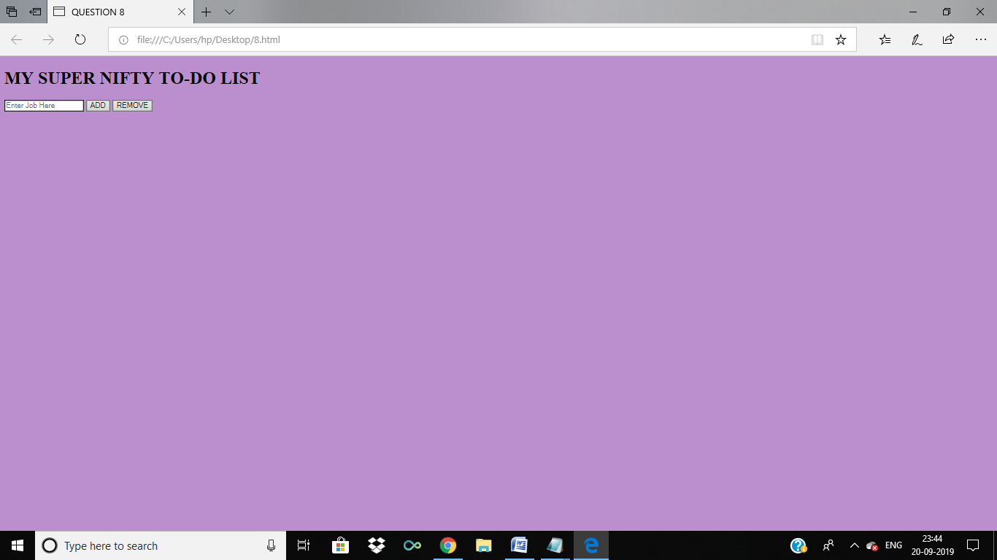

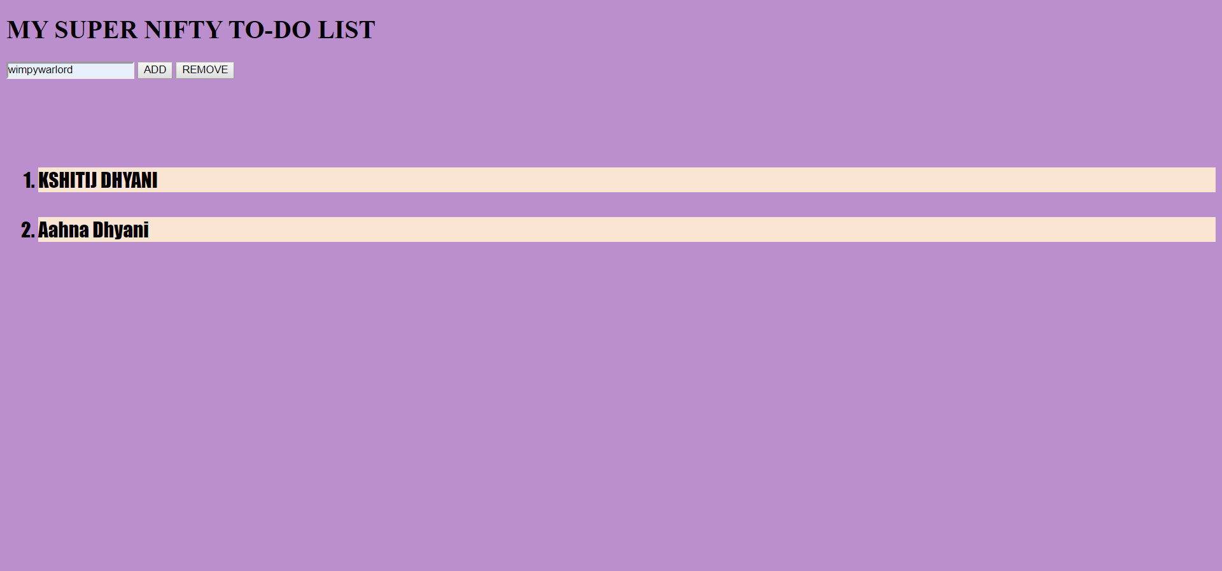

9. a) Validate the Event Registration Form given below using Jquery for the following conditions.

1) All fields are mandatory

2) Zip code should be exactly five digits

3) Email validation

b) Create a JSON file for a list of cities. Provide autocomplete option for city field using the JSON file as source.

CODE:

<!DOCTYPE html>

<html>

<head>

<title>QUESTION 9</title>

<link href="https://fonts.googleapis.com/css?family=Roboto+Condensed&display=swap" rel="stylesheet">

<style type="text/css">

#form_heading

{

background-color: #34495E;

color: white;

padding: 30px;

font-family: 'Roboto Condensed', sans-serif;

}

#line

{

border-top:3px dotted #000;

}

#form_body

{

padding: 30px;

background-color: #AEB6BF ;

}

#submit

{

padding: 20px;

background-color: #34495E;

}

#error_box

{

text-align: center;

background-color: #F5B7B1;

}

</style>

<script type="text/javascript" src="lib/j.js"></script>

<script type="text/javascript">

function valid()

{

console.log($("#first_name").val());

if($("#first_name").val()=="" || $("#last_name").val()=="" || $("#email").val()=="" || $("#zip_code").val()=="" || $("#first_name").val()=="")

{

var obj = $("#error").text("All fields are necessary");

obj.css({

color:"red",

fontSize:"20px",

});

}

else

{

if($("#zip_code").val().length!=5)

{

var obj = $("#error").text("Zip Code has to be 5 character long");

obj.css({

color:"red",

fontSize:"20px",

});

}

else

{

if(!$("#email").val().match(/\S+@\S+\.\S+/))

{

var obj = $("#error").text("Enter A valid email");

obj.css({

color:"red",

fontSize:"20px",

});

}

else

{

var obj = $("#error").text("Successfully Submitted.");

obj.css({

color:"green",

fontSize:"20px",

});

$("#error_box"). css({

backgroundColor:"#82E0AA "

}

);

}

}

}

}

var options = {

data: ["Delhi","Vellore"]

};

$("#city").easyAutocomplete(options);

</script>

</head>

<body>

<div id="form_box">

<div id="form_heading">

<h1>EVENT REGISTRATION FORM</h1>

</div>

<form>

<div id="form_body">

First Name :<input type="text" name="first_name" id="first_name">

<br>

<br>

Last Name : <input id="last_name" type="text" name="last_name">

<br>

<br>

Email : <input type="text" name="email" id="email">

<br>

<br>

City :

<input type="text" name="city" id="city">

<br>

<br>

State:

<select>

<option>Delhi</option>

<option>UP</option>

<option>UK</option>

<option>PUNJAB</option>

</select>

<br>

<br>

Zip Code : <input type="text" name="zip_code" id="zip_code"><br>

<br>

<hr id="line">

Speaking at the Conference :

Yes<input type="radio" name="speak" value="yes">

No<input type="radio" name="speak" value="no">

<br>

Conference Pass:<br>

1-Day Pass<input type="radio" name="pass" value="1day"><br>

2-Day Pass<input type="radio" name="pass" value="2day"><br>

3-Day Pass<input type="radio" name="pass" value="3day"><br>

4-Day Pass<input type="radio" name="pass" value="4day"><br>

<hr id="line">

Meal Preference :

<select>

<option>Veg</option>

<option>Non-Veg</option>

</select>

</div>

<div id="submit">

<center>

<input type="button" name="submit" onclick="valid()" id="on_submit" value="Submit">

</center>

</div>

</form>

<div id="error_box">

<p id="error"></p>

</div>

</div>

</body>

</html>

OUTPUT:

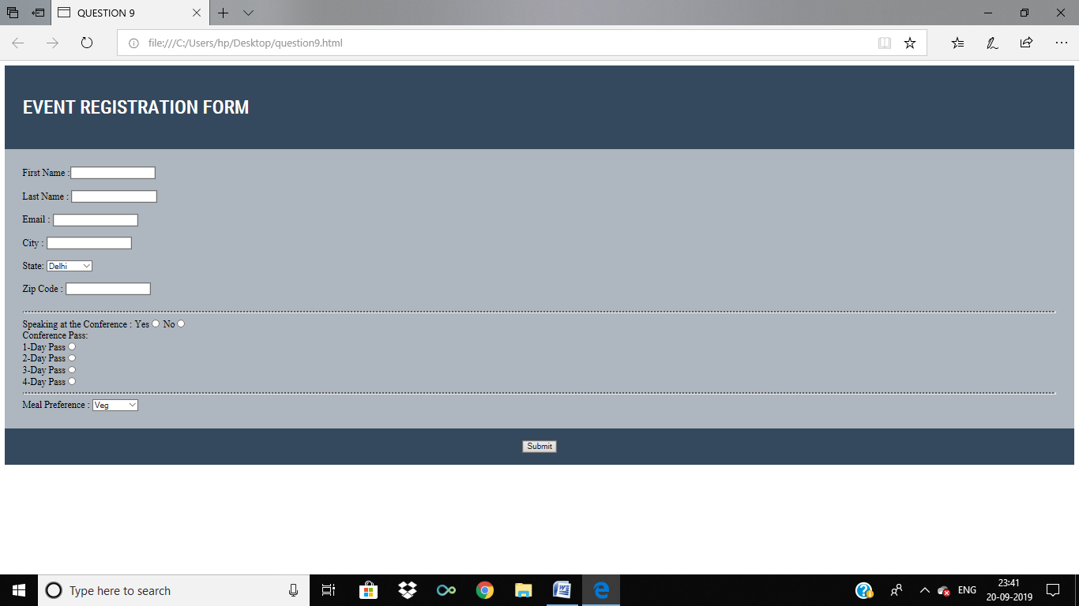

10. Write the XHTML code to create the form with the following capabilities

a) A text widget to collect the users name

b) Four check boxes, one each for the following items i. Four 100 watt light bulbs for Rs. 20=39 ii. Eight 100 watt light bulbs for Rs 40=20 iii. Four 100 watt long life light bulbs for Rs. 30=95 iv. Eight 100 watt long life light bulbs for Rs 70=49

c) A collection of 3 radio buttons that are labeled as follows

i. Visa ii. Master Card iii. Discover

d) Write an AJAX script that computes the total cost of the ordered light bulbs for the above program after adding 13.5% VAT. The program must inform the buyer of exactly what was ordered in table.

CODE:

<!DOCTYPE html>

<html>

<head>

<title>QUESTION 10</title>

<script type="text/javascript" src="lib/j.js"></script>

<script type="text/javascript">

function ans()

{

console.log("adsasd");

console.log($("#1").val());

if($("#1").is(":checked"))

{

$("#output1").text($("#1").val());

}

if($("#2").is(":checked"))

{

$("#output2").text($("#2").val());

}

if($("#3").is(":checked"))

{

$("#output3").text($("#3").val());

}

if($("#4").is(":checked"))

{

$("#output4").text($("#4").val());

}

}

</script>

</head>

<body bgcolor="#7FB3D5">

<center>

<form id="form">

<input type="text" name="username" placeholder="username">

<br>

<br>

<label>Four 100 watt light bulbs for Rs. 20=39 </label><input type="checkbox" id="1" name="1" value="Four 100 watt light bulbs for Rs. 20=39 ">

<br>

<br>

<label>Eight 100 watt light bulbs for Rs 40=20 </label><input type="checkbox" id="2" name="2" value="Eight 100 watt light bulbs for Rs 40=20">

<br>

<br>

<labelw>Four 100 att long life light bulbs for Rs. 30=95</label><input type="checkbox" id="3" name="3" value="Four 100 att long life light bulbs for Rs. 30=95">

<br>

<br>

<label>Eight 100 watt long life light bulbs for Rs 70=49</label><input type="checkbox" id="4" name="4" value="Eight 100 watt long life light bulbs for Rs 70=49">

<br>

<br>

<label>Visa</label><input type="radio" name="5" value="visa">

<br>

<br>

<label>Master Card</label> <input type="radio" name="5" value="mastercard">

<br>

<br>

<label>Discover</label><input type="radio" name="5" value="discover">

<br>

<br>

<input type="button" name="submit" onclick="ans()" value="Submit">

</form>

</center>

<h1>WHAT WAS ORDERED</h1>

<p id="output1">

</p>

<p id="output2">

</p>

<p id="output3">

</p>

<p id="output4">

</p>

</body>

</html>

OUTPUT:

