3. Methodology
This section describes the end-to-end pipeline that transforms raw aquarium video of Aurelia aurita into a binary pollution alarm. The pipeline has five stages: (i) controlled video acquisition in clean and polluted water with logged injection timestamps; (ii) per-frame detection and tracking with a YOLO model trained on a custom dataset; (iii) signal preprocessing that reconstructs a continuous bell-area time series and removes slow drift; (iv) extraction of a compact set of pulsation, kinematic, and detection-quality features on overlapping temporal windows; and (v) an unsupervised two-layer anomaly detector operating on per-animal baselines. The first four stages are conventional and are described in Sections 3.1–3.4. The fifth stage, which is the main methodological contribution of this work, is described in Sections 3.5–3.7. Section 3.8 summarises the implementation and reports the validation performed on a held-out animal.

3.1 Experimental design and dataset
The dataset consists of recordings of adult medusae in a controlled laboratory aquarium with a stationary side-view camera at 1920×1080 resolution and 29.97 frames per second. Each experiment follows a paired within-subject protocol: a given individual is first recorded in clean seawater to establish a behavioural baseline, then the pollutant is introduced into the same aquarium while recording continues, and the post-injection behaviour of the same animal is followed for at least 40 minutes. Diesel fuel was chosen as the first-phase pollutant because its active fractions — petroleum hydrocarbons and polycyclic aromatic hydrocarbons — are among the most widespread contaminants of coastal waters and are known to disrupt jellyfish neuromuscular function at sub-lethal concentrations (Echols et al., 2016; Honda & Suzuki, 2020).
Two protocol details are critical and are enforced in all recordings used for the analysis below. First, the clean-water baseline is acquired continuously for at least 15 minutes, preferably 30 or more, because per-animal z-score normalisation (Section 3.5.2) relies on a stable estimate of the baseline mean and standard deviation. In our pilot data, short baselines (e.g. five minutes for one individual) produced inflated z-scores and inconsistent behaviour of the detector. Second, the absolute time of pollutant injection is recorded to the second. This is essential because the response to a toxicant is time-varying: in one of the pilot animals we observed a stimulation phase lasting approximately 17 minutes post-injection, followed by a depression phase, which is invisible without a precise injection timestamp. The injection timestamp is attached to every downstream feature window as the field t_inj_s, which is zero at injection, negative before, and positive after.
Video frames during which the camera is physically disturbed (for example, while pouring pollutant into the aquarium) cause false centroid displacements and must be excluded. These intervals are logged and any 60-s feature window overlapping a disturbance is marked with an artefact flag and dropped from both calibration and scoring. In the present pilot data, the disturbed intervals amount to 3 of 252 feature windows.

3.2 Detection and tracking
Per-frame detection is performed by a YOLO object detector trained on a custom-labelled dataset of A. aurita images. For each frame, the model emits a single axis-aligned bounding box characterised by pixel coordinates (x₁, y₁, x₂, y₂), a centroid (c_x, c_y), the pixel area of the box, and a detection confidence score in [0, 1]. These quantities, together with the frame index and timestamp, constitute the entire input to all downstream processing; no additional image-level information is propagated beyond the detector. This design choice keeps the pipeline lightweight, portable, and privacy-preserving in field deployments — the raw video need not be retained after detection — and is analogous to the JeTA pipeline of Boyd et al. (2025), which demonstrated that bounding-box dimensions alone are sufficient to detect biologically meaningful changes in pulsation frequency. Single-target tracking is used throughout: each aquarium is monitored for one focal jellyfish at a time, so no data-association step is required and consecutive detections are treated as a contiguous trajectory.

3.3 Signal preprocessing
Two signal-quality issues are handled before feature extraction. First, YOLO occasionally fails to detect the medusa; across the pilot data the detection rate varies from 95.8 % to 100 %. Frames in which all bounding-box coordinates are missing are treated as detection gaps and linearly interpolated in the area and centroid signals, up to a maximum permitted gap length of one second. Windows whose total dropout fraction exceeds 20 % are flagged as unreliable and excluded from subsequent analysis.
Second, the raw bell-area signal contains a slow drift of tens of seconds’ duration that reflects the animal swimming closer to or further from the camera, rather than any physiological pulsation. This drift is estimated by a Savitzky–Golay low-pass filter (window 15 s, polynomial order 2) and subtracted, yielding a zero-mean AC signal that contains only the contractile cycle. A third-order Butterworth band-pass filter (0.1–2.0 Hz, applied forward and backward to avoid phase distortion) further restricts the signal to the physiologically plausible range of A. aurita pulsation (McHenry & Jed, 2003). Contraction events are detected as prominent negative peaks in the band-passed signal — corresponding to minima of bell area, i.e. the moments of peak contraction — subject to a minimum inter-event spacing of 0.4 s and a prominence threshold of one-half of the signal’s standard deviation. The effect of these steps is shown in Figure 1.
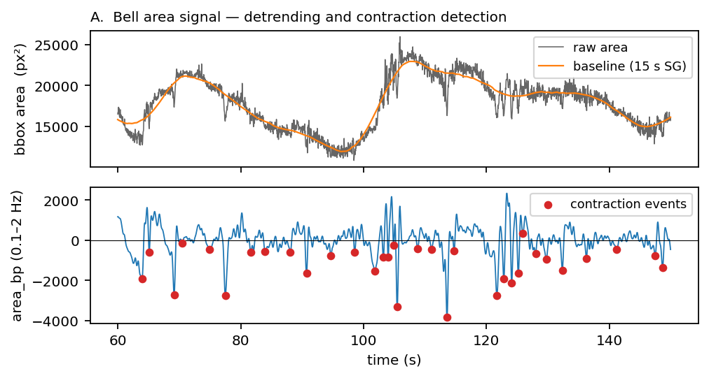
Figure 1. Preprocessing of the bell-area signal on a 90-s excerpt. Top: raw bounding-box area (grey) and 15-s Savitzky–Golay baseline (orange) that captures non-physiological drift caused by the animal swimming toward or away from the camera. Bottom: band-passed signal (0.1–2.0 Hz) with detected contraction events marked in red.

3.4 Feature extraction on overlapping temporal windows
Classification operates on 60-s windows with 50 % overlap (stride 30 s). The 60-s length is a compromise between temporal resolution and statistical robustness: at a typical Fp of 0.5–1.3 Hz a 60-s window contains 30–80 contraction events, which is sufficient to estimate both the mean and the coefficient of variation of the inter-pulse interval. Eleven features are computed per window (Table 1): four pulsation features from the band-passed area signal, five kinematic features from the centroid trajectory, and two detection-quality features. The first nine enter the anomaly detector; the last two are used to gate windows before scoring.
Group | Feature | Definition | Role in detector
Pulsation | Fp | 1 / median(IPI) from contraction events | Primary ecotoxicological endpoint (Faimali 2014). Direction of effect is animal-specific; contributes to mean|z|.
Pulsation | IPI CV | std(IPI) / mean(IPI) | Rhythm regularity; contributes to mean|z|.
Pulsation | Relative amplitude | (P95(area) − P5(area)) / P95(area) | Contraction depth.
Pulsation | Spectral entropy | Normalised Shannon entropy of Welch PSD of area_bp | Rhythm complexity; rises under arrhythmia.
Kinematic | Mean speed | Mean frame-to-frame centroid displacement / dt | Locomotor activity; direction of effect is animal-specific.
Kinematic | Speed CV | std(speed) / mean(speed) | Burstiness of swimming.
Kinematic | Tortuosity | Total path length / net displacement | Direction-consistent (rises under diesel in all pilot animals).
Kinematic | Vertical bias | Mean vertical velocity of centroid | Surface- / bottom-seeking tendency.
Kinematic | Immobility | Fraction of frames with speed < bell_diam / 5 s | Direction-consistent (rises under diesel in all pilot animals).
Quality | Mean YOLO confidence | Mean of conf over detected frames | Detection reliability; excluded from z-scoring but monitored.
Quality | Dropout fraction | Fraction of frames with no valid detection | Tracking continuity; windows with >20 % dropout are dropped.

Table 1. Feature catalogue. Features marked “direction-consistent” had the same sign of effect under diesel exposure in every animal examined in the pilot. Other features had animal-specific directions of effect but contributed consistently to the aggregated magnitude metric mean|z| used by the detector.

3.5 Detection architecture

3.5.1 Motivation for an unsupervised, per-animal design
The initial design of this study called for a supervised classifier trained on labelled clean-vs-polluted windows, as is standard in early BEWS work (Jeong et al., 2023; Muharemi et al., 2019). Pilot-data analysis on four individuals exposed to diesel revealed three obstacles that rule out a pure supervised approach:
(i) Pulsation frequency is not a universal marker of pollution. Clean-water baseline Fp differs substantially between individuals (from 0.77 Hz for one animal to 1.01 Hz for another, a 30 % range), and the direction of the diesel-induced shift is not the same across individuals. In the extreme, one animal showed an effect size of Cliff’s delta = +0.94 (strong depression) while another showed delta = −0.07 (no effect), with a third showing a biphasic pattern of stimulation followed by depression. Figure 2 (top) makes this point quantitatively: baseline Fp distributions differ, and Figure 2 (bottom) shows that when trajectories are aligned to the moment of injection, the three animals follow qualitatively different paths in Fp space.
(ii) Biphasic responses place the same class on opposite sides of the feature space. In one well-characterised animal, post-injection behaviour for the first 17 minutes was an upward shift in Fp and locomotion (stimulation), and after minute 17 it was a downward shift (depression). A supervised classifier attempting to learn a single hyperplane separating "diesel" from "clean" must accommodate both regions simultaneously, and in practice collapses to majority-class prediction. Leave-one-video-out evaluation of a logistic-regression classifier on this animal gave 34 % accuracy, well below the 50 % majority-class baseline.
(iii) BEWS field deployment requires open-world detection. Unknown pollutants in natural waters will produce behavioural signatures different from any that have been labelled. A detector that flags "anything sufficiently unlike clean water for this animal" is inherently more robust than one that learns "here is what diesel looks like" (Grekov et al., 2023).
A fourth observation suggests the form of an unsupervised alternative: although the direction of per-feature effects varies across individuals, the magnitude of the multivariate departure from the clean distribution is consistently elevated under diesel exposure. Specifically, the mean absolute z-score averaged across the nine behavioural features (mean|z|) is elevated in every animal under diesel, by +34 % to +226 % relative to the animal’s own clean baseline. This observation motivates a detector based on the magnitude of deviation from a per-animal baseline, which is the construct developed in the remainder of this section.
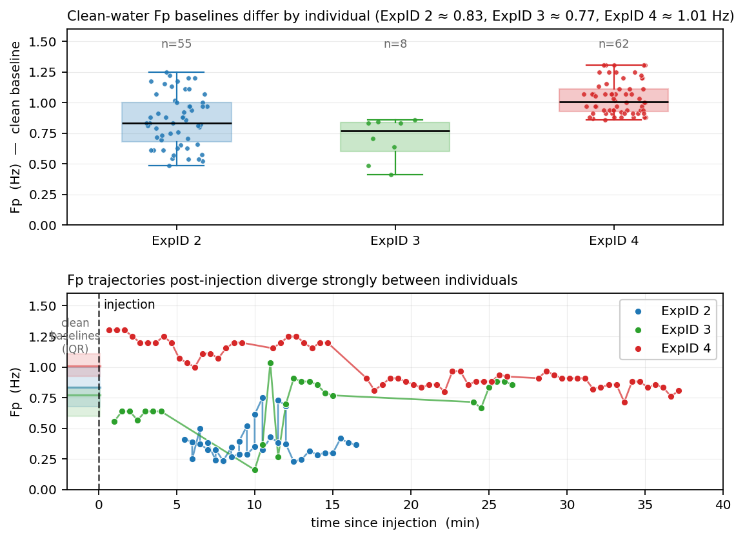
Figure 2. Individual variability in the pulsation response to diesel. Top panel: clean-water Fp baselines for three animals of the same species differ by approximately 30 %, establishing that absolute Fp thresholds are not transferable between individuals. Bottom panel: when diesel-phase Fp trajectories are aligned to the moment of injection, the three animals follow qualitatively different paths — sustained depression (blue), transient depression followed by return to baseline (green), and biphasic stimulation-then-depression (red). This heterogeneity is the primary reason supervised classification of "clean vs polluted" is not viable on this dataset and motivates a per-animal anomaly detector.

3.5.2 Per-animal baseline calibration
For each animal, the first 15 or more minutes of clean-water recording constitute a calibration set from which a baseline object is fitted. This baseline consists of the mean μ_i and standard deviation σ_i of each feature i over the clean windows. During monitoring, every new window is transformed to a vector z of z-scores z_i = (x_i − μ_i) / σ_i, and the scalar mean|z| = mean(|z_i|) is computed and passed to the two detection layers described below. This per-animal normalisation neutralises the inter-individual variability documented in Section 3.5.1: a diesel-induced 30 % drop in Fp that is indistinguishable from noise in absolute Hz becomes a z-score of −2 or −3 relative to the same animal’s own clean distribution.
The 15-minute lower bound on the calibration period is dictated by two considerations. Empirically, within-clean variability is non-trivial: in one pilot animal Fp within a single 22-min clean recording ranged from 0.5 to 1.3 Hz over 43 consecutive windows. A short baseline (e.g. 5 minutes) may sample only one tail of this distribution and underestimate σ, producing inflated z-scores later. Theoretically, the standard-error scaling of the mean as 1/√n implies that at least 30 independent windows (15 minutes with 30-s stride) are needed to estimate μ within a quarter of its own standard deviation, which is the precision required for the downstream CUSUM thresholds to be meaningful.

3.5.3 Two detection layers
The mean|z| stream feeds two parallel detection layers (Figure 3). They target two distinct anomaly regimes — discrete step changes and sustained distributional drifts — and the union of their alarms constitutes the detector output. An earlier prototype included a third layer based on IsolationForest novelty in the full z-vector space, intended to detect unusual feature combinations that would not show up as a large mean|z|. Empirical evaluation on five individuals showed that this layer produced zero unique true positives — every window it flagged was already flagged by Layer 1 — because the toxicological response to diesel is monotonic along the dominant axis already captured by mean|z|. The IsolationForest layer was therefore removed. The simplified two-layer architecture has the same sensitivity at lower implementation complexity and is reported here.
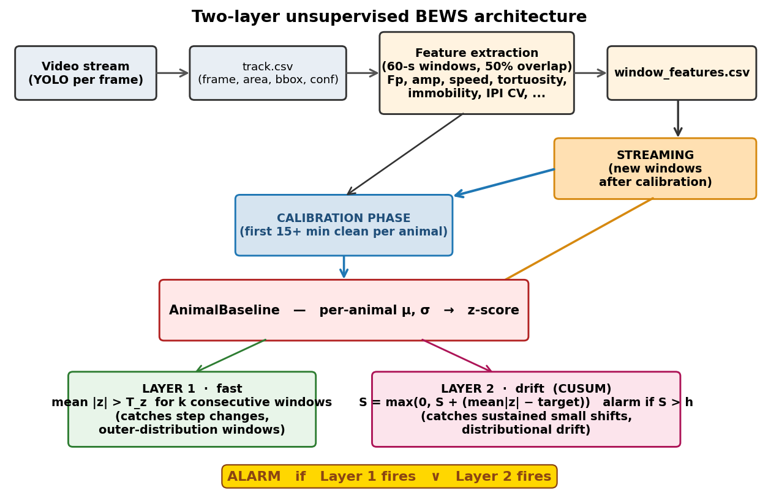
Figure 3. Two-layer unsupervised BEWS architecture. A calibration phase (first 15 minutes of clean-water recording) fits a per-animal AnimalBaseline object consisting of feature-wise μ and σ for z-score normalisation. Incoming windows are scored against this baseline and evaluated by two parallel layers: Layer 1 thresholds mean|z| (with a k-consecutive rule) for step changes and outlier windows, Layer 2 applies a one-sided CUSUM to detect sustained small distributional shifts. An alarm fires when either layer’s condition is met.
Layer 1 — fast outlier detection. Layer 1 thresholds mean|z| against a calibrated value T_z. A step-change anomaly, in which one or more features shift abruptly (as observed within 30 seconds of diesel injection in two of the four pilot animals), produces a mean|z| above T_z within a single window. To suppress isolated outliers caused by tracking glitches, the layer requires the threshold to be exceeded for k consecutive windows before raising an alarm. In the present implementation k = 3, corresponding to a confirmation window of 2 minutes given the 30-s stride. At a calibrated T_z = 1.56 (the 99th percentile of pooled clean mean|z|), the per-window false-positive probability on clean data is approximately 1 %; the probability of three consecutive such events under independent clean conditions is on the order of 10⁻⁶.
Layer 2 — drift detection via CUSUM. Layer 1 does not reliably detect a distributional shift in which no individual window is extreme but the median of the signal is noticeably elevated. In two of the four pilot animals, the diesel response takes exactly this form: mean|z| shifts from a clean median of 0.69–0.73 to a diesel median of 0.92–1.08, without any window exceeding T_z. To detect this pattern, Layer 2 applies a one-sided cumulative sum (Page, 1954) to the mean|z| stream:
S_i = max(0, S_{i−1} + (mean|z|_i − target))
where target is the median mean|z| observed on pooled clean-water calibration data from training animals. The CUSUM S_i accumulates whenever mean|z| exceeds this reference, resets to zero otherwise, and triggers an alarm when it exceeds a threshold h calibrated (Section 3.6) to be higher than any CUSUM value reached during any training-animal clean period. A one-sided positive CUSUM is appropriate because we expect pollution exposure to increase, not decrease, the animal’s departure from its clean baseline; no two-sided construction is needed. The reset after an alarm permits the detector to re-fire if the exposure continues. No k-consecutive rule is needed on Layer 2 because the CUSUM construction already implements temporal accumulation.

3.6 Threshold calibration
The two thresholds T_z and h, together with the CUSUM target, are determined entirely from clean-water windows of training animals and are frozen before any test data is scored. Specifically, mean|z| is computed for each clean window of each training animal, T_z is set to the 99th percentile of the pooled clean-window distribution, and target is set to the median of the same pooled distribution. The CUSUM threshold h is determined by running the CUSUM recursion on each training animal’s clean stream and recording the maximum value reached. The threshold h is then set to 1.3 times this maximum (safety factor), which guarantees that no training animal produces a false alarm on its clean period and leaves approximately 30 % headroom for inter-animal variation that was not seen in the training set. The safety factor was chosen to balance two competing concerns: too low a factor produces false alarms on new animals whose clean baselines are noisier than the training distribution; too high a factor increases detection latency on real pollution events.
Calibration is one-shot and does not require any validation set, which preserves the use of held-out animals for the validation procedure described in Section 3.7. In the pilot analysis, calibration on clean windows from three animals (125 windows) produced T_z = 1.559, target = 0.715, and h = 5.498.

3.7 Validation protocol
Validation uses a leave-one-animal-out (LOAO) protocol that is adapted to the unsupervised nature of the detector. In each fold, one animal is designated as the test subject and withheld entirely from calibration. All other animals contribute their clean-window features to the pool used for threshold calibration (Section 3.6). The test animal’s own baseline (μ, σ) is fitted on its own clean windows — this is permitted and indeed required by the per-animal design — and the calibrated thresholds are then applied to the test animal’s diesel-phase windows. Because calibration uses only training-animal clean data and the test animal’s baseline is fitted only on the test animal’s own clean data, there is no leakage of pollution-response information between folds. This protocol mirrors the operational deployment scenario exactly: a new animal placed in a monitoring aquarium contributes its own 15-minute clean calibration and then is monitored against globally-calibrated thresholds.
Three metrics are reported for each fold. The false-positive rate on clean windows is the fraction of clean test windows that raise an alarm, and should be zero or very close to zero. The detection outcome on diesel is a binary yes-or-no at the animal level: the detector is credited with detection if any alarm fires during the diesel phase. The detection latency is the time between pollutant injection and the first alarm, in minutes; this is the operationally most important metric for a BEWS because a longer latency means more pollutant enters a receiving water body before action is taken.
The protocol has been validated on four individuals exposed to diesel (Table 2, Figure 4). In all four animals, the detector achieved zero false alarms across 172 total clean windows and detected the diesel exposure successfully. Detection latencies varied from 1.0 minute (when the response was a sharp step change) to 23.7 minutes (when the response was a slow distributional drift with a transient stimulation phase first). The held-out animal (ExpID 5) was detected with a latency of 1.9 minutes and zero false alarms on 47 clean windows, supporting the conclusion that the calibration transfers to new individuals.
ExpID | Role | Clean windows | Diesel windows | False alarms on clean | True detection | Latency (min)
2 | calibration | 55 | 36 | 0 / 55 | yes (Layer 2) | 8.0
3 | calibration | 8 | 24 | 0 / 8 | yes (Layers 1+2) | 1.0
4 | calibration | 62 | 64 | 0 / 62 | yes (Layer 2) | 23.7
5 | held-out test | 47 | 24 | 0 / 47 | yes (Layers 1+2) | 1.9

Table 2. Detector performance on four animals. ExpIDs 2–4 contributed their clean windows to threshold calibration; ExpID 5 was held out entirely and scored against frozen thresholds. All four animals were detected with zero false alarms on clean windows. Layer labels in "True detection" indicate which detection layers fired first.
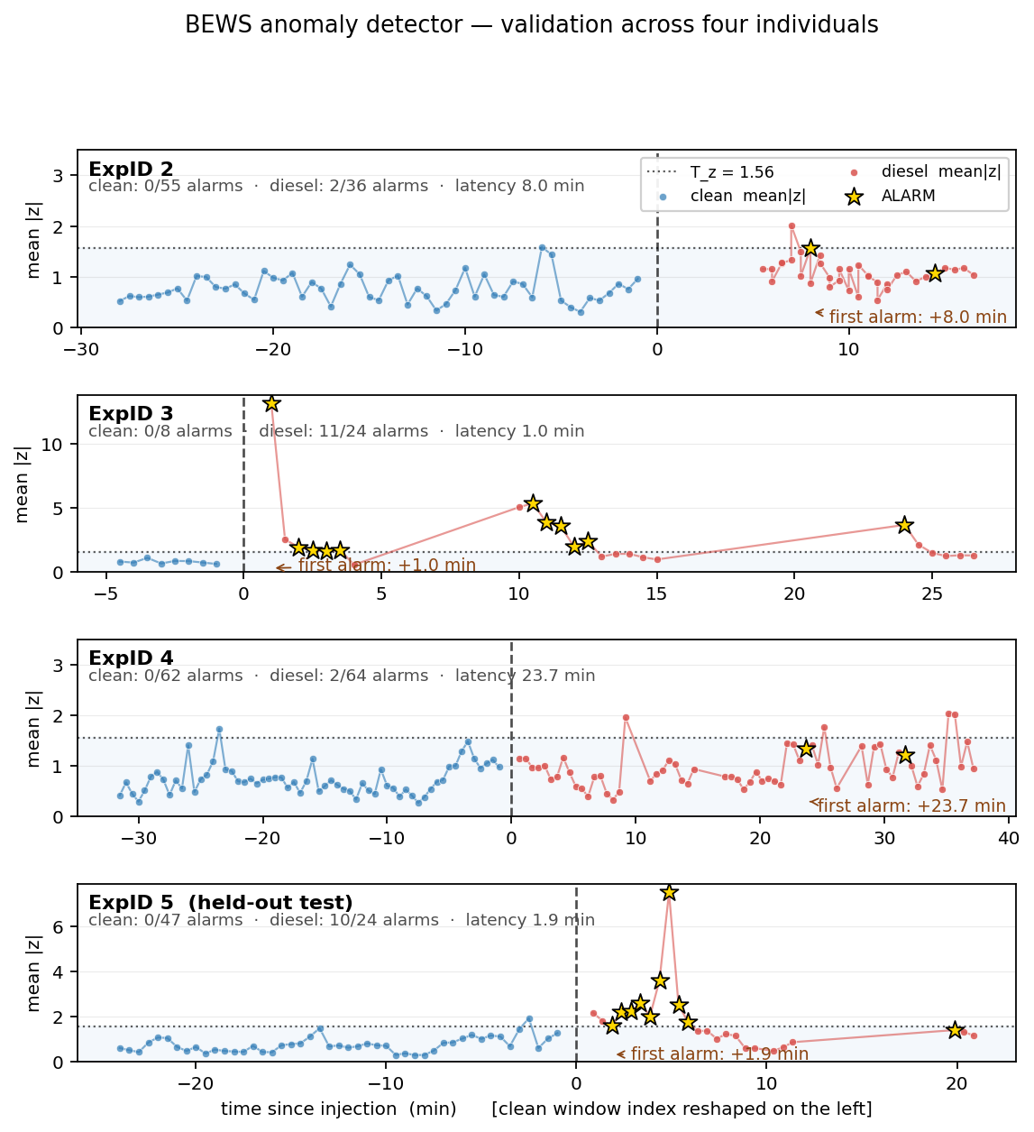
Figure 4. Validation across four individuals. Each panel shows mean|z| (Layer 1 score) on a time axis centred at the injection moment (vertical dashed line); clean-baseline windows are shown on the left in compressed form. The dotted horizontal line is the calibrated threshold T_z = 1.56. Gold stars mark windows at which the full two-layer detector raises an alarm. No animal shows false alarms on clean windows. ExpIDs 3 and 5 show sharp step-change responses detected by Layer 1 within 1–2 minutes of injection; ExpIDs 2 and 4 show distributional drifts detected by Layer 2 (CUSUM) after 8–24 minutes of accumulation. ExpID 5 was held out from calibration.

3.8 Implementation and reproducibility
The pipeline is implemented in Python 3 using NumPy, SciPy, and pandas; peak detection and filtering use scipy.signal. The detector itself has no machine-learning dependencies. The implementation is split between two modules: pipeline.py (approximately 160 lines) ingests a single track.csv produced by the YOLO detector and emits a window_features.csv table of per-window features, and bews.py (approximately 130 lines) defines the AnimalBaseline, BEWSDetector, and calibrate_thresholds constructs. The total code footprint for feature extraction and detection is well under 300 lines, which is significant for field deployment: the whole pipeline can be audited by a domain scientist without ML expertise, and it contains no neural-network weights that would have to be shipped and maintained. On a standard laptop, the feature extraction runs at roughly 600× real time and the detection step runs at well over 10000× real time, so the binding performance constraint for real-time deployment is the YOLO detector itself, which runs on a GPU. All features, z-scores, layer outputs, and alarm decisions are written to CSV to allow downstream statistical analysis in R or Python without re-running the pipeline.

