**CREATE A CHATBOT USING PYTHON**

**PHASE4: PROJECT SUBMISSION**

* Creating a simple chatbot using Python, Flask, and a dataset is a great way to get started with conversational AI. ,
* I'll guide you through creating a basic chatbot using a predefined dataset and Flask.

Here are the steps to create a basic chatbot:

* **Setup Your Environment**:
  + Make sure you have Python installed.
  + Install Flask using **pip install Flask**.
* **Create Your Dataset**:
  + Create a JSON file (**dataset.json**) with questions and corresponding answers. For example:
* 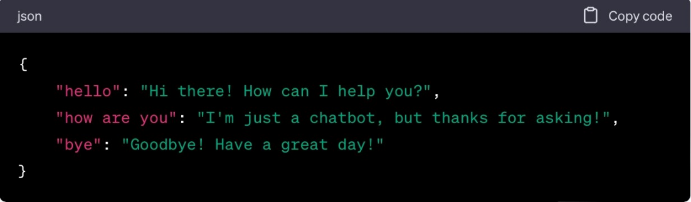
* **Create a Flask App**: Create a Python script (**app.py**) for your Flask application.

PythonCopy

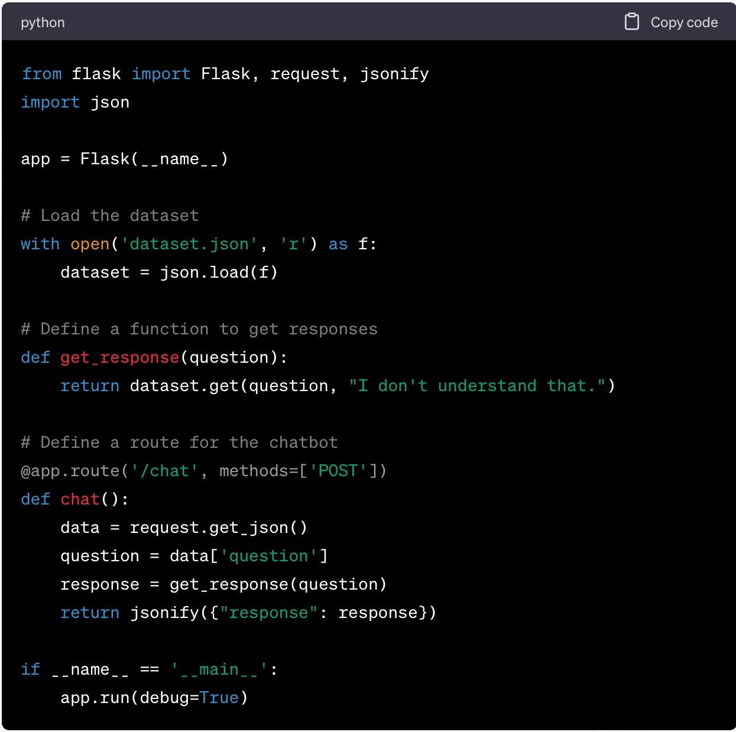

* **Run the Flask App**: Open your terminal and navigate to the directory where **app.py** is located, then run it with **python app.py**.
* **Test Your Chatbot**: Use a tool like Postman or write a simple HTML form to send POST requests to your Flask app. Here's a simple HTML form example:

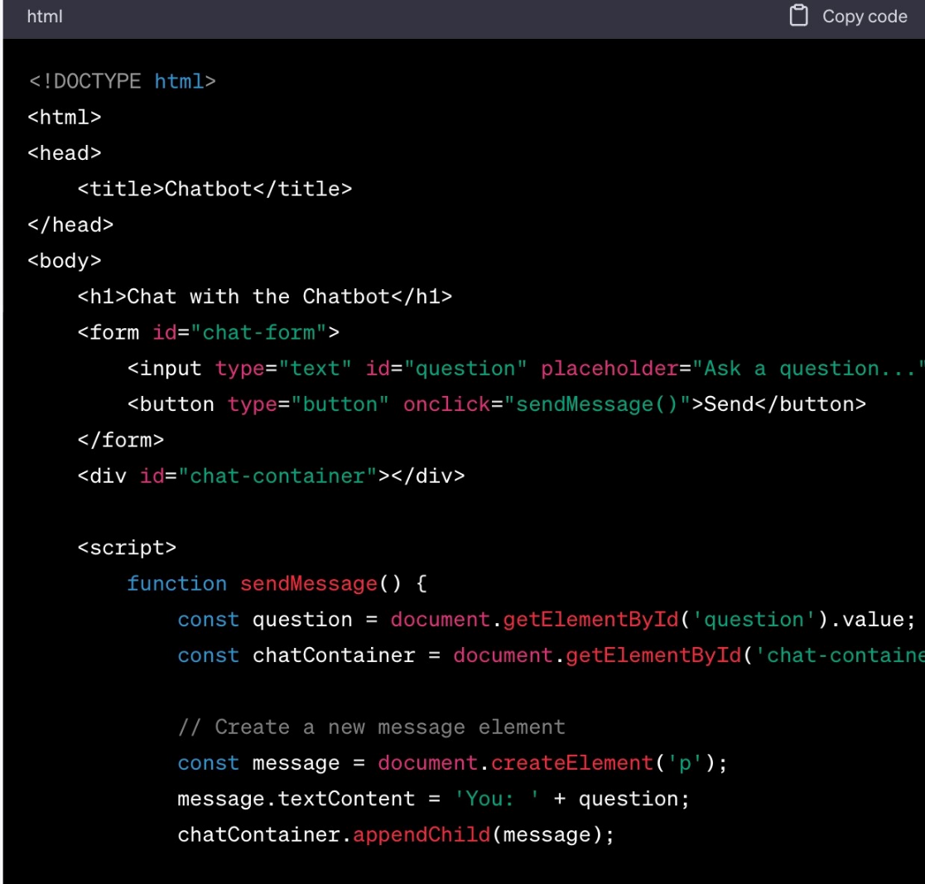

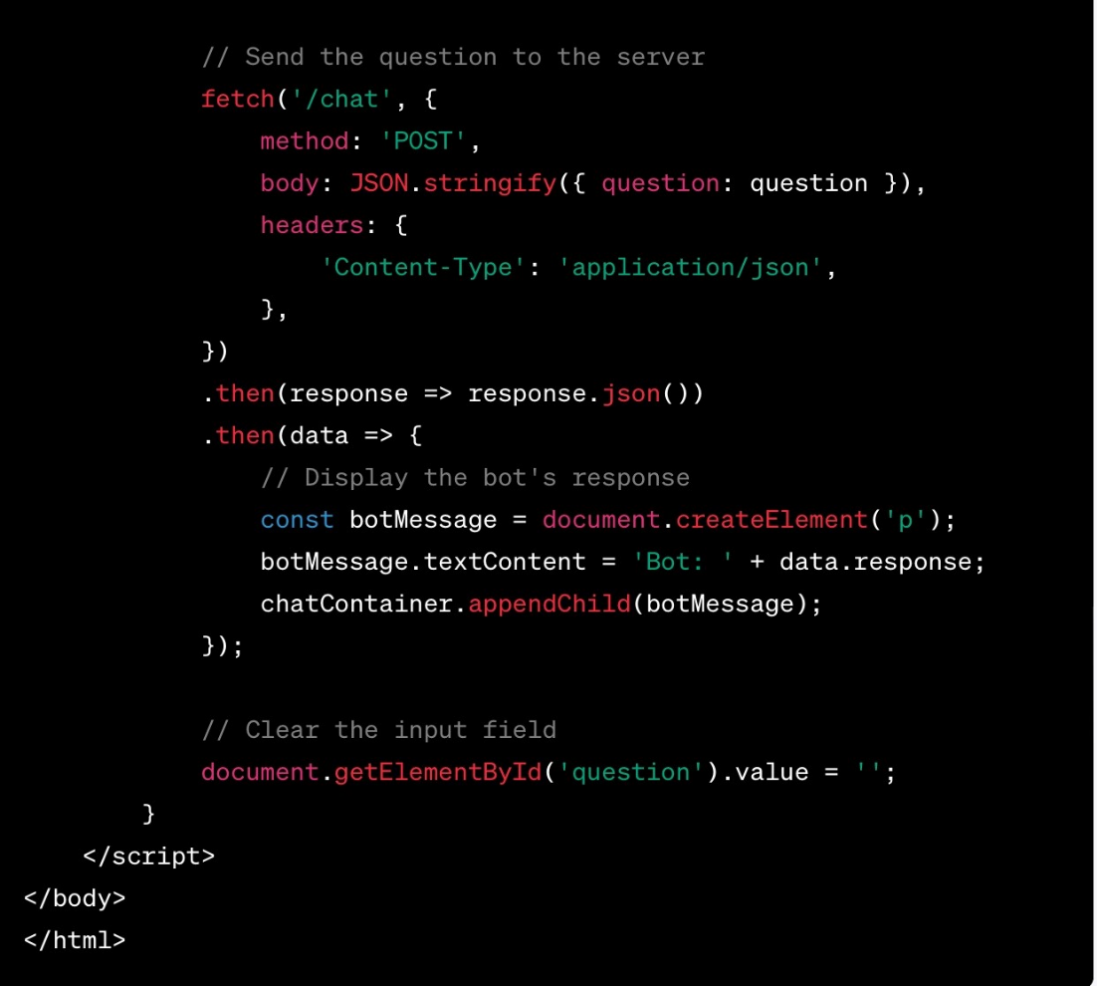

* This HTML file creates a basic web interface for interacting with your chatbot. Save it as **index.html** in the same directory as your Flask app.
* Now, when you run your Flask app and open **index.html** in a web browser, you can ask questions to your chatbot, and it will provide responses based on the dataset.