**A Project Proposal**

**“Hotel Management System”**



***Submitted To***

**Department of Computer and Software Engineering**

**School of Engineering**

**Pokhara University**

In the Partial Fulfillment of the

Requirements for the Degree of Bachelor of Engineering in Computer/Software

Engineering Awarded By Pokhara University

**(June 2022)**

**Hotel Management System**

***Submitted By***

Kiran Kumar Acharya [19180058]

Sirish Burlakoti [19180086 ]

Manoj Khadka [19180061]

Prasiddha Bhusal [19180066]

**Submitted To**

Department of Computer and Software Engineering

School of Engineering

Pokhara University

**Acceptance**

We recommended the project entitled **"Hotel Management System"** submitted by Kiran Kumar Acharya and his team in partial fulfillment of the requirements for the degree of Bachelor of Engineering in Computer/Software Engineering has been examined by us and accepted for the award of the degree under Pokhara University.

……………………………..

Rishi Khanal

**Program coordinator**

School of Engineering

Pokhara University

**Abstract**

Hotel Management System is the fully functional System which make the hotel operation smooth so that the hotel staff can quickly and easily complete the hotel management task. It will handle guest details, reservation details, room service details, staff management details and room types.

Keywords:

Hotel operation, guest details, room services, staff management

**Table of Contents**

|  |  |  |
| --- | --- | --- |
| Abstract | | **4** |
| Table of Contents | | **5** |
| List of Figures | | **6** |
| Introduction | | **7** |
| 1.1 | Background | 7 |
| 1.2 | Problem Statement | 7 |
| 1.3 | Objectives | 7 |
| 1.4 | Significance | 8 |
| 1.5 | Features | 8 |
| 1.6 | Application | 8 |
| Literature Review | | **9** |
| Introduction | | 9 |
| Literature Studies | | 10 |
| Conclusion | | 10 |
| Methodology | | **1**1 |
| 3.1 | Required tools & technologies | 12 |
| 3.2 Approach Used | | 13 |
| 3.3 Data Flow Diagram | | 15 |
| Work Schedule | | 16 |
| Conclusion | | 16 |

**List of Figures**

Figure 3.1: ---------------------------------------------------------------------------------------------------------------- 13

Figure 3.3: ---------------------------------------------------------------------------------------------------------------- 15

Figure 3.4: ---------------------------------------------------------------------------------------------------------------- 17

Figure 4.1: ---------------------------------------------------------------------------------------------------------------- 17

**Chapter 1**

**Introduction**

**1.1** **Background**

In our day to day life, many hotels find it difficult to manage and keep tracking by manually. So, the Hotel Management System is a go-to solution to keep track and manage details, reservation details, room services details, staff management details and room types.

**1.2 Problem Statement**

We Currently many hotels are using a manual system to handle hotel processes. When a guest makes a reservation, all the reservation details (including guest details) are recorded in a file and those files are stored in a special cabinet. Calculation of bills are done manually too. As the current system is a file based one. Management of the hotel needs much effort on securing those files. They can easily get damaged by a fire, insects or even by a natural disaster. Keeping files takes much time and wastes many precious hours. Although we can’t trust the accuracy of calculations done manually, it’s not a surprise to encounter problems. If we want to check for a previous room record or a reservation details, management will be in a great problem. It’s a tough and time taking process to search for a record in a file.All these things have to be carried out manually and if the hotel is very large,proper record keeping will become a major problem as manual record keeping has never been a reliable method because people tend to forget things.

**1.3 Objectives**

Overall objectives of this project include:

1. To keep track record of hotel, customers
2. To keep proper accounting records of the hotel
3. To provide a proper billing system for customers.

**1.4 Significance**

Information Technology has revolutionized the life of human beings and has made lives easier by the various kinds of applications. In the light of the rapid changes with the use of Information Technology, there are many tools, technologies and systems that have been produced and invented.

**1.5** **Features**

1. Generate Reports
2. Security
3. Backup and restoring
4. User friendly Dashboard
5. Email Reminder

**1.6 Application**

Hotel management System (HMS) provides a simple GUI (Graphical User Interface) for the Hotel Staff to manage the functions of the hotel effectively. Each actor will have various levels of access to the system which is described later in the proposal.We emphasize more on building features for customers to reserve rooms. In addition, we also consider hotel management related features like employee management. Guests will register to the system and login, on registration a guest user will be able search for suitable accommodation and reserve at a particular time. Guests can even cancel the earlier reservations made by him/her or can view previous reservation.Employees can login to the system and provide on-call services to guests. New hotels and room details can be added by employees. He can even update or delete the hotel/rooms from the system.System Administrator will manage guests/employees. In addition, he can produce various reports like available rooms, reservation made during certain period of time and profit

**Chapter 2**

**Literature Review**

This section discusses findings and observations done by some research works on the hotel management System.

**2.1** **Introduction**

Technology has made a considerable impact on the Hospitality industry in recent years and will continue to do so with the increasing use of computer, controlled equipment and the growth of information technology in general in the last two decades, technology has become far more advanced and far more widely used throughout all types of industry. The tourism and hospitality industry is no exception. Indeed, many tourism and leisure establishments rely on technological systems for the vast majority of their operations.

HAMRO Hotel uses computer programs for everything from booking, communications, Security and payment. If a hospitality establishment does not use some sort of advanced technological system in its operations, it is deemed to be out of date and disorganized. Indeed, raju khadka begins to outline the importance of these programs by claiming that “a well-organized, managed software allows hotels to ensure a steady flow of guests into their properties”. Furthermore “Profitable business ventures rely on effective marketing, which includes reviewing people who require hotel products and services, determining their specific needs, developing products and services that meet those needs, and making a profit on the sale of those products and services''.

To overcome the short of the problem, our hotel management system makes it easier for staff members, allowing them to work more efficiently and taking away time consuming activities which can be carried out by our technology.

**2.2 Literature Studies**

The Project work will ensure reservation of hotel rooms, staff management, and resource management. A “Use Case” scenario is the room search for room reservation. Users may face difficulties searching between available and booked rooms, but the automated system would search more efficiently with the proficient search algorithm. All details of the rooms are stored in the database servers and can be retrieved or modified with very little stress. Another “Use Case” is the accounts receivable and payable field of the F&A module. The accounts receivable simply captures all funds coming-in with their sources and dates while the accounts payable displays the money going-out of the organization with their destination. The business flow is quite simple; however, to accomplish all these tasks is burdensome for both the customer side and the hotel side without an efficient and integrated hotel management system. With the HMIS (Hotel Management Information System), Restrictions and access levels can be stipulated to prevent unauthorized or unwanted personnel from any point of operation i.e. workers cannot have access to areas not pertaining to their roles as set by the administrator. The administrator can also decide what operations can be carried out on the application. For example a staff with the role “Housekeeping” should not be able to modify the schedule set for him/her for the month by the Housekeeping Manager, and the catering staff should not have access to the “cashier posting” of customer accommodation. Staff Payroll can be generated and added to records with details from the staff record (HR) and accounting computation.ie specific details from the staff record will be brought up during the preparation of staff salaries and the gross and net pay will be calculated. The Assets Register will enable record keeping of both the fixed asset and floating asset in the organization. The project simply serves as an ERP (Enterprise resource planner/ Management System) for the hotel organization and should function effectively if utilized properly

**2.3** **Conclusion**

Most of the software we tested do not provide clean user experience or do not satisfy the system. Our Hotel Management System will give a much cleaner look and provide full satisfaction and experience to the end users.

**Chapter 3**

**Methodology**

**3.1 Methodology**

To make our approach simple and working, we’ve used the Incremental Model of Software Process. This model is the combination of Linear/Sequential Model and Iterative Prototype Model. The first increment is a “core product” with very basic functionalities of making order and marking the delivered order as “served”. The plan addresses the modification of the core product to meet the needs of the customer and delivery of additional features, functionality and design. We’ve planned for making the system usable by customers in the next iteration. Later, the system will feature more features and design with enhanced functionalities like search. Later in future releases we’ve planned applying data visualization for proper analysis of data. For the next version of this release, we’ll focus on the customer-side approach with user-friendly design and development.

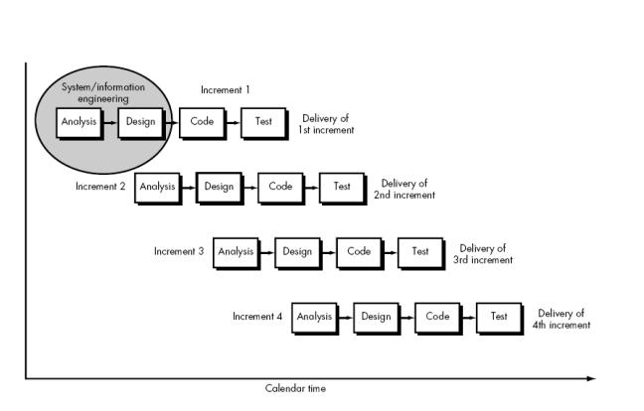

Fig. 3.1 Incremental Model

**Analysis**

In this phase, the requirements of software were analyzed which resulted in “Software Requirement Specifications.”

**Design**

In this phase, the first version of software was designed with some key features that is to be delivered by the system. Some modification was required in the initial design that landed us to this stage. The design included database design and basic UI design.

**Coding**

This phase is the implementation of our paper-design in the form of Python code under Django Framework.

**Test**

In this phase, the efficiency of the system was tested. It required some modifications. After applying the modification, we’ve reached the stage of the initial version of the working system.

**3.2 Required tools & technologies**

During the development of the system, we required various tools essential for the project. Our project could not be completed without these tools. Here are some lists of tools used in the project.

1. Visual Studio Code : IDE, compilation and building the project.
2. Python: Programming Language
3. Framework: Django
4. Database: SQLite

**3.3** **Approach Used**

The methodology we chose is the Agile method. Agile web development is a methodology based on the principles outlined in the Manifesto for Agile Software Development . The main goal of this approach is to provide flexibility and satisfy the customer through early and continuous delivery of valuable software.

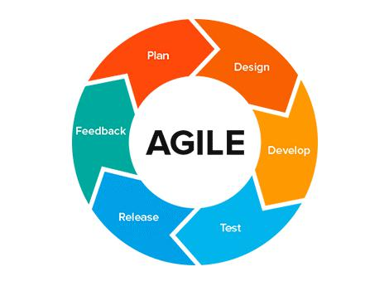

Fig 3.3: Agile Methodology

Before talking about agile methodology in web development, it is important to understand the traditional web development process. The traditional waterfall method follows a linear and sequential way of software development, usually in stages usually cover the following order:

1. Project planning.
2. Requirements gathering and documentation.
3. Analysis.
4. System design.
5. Coding.
6. Testing (code, unit, system, user acceptance testing).
7. Deployment.

Each step of the traditional development process is properly documented and reviewed, with months spent on the implementation of each stage. Over time developers have understood that creating software shouldn’t be an entirely sequential process. So, an agile method was developed.

Within the agile approach the steps of web development are mostly simultaneous. All team members, from decision-makers to designers and content creators should organize meetings during the early stages of web development. Understanding of project requirements on all stages by all team members reduces the need for constant emails, calls and meetings throughout the entire process. Due to agile approach work that took 4-8 months can now be accomplished much faster. The typical agile web development process is divided into a series of sprints. Each sprint involves discovery, design, development and testing.

The main benefits of Agile Web Development can be summarized as:

* + Customers are always involved in the process of web development. Such engagement throughout the project lets the customer monitor the process and ask for any changes or improvements if necessary.
* Increased Project Control
* Focus on Business Value
* Regular Check-ups
* Faster development eliminates the need for overtime payment.
* The opportunity to better estimate the project provides a higher productivity.
* Early and Predictable Delivery
* Reduced Risks
* Flexibility

**3.4** **Data Flow Diagrams**

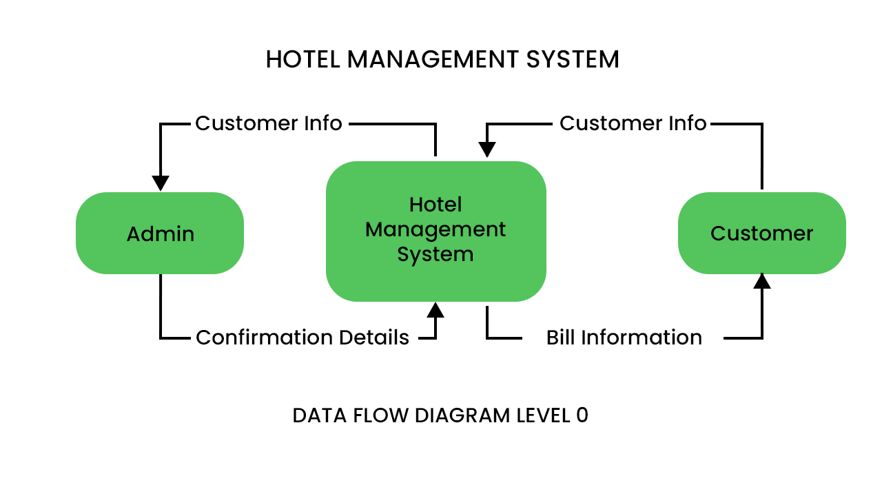







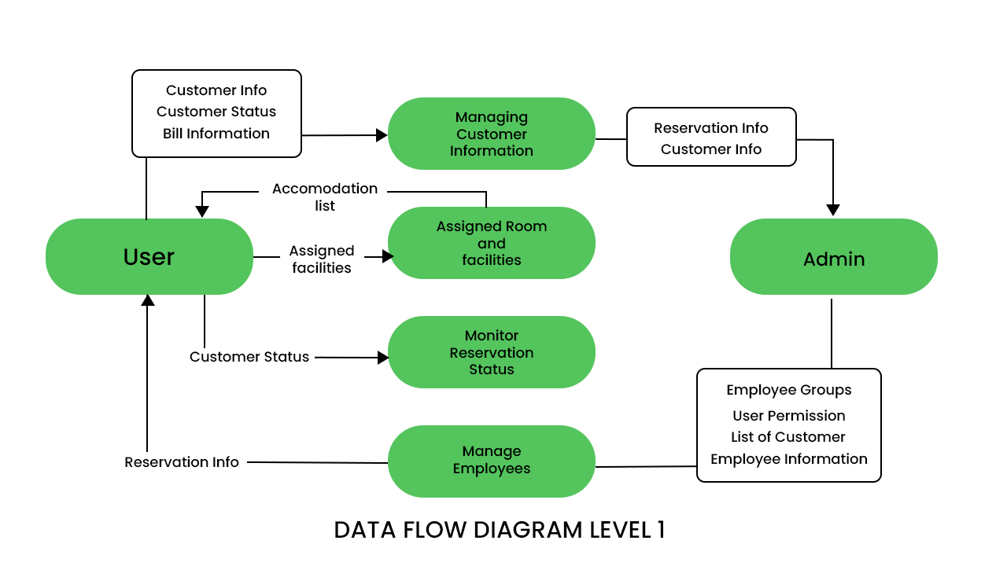

Fig 3.4 Data Flow Diagram for the Hotel Management System

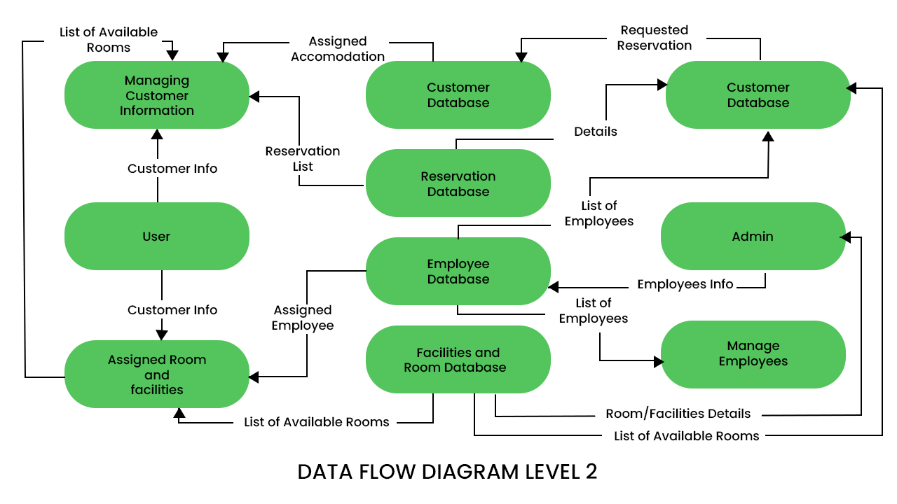

**Chapter 4**

**Work Schedule**

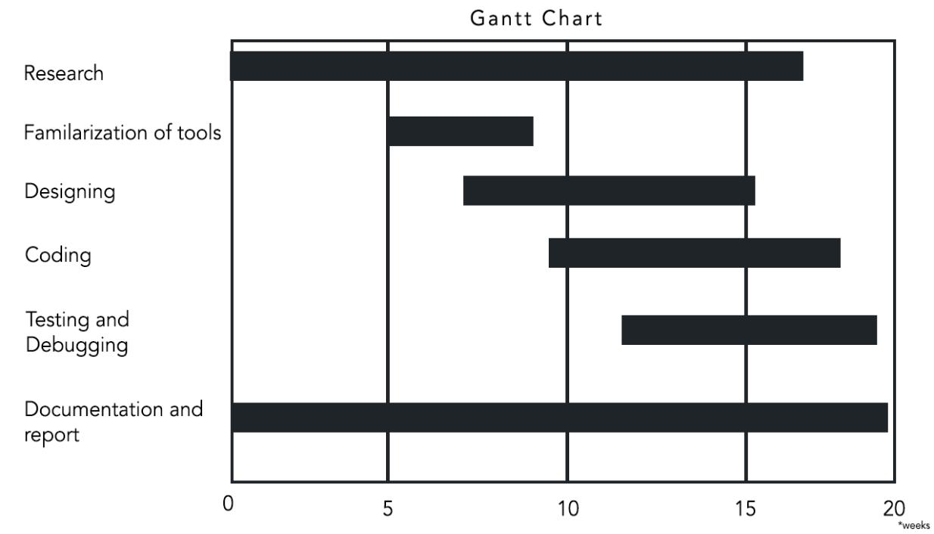

Figure 4.1: Gantt Chart

**Chapter 5**

**Conclusion**

**Conclusion**

In conclusion, we believe this project if properly utilized will save time, reduce the amount of work the administration has to do, and will replace the stationery material with electronic apparatus. The system should also serve as a major tool to improve efficiency in Hotel management.

**References**

1. Wikipedia. Iterative and Incremental Development., URL <https://en.wikipedia.org/wiki/Iterative_and_incremental_development>
2. <https://www.irjmets.com/uploadedfiles/paper/volume2/issue_3_march_2020/276/1628082965.pdf>
3. Book: Ian Sommerville, Software engineering, 9th edition, Pearson education
4. ”Hotel Management Case Study”, March.6, 2010. [Online].Available:pdf