**DAILY ONLINE ACTIVITIES SUMMARY**

|  |  |  |  |  |  |  |  |  |
| --- | --- | --- | --- | --- | --- | --- | --- | --- |
| **Date:** | **01 July 2020** | | | | | **Name:** | **Keertana Ganesh Ganiga** | |
| **Sem & Sec** | **4th sem, 2nd year** | | | | | **USN:** | **4al18cs036** | |
| **Online Test Summary** | | | | | | | | |
| **Subject** | | **---------** | | | | | | |
| **Max. Marks** | | **----** | | **Score** | | | **---** | |
| **Certification Course Summary** | | | | | | | | |
| **Course** | **Machine learning with python** | | | | | | | |
| **Certificate Provider** | | | **GreatLearning** | | **Duration** | | | **10.5 hours** |
| **Coding Challenges** | | | | | | | | |
| **Problem Statement:1 program** | | | | | | | | |
| **Status: Executed** | | | | | | | | |
| **Uploaded the report in Github** | | | | | **Yes** | | | |
| **If yes Repository name** | | | | | <https://github.com/keertanaganiga/Lockdown_coding>  <https://github.com/keertanaganiga/Lockdown_certification>  <https://github.com/keertanaganiga/lockdown_reports> | | | |
| **Uploaded the report in slack** | | | | | **Yes** | | | |

#### *Certification Course Summary:*

#### Today I started new Machine learning with python in Great Learning which is of 10.5 hrs. After the completion of course, certificate will be provided.

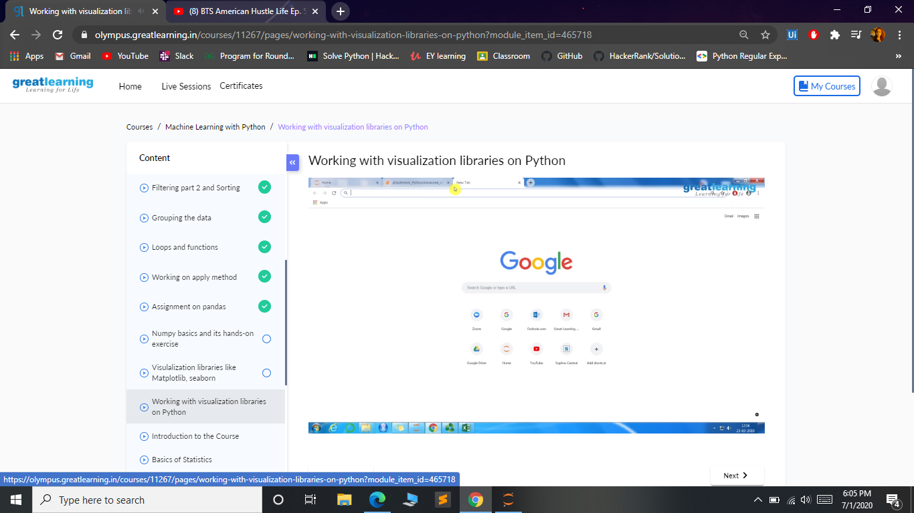

***Coding Challenges:***

Today I solved 1 coding challenge,

1. **Given two lists, sort the values of one list using the second list.**

**Examples:**

**Input:**  
list1 = ["a", "b", "c", "d", "e", "f", "g", "h", "i"] list2 = [ 0, 1, 1, 0, 1, 2, 2, 0, 1]

**Output:**  
['a', 'd', 'h', 'b', 'c', 'e', 'i', 'f', 'g'] Input : list1 = ["g", "e", "e", "k", "s", "f", "o", "r", "g", "e", "e", "k", "s"] list2 = [ 0, 1, 1, 0, 1, 2, 2, 0, 1] Output : ['g', 'k', 'r', 'e', 'e', 'g', 's', 'f', 'o']

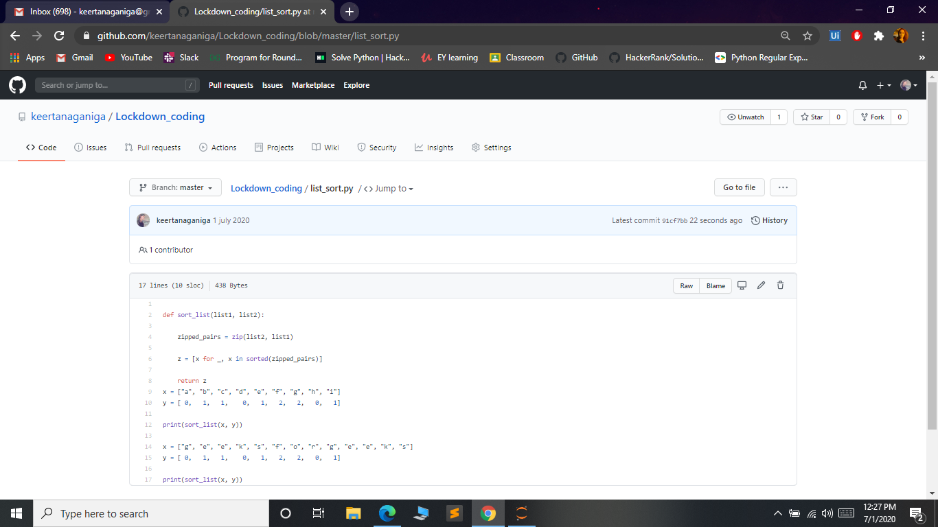

***Extra Activity:***

Today I attended Live webinar on EVERYTHING IS CONNECTED by   
Mr. Bhuvan, That was very interacting session on IoT.Certificate will be provided.

