**DAILY ONLINE ACTIVITIES SUMMARY**

|  |  |  |  |  |  |  |  |  |
| --- | --- | --- | --- | --- | --- | --- | --- | --- |
| **Date:** | **01 June 2020** | | | | | **Name:** | **Keertana Ganesh Ganiga** | |
| **Sem & Sec** | **4th sem, 2nd year** | | | | | **USN:** | **4al18cs036** | |
| **Online Test Summary** | | | | | | | | |
| **Subject** | | **COMPLEX ANALYSIS, PROBABILITY AND STATISTICAL METHODS (18MAT41)** | | | | | | |
| **Max. Marks** | | **30** | | **Score** | | | **29** | |
| **Certification Course Summary** | | | | | | | | |
| **Course** | **Front end Development-HTML** | | | | | | | |
| **Certificate Provider** | | | **Great Learning** | | **Duration** | | | **3.5 hours** |
| **Coding Challenges** | | | | | | | | |
| **Problem Statement:2 program** | | | | | | | | |
| **Status: Executed** | | | | | | | | |
| **Uploaded the report in Github** | | | | | **Yes** | | | |
| **If yes Repository name** | | | | | <https://github.com/keertanaganiga/Lockdown_coding>  <https://github.com/keertanaganiga/Lockdown_certification>  <https://github.com/keertanaganiga/lockdown_reports> | | | |
| **Uploaded the report in slack** | | | | | **Yes** | | | |

**Certification Course Summary:** **Today I started new certificate course through Great Learning I selected Front end Development-HTML, Todays I learnt about Introduction to forms, Introduction to input elements, different type of input elements, Labels, Forms, method attributes, HTML 5 attributes, HTML 5 input elements and each concept related quiz.**

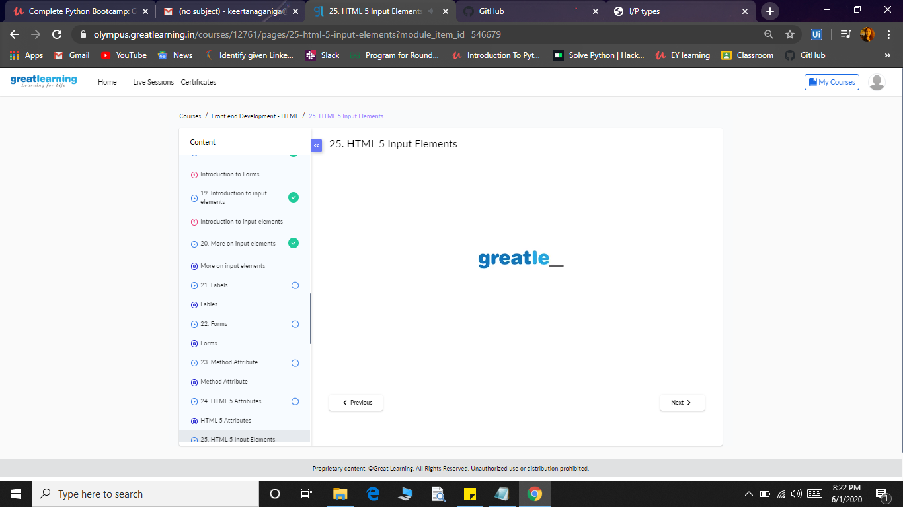

**Coding Challenges:**

Today I solved 2 coding challenge,

1.Java program for **Define a class Point with two fields x and y each of type double. Also, define a method distance (Point p1, point p2) to calculate the distance between points p1 and p2 and return the value in double... Use Math.sqrt() to calculate the square root.**

**2.** **Given an array arr [] of size N and an integer K. The task is to find the count of subarrays such that each subarray has exactly K distinct elements**.

