**DAILY ONLINE ACTIVITIES SUMMARY**

|  |  |  |  |  |  |  |  |  |
| --- | --- | --- | --- | --- | --- | --- | --- | --- |
| **Date:** | **02 July 2020** | | | | | **Name:** | **Keertana Ganesh Ganiga** | |
| **Sem & Sec** | **4th sem, 2nd year** | | | | | **USN:** | **4al18cs036** | |
| **Online Test Summary** | | | | | | | | |
| **Subject** | | **---------** | | | | | | |
| **Max. Marks** | | **----** | | **Score** | | | **---** | |
| **Certification Course Summary** | | | | | | | | |
| **Course** | **Machine learning with python** | | | | | | | |
| **Certificate Provider** | | | **GreatLearning** | | **Duration** | | | **10.5 hours** |
| **Coding Challenges** | | | | | | | | |
| **Problem Statement:2 program** | | | | | | | | |
| **Status: Executed** | | | | | | | | |
| **Uploaded the report in Github** | | | | | **Yes** | | | |
| **If yes Repository name** | | | | | <https://github.com/keertanaganiga/Lockdown_coding>  <https://github.com/keertanaganiga/Lockdown_certification>  <https://github.com/keertanaganiga/lockdown_reports> | | | |
| **Uploaded the report in slack** | | | | | **Yes** | | | |

#### *Certification Course Summary:*

#### Today I started new Machine learning with python in Great Learning which is of 10.5 hrs. After the completion of course, certificate will be provided.

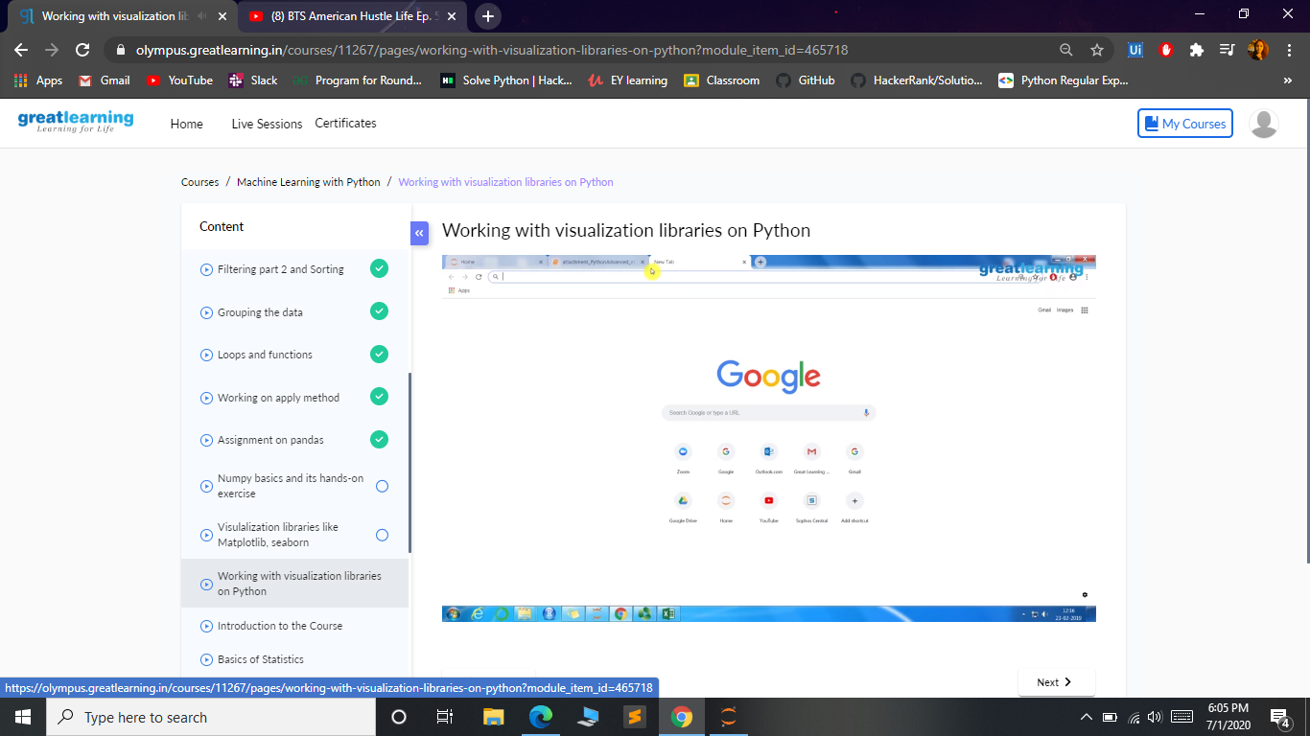

***Coding Challenges:***

Today I solved 1 coding challenge,

**1. Given the participants' score sheet for your University Sports Day, you are required to find the runner-up score. You are given scores. Store them in a list and find the score of the runner-up.**

Input Format:

The first line contains n. The second line contains an array A[] of n integers each separated by a space.

Output Format:  
Print the runner-up score.

sample input:  
5  
2 3 6 6 5

sample output:  
5

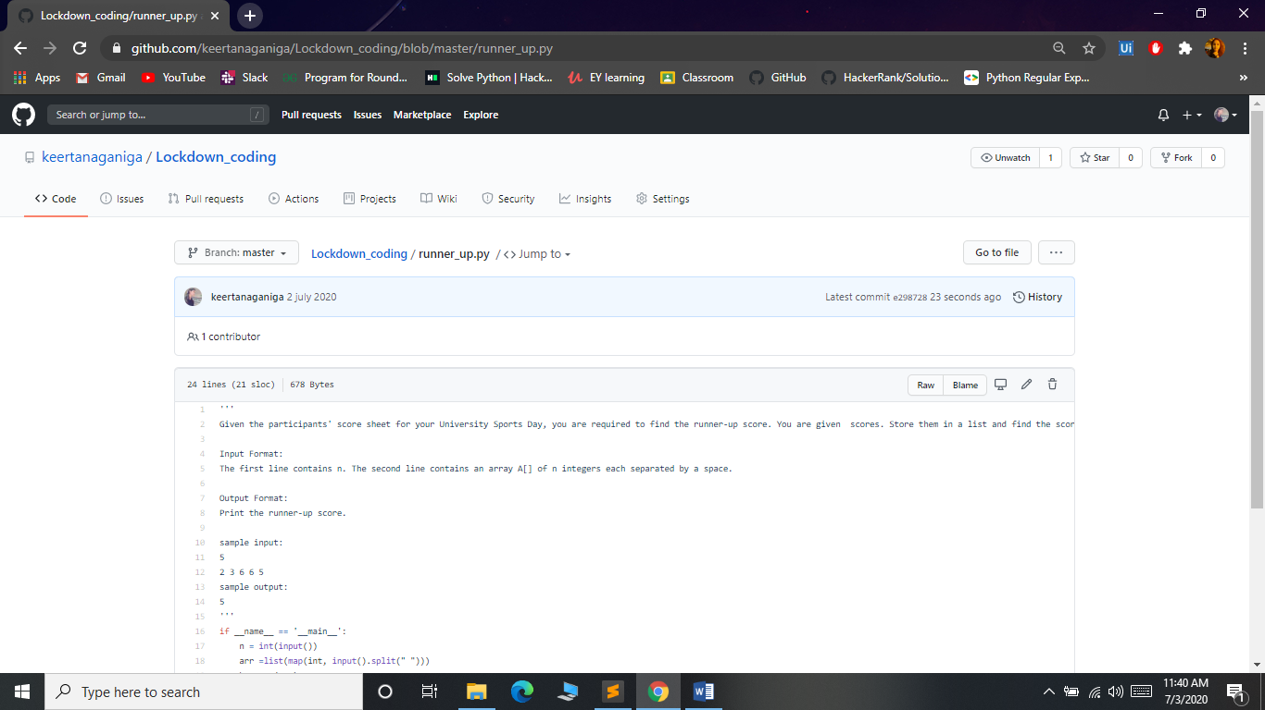

**2.Hello firstname lastname! You just delved into python.**

Input Format:  
The first line contains the first name, and the second line contains the last name.

Output Format:  
Print the output as mentioned above.

Sample Input:  
Ross  
Taylor

Sample Output:  
Hello Ross Taylor! You just delved into python.

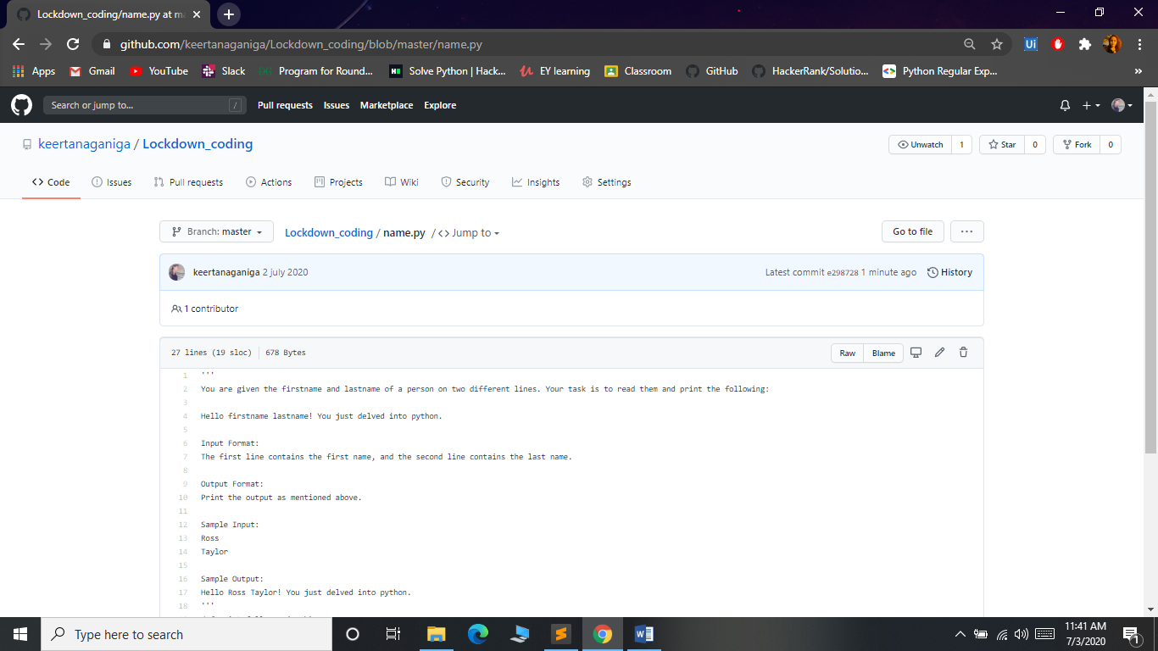

***Online class:***Today I attended Online training on C++ from 12:00-2:00 PM.Quizzes are conducted at the end of the class.

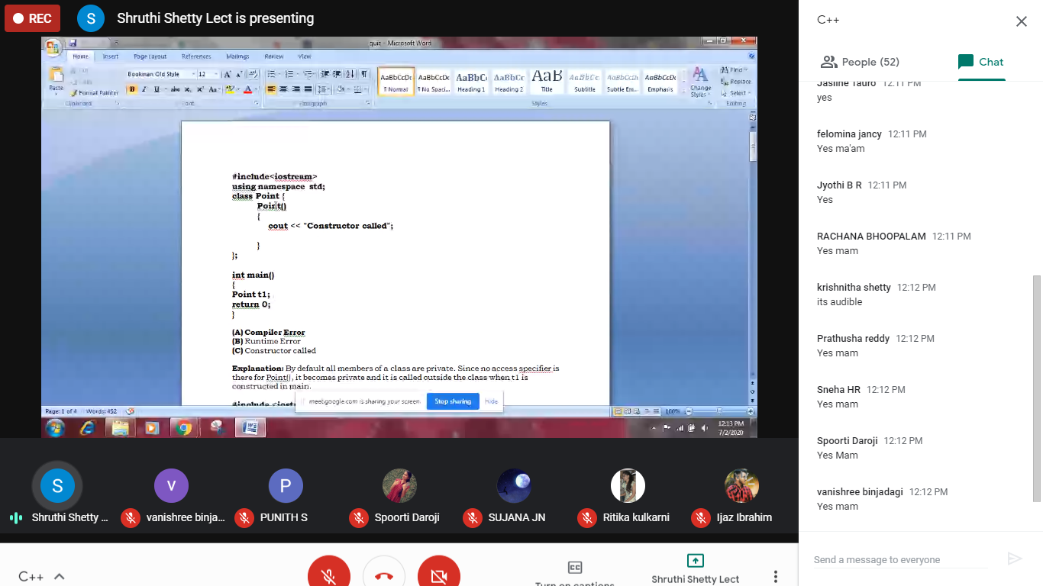

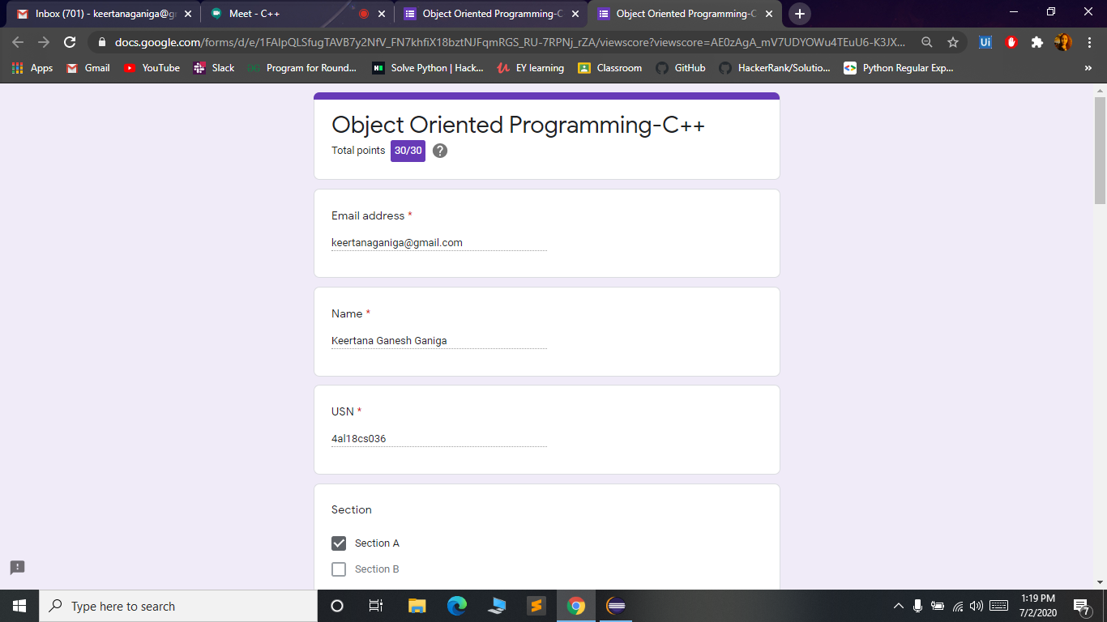

***Extra Activity:***

Today I attended Live webinar on Artificial Intelligence. Which was start at 4:30-7:00 pm.

