**DAILY ONLINE ACTIVITIES SUMMARY**

|  |  |  |  |  |  |  |  |  |
| --- | --- | --- | --- | --- | --- | --- | --- | --- |
| **Date:** | **02 June 2020** | | | | | **Name:** | **Keertana Ganesh Ganiga** | |
| **Sem & Sec** | **4th sem, 2nd year** | | | | | **USN:** | **4al18cs036** | |
| **Online Test Summary** | | | | | | | | |
| **Subject** | | **---------** | | | | | | |
| **Max. Marks** | | **---------------** | | **Score** | | | **-----------** | |
| **Certification Course Summary** | | | | | | | | |
| **Course** | **Front end Development-HTML** | | | | | | | |
| **Certificate Provider** | | | **Great Learning** | | **Duration** | | | **3.5 hours** |
| **Coding Challenges** | | | | | | | | |
| **Problem Statement:3 program** | | | | | | | | |
| **Status: Executed** | | | | | | | | |
| **Uploaded the report in Github** | | | | | **Yes** | | | |
| **If yes Repository name** | | | | | <https://github.com/keertanaganiga/Lockdown_coding>  <https://github.com/keertanaganiga/Lockdown_certification>  <https://github.com/keertanaganiga/lockdown_reports> | | | |
| **Uploaded the report in slack** | | | | | **Yes** | | | |

**Certification Course Summary:** **Today I started new certificate course through Great Learning I selected Front end Development-HTML, Todays I learnt about HTML 5 input elements, Text area, Drop down and value attribute, Radio button and check boxes, Button types, div tags.**

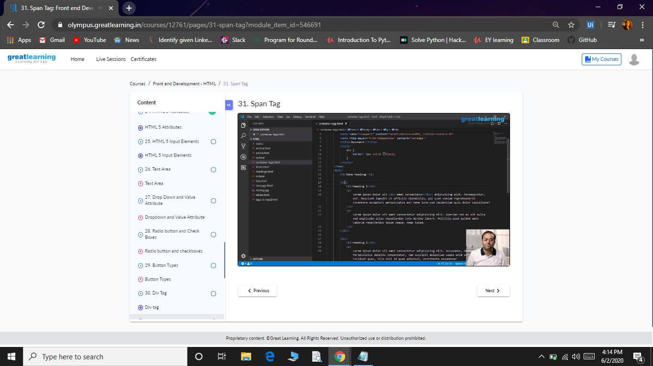

**Coding Challenges:**

Today I solved 3 coding challenge,

1. **Given an array of positive integers. Write a C Program to find inversion count of array.**
2. **Write a Java program to find Perfect Sum Problem**
3. **Write a program in java, an array of integer data to be initialized. During the initialization, if a user enters a value other than integer value, then it will throw InputMismatchException exception. On the occurrence of such an exception, your program should print “You entered bad data.” If there is no such exception it will print the total sum of the array.**

