**DAILY ONLINE ACTIVITIES SUMMARY**

|  |  |  |  |  |  |  |  |  |
| --- | --- | --- | --- | --- | --- | --- | --- | --- |
| **Date:** | **03 August 2020** | | | | | **Name:** | **Keertana Ganesh Ganiga** | |
| **Sem & Sec** | **4th sem, 2nd year** | | | | | **USN:** | **4al18cs036** | |
| **Online Test Summary** | | | | | | | | |
| **Subject** | | **-----** | | | | | | |
| **Max. Marks** | | **--** | | **Score** | | | **---** | |
| **Certification Course Summary** | | | | | | | | |
| **Course** | Python Data Structure | | | | | | | |
| **Certificate Provider** | | | **Coursera** | | **Duration** | | | **19 hrs** |
| **Coding Challenges** | | | | | | | | |
| **Problem Statement: 1 program** | | | | | | | | |
| **Status: executed** | | | | | | | | |
| **Uploaded the report in Github** | | | | | **Yes** | | | |
| **If yes Repository name** | | | | | <https://github.com/keertanaganiga/Lockdown_coding>  <https://github.com/keertanaganiga/Lockdown_certification>  <https://github.com/keertanaganiga/lockdown_reports> | | | |
| **Uploaded the report in slack** | | | | | **Yes** | | | |

#### Certification Course Summary:

#### Today I continued new course in Coursera, Python Data Structure which is of 19 Hrs course.

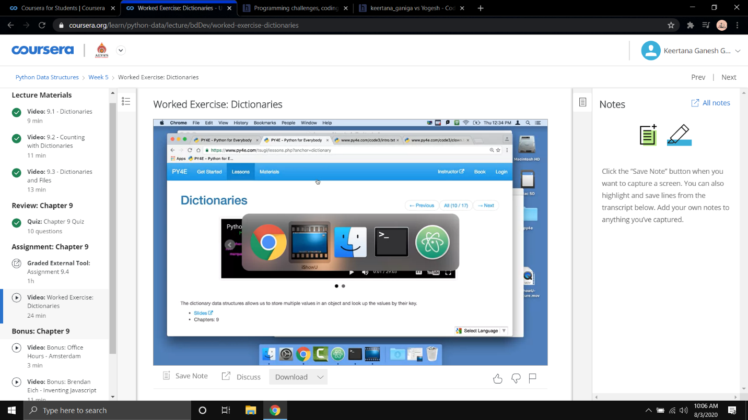

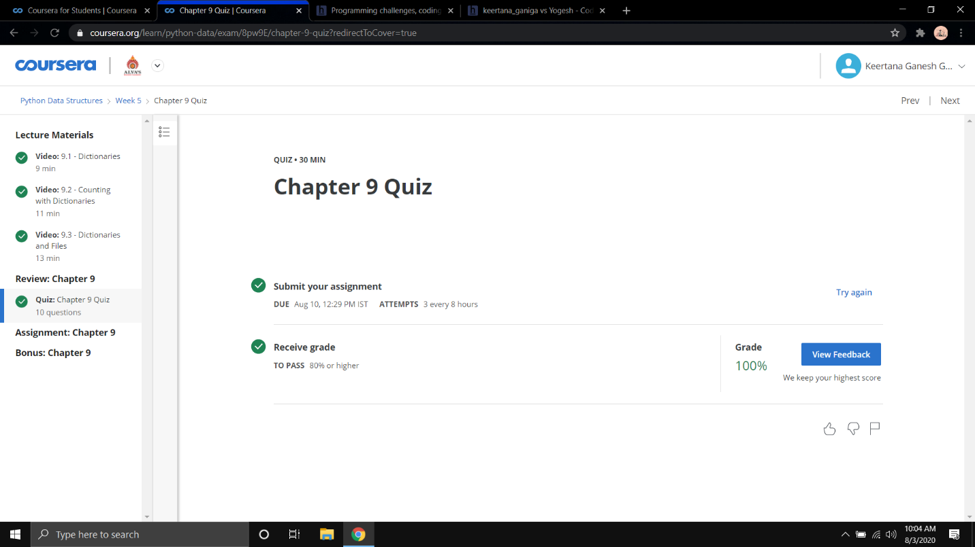

**Online coding:**

*Probably, you have already guessed that Benny doesn't like math at all. Especially, she is really bad at number theory.*

*Little Benny wants you to answer one single question that disturbs her every night.*

*You will be given three integers: l, r, g. You have to output the number of pairs of integers x and y such that and.*

*Note that pairs and are different.*

*Input format:*

*The first line contains three integers l, r and g*

*Output format:*

*Output single integer: the answer to the problem.*

*SAMPLE INPUT*

*1 11 5*

*SAMPLE OUTPUT*

*3*

