**DAILY ONLINE ACTIVITIES SUMMARY**

|  |  |  |  |  |  |  |  |  |
| --- | --- | --- | --- | --- | --- | --- | --- | --- |
| **Date:** | **03 July 2020** | | | | | **Name:** | **Keertana Ganesh Ganiga** | |
| **Sem & Sec** | **4th sem, 2nd year** | | | | | **USN:** | **4al18cs036** | |
| **Online Test Summary** | | | | | | | | |
| **Subject** | | **---------** | | | | | | |
| **Max. Marks** | | **----** | | **Score** | | | **---** | |
| **Certification Course Summary** | | | | | | | | |
| **Course** | **Machine learning with python** | | | | | | | |
| **Certificate Provider** | | | **GreatLearning** | | **Duration** | | | **10.5 hours** |
| **Coding Challenges** | | | | | | | | |
| **Problem Statement:2 program** | | | | | | | | |
| **Status: Executed** | | | | | | | | |
| **Uploaded the report in Github** | | | | | **Yes** | | | |
| **If yes Repository name** | | | | | <https://github.com/keertanaganiga/Lockdown_coding>  <https://github.com/keertanaganiga/Lockdown_certification>  <https://github.com/keertanaganiga/lockdown_reports> | | | |
| **Uploaded the report in slack** | | | | | **Yes** | | | |

#### *Certification Course Summary:*

#### Today I started new Machine learning with python in Great Learning which is of 10.5 hrs. After the completion of course, certificate will be provided.

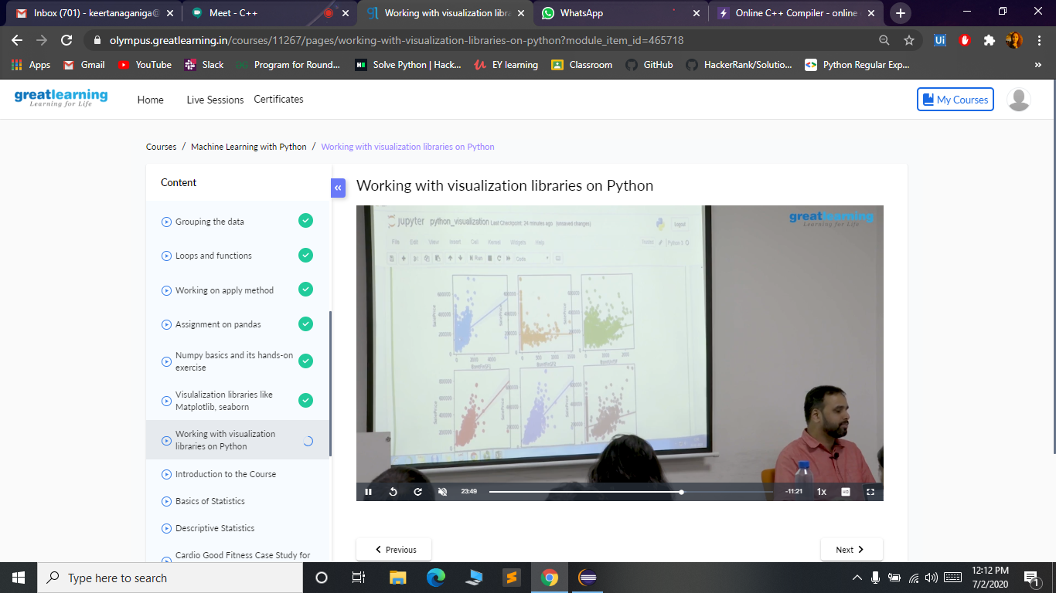

***Coding Challenges:***

Today I solved 1 coding challenge,

**1.You are given a string and your task is to swap cases. In other words, convert all lowercase letters to uppercase letters and vice versa.**

**For Example:  
Www.HackerRank.com → wWW.hACKERrANK.COM  
Pythonist 2 → pYTHONIST 2**

**Input Format  
A single line containing a string S.**

**Output Format:  
Print the modified string S.**

**Sample Input:  
HackerRank.com presents "Pythonist 2".**

**Sample Output:  
hACKERrANK.COM PRESENTS "pYTHONIST 2".**

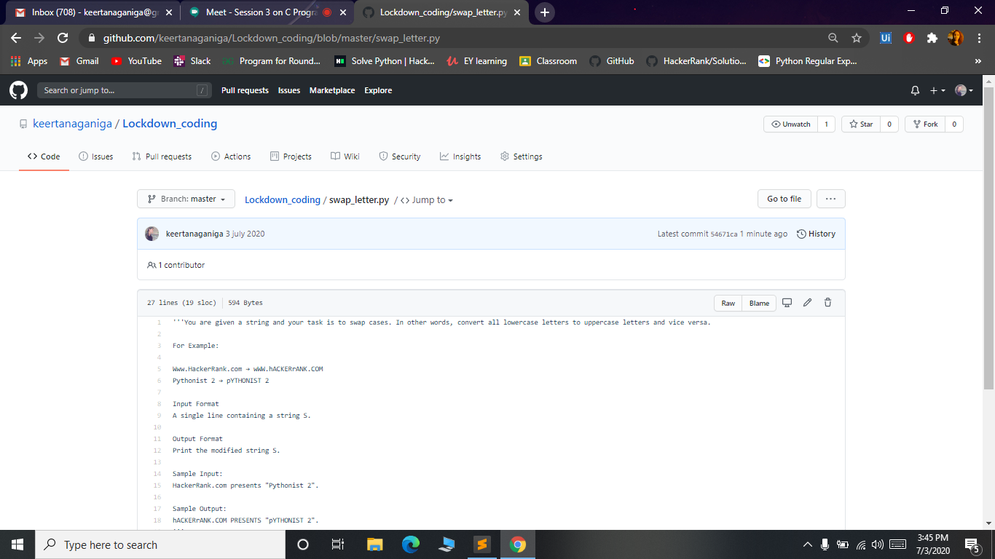

**2.** **You have a record of N students. Each record contains the student's name, and their percent marks in Maths, Physics and Chemistry. The marks can be floating values. The user enters some integer N followed by the names and marks for N students. You are required to save the record in a dictionary data type. The user then enters a student's name. Output the average percentage marks obtained by that student, correct to two decimal places.**

**Input Format:  
The first line contains the integer N, the number of students. The next N lines contains the name and marks obtained by that student separated by a space. The final line contains the name of a particular student previously listed.**

**Output Format:  
Print one line: The average of the marks obtained by the particular student correct to 2 decimal places.**

**Sample Input: 3  
Krishna 67 68 69  
Arjun 70 98 63  
Malika 52 56 60  
Malika**

**Sample Output: 56**

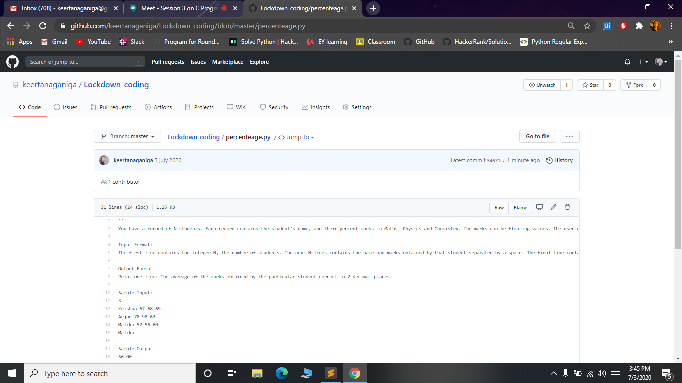

***Online class:***Today I attended Online training on C from 2:30-4:00 PM. Quizzes are conducted at the end of the class.

