**DAILY ONLINE ACTIVITIES SUMMARY**

|  |  |  |  |  |  |  |  |  |
| --- | --- | --- | --- | --- | --- | --- | --- | --- |
| **Date:** | **04 July 2020** | | | | | **Name:** | **Keertana Ganesh Ganiga** | |
| **Sem & Sec** | **4th sem, 2nd year** | | | | | **USN:** | **4al18cs036** | |
| **Online Test Summary** | | | | | | | | |
| **Subject** | | **---------** | | | | | | |
| **Max. Marks** | | **----** | | **Score** | | | **---** | |
| **Certification Course Summary** | | | | | | | | |
| **Course** | **Machine learning with python** | | | | | | | |
| **Certificate Provider** | | | **GreatLearning** | | **Duration** | | | **10.5 hours** |
| **Coding Challenges** | | | | | | | | |
| **Problem Statement:1 program** | | | | | | | | |
| **Status: Executed** | | | | | | | | |
| **Uploaded the report in Github** | | | | | **Yes** | | | |
| **If yes Repository name** | | | | | <https://github.com/keertanaganiga/Lockdown_coding>  <https://github.com/keertanaganiga/Lockdown_certification>  <https://github.com/keertanaganiga/lockdown_reports> | | | |
| **Uploaded the report in slack** | | | | | **Yes** | | | |

#### *Certification Course Summary:*

#### Today I started new Machine learning with python in Great Learning which is of 10.5 hrs. After the completion of course, certificate will be provided.

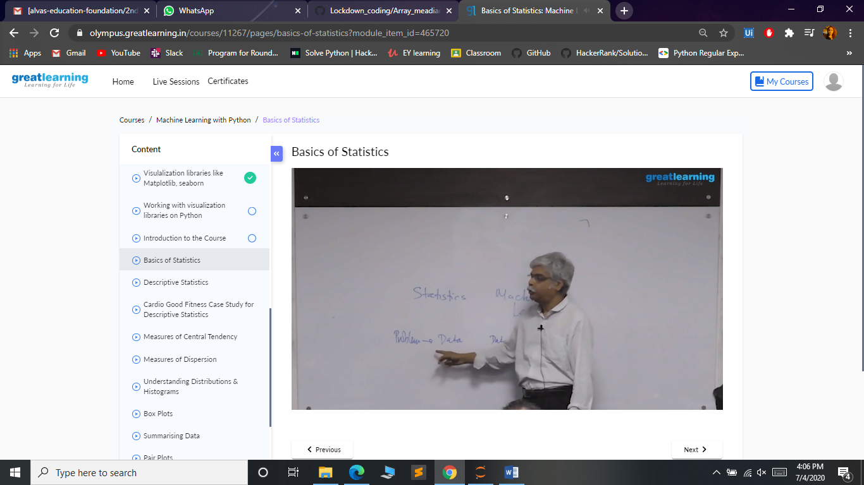

***Coding Challenges:***

Today I solved 1 coding challenge,

**1.** **Given an array of integer arr[] and an integer k, the task is to find the median of each window of size k starting from the left and moving towards the right by one position each time.**

**Examples:**   
  
**Input:**   
arr[] = {-1, 5, 13, 8, 2, 3, 3, 1}  
 k = 3   
**Output:**  
 5 8 8 3 3 3

**Input:**   
arr[] = {-1, 5, 13, 8, 2, 3, 3, 1},  
 k = 4   
**Output:**   
6.5 6.5 5.5 3.0 2.5

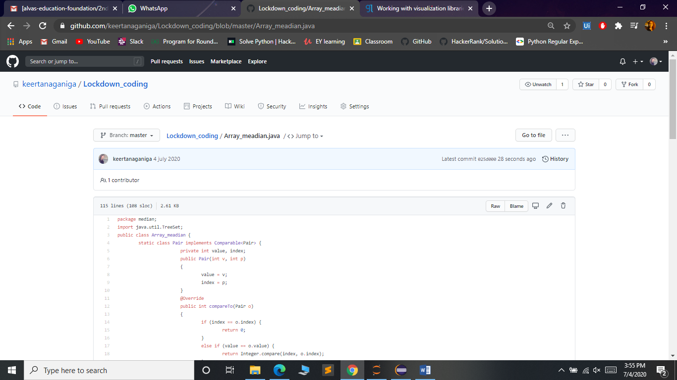

***Extra Activity:***

Today I attended Live webinar on Advanced IT requirements for future Engineers from 10am to 11am by our Almuni Mr. Aditya Naik, Site Core Developer, Valtech, Bangalore.

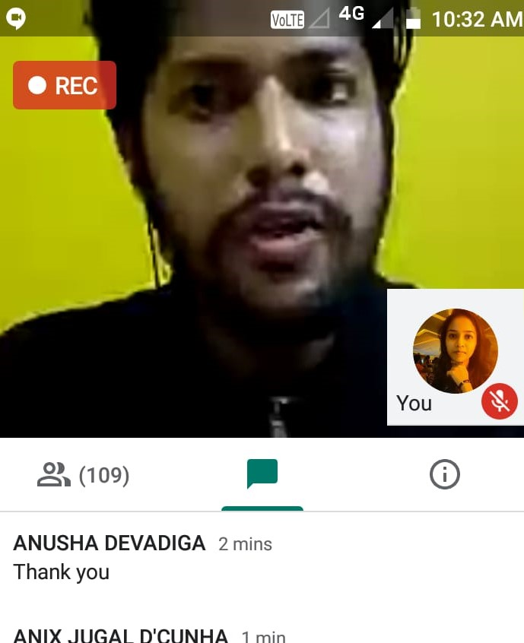

Today we received certificate of participation in “Everything is Connected” ,a webinar of IoT.

