**DAILY ONLINE ACTIVITIES SUMMARY**

|  |  |  |  |  |  |  |  |  |
| --- | --- | --- | --- | --- | --- | --- | --- | --- |
| **Date:** | **05 July 2020** | | | | | **Name:** | **Keertana Ganesh Ganiga** | |
| **Sem & Sec** | **4th sem, 2nd year** | | | | | **USN:** | **4al18cs036** | |
| **Online Test Summary** | | | | | | | | |
| **Subject** | | **---------** | | | | | | |
| **Max. Marks** | | **----** | | **Score** | | | **---** | |
| **Certification Course Summary** | | | | | | | | |
| **Course** | **Machine learning with python** | | | | | | | |
| **Certificate Provider** | | | **GreatLearning** | | **Duration** | | | **10.5 hours** |
| **Coding Challenges** | | | | | | | | |
| **Problem Statement:1 program** | | | | | | | | |
| **Status: Executed** | | | | | | | | |
| **Uploaded the report in Github** | | | | | **Yes** | | | |
| **If yes Repository name** | | | | | <https://github.com/keertanaganiga/Lockdown_coding>  <https://github.com/keertanaganiga/Lockdown_certification>  <https://github.com/keertanaganiga/lockdown_reports> | | | |
| **Uploaded the report in slack** | | | | | **Yes** | | | |

#### *Certification Course Summary:*

#### Today I started new Machine learning with python in Great Learning which is of 10.5 hrs. After the completion of course, certificate will be provided.

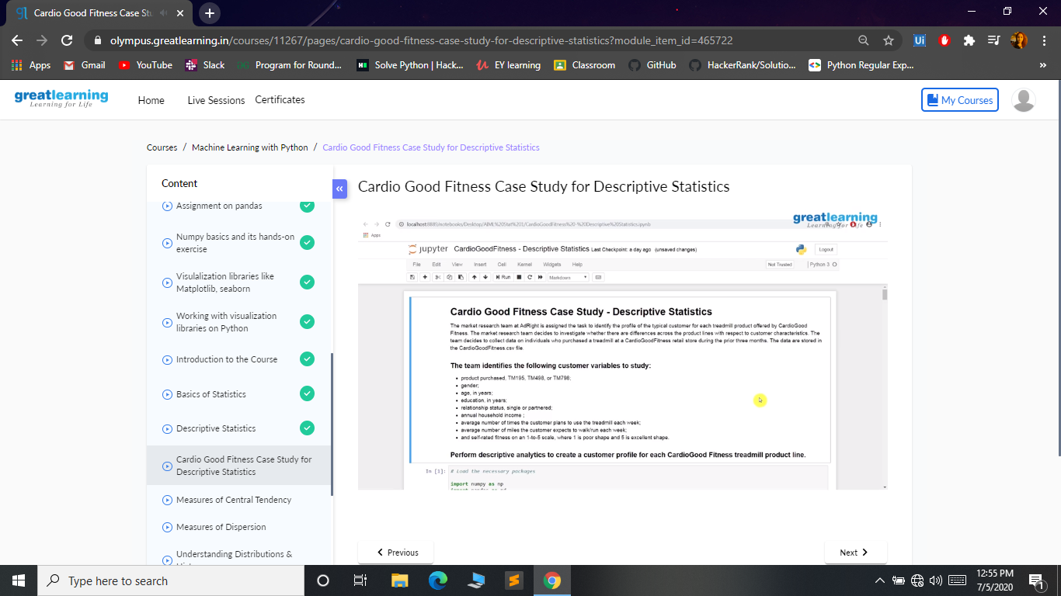

***Coding Challenges:***

Today I solved 1 coding challenge,

**You are asked to ensure that the first and last names of people begin with a capital letter in their passports. For example, alison heck should be capitalised correctly as Alison Heck.**

**alison heck=>Alison Heck  
Given a full name, your task is to capitalize the name appropriately.**

**Input Format:  
A single line of input containing the full name, S.**

**Output Format:  
Print the capitalized string, S.**

**Sample Input:  
chris alan**

**Sample Output:  
Chris Alan**

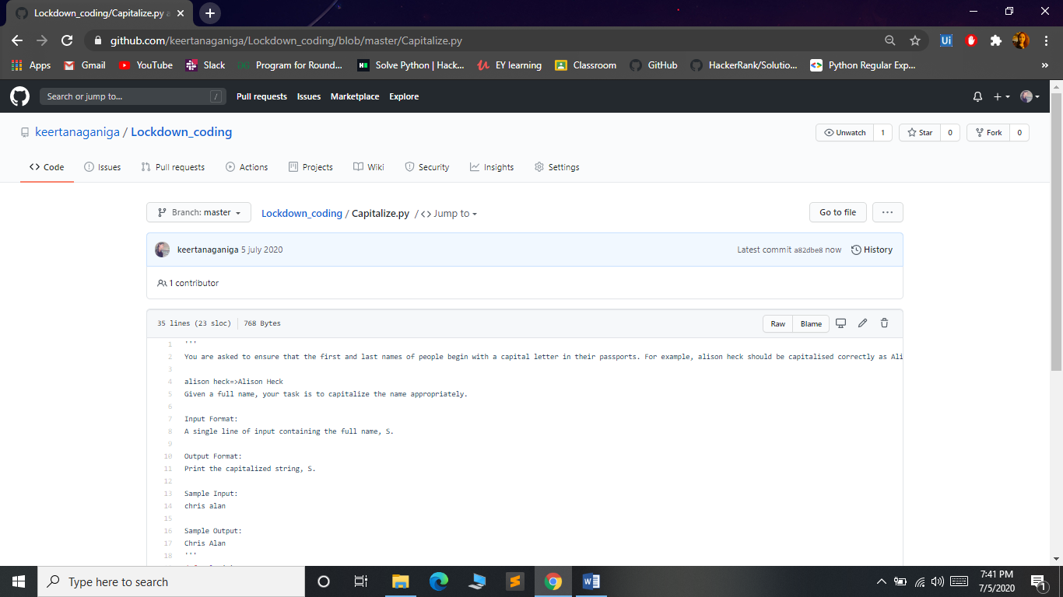

**Online webinar:**

participated in the webinar on "ARTIFICIAL INTELLIGENCE - OPPORTUNITIES AND CHALLENGES" held on 03/07/2020 organized by the Department of Computer Science and Engineering at Dr. Ambedkar Institute of Technology, Bengaluru.

