**DAILY ONLINE ACTIVITIES SUMMARY**

|  |  |  |  |  |  |  |  |  |
| --- | --- | --- | --- | --- | --- | --- | --- | --- |
| **Date:** | **06 July 2020** | | | | | **Name:** | **Keertana Ganesh Ganiga** | |
| **Sem & Sec** | **4th sem, 2nd year** | | | | | **USN:** | **4al18cs036** | |
| **Online Test Summary** | | | | | | | | |
| **Subject** | | **18MAT41** | | | | | | |
| **Max. Marks** | | **----** | | **Score** | | | **---** | |
| **Certification Course Summary** | | | | | | | | |
| **Course** | **Machine learning with python** | | | | | | | |
| **Certificate Provider** | | | **GreatLearning** | | **Duration** | | | **10.5 hours** |
| **Coding Challenges** | | | | | | | | |
| **Problem Statement:1 program** | | | | | | | | |
| **Status: Executed** | | | | | | | | |
| **Uploaded the report in Github** | | | | | **Yes** | | | |
| **If yes Repository name** | | | | | <https://github.com/keertanaganiga/Lockdown_coding>  <https://github.com/keertanaganiga/Lockdown_certification>  <https://github.com/keertanaganiga/lockdown_reports> | | | |
| **Uploaded the report in slack** | | | | | **Yes** | | | |

#### Online Exam: Today we attended 18MAT41 first IA test.

#### 

#### Certification Course Summary:

#### Today I started new Machine learning with python in Great Learning which is of 10.5 hrs. After the completion of course, certificate will be provided.

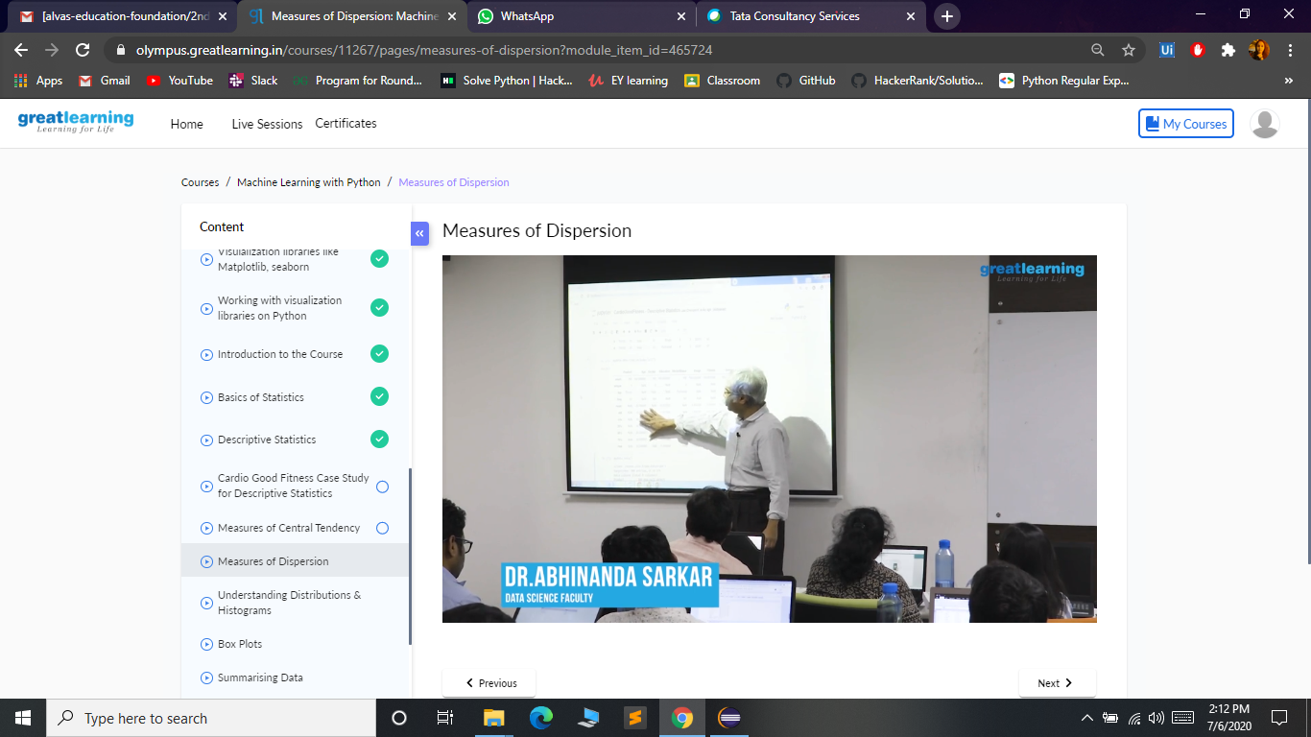

**Coding Challenges:**

Today I solved 1 coding challenge,

1**. Write a Java program to find the Nth natural number with exactly two bits set**   
Given an integer N, the task is to find the Nth natural number with exactly two bits set.  
Examples:

Input: N = 4  
Output: 9

Input: N = 15  
Output: 48

**Hint**  
***Explanation: of 1st example***  
Binary representation of numbers 1 -0001, 2- 0010, **3- 0011**, 4-0100, **5-0101**, **6-0110**, 7- 0111, 8-1000, **9 - 1001**, **10- 1010** etc. Here only for the bold numbers binary values contains exactly 2 bits 1's hence  
Numbers with exactly two bits set: 3, 5, 6, 9, 10, 12, …  
4th number in this is 9.

**output:  
9**

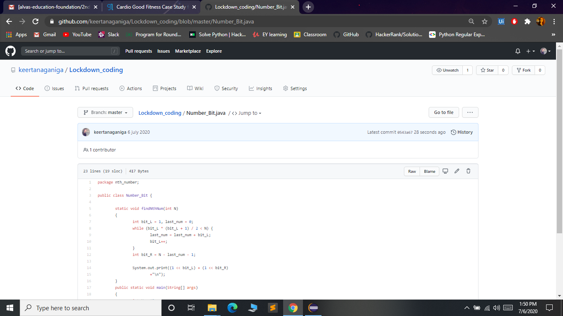

**Online webinar:**

**Today we attended the session on Salesforce - Job ready program at Time: 11.30AM.**

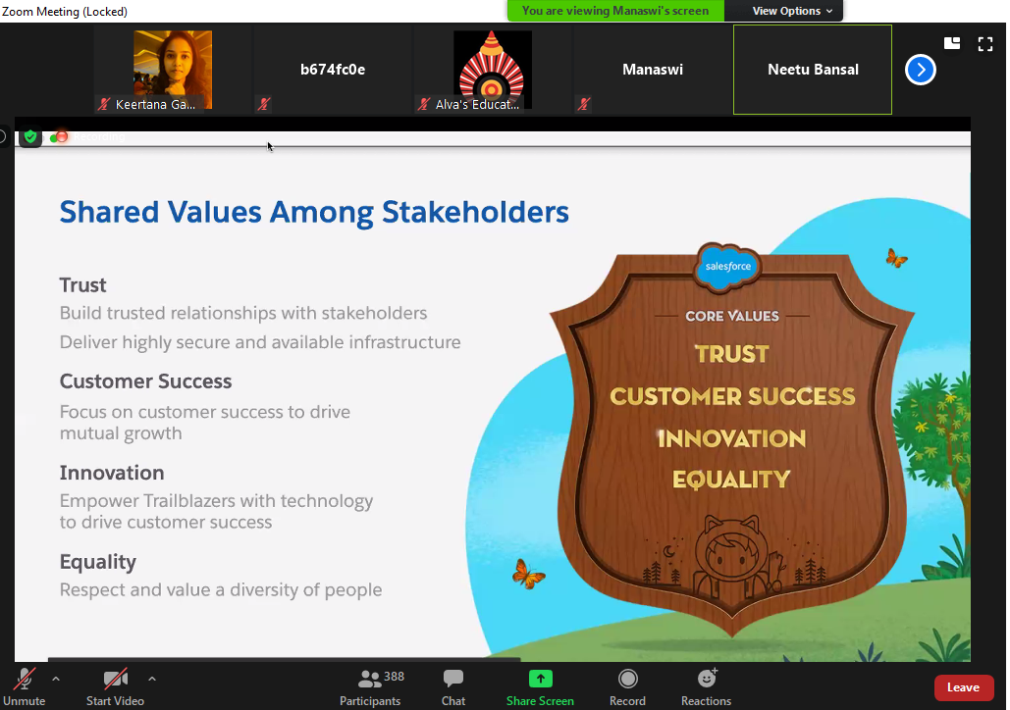

At afternoon we attended the webinar TCS iON Session on How to use Remote Internship Opportunities at 2:15.

