**DAILY ONLINE ACTIVITIES SUMMARY**

|  |  |  |  |  |  |  |  |  |
| --- | --- | --- | --- | --- | --- | --- | --- | --- |
| **Date:** | **08 July 2020** | | | | | **Name:** | **Keertana Ganesh Ganiga** | |
| **Sem & Sec** | **4th sem, 2nd year** | | | | | **USN:** | **4al18cs036** | |
| **Online Test Summary** | | | | | | | | |
| **Subject** | | **-----** | | | | | | |
| **Max. Marks** | | **----** | | **Score** | | | **---** | |
| **Certification Course Summary** | | | | | | | | |
| **Course** | **Machine learning with python, Introduction to HTML5** | | | | | | | |
| **Certificate Provider** | | | **GreatLearning, coursera** | | **Duration** | | | **10.5 hours, 12 hrs** |
| **Coding Challenges** | | | | | | | | |
| **Problem Statement:1 program** | | | | | | | | |
| **Status: Executed** | | | | | | | | |
| **Uploaded the report in Github** | | | | | **Yes** | | | |
| **If yes Repository name** | | | | | <https://github.com/keertanaganiga/Lockdown_coding>  <https://github.com/keertanaganiga/Lockdown_certification>  <https://github.com/keertanaganiga/lockdown_reports> | | | |
| **Uploaded the report in slack** | | | | | **Yes** | | | |

Online Exam:

Today DAA exam was conducted at 10:00 AM.

#### Certification Course Summary:

#### Today I started new Machine learning with python in Great Learning which is of 10.5 hrs. After the completion of course, certificate will be provided.

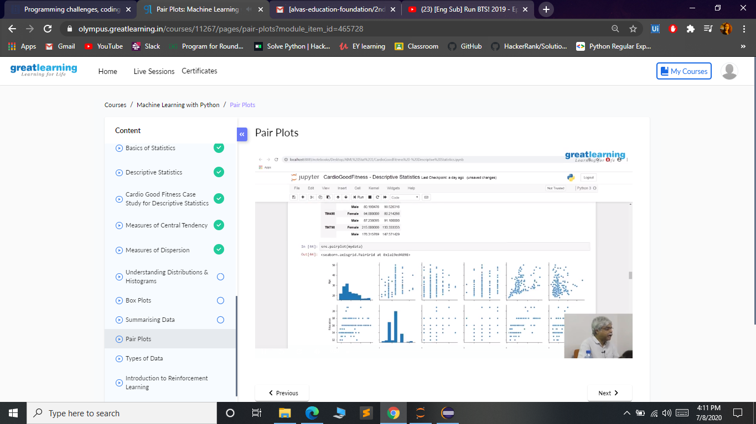

**Today I started new course in coursera with is provided by our organization and I started Introduction to HTML5 with is of 12 hrs.  
course**

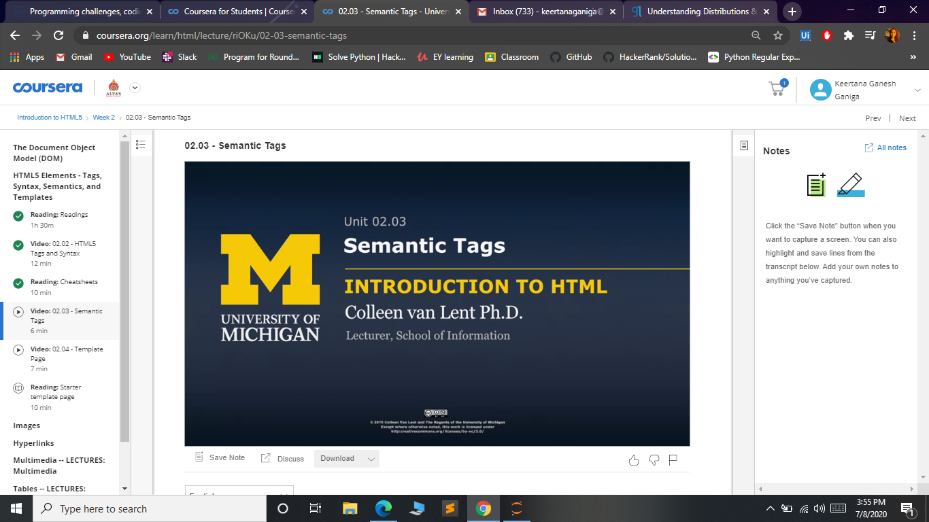

**Online coding:  
Write a java program to find whether the given strings are anagram**Given two strings a and b consisting of lowercase characters. The task is to check whether two given strings are anagram of each other or not. An anagram of a string is another string that contains same characters, only the order of characters can be different. For example, “act” and “tac” are anagram of each other.

**Example:**  
Input:  
alvasinsitute aalvsiittnsue  
allergy allergic

**Output:**  
YES  
NO

Explanation:  
Testcase 1: Both the string have same characters with same frequency. So, both are anagrams.  
Testcase 2: Characters in both the strings are not same, so they are not anagrams.

