**DAILY ONLINE ACTIVITIES SUMMARY**

|  |  |  |  |  |  |  |  |  |
| --- | --- | --- | --- | --- | --- | --- | --- | --- |
| **Date:** | **10 July 2020** | | | | | **Name:** | **Keertana Ganesh Ganiga** | |
| **Sem & Sec** | **4th sem, 2nd year** | | | | | **USN:** | **4al18cs036** | |
| **Online Test Summary** | | | | | | | | |
| **Subject** | | OBJECT-ORIENTED CONCEPTS (18CS43) | | | | | | |
| **Max. Marks** | | **30** | | **Score** | | | **---** | |
| **Certification Course Summary** | | | | | | | | |
| **Course** | **Machine learning with python, Introduction to HTML5** | | | | | | | |
| **Certificate Provider** | | | **GreatLearning, coursera** | | **Duration** | | | **10.5 hours, 12 hrs** |
| **Coding Challenges** | | | | | | | | |
| **Problem Statement: --** | | | | | | | | |
| **Status: --** | | | | | | | | |
| **Uploaded the report in Github** | | | | | **Yes** | | | |
| **If yes Repository name** | | | | | <https://github.com/keertanaganiga/Lockdown_coding>  <https://github.com/keertanaganiga/Lockdown_certification>  <https://github.com/keertanaganiga/lockdown_reports> | | | |
| **Uploaded the report in slack** | | | | | **Yes** | | | |

Online Exam:  
Today OBJECT-ORIENTED CONCEPTS (18CS43) was conducted for 30 marks from 9:30-10:15 Am

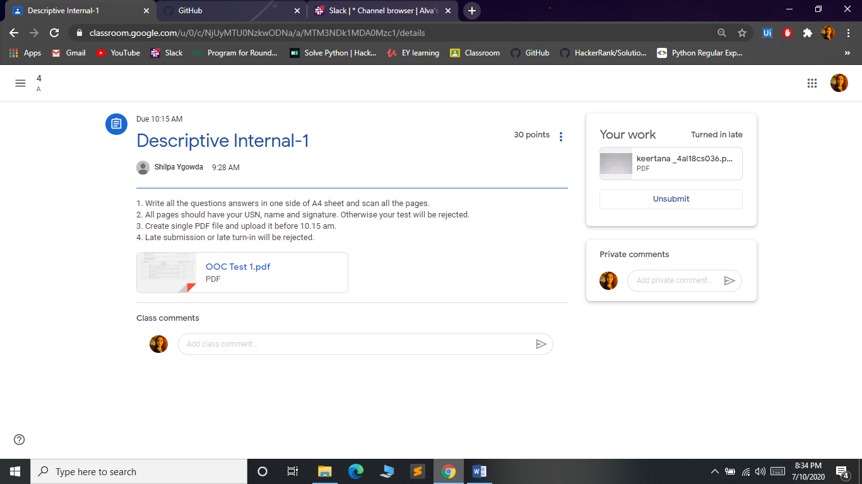

#### Certification Course Summary:

#### Today I continued new Machine learning with python in Great Learning which is of 10.5 hrs. After the completion of course, certificate will be provided.

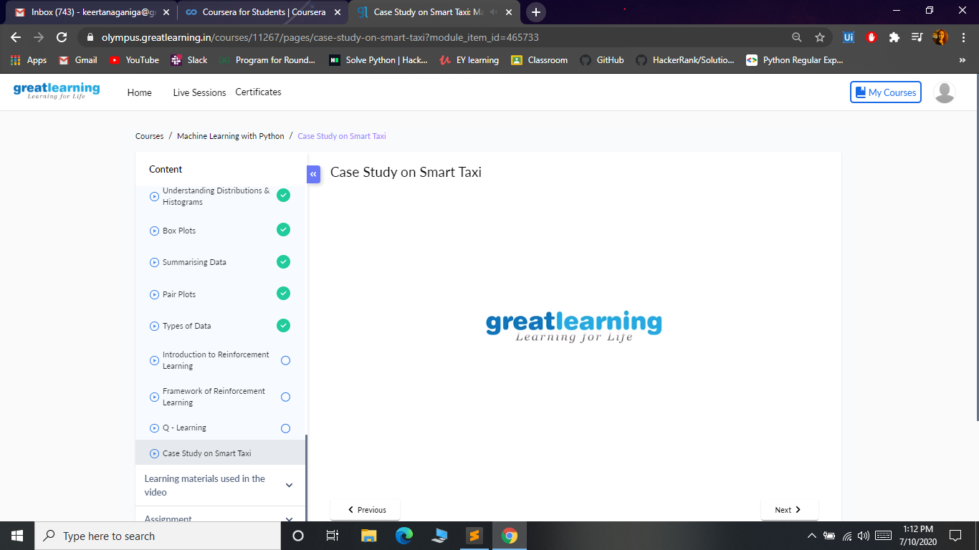

**Today I continued new course in coursera with is provided by our organization and I started Introduction to HTML5 with is of 12 hrs.  
course**

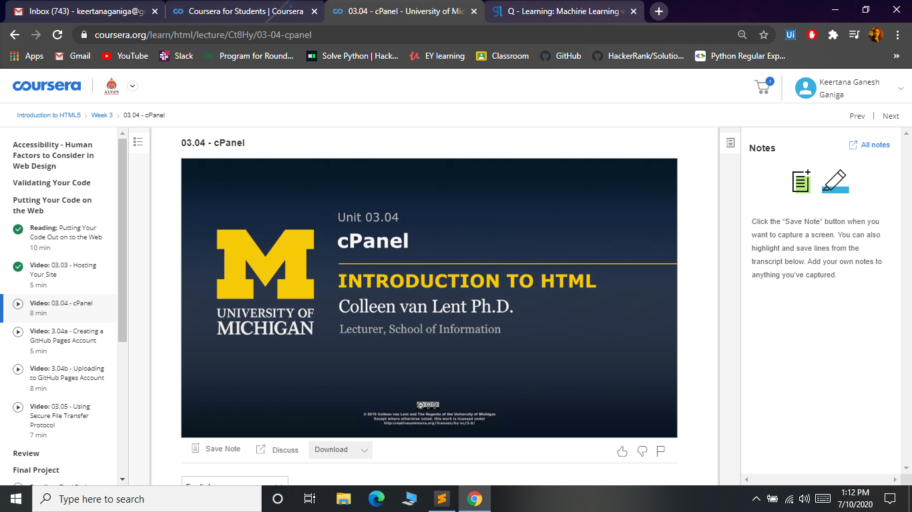

**I attended Data Analytic Quiz organized by Departmentt of Computer Science and Engineering TOCE.**

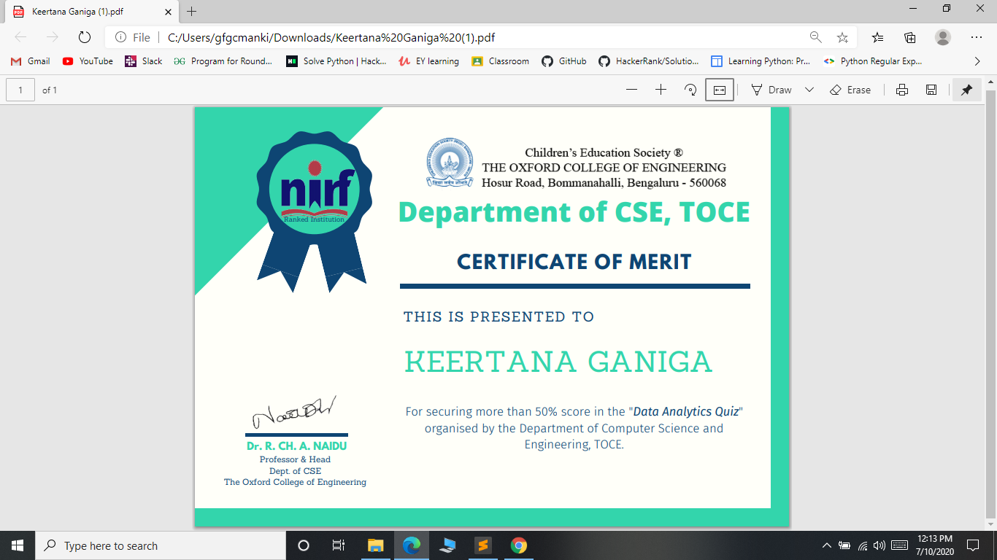

Got certificate in Coursera for Object Oriented Programming with java of 60 minutes class

