**DAILY ONLINE ACTIVITIES SUMMARY**

|  |  |  |  |  |  |  |  |  |
| --- | --- | --- | --- | --- | --- | --- | --- | --- |
| **Date:** | **10 June 2020** | | | | | **Name:** | **Keertana Ganesh Ganiga** | |
| **Sem & Sec** | **4th sem, 2nd year** | | | | | **USN:** | **4al18cs036** | |
| **Online Test Summary** | | | | | | | | |
| **Subject** | | **OBJECT ORIENTED CONCEPTS (18cs45)** | | | | | | |
| **Max. Marks** | | **30** | | **Score** | | | **12** | |
| **Certification Course Summary** | | | | | | | | |
| **Course** | **Introduction to mobile and cloud computing** | | | | | | | |
| **Certificate Provider** | | | **Alison** | | **Duration** | | | **2 hours** |
| **Coding Challenges** | | | | | | | | |
| **Problem Statement:2 program** | | | | | | | | |
| **Status: Executed** | | | | | | | | |
| **Uploaded the report in Github** | | | | | **Yes** | | | |
| **If yes Repository name** | | | | | <https://github.com/keertanaganiga/Lockdown_coding>  <https://github.com/keertanaganiga/Lockdown_certification>  <https://github.com/keertanaganiga/lockdown_reports> | | | |
| **Uploaded the report in slack** | | | | | **Yes** | | | |

**Online Test Summary**

**Today OBJECT-ORIENTED CONCEPTS (18cs45) was conducted for 30 marks.**

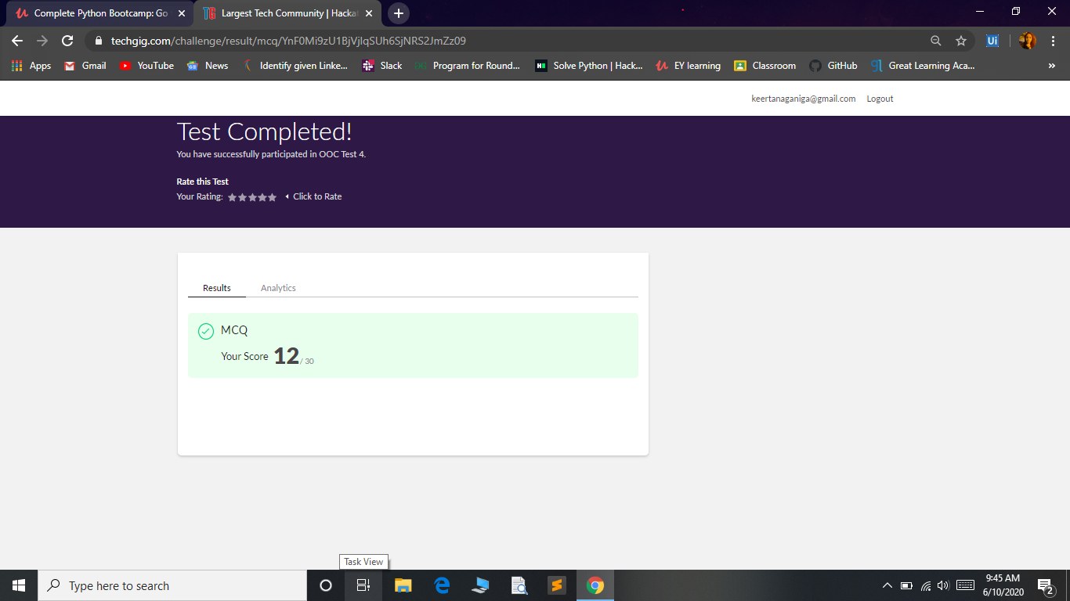

**Certification Course Summary:** **Today I started new certificate course through Alison, Introduction to mobile and cloud computing. I completed the course but for certificate I have pay I attached screenshot of that.**

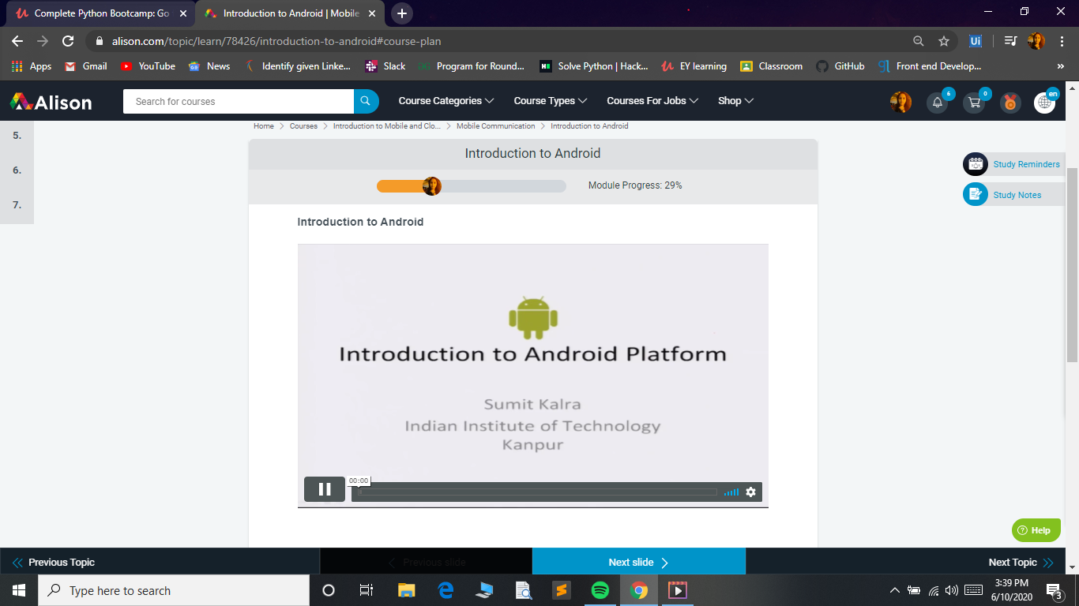

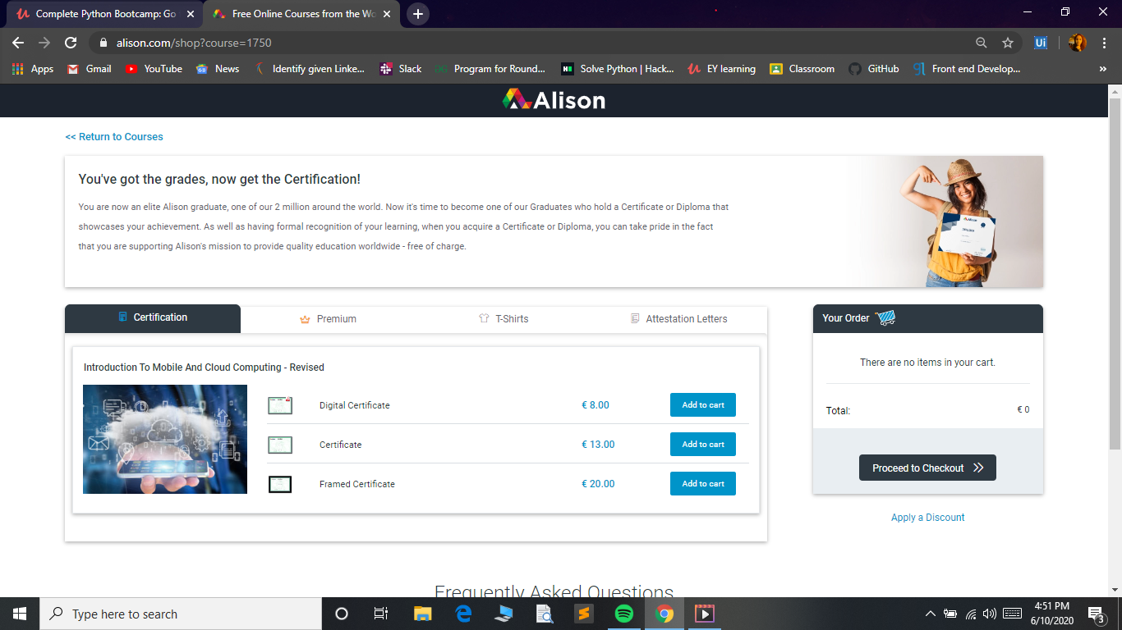

**Coding Challenges:**

Today I solved 2 coding challenge,

1. **Java Program to find the longest repeating sequence in a string**
2. **Write a C Program to print the sum of boundary elements of a matrix**

