**DAILY ONLINE ACTIVITIES SUMMARY**

|  |  |  |  |  |  |  |  |  |
| --- | --- | --- | --- | --- | --- | --- | --- | --- |
| **Date:** | **11 August 2020** | | | | | **Name:** | **Keertana Ganesh Ganiga** | |
| **Sem & Sec** | **4th sem, 2nd year** | | | | | **USN:** | **4al18cs036** | |
| **Online Test Summary** | | | | | | | | |
| **Subject** | | **-----** | | | | | | |
| **Max. Marks** | | **--** | | **Score** | | | **---** | |
| **Certification Course Summary** | | | | | | | | |
| **Course** | Java Programming: Arrays, Lists, and Structured Data | | | | | | | |
| **Certificate Provider** | | | **Coursera** | | **Duration** | | | **12 hrs** |
| **Coding Challenges** | | | | | | | | |
| **Problem Statement: python program** | | | | | | | | |
| **Status: executed** | | | | | | | | |
| **Uploaded the report in Github** | | | | | **Yes** | | | |
| **If yes Repository name** | | | | | <https://github.com/keertanaganiga/Lockdown_coding>  <https://github.com/keertanaganiga/Lockdown_certification>  <https://github.com/keertanaganiga/lockdown_reports> | | | |
| **Uploaded the report in slack** | | | | | **Yes** | | | |

#### Certification Course Summary:

#### Today I continued new course in Coursera, Java Programming: Arrays, Lists, and Structured Data which is of 12 hours.

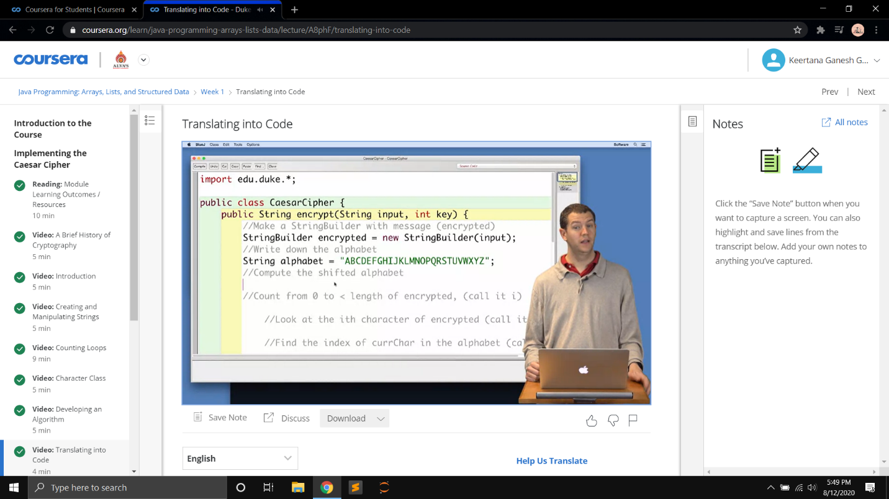

**Online program:**Write a C program that accepts the marks in 6 subjects of a student, calculates the average mark of the student and prints the student's grade. If the average mark is greater than or equal to 90, then the grade is 'A'. If the average mark is greater than or equal to 80, then the grade is ‘B'. If the average mark is greater than or equal to 70, then the grade is 'C'. If the average mark is greater than or equal to 60, then the grade is 'D'. If the average mark is greater than or equal to 50, then the grade is 'E'. If the average mark is less than 50, then the grade is 'F'.  
  
**Input Format:**  
Input consists of 6 lines. Each line consists of an integer.  
  
**Output Format:**  
The output consists of a single line. Refer sample output for the format.  
  
**Refer sample input and output for formatting specifications.  
[All text in bold corresponds to the input and the rest corresponds to output].  
  
Sample Input and Output 1:**  
**65  
78  
90  
45  
56  
98**  
The grade is C  
  
**Sample Input and Output 2:**  
**99  
100  
98  
96  
98  
95**  
The grade is A

