**DAILY ONLINE ACTIVITIES SUMMARY**

|  |  |  |  |  |  |  |  |  |
| --- | --- | --- | --- | --- | --- | --- | --- | --- |
| **Date:** | **11 July 2020** | | | | | **Name:** | **Keertana Ganesh Ganiga** | |
| **Sem & Sec** | **4th sem, 2nd year** | | | | | **USN:** | **4al18cs036** | |
| **Online Test Summary** | | | | | | | | |
| **Subject** | | **----** | | | | | | |
| **Max. Marks** | | **--** | | **Score** | | | **---** | |
| **Certification Course Summary** | | | | | | | | |
| **Course** | **Machine learning with python, Introduction to HTML5** | | | | | | | |
| **Certificate Provider** | | | **GreatLearning, coursera** | | **Duration** | | | **10.5 hours, 12 hrs** |
| **Coding Challenges** | | | | | | | | |
| **Problem Statement: 1** | | | | | | | | |
| **Status: executed** | | | | | | | | |
| **Uploaded the report in Github** | | | | | **Yes** | | | |
| **If yes Repository name** | | | | | <https://github.com/keertanaganiga/Lockdown_coding>  <https://github.com/keertanaganiga/Lockdown_certification>  <https://github.com/keertanaganiga/lockdown_reports> | | | |
| **Uploaded the report in slack** | | | | | **Yes** | | | |

#### Certification Course Summary:

#### Today I continued new Machine learning with python in Great Learning which is of 10.5 hrs. After the completion of course, certificate will be provided.

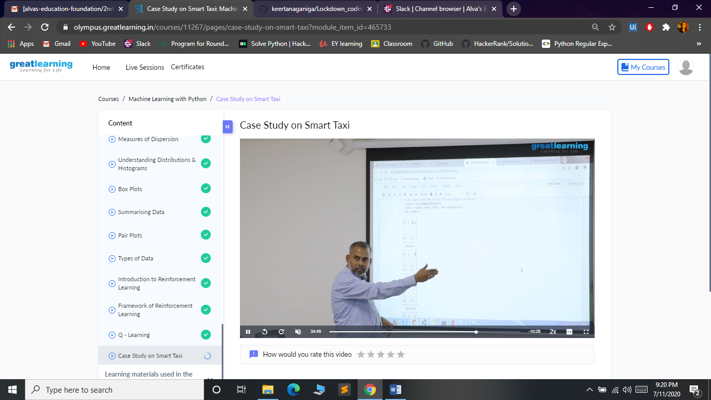

**Today I continued new course in coursera with is provided by our organization and I started Introduction to HTML5 with is of 12 hrs.  
course**

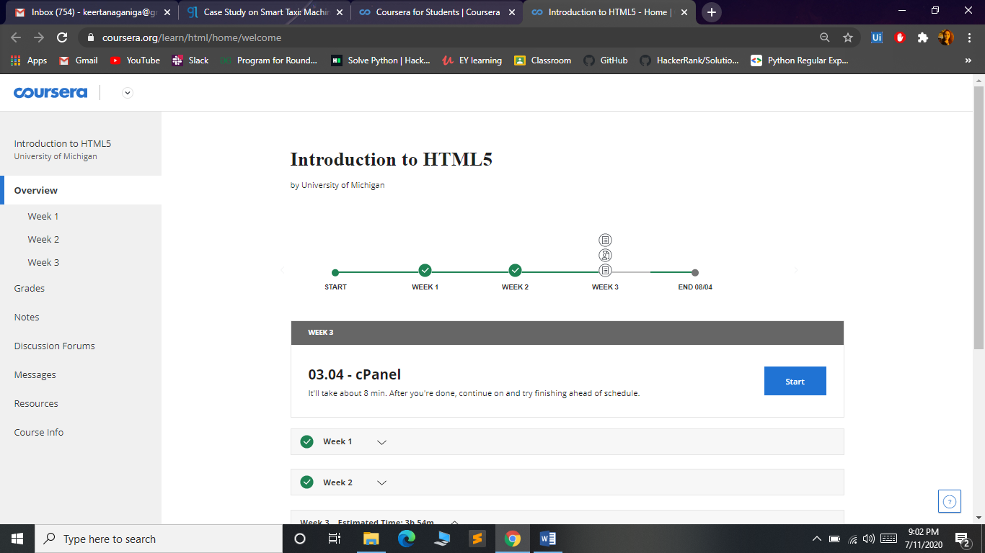

Online coding:  
**Write a Java program for Reversal algorithm for array rotation by 3**.  
Given an array a[], array size n and d the number of index to be rotated task is to write a function rotate(arr[], d, n) that rotates arr[] of size n by d elements.

Example:  
  
Input:  
n= 6  
arr[]= {1,2,3,4,5,6}  
d=3 (specific)  
  
Output:   
arr[]= {4,5,6,1,2,3}

