**DAILY ONLINE ACTIVITIES SUMMARY**

|  |  |  |  |  |  |  |  |  |
| --- | --- | --- | --- | --- | --- | --- | --- | --- |
| **Date:** | **11 June 2020** | | | | | **Name:** | **Keertana Ganesh Ganiga** | |
| **Sem & Sec** | **4th sem, 2nd year** | | | | | **USN:** | **4al18cs036** | |
| **Online Test Summary** | | | | | | | | |
| **Subject** | | **--------** | | | | | | |
| **Max. Marks** | | **----** | | **Score** | | | **----** | |
| **Certification Course Summary** | | | | | | | | |
| **Course** | **HTML for beginners** | | | | | | | |
| **Certificate Provider** | | | **Udemy** | | **Duration** | | | **2 hours** |
| **Coding Challenges** | | | | | | | | |
| **Problem Statement:1 program** | | | | | | | | |
| **Status: Executed** | | | | | | | | |
| **Uploaded the report in Github** | | | | | **Yes** | | | |
| **If yes Repository name** | | | | | <https://github.com/keertanaganiga/Lockdown_coding>  <https://github.com/keertanaganiga/Lockdown_certification>  <https://github.com/keertanaganiga/lockdown_reports> | | | |
| **Uploaded the report in slack** | | | | | **Yes** | | | |

**Certification Course Summary:** **Today I started new certificate course in Udemy that is Introduction to HTML for beginners Installation of basic tools, quick start with simple page, creating templets, Gallery pages etc.**

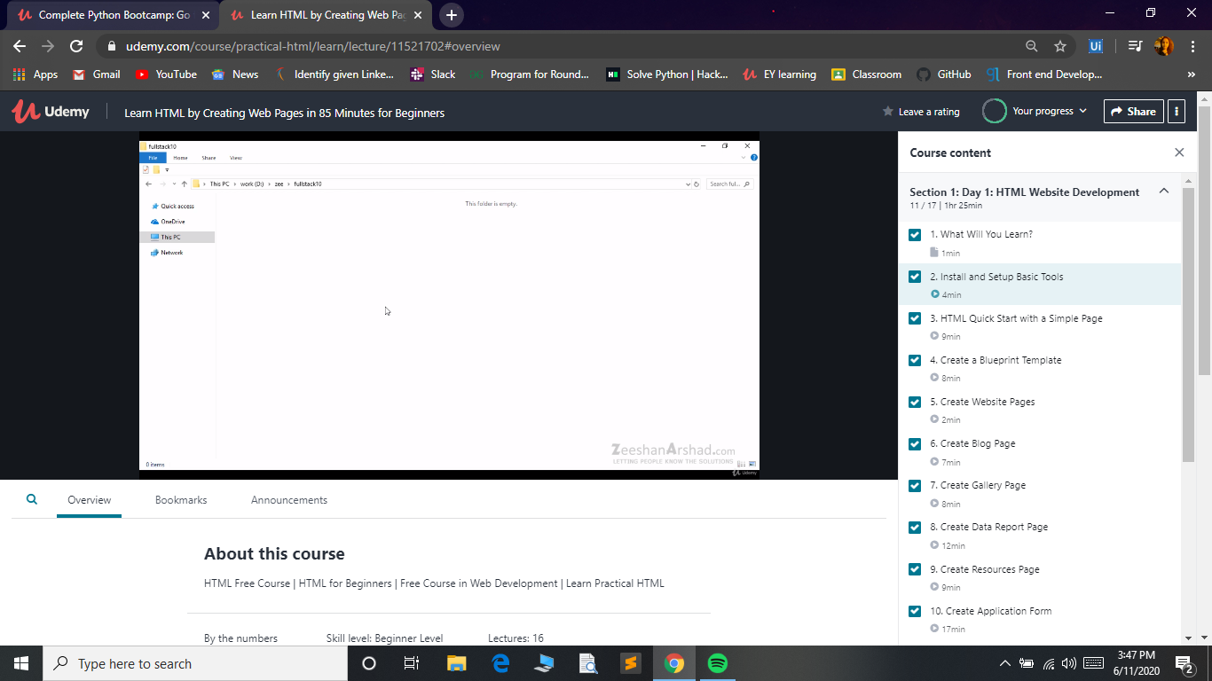

**Coding Challenges:**

Today I solved 1 coding challenge,

**1.Write a Java Program to Segregate Even and Odd numbers**

