**DAILY ONLINE ACTIVITIES SUMMARY**

|  |  |  |  |  |  |  |  |  |
| --- | --- | --- | --- | --- | --- | --- | --- | --- |
| **Date:** | **12 August 2020** | | | | | **Name:** | **Keertana Ganesh Ganiga** | |
| **Sem & Sec** | **4th sem, 2nd year** | | | | | **USN:** | **4al18cs036** | |
| **Online Test Summary** | | | | | | | | |
| **Subject** | | **-----** | | | | | | |
| **Max. Marks** | | **--** | | **Score** | | | **---** | |
| **Certification Course Summary** | | | | | | | | |
| **Course** | Java Programming: Arrays, Lists, and Structured Data | | | | | | | |
| **Certificate Provider** | | | **Coursera** | | **Duration** | | | **12 hrs** |
| **Coding Challenges** | | | | | | | | |
| **Problem Statement: python program** | | | | | | | | |
| **Status: executed** | | | | | | | | |
| **Uploaded the report in Github** | | | | | **Yes** | | | |
| **If yes Repository name** | | | | | <https://github.com/keertanaganiga/Lockdown_coding>  <https://github.com/keertanaganiga/Lockdown_certification>  <https://github.com/keertanaganiga/lockdown_reports> | | | |
| **Uploaded the report in slack** | | | | | **Yes** | | | |

#### Certification Course Summary:

#### Today I continued new course in Coursera, Java Programming: Arrays, Lists, and Structured Data which is of 12 hours.

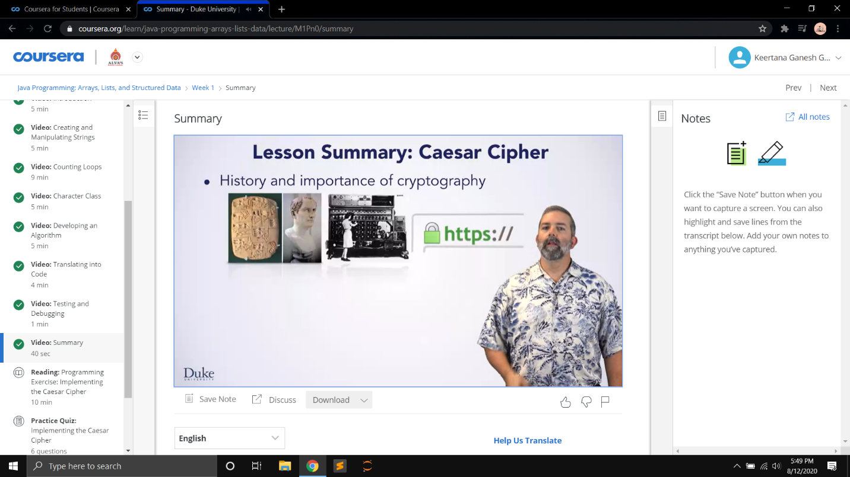

### **Online program:** ODD OR EVEN (WITHOUT USING ELSE)

**Odd or Even (without using else)**

Write a c program to determine whether a given number is 'odd' or 'even' and print the message NUMBER IS EVEN or NUMBER IS ODD without using else option.  
  
**Input format :**  
Input consists of integer value  
**Output format :**  
Output should print the message NUMBER IS EVEN or NUMBER IS ODD**.**  
  
**Refer sample input and output for formatting specifications.  
[All text in bold corresponds to input and the rest corresponds to output].  
  
Sample Input and Output 1:**  
40  
NUMBER IS EVEN  
**Sample Input and Output 2:**  
45  
NUMBER IS ODD

