**DAILY ONLINE ACTIVITIES SUMMARY**

|  |  |  |  |  |  |  |  |  |
| --- | --- | --- | --- | --- | --- | --- | --- | --- |
| **Date:** | **12 July 2020** | | | | | **Name:** | **Keertana Ganesh Ganiga** | |
| **Sem & Sec** | **4th sem, 2nd year** | | | | | **USN:** | **4al18cs036** | |
| **Online Test Summary** | | | | | | | | |
| **Subject** | | **----** | | | | | | |
| **Max. Marks** | | **--** | | **Score** | | | **---** | |
| **Certification Course Summary** | | | | | | | | |
| **Course** | **Machine learning with python, Introduction to HTML5** | | | | | | | |
| **Certificate Provider** | | | **GreatLearning, coursera** | | **Duration** | | | **10.5 hours, 12 hrs** |
| **Coding Challenges** | | | | | | | | |
| **Problem Statement: 1** | | | | | | | | |
| **Status: executed** | | | | | | | | |
| **Uploaded the report in Github** | | | | | **Yes** | | | |
| **If yes Repository name** | | | | | <https://github.com/keertanaganiga/Lockdown_coding>  <https://github.com/keertanaganiga/Lockdown_certification>  <https://github.com/keertanaganiga/lockdown_reports> | | | |
| **Uploaded the report in slack** | | | | | **Yes** | | | |

#### Certification Course Summary:

#### Today I continued new Machine learning with python in Great Learning which is of 10.5 hrs. Completed the course with certificate.

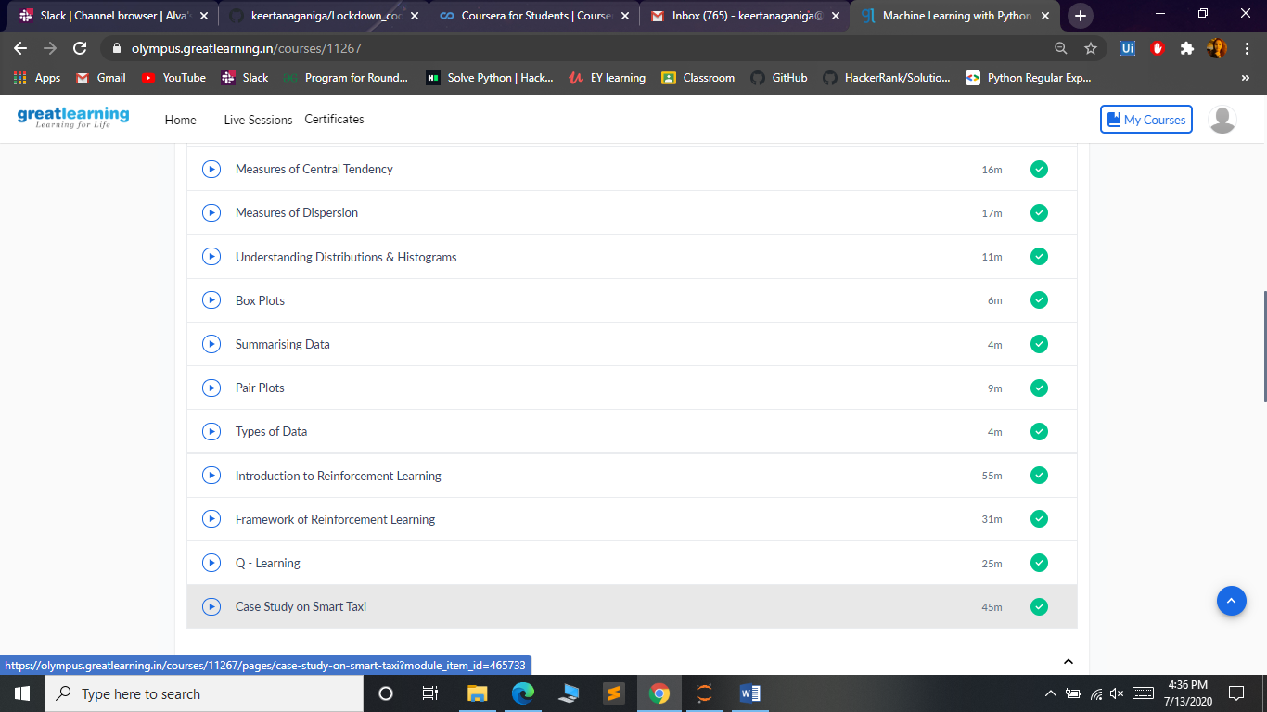

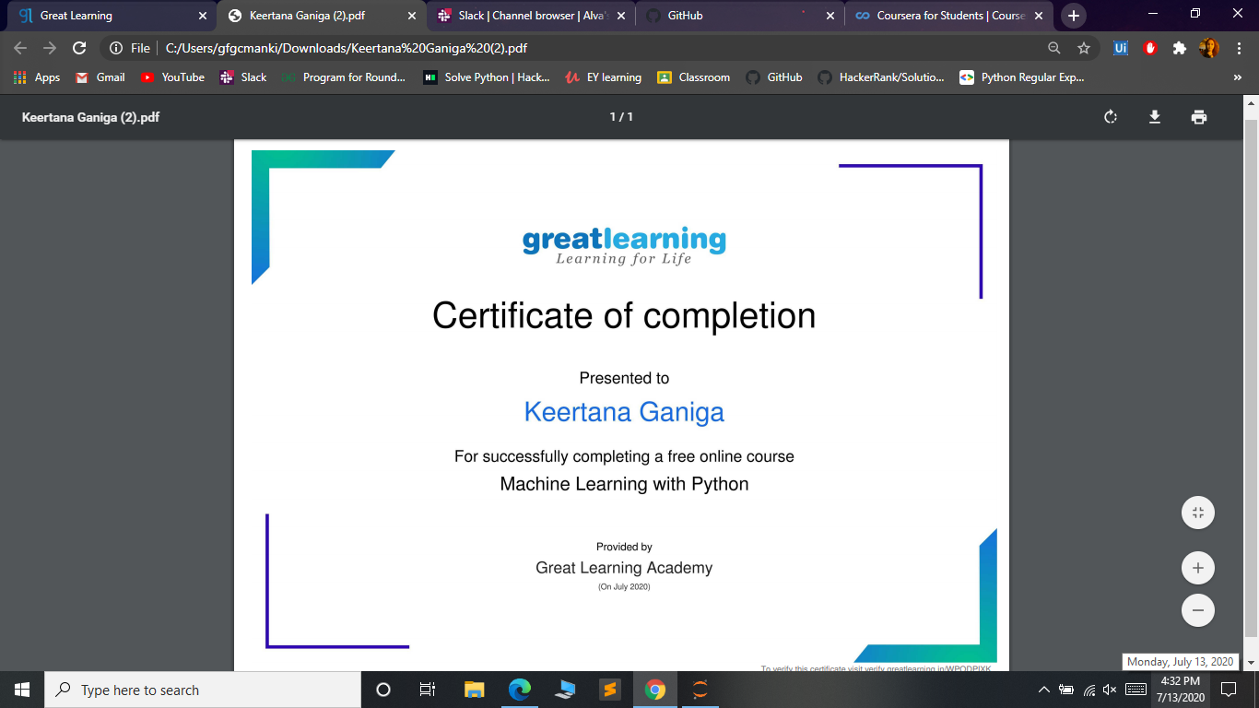

**Online coding:**

Let's learn about list comprehensions! You are given three integers x,y and z representing the dimensions of a cuboid along with an integer. Print a list of all possible coordinates given by (i, j, k) on a 3D grid where the sum of i+j+k is not equal to n. Here,0<=i<=x;0<=j<=y;0<=k<=z. Please use list comprehensions rather than multiple loops, as a learning exercise.

Input Format:  
Four integers x,y,z and n, each on a separate line.

Constraints:  
Print the list in lexicographic increasing order.

Sample Input:  
1  
1  
1  
2

Sample Output:  
[[0, 0, 0], [0, 0, 1], [0, 1, 0], [1, 0, 0], [1, 1, 1]]

