**DAILY ONLINE ACTIVITIES SUMMARY**

|  |  |  |  |  |  |  |  |  |
| --- | --- | --- | --- | --- | --- | --- | --- | --- |
| **Date:** | **12 June 2020** | | | | | **Name:** | **Keertana Ganesh Ganiga** | |
| **Sem & Sec** | **4th sem, 2nd year** | | | | | **USN:** | **4al18cs036** | |
| **Online Test Summary** | | | | | | | | |
| **Subject** | | **Adalitha kannada** | | | | | | |
| **Max. Marks** | | **25** | | **Score** | | | **19** | |
| **Certification Course Summary** | | | | | | | | |
| **Course** | **HTML for beginners** | | | | | | | |
| **Certificate Provider** | | | **Udemy** | | **Duration** | | | **2 hours** |
| **Coding Challenges** | | | | | | | | |
| **Problem Statement:1 program** | | | | | | | | |
| **Status: Executed** | | | | | | | | |
| **Uploaded the report in Github** | | | | | **Yes** | | | |
| **If yes Repository name** | | | | | <https://github.com/keertanaganiga/Lockdown_coding>  <https://github.com/keertanaganiga/Lockdown_certification>  <https://github.com/keertanaganiga/lockdown_reports> | | | |
| **Uploaded the report in slack** | | | | | **Yes** | | | |

**Online Test Summary**

**Today kannada exam was conducted in google classroom for 25 marks with duration of 25 min.**

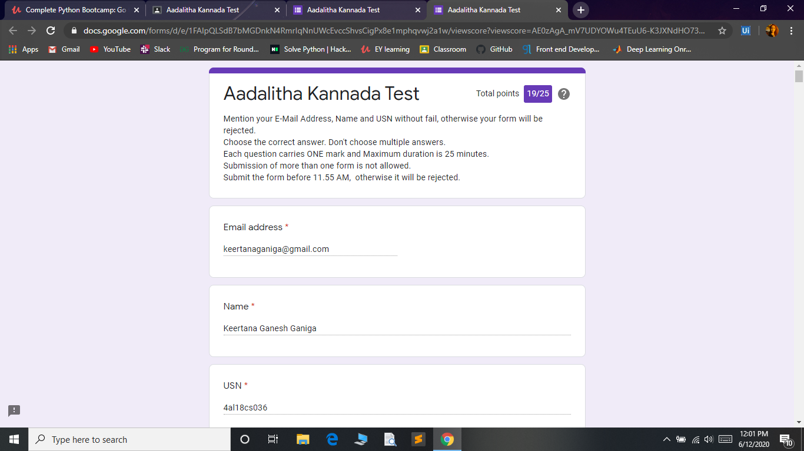

**Certification Course Summary:** **Today I learn about creating data report pages, creating resources pages, creating application forms, adding links, adding videos and buttons all the basic concepts and completed the course. But certificate is paid.**

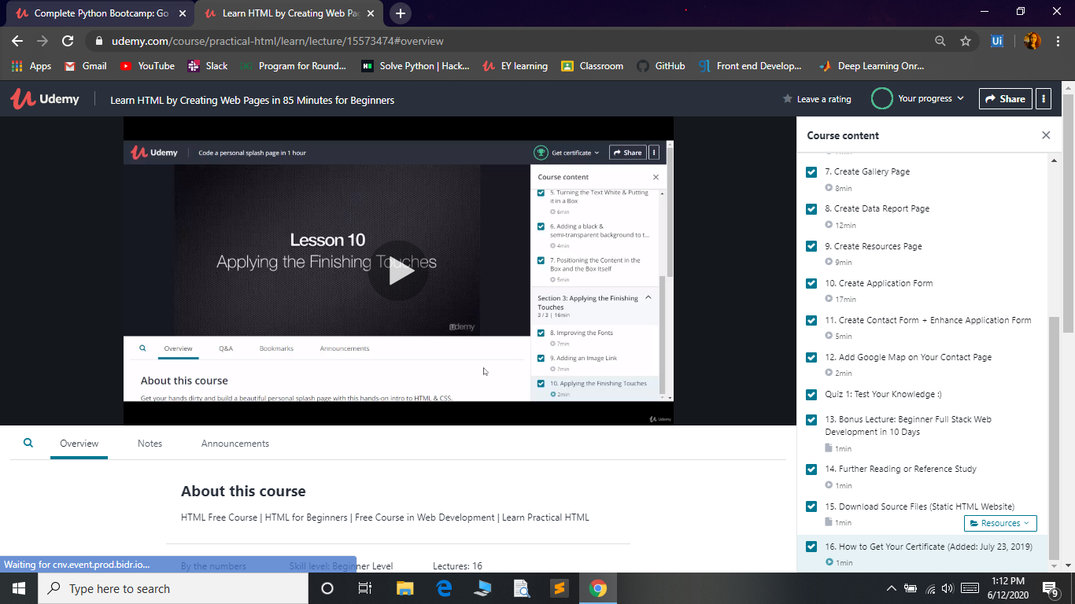

**Coding Challenges:**

Today I solved coding challenge,

1. **Given two positive integers start and end. The task is to write a Python program to print all Prime numbers in an Interval.**

**Explanation: A prime number is a natural number greater than 1 that has no positive divisors other than 1 and itself. The first few prime numbers are {2, 3, 5, 7, 11, ….}. The idea to solve this problem is to iterate the val from start to end using a for loop and for every number, if it is greater than 1, check if it divides n. If we find any other** number which divides, print that value

