**DAILY ONLINE ACTIVITIES SUMMARY**

|  |  |  |  |  |  |  |  |  |
| --- | --- | --- | --- | --- | --- | --- | --- | --- |
| **Date:** | **13 June 2020** | | | | | **Name:** | **Keertana Ganesh Ganiga** | |
| **Sem & Sec** | **4th sem, 2nd year** | | | | | **USN:** | **4al18cs036** | |
| **Online Test Summary** | | | | | | | | |
| **Subject** | | **DATA COMMUNICATION (18cs46)** | | | | | | |
| **Max. Marks** | | **30** | | **Score** | | | **29** | |
| **Certification Course Summary** | | | | | | | | |
| **Course** | **Introduction to Ethical Hacking** | | | | | | | |
| **Certificate Provider** | | | **GreatLearning** | | **Duration** | | | **4 hours** |
| **Coding Challenges** | | | | | | | | |
| **Problem Statement:1 program** | | | | | | | | |
| **Status: Executed** | | | | | | | | |
| **Uploaded the report in Github** | | | | | **Yes** | | | |
| **If yes Repository name** | | | | | <https://github.com/keertanaganiga/Lockdown_coding>  <https://github.com/keertanaganiga/Lockdown_certification>  <https://github.com/keertanaganiga/lockdown_reports> | | | |
| **Uploaded the report in slack** | | | | | **Yes** | | | |

**Online Test Summary**

**DATA COMMUNICATION (18cs46) was conducted of 30marks with duration of 30 minutes.**

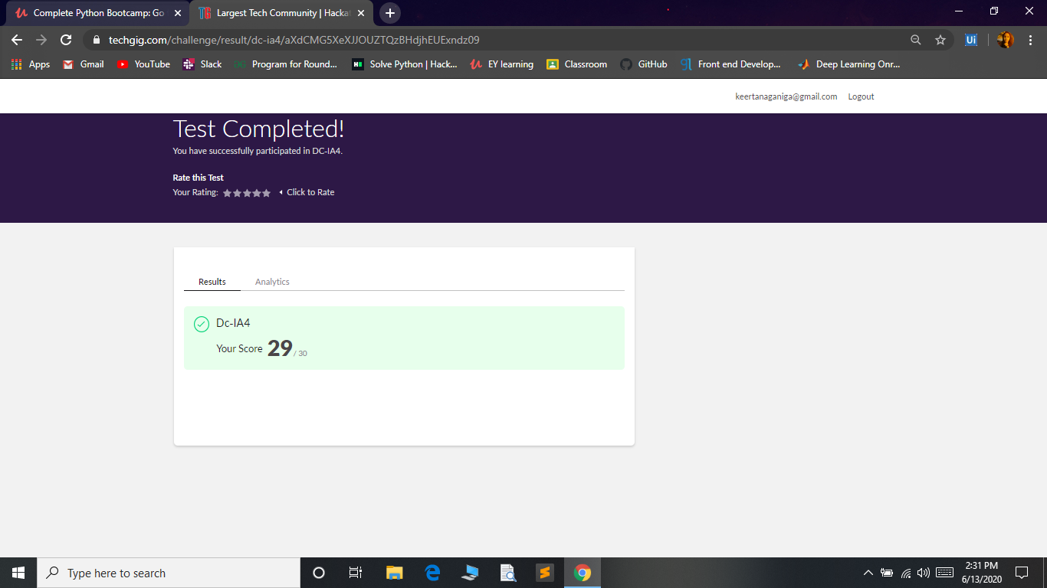

**Certification Course Summary:** **Today I started new course Introduction to ethical hacking in Great Learning which is of 4 hrs. After the completion of course, certificate will be provided.**

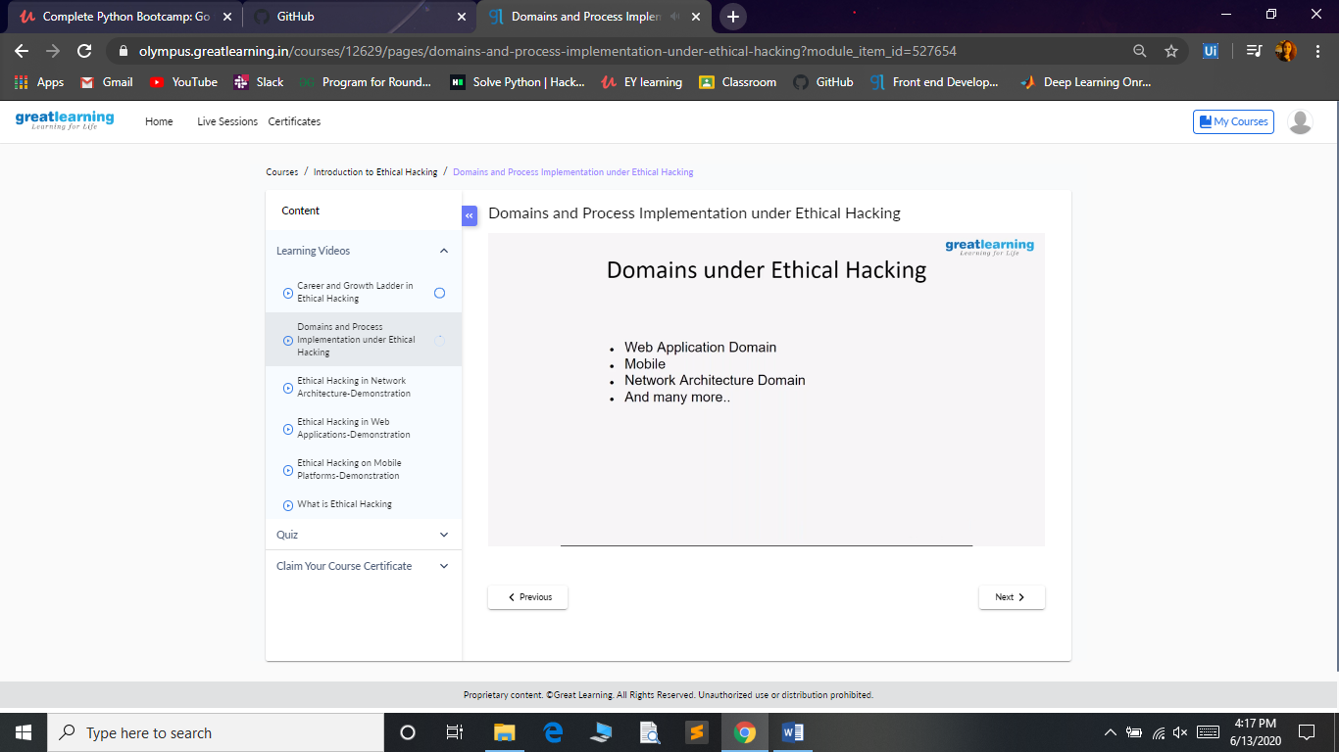

**Coding Challenges:**

Today I solved coding challenge,

**1.** **How to find the first non-repeated character of a given String?**

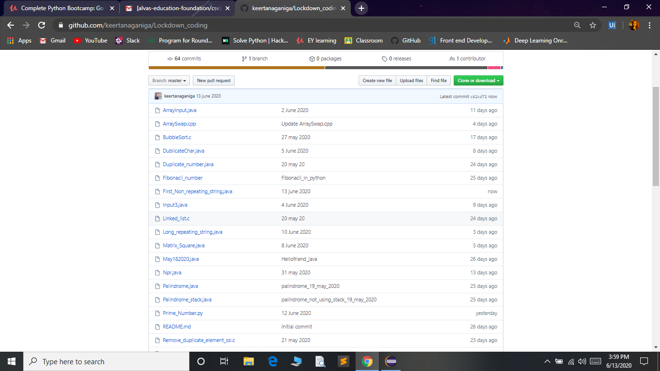

**Extra activity:**

**I attended E-Quiz on “Aptitude and General Knowledge” and I got certificate with 96%.**

