**DAILY ONLINE ACTIVITIES SUMMARY**

|  |  |  |  |  |  |  |  |  |
| --- | --- | --- | --- | --- | --- | --- | --- | --- |
| **Date:** | **14 June 2020** | | | | | **Name:** | **Keertana Ganesh Ganiga** | |
| **Sem & Sec** | **4th sem, 2nd year** | | | | | **USN:** | **4al18cs036** | |
| **Online Test Summary** | | | | | | | | |
| **Subject** | | **----------------** | | | | | | |
| **Max. Marks** | | **---** | | **Score** | | | **-------** | |
| **Certification Course Summary** | | | | | | | | |
| **Course** | **Introduction to Ethical Hacking** | | | | | | | |
| **Certificate Provider** | | | **GreatLearning** | | **Duration** | | | **4 hours** |
| **Coding Challenges** | | | | | | | | |
| **Problem Statement:1 program** | | | | | | | | |
| **Status: Executed** | | | | | | | | |
| **Uploaded the report in Github** | | | | | **Yes** | | | |
| **If yes Repository name** | | | | | <https://github.com/keertanaganiga/Lockdown_coding>  <https://github.com/keertanaganiga/Lockdown_certification>  <https://github.com/keertanaganiga/lockdown_reports> | | | |
| **Uploaded the report in slack** | | | | | **Yes** | | | |

**Certification Course Summary:** **Today I started new course Introduction to ethical hacking in Great Learning which is of 4 hrs. After the completion of course, certificate will be provided.**

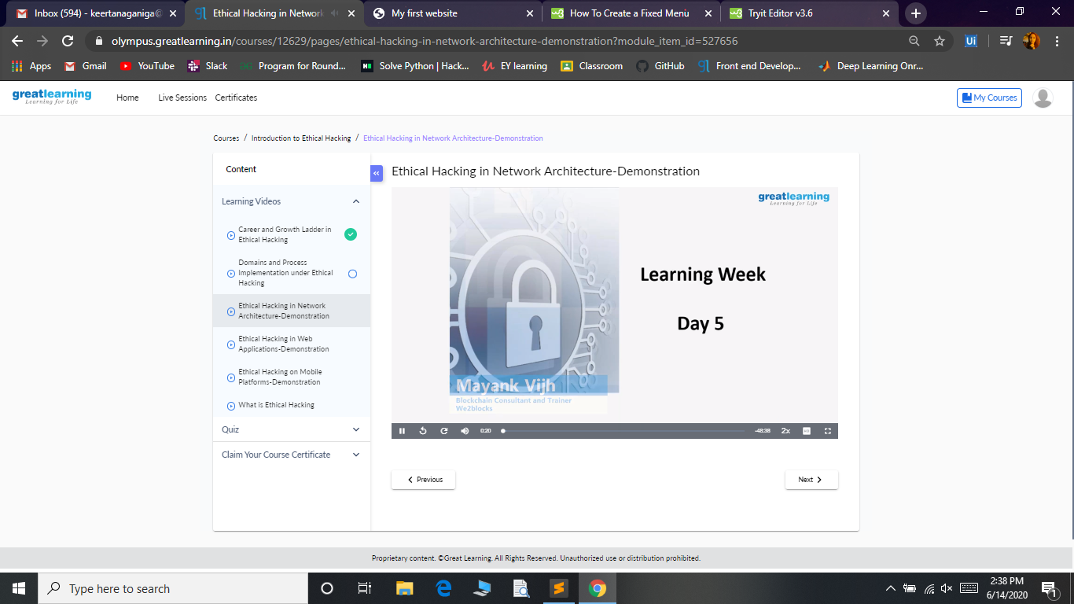

**Coding Challenges:**

Today I solved coding challenge,

1. **Write a C program to remove specific characters in the String**

**Example  
If the original string is "Welcome to AIET" and the user inputs string to remove "co" then the it should print "Welcome to AIET" as output.**

**Input  
First line read a string  
Second line read key character to be removed.**

**Output  
String which doesn't contain key character**

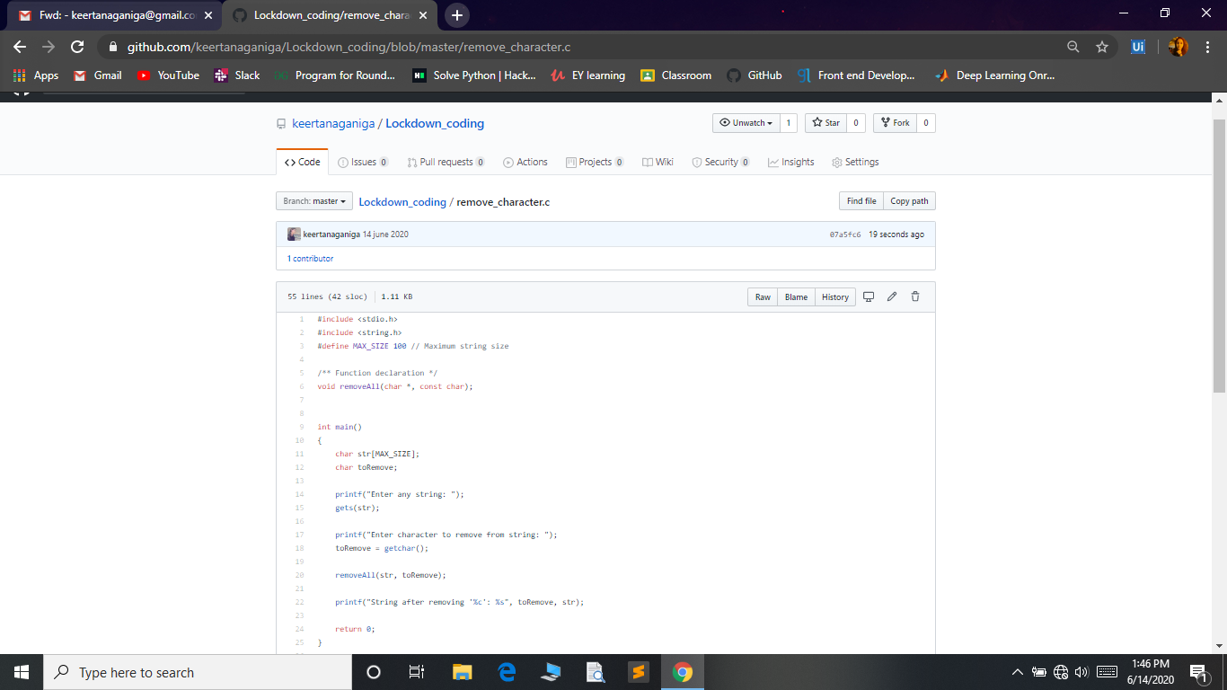

**Extra activity:**

**I attended E-Quiz on “Python Online Quiz” and I got certificate.**



