**DAILY ONLINE ACTIVITIES SUMMARY**

|  |  |  |  |  |  |  |  |  |
| --- | --- | --- | --- | --- | --- | --- | --- | --- |
| **Date:** | **16 June 2020** | | | | | **Name:** | **Keertana Ganesh Ganiga** | |
| **Sem & Sec** | **4th sem, 2nd year** | | | | | **USN:** | **4al18cs036** | |
| **Online Test Summary** | | | | | | | | |
| **Subject** | | **18MAT41** | | | | | | |
| **Max. Marks** | | **30** | | **Score** | | | **22** | |
| **Certification Course Summary** | | | | | | | | |
| **Course** | **Introduction to Ethical Hacking** | | | | | | | |
| **Certificate Provider** | | | **GreatLearning** | | **Duration** | | | **4 hours** |
| **Coding Challenges** | | | | | | | | |
| **Problem Statement:1 program** | | | | | | | | |
| **Status: Executed** | | | | | | | | |
| **Uploaded the report in Github** | | | | | **Yes** | | | |
| **If yes Repository name** | | | | | <https://github.com/keertanaganiga/Lockdown_coding>  <https://github.com/keertanaganiga/Lockdown_certification>  <https://github.com/keertanaganiga/lockdown_reports> | | | |
| **Uploaded the report in slack** | | | | | **Yes** | | | |

**Online Test Summary:**

**Today 18MAT41 was conducted for 15 questions of 30 marks.**

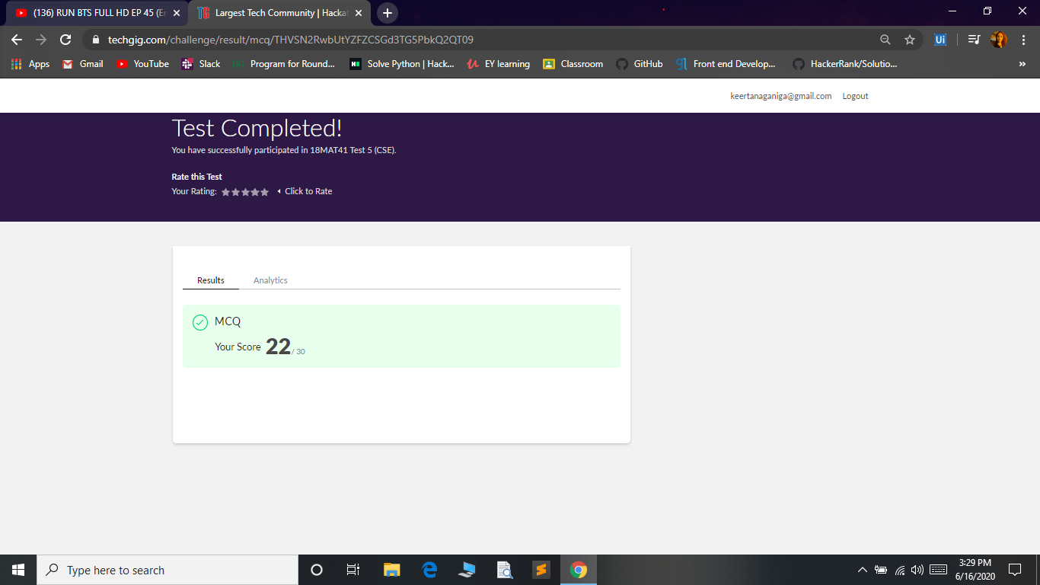

**Certification Course Summary:** **Today I started new course Introduction to ethical hacking in Great Learning which is of 4 hrs. After the completion of course, certificate will be provided.**

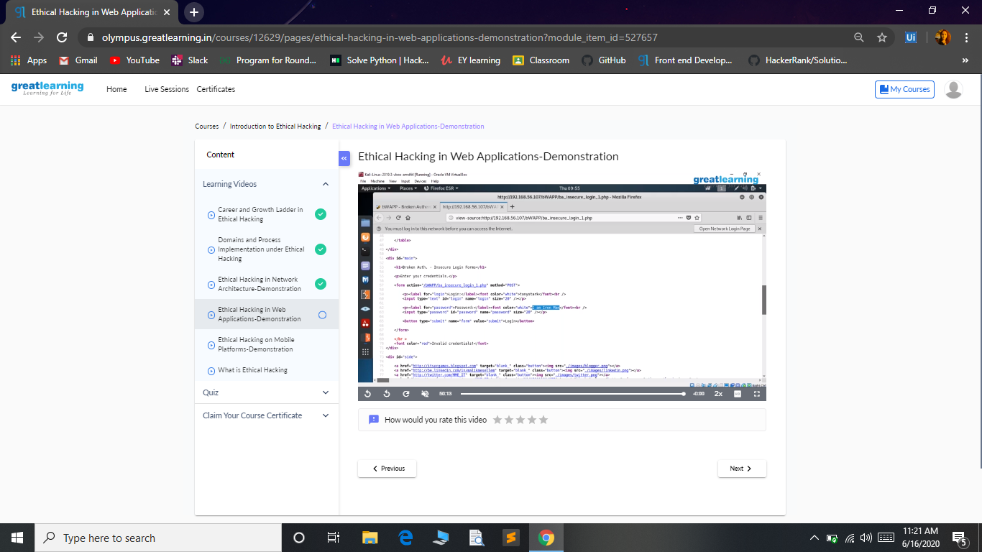

**Coding Challenges:**

Today I solved coding challenge,

1. **Write a Python program to check whether a given a binary tree is a valid binary search tree (BST) or not?**

