**DAILY ONLINE ACTIVITIES SUMMARY**

|  |  |  |  |  |  |  |  |  |
| --- | --- | --- | --- | --- | --- | --- | --- | --- |
| **Date:** | **17 June 2020** | | | | | **Name:** | **Keertana Ganesh Ganiga** | |
| **Sem & Sec** | **4th sem, 2nd year** | | | | | **USN:** | **4al18cs036** | |
| **Online Test Summary** | | | | | | | | |
| **Subject** | | **----------------** | | | | | | |
| **Max. Marks** | | **---** | | **Score** | | | **-------** | |
| **Certification Course Summary** | | | | | | | | |
| **Course** | **Introduction to Ethical Hacking** | | | | | | | |
| **Certificate Provider** | | | **GreatLearning** | | **Duration** | | | **4 hours** |
| **Coding Challenges** | | | | | | | | |
| **Problem Statement:1 program** | | | | | | | | |
| **Status: Executed** | | | | | | | | |
| **Uploaded the report in Github** | | | | | **Yes** | | | |
| **If yes Repository name** | | | | | <https://github.com/keertanaganiga/Lockdown_coding>  <https://github.com/keertanaganiga/Lockdown_certification>  <https://github.com/keertanaganiga/lockdown_reports> | | | |
| **Uploaded the report in slack** | | | | | **Yes** | | | |

**Certification Course Summary:** **Today I started new course Introduction to ethical hacking in Great Learning which is of 4 hrs. After the completion of course, certificate will be provided.**

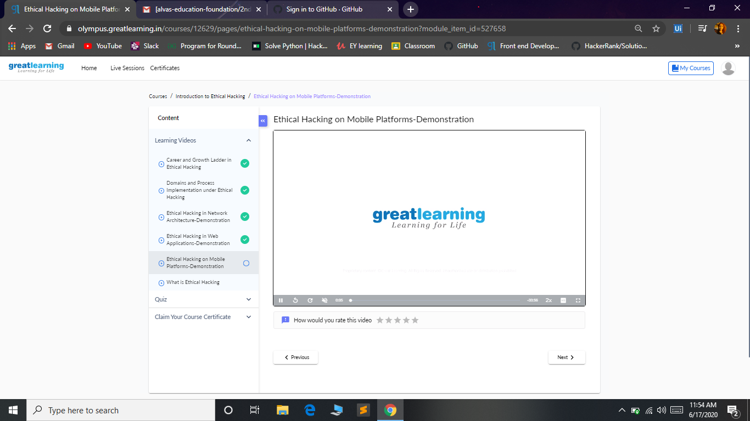

**Coding Challenges:**

Today I solved coding challenge,

**Write a C Program to Count numbers that don’t contain 3**

Given a number n, write a function that returns count of numbers from 1 to n that don’t contain digit 3 in their decimal representation.  
**Examples:**  
**Input:** n = 10  
**Output:** 9  
Here input is 10 means the numbers within 10 are 1,2,3,4,5,6,7,8,9,10 in this series 3 occurs only 1 time so answer is 9

**More examples**  
Input: n = 45  
Output: 31  
// Numbers 3, 13, 23, 30, 31, 32, 33, 34,  
// 35, 36, 37, 38, 39, 43 contain digit 3.

Input: n = 578  
Output: 385

