**DAILY ONLINE ACTIVITIES SUMMARY**

|  |  |  |  |  |  |  |  |  |
| --- | --- | --- | --- | --- | --- | --- | --- | --- |
| **Date:** | **18 July 2020** | | | | | **Name:** | **Keertana Ganesh Ganiga** | |
| **Sem & Sec** | **4th sem, 2nd year** | | | | | **USN:** | **4al18cs036** | |
| **Online Test Summary** | | | | | | | | |
| **Subject** | | **---** | | | | | | |
| **Max. Marks** | | **--** | | **Score** | | | **---** | |
| **Certification Course Summary** | | | | | | | | |
| **Course** | Python Data Structure | | | | | | | |
| **Certificate Provider** | | | **Coursera** | | **Duration** | | | **19 hrs** |
| **Coding Challenges** | | | | | | | | |
| **Problem Statement: 1** | | | | | | | | |
| **Status: executed** | | | | | | | | |
| **Uploaded the report in Github** | | | | | **Yes** | | | |
| **If yes Repository name** | | | | | <https://github.com/keertanaganiga/Lockdown_coding>  <https://github.com/keertanaganiga/Lockdown_certification>  <https://github.com/keertanaganiga/lockdown_reports> | | | |
| **Uploaded the report in slack** | | | | | **Yes** | | | |

#### Certification Course Summary:

#### Today I continued new course in Coursera, Python Data Structure which is of 19 Hrs course.

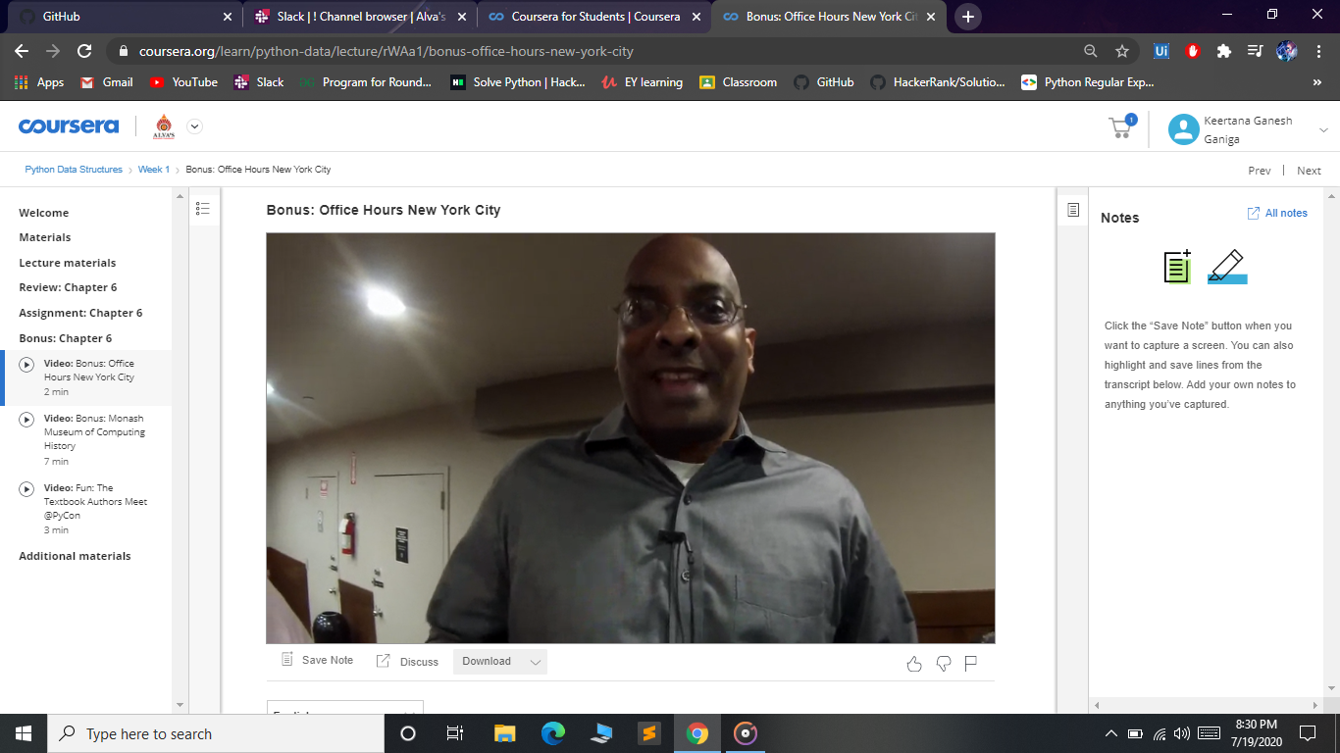

**Online coding:  
Given three numbers N, A and B. Find how integers in range from 1 to N are divisible by A or B.**

**Input:  
Input contains three integers N, A and B separated by space.**

**Output:  
Print total numbers of integers in range from 1 to N are divisible by A or B.**

**SAMPLE INPUT :  
25 3 5**

**SAMPLE OUTPUT :  
12**

