**DAILY ONLINE ACTIVITIES SUMMARY**

|  |  |  |  |  |  |  |  |  |
| --- | --- | --- | --- | --- | --- | --- | --- | --- |
| **Date:** | **20 June 2020** | | | | | **Name:** | **Keertana Ganesh Ganiga** | |
| **Sem & Sec** | **4th sem, 2nd year** | | | | | **USN:** | **4al18cs036** | |
| **Online Test Summary** | | | | | | | | |
| **Subject** | | **Data Communication** | | | | | | |
| **Max. Marks** | | **30** | | **Score** | | | **27** | |
| **Certification Course Summary** | | | | | | | | |
| **Course** | **Cloud Computing with AWS** | | | | | | | |
| **Certificate Provider** | | | **GreatLearning** | | **Duration** | | | **12 hours** |
| **Coding Challenges** | | | | | | | | |
| **Problem Statement:2 program** | | | | | | | | |
| **Status: Executed** | | | | | | | | |
| **Uploaded the report in Github** | | | | | **Yes** | | | |
| **If yes Repository name** | | | | | <https://github.com/keertanaganiga/Lockdown_coding>  <https://github.com/keertanaganiga/Lockdown_certification>  <https://github.com/keertanaganiga/lockdown_reports> | | | |
| **Uploaded the report in slack** | | | | | **Yes** | | | |

#### *Online Test Summary:*

#### Today Data Communication exam was conducted for 30 marks for duration of 30 min.

#### 

#### *Certification Course Summary:*

#### Today I started new course Cloud Computing with AWS in Great Learning which is of 12 hrs. After the completion of course, certificate will be provided.

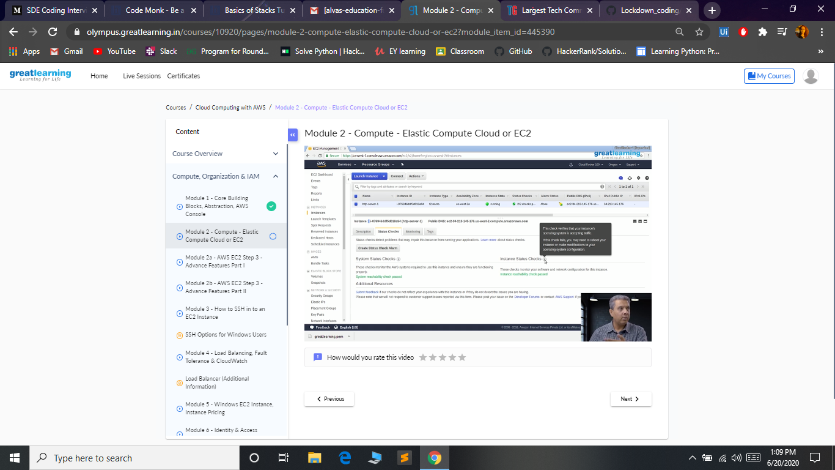

***Coding Challenges:***

Today I solved 2 coding challenge,

1. **Write a C++ Program to rotate an array by K positions.**

Circular array rotation means rotating the elements in the array where one rotation operation moves the last element of the array to the first position and shifts all remaining elements to the right.

For example, consider the following array = [4, 5, 6],  
• Initial array [4, 5, 6]  
• After one rotation [6, 4, 5]  
• After two rotations [5, 6, 4]

OUTPUT

Element at index 0: 5  
Element at index 1: 6  
Element at index 2: 4

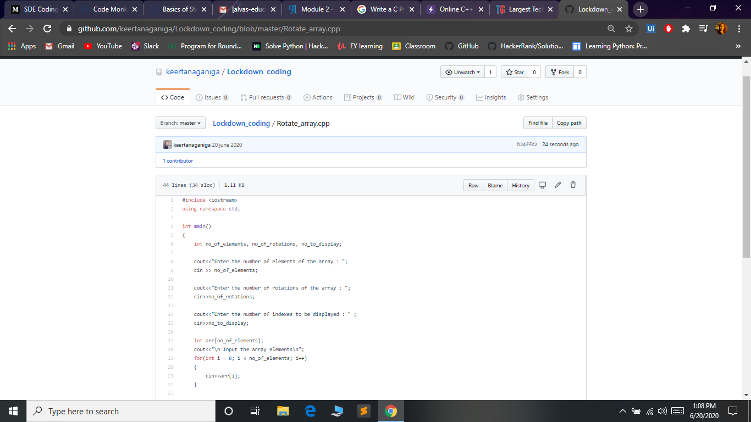

2. **Java** **program that compares counting words in files using an Array List and a Map**

