**DAILY ONLINE ACTIVITIES SUMMARY**

|  |  |  |  |  |  |  |  |  |
| --- | --- | --- | --- | --- | --- | --- | --- | --- |
| **Date:** | **21 June 2020** | | | | | **Name:** | **Keertana Ganesh Ganiga** | |
| **Sem & Sec** | **4th sem, 2nd year** | | | | | **USN:** | **4al18cs036** | |
| **Online Test Summary** | | | | | | | | |
| **Subject** | | **----------------** | | | | | | |
| **Max. Marks** | | **----** | | **Score** | | | **-----** | |
| **Certification Course Summary** | | | | | | | | |
| **Course** | **Cloud Computing with AWS** | | | | | | | |
| **Certificate Provider** | | | **GreatLearning** | | **Duration** | | | **12 hours** |
| **Coding Challenges** | | | | | | | | |
| **Problem Statement:1 program** | | | | | | | | |
| **Status: Executed** | | | | | | | | |
| **Uploaded the report in Github** | | | | | **Yes** | | | |
| **If yes Repository name** | | | | | <https://github.com/keertanaganiga/Lockdown_coding>  <https://github.com/keertanaganiga/Lockdown_certification>  <https://github.com/keertanaganiga/lockdown_reports> | | | |
| **Uploaded the report in slack** | | | | | **Yes** | | | |

#### *Certification Course Summary:*

#### Today I started new course Cloud Computing with AWS in Great Learning which is of 12 hrs. After the completion of course, certificate will be provided.

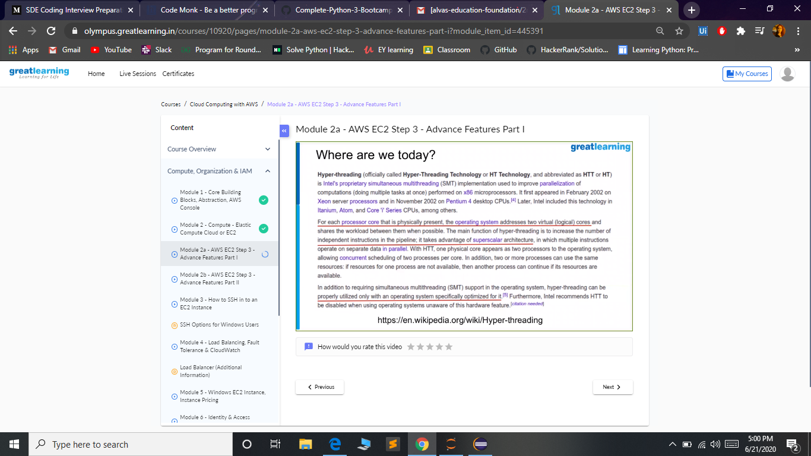

***Coding Challenges:***

Today I solved 1 coding challenge,

1**. Write a Java program to count number of bits to be flipped to convert A to B**

Given two numbers ‘a’ and b’. Write a program to count number of bits needed to be flipped to convert ‘a’ to ‘b’.  
**Example:**

Input: a = 10, b = 20  
Output: 4  
Binary representation of a is 000**0101**0  
Binary representation of b is 00010100  
We need to flip highlighted four bits in a  
to make it b.

Input: a = 7, b = 10  
Output: 3  
Binary representation of a is 0000**01**1**1**  
Binary representation of b is 00001010  
We need to flip highlighted three bits in a  
to make it b.

**Hint**

1. Calculate XOR of A and B.  
   a_xor_b = A ^ B
2. Count the set bits in the above  
   calculated XOR result.  
   countSetBits(a_xor_b)

